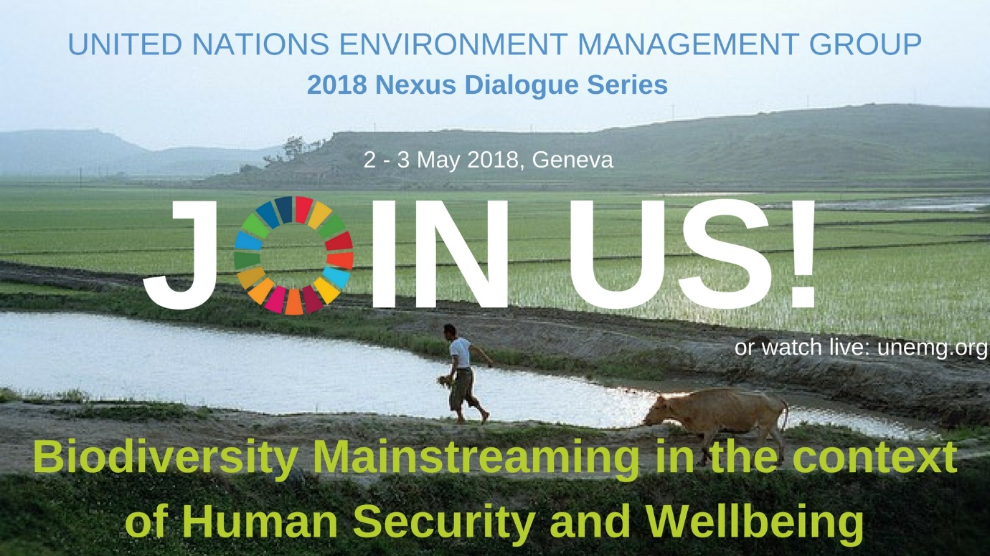

The Environment Management Group would like to invite you to the first of the 2018 Nexus Dialogue Series on Biodiversity Mainstreaming in the context of Human Security and Well-being, which will take place at the International Environment House II in Geneva on May 2-3, 2018.
This Nexus Dialogue will consist of two days of technical discussions. During these two days, the discussions will be divided into eight sessions, each focusing on interlinkages of biodiversity with a range of human security and wellbeing components. During each session, through short statements, the presenters will focus on examples of biodiversity mainstreaming in their sector, highlighting their success stories as well as challenges. At the end of each session there will be a panel discussion, which will build upon the points shared in the presentations exploring the importance of mainstreaming biodiversity targets in sustainable development as well as human security and wellbeing. In doing so, the Dialogue will consider how UN agencies and their partners could, during the next two years, further enhance their collaborative and individual efforts to support implementation of the Strategic Plan for Biodiversity 2011-2020 and Aichi Biodiversity Targets and the associated Goals and targets of the 2030 Agenda for Sustainable Development.
The outcomes of these technical discussions will be discussed at a high-level event at the High Level Political Forum in New York in July 2018.
The Dialogue is organized by the Environment Management Group in cooperation with the Secretariat of the Convention on Biological Diversity and with the support of the Government of Switzerland and is expected to bring together a number of UN entities, Member States and Civil Society representatives for an open, frank and interactive discussion. It is hoped that this event contributes to the acceleration of actions in implementing the Aichi Biodiversity Targets as part of the Sustainable Development Goals.
For more information about this Nexus Dialogue and to register your attendance, kindly access the following link at http://unemg.org/emg-nexus-dialogues/2018-nexus-dialogue-series.
Should you need any additional information on the Dialogue, please contact the EMG secretariat by email at emg@unep.org

With best regards,
EMG Secretariat
================================

Secretariat of the Environment Management Group (EMG)
International Environment House
11-13 Chemin des Anémones
CH-1219 Châtelaine, Geneva
Tel: +41-22-917-8693
Fax: +41-22-917-8024
emg@un.org
http://www.unemg.org

