
Chemicals in Products: Strengthening Action Workshop
25-26 October 2017, Geneva, Switzerland

Practical Information

Date and venue:
The Chemicals in Products: Strengthening Action Workshop will take place in Geneva, Switzerland on Wednesday 25 and Thursday 26, October 2017 from 9:00 am to 6:00 pm. Registration for the workshop will be open from 8:30 am to 9:00 am on 25 October 2017.
Venue of the meeting will be at the:

International Environment House 1 (IEH 1)
Chemin de Balexert 7
CH-1219 Châtelaine (GE)
Switzerland

The meeting will be conducted in English.

Transport within Geneva:
For those arriving to the venue by taxi, please either ask the hotel reception to order a taxi or call +41 (0) 22 331 41 33.
For those coming to the venue by public transport, the following options are recommended:
- From the airport: Bus Y, 23 or 28 to ‘Blandonnet’ (direction “Ferney-Voltaire-Mairie” for Y, “ZIPLO” for 23 and “parfumerie” for the 28), then switch to Tram 14 (direction “Meyrin”) or 18 (direction “CERN”) and alight at ‘Balexert’ (direction 5 min. walking distance to the IEH)

- From ‘Gare Cornavin’ (main train station): Tram 14 (direction “Meyrin”) or 18 (direction “CERN”) to ‘Balexert’ (5 min. walking distance to the IEH)

- From ‘22 Cantons’ (1 min. walking distance from ‘Gare Cornavin’): Bus 6 or 19 (direction “Vernier village”) and alight at ‘Chatelaine’ (2 min. walking distance to the IEH)

Itineraries can be accessed at http://www.tpg.ch/en/web/site-international. Bus tickets for one hour within the Geneva area cost 3,00 CHF. A short trip (“saut de puce”; 3 stops max) costs 2,00 CHF. A day travel card costs 10,60 CHF. Tickets have to be bought at the machines at the bus/tram stop before entering the bus.
A 80min free ticket can be obtained at the airport arrival in the baggage collection area and it is valid for the whole city.

The following map illustrates the location of the meeting venue (International Environment House 2) and the nearby bus and tram stops:

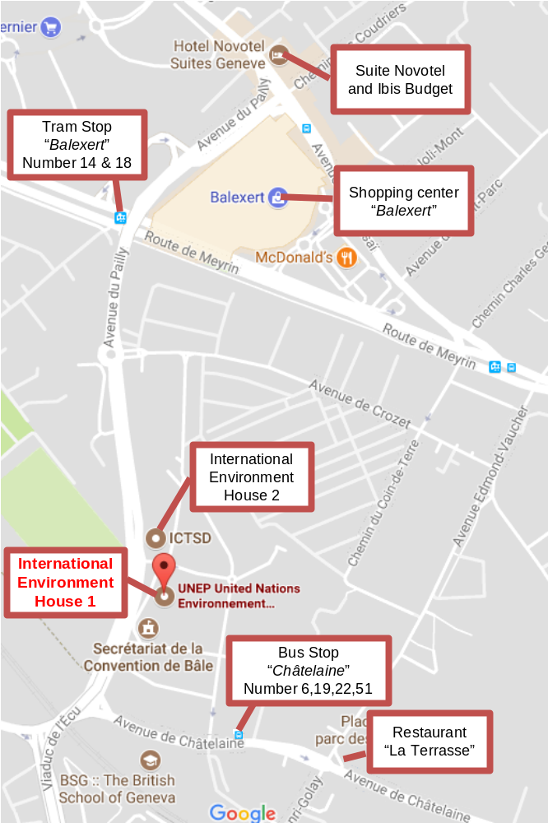

Accommodation:
All participants (DSA funded and non-funded) are responsible to make their own arrangements for accommodation. If you wish to stay close to the meeting venue, we would recommend either of the following hotels:
- ‘Suite Novotel’ (http://www.suitenovotel.com/gb/hotel-5654-suite-novotel-geneve/index.shtml): 3-star hotel; located right opposite the ‘Balexert’ shopping center; prices starting around 180 CHF per night, plus 24 CHF for breakfast.
- ‘Ibis Budget Geneva’ (http://www.accorhotels.com/gb/hotel-5653-ibis-budget-geneve/index.shtml): economy hotel; located right opposite the ‘Balexert’ shopping center; prices around 110 CHF per night, plus 12 CHF breakfast.
For other options, please see the following website:
http://www.geneve-tourisme.ch/en/accommodation/

Meals:
Coffee, tea and snacks will be offered during coffee breaks on Wednesday 25 and Thursday 26 October. Lunch can be taken at the International Environment House 1 cafeteria at own expense.
Options nearby the venue also include the following:
- La Terrasse: Italian food (see map)
- Several restaurants and snack-bars can be found in the nearby shopping center ‘Balexert’ (http://www.balexert.ch/categorie/restaurants/) located 5 min walking distance from the IEH (also see map)
For other options, please visit the following website:
http://www.geneve-tourisme.ch/en/eating-drinking/

Other:
- Electricity: Switzerland uses plug type J. You may need to bring a plug adaptor.
- Weather: Rainy weather with ca. 10°C day time high temperatures are common in the Fall.
- Time zone: Geneva time is CET, which is GMT + 02:00 hours for the days of the Workshop.

Documents:
Meeting documents can be accessed on UNEP website:

http://www.unep.org/chemicalsandwaste/what-we-do/science-and-knowledge/chemicals-products/meetings/events/chemicals-products-strengthening

Agenda:
The meeting agenda will be available on the website.

Contacts:

Mr. Kevin Munn
Programme Officer
UN Environment, Economy Division
Chemicals and Health Branch
Phone: +41 22 917 8186
Email: Kevin.Munn@unep.org

We look forward to welcoming you in Geneva.

