Energizing Asia-Pacific's National Ozone Teams for
Enhanced Implementation of the Montreal Protocol
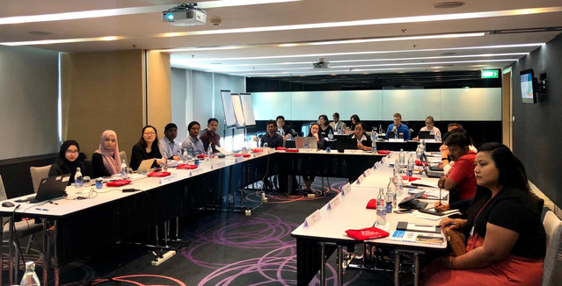
Bangkok, 24 December 2019 ̶ How well Ozone Officers and their teams do in their work – developing projects, managing national strategies, reporting data, developing and enforcing policies, working with national and international institutions – directly or indirectly affects the status of their country's compliance with its obligations under the Montreal Protocol on Substances that Deplete the Ozone Layer. Helping these new officers do their job efficiently is why UNEP OzonAction brought together 17 National Ozone Officers and staff from 15 National Ozone Units of Brunei, China, India, Indonesia, Malaysia, Maldives, Mongolia, Myanmar, Nepal, Pakistan, Singapore, Sri Lanka, Thailand, Timor Leste, and Tuvalu to participate in an intense, hands-on training workshop in Thailand's capital from 3 to 4 December 2019.

Empowered and skilled Ozone Officers are one of the strong foundations for the success of national implementation of the Montreal Protocol on Substances that Deplete the Ozone Layer. OzonAction’s Compliance Assistance Programme (CAP) developed this training in 2017 to help address the challenges of the high turn-over of National Ozone Officers and their staff. It uses a number of approaches such as frequent communication with and mentoring for National Ozone Officers, direct support via country missions, and country-to-country cooperation for on-the-job training in an experienced National Ozone Unit.

Now with an updated curriculum, the interactive training in Bangkok focuses on the function of the National Ozone Unit. The participants actively engaged in group exercises, puzzles, crossroads and role-playing activities to review the knowledge and practice the skills they learned about the national policy setup, enforcement, and national stakeholders’ consultation and coordination. The participants received essential information about ozone depletion, the Montreal Protocol, its bodies and control measures, details about the roles, responsibilities and expectations of Ozone Officers and their teams, the activities and projects that a National Ozone Unit needs to undertake, and the key skills required for daily operations to efficiently support the implementation of the Montreal Protocol in their countries. The participants also reviewed the achievements of the implementation of the Montreal Protocol, and identified challenges for the next major stage in the life of the Protocol: the Kigali Amendment.

In her opening statements, UNEP's Regional Director and Representative, Ms. Dechen Tsering, emphasized that emissions reductions of greenhouse gases are on top of most governments' agenda, and the potential contribution to this effort by simply complying with the Montreal Protocol. She conveyed the message of the UN Secretary General that implementation of the Kigali Amendment will be front and center for climate action.

OzonAction organized this specialised training in response to the needs of the countries that recently recruited new staff. Notably, India, Singapore and Thailand self-funded the participation of their respective staff. Dr. JD Marcus Knight, Scientist C, Ministry of Environment, Forest and Climate Change who jointed the Ozone Cell in early October 2019 expressed his “appreciation for this comprehensive and timely organized training workshop.”

In 2018, UNEP OzonAction organized two National Ozone Officers/staff training workshops in Bangkok for selected countries of the Pacific Island Countries, and South Asia/Southeast Asia networks respectively.

For further information, please contact:

Mr. Shaofeng Hu
Senior Montreal Protocol Regional Coordinator, OzonAction
UNEP Asia and Pacific Office
E-mail: hus@un.org

Mr. Mikheil Tushishvili
Programme Officer, OzonAction
UN Environment, Law Division
Email: mikheil.tushishvili@un.org

