United Nations Environment Programme
5 May 2020
Committee of Permanent Representatives
Subcommittee Meeting
12 May 2020
2:00 to 5:00 p.m.
Virtual meeting
United Nations Office at Nairobi

Note from the Secretariat for the consultation meeting on the CPR-based review:
Options under subparagraph 10 (d)

This note is developed in support of the process for review by the Committee of Permanent Representatives (CPR) of the United Nations Environment Assembly (UNEA) and its subsidiary bodies, as mandated by paragraphs 9 –13 of UNEA decision 4/2.

At the subcommittee meeting of the Committee on 27 February 2020, Member States considered a consolidated proposal for an improved reporting framework for the implementation of UNEA resolutions, as well as a revised roadmap for the monitoring mechanism for the implementation of UNEA resolutions, in accordance with previous guidance received from the Committee of Permanent Representatives at the 146th meeting of the Committee, the 6th Annual Subcommittee and the 148th meeting of the Committee. At that meeting, the Committee decided as follows (quote from the meeting summary): “The meeting agreed that the Secretariat should be guided by the consolidated reporting proposal in its future work, and that the Secretariat should continue to develop a web-based monitoring mechanism as outlined in the roadmap, taking into account the need to make it operational as soon as possible, also taking into account it could support Member States in their preparations of UNEA-5.“

The document attached in this note, which was considered by the Subcommittee on 27 February 2020 under Agenda Item 4: Implementation of resolution UNEP/EA.4/Res.22, entitled “Implementation and follow up of United Nations Environment Assembly Resolutions,” responds in full to the Secretariat proposal for how to address the subparagraph 10 (d) in Decision 4/2.

On this basis, Member States are invited to further consider concrete options related to subparagraph 10 (d) of Decision UNEP/EA.4/2, “Monitoring and reporting on the implementation of the programme of work and budget and of the resolutions of the Environment Assembly, in line with the adopted roadmap for the Process for review by the CPR. It is expected that this meeting will not devote further in-depth attention to the proposed way forward, as it has already been endorsed by the Committee members.
Note from the Secretariat in support of consultations on the process for review by the Committee of Permanent Representatives: Subparagraph 10 (d)

I. Introduction
This paper presents a consolidated proposal for an improved reporting framework for the implementation of UNEA resolutions for consideration at a Sub-Committee meeting of the Committee of Permanent Representatives scheduled for 27 February 2020. It also presents a revised roadmap for the monitoring mechanism for the implementation of UNEA resolutions.

II. Background
UNEA resolution UNEP/EA.4/Res. 22, entitled “Implementation and follow-up of UN Environment Assembly Resolutions,” requested the Executive Director of the UNEP: to develop a monitoring mechanism, in consultation with the Committee of Permanent Representatives, to track and assess UNEP’s implementation of resolutions in the framework of the Programme of Work and Budget. It also requested: the Executive Director to propose to the CPR at its 146th meeting options for an improved framework for reporting on the implementation of UNEA resolutions to be integrated with the reporting on the Programme of Work and budget.

The 146th meeting of the Committee of Permanent Representatives considered a paper prepared by the Secretariat, on “Options for an Improved Framework for Reporting on Implementation of UN Environment Assembly Resolutions.” The Secretariat proposed three options, Option One: Improved Status Quo, Option Two: Rationalization and Option Three: Minimalistic. The Committee requested that the Secretariat submit for consideration at its next regular meeting, a revised options paper incorporating comments received, as well as a proposal for the monitoring mechanism.

The 6th Annual Sub-Committee meeting of the Committee of Permanent Representatives, held from 7-11 October 2019, considered the revised paper prepared by the Secretariat. In addition to the revised reporting options, the paper provided a detailed proposal for a web-based monitoring mechanism.
Member States provided additional guidance and agreed to continue consultations on the proposal and the reporting options at a forthcoming sub-committee meeting. On the reporting options, initial preference was expressed for options two and three.

On 10 December 2019, the 148th meeting of the Committee considered the matter. The Secretariat sought guidance from Member States on their preferred reporting option, parameters for voluntary reporting by Member States and Secretariat monitoring and reporting as well as frequency of reporting in the monitoring mechanism.

The meeting requested the Secretariat to present a final consolidated proposal, based on options 2 and 3, and to continue to develop the website on monitoring of the implementation of resolution along the lines proposed in the background document, taking into account, comments received. It also decided to revert to the issue at a Subcommittee meeting in February 2020.

III. Consolidated proposal for revised reporting framework
The Consolidated proposal combines mandatory reporting to UNEA with three forms of inter-sessional reporting, which will also serve to strengthen the links between reporting on implementation of UNEA resolutions and the UNEP Programme of Work. These inter-sessional reports will include:

- References to implementation of the resolutions reported in Quarterly reports of the Executive Director to the CPR, as part of the programmatic update.
- Presentations in support of relevant agenda items at Regular meetings, Annual Sub-Committee and Sub-Committee meetings of the Committee of Permanent Representatives.
- Updates on relevant resolutions through the annual and biennial Programme Performance Reports.

In addition to the above, and in further response to UNEA 4/22, the UNEP secretariat is developing an online monitoring and reporting mechanism (see figure 1 below) that will enable open and transparent access, on implementation of both UNEA resolutions and UNEP’s Programme of Work.

IV. Benefits of the Consolidated Proposal
The proposal meets the mandatory requirements for UNEA resolution reporting by providing for reporting both to future sessions of UNEA and during the inter-sessional period. The proposal is responsive to Member States information needs, while also considering the reporting burden on the Secretariat. This includes avoiding duplication of reporting through the annual and biennial Programme Performance Reports; Quarterly reports of the Executive Director to the Committee of Permanent Representatives; and programme performance reviews and reports on implementation of resolutions. The monitoring and reporting mechanism, once operational, will provide online access to information on the implementation of resolutions interlinked with the Programme of Work. Thus, it is hoped that fewer specific reports and briefings on resolution implementation to Member States will be needed.

The consolidated proposal will strengthen the link between reporting on implementation of resolutions and the Programme of Work and its expected accomplishment indicators through combined reporting of the implementation of relevant resolutions with Programme of Work in the Quarterly reports of the Executive Director to CPR and in the Programme Performance Reports. The new reporting on resolutions will be more streamlined and structured because in addition to enhancing integration with Programme of Work reporting, it will standardize the content of the reports in line with the reporting parameters. Improved features include the use of milestones to improve implementation tracking, as well as comparison across resolutions, tracking impact and linkages to higher goals like SDGs, and access to information on voluntary reporting by Member States.

V. Revised Roadmap for Proposed Web-based Monitoring and Reporting Mechanism
The Secretariat presented an initial roadmap for the monitoring and reporting mechanism to the 6th Annual Sub-Committee meeting. That roadmap has been updated in light of discussions at the Annual Sub-committee meeting and 148th meeting of the Committee of Permanent Representatives.

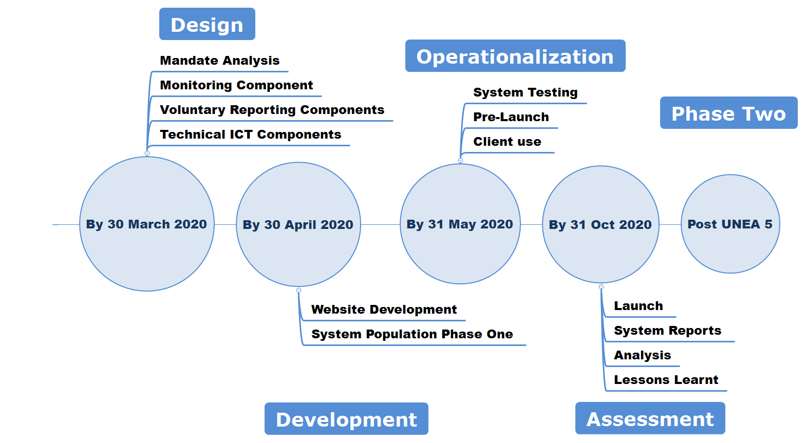
Figure 1: Revised Roadmap for Monitoring and Reporting Mechanism

It is envisaged that the work will be carried out in phases. The second phase would not only incorporate feedback received on the first phase, it would also consider reporting by other actors like Major Groups and stakeholders, UN agencies, and any other partners as agreed by Member States.

VI. Next Steps
- Member States are invited to consider for endorsement the consolidated proposal for a revised reporting framework.
- Member States are invited to take note of the revised roadmap for the proposed web-based monitoring and reporting mechanism.
- The Secretariat will continue work on the development of the monitoring and reporting mechanism in line with the revised roadmap.

VII. Annexes
- Annex 1: UNEP/EA.4/Res. 22 (L.26): Implementation and follow-up of the UN Environment Assembly Resolutions: Mandates for the Executive Director (available here)
- Annex 2: List of Resolutions and Decisions: First to Fourth Sessions of the UN Environment Assembly (available here)

