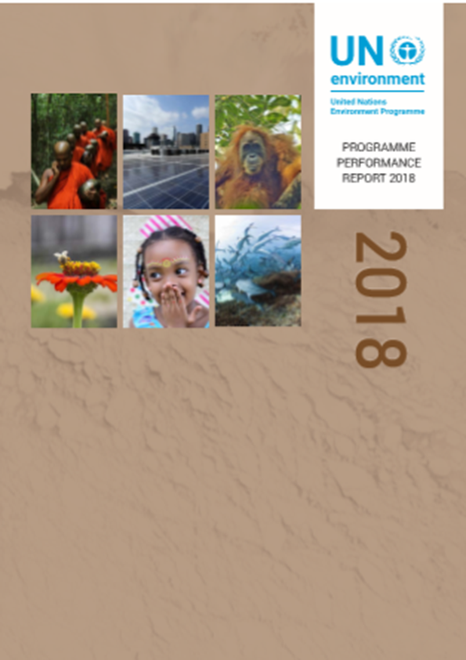
OVERVIEW
2018 was the first year of our Programme of Work 2018-2019, which itself folds into the umbrella 4-year Medium-Term Strategy for 2018-2021. The strategy provides a stepping stone towards a vision for 2030 where all people live on a healthier planet.
While 2018 was a challenging year, we witnessed growing commitments and actions that innovatively tackle environmental challenges and grasp sustainable development opportunities. We highlighted best practices, advocated for action and brought together governments, civil society and businesses. We scaled-up the use of tools and services by working through partners and leveraging the strengths of key actors.

Towards a Pollution Free Planet
The third session of the UN Environment Assembly, held in December 2017 on the theme, ‘Towards a Pollution-free Planet’, expanded our mandate for work on environment and health issues and set the stage for much of our work and influence in 2018.
World Environment Day 2018, hosted by India, inspired unprecedented action on plastic pollution, reaching hundreds of millions of people in over 190 countries. In pledging to phase-out single-use plastic by 2022, India set the bar high for the rest of the world. Commitments from 57 nations covering over 60 percent of the world’s coastlines made our Clean Seas campaign the largest global compact for combatting marine litter.
In 2018, we also partnered with the World Health Organisation, which hosted the first global meeting on air pollution, which causes 6 to 7 million premature deaths every year. We supported national strategies and policies on cleaner transport, a key step in reducing air pollution and mitigating climate change. For example, we supported the development of national strategies for electric mobility in several countries in Latin America.
We helped governments, businesses and industries, and civil society organizations to develop strategies for environmental management of waste. This means placing emphasis on waste avoidance, prevention and segregation. It enables society to reuse, recycle or treat waste before its disposal.

A Stronger Science-policy Interface
UN Environment Programme completed the sixth Global Environment Outlook (GEO-6) and its Summary for Policy Makers. These have been submitted for inter-governmental review and approval. GEO-6 shows that the overall environmental situation is deteriorating globally and the window for action is closing. It has three main messages:
(1) We need to find ways to decrease our use of fossil fuels while nonetheless cater for a significant jump in energy demand;
(2) We need to feed 10 billion people by 2050, while reducing by two-thirds the environmental impact of food production, and
(3) We need to move to a circular economy which sees near-zero waste by 2050.
The GEO-6 also provides practical solutions for us to implement.
UN Environment Programme’s Emissions Gap Report 2018 complemented the Intergovernmental Panel on Climate Change Report on Global Warming of 1.5-degrees Celsius. Both effectively sounded the alarm on the significant impacts of even a 1.5-degree-warmer world when compared with its 2-degree-warmer variant. This has reignited global attention to the need for action on climate change, and informed priorities of the 2019 Climate Summit.

High-level Political Forum on Sustainable Development (HLPF)
The High-Level Political Forum on Sustainable Development under the theme, “Transformation towards sustainable and resilient societies”, reviewed progress towards the Sustainable Development Goals with a focus on Goals 6, 7, 11, 12,15 and 17. The President of the UN Environment Assembly presented the key messages of the Third Session of the Environment Assembly to the Forum, which, through its Ministerial Declaration, welcomed the main outcomes of the session. Ministers acknowledged the progress achieved in implementing the 10-Year Framework of Programmes on Sustainable Consumption and Production Patterns (10YFP), recognized the One Planet network as an important implementation mechanism for Sustainable Development Goal 12 and agreed to further accelerate action on the 10-Year Framework of Programmes.

SDG indicators
Of the 93 environment-related SDGs indicators, there are 20 (equivalent to 22 per cent) for which good progress has been made over the last 15 years. If this progress continues, it is likely that these SDGs targets will be met. However, for the other 78 per cent of the environment-related SDGs indicators, either there is insufficient data to assess progress (62 per cent) or it is unlikely that the target will be met without upscaling action (16 per cent).
Many of the indicators for which progress has been made reflect a mix of policy changes, improved reporting and increased funding efforts. For example, there has been an increase in terrestrial, mountain and marine protected areas; growth in the effort to combat invasive species; significant progress towards renewable energy; an increase in sustainability reporting and mainstreaming in policy; and an increase in development assistance for climate change and the environment.
Many of the indicators related to the state of the environment also show a negative trend. This includes indicators related to forests, sustainable fisheries, endangered species, domestic material consumption, and material footprint. Many of the indicators without available data correspond with issues that have received insufficient attention in terms of the SDGs implementation. Additional action on these areas is particularly important.
As custodian agency for 26 SDG indicators, UN Environment Programme continued its work on developing and refining methodologies to measure SDG targets, including an elaboration on the need for disaggregated and geospatial information. For example, on SDG indicator 12.c.1, UN Environment Programme worked with others to develop a methodology to measure fossil fuel subsidies. We also worked with the Food and Agricultural Organization and other key partners to develop the indicator methodology for the food waste element of SDG target 12.3, which aims to halve the 1.3 billion tonnes of annual food waste or loss by 2030. Geospatial data are part of methodologies for SDG indicators 6.6.1 on extent of water ecosystems, and 14.1.1 on coastal eutrophication and marine litter.

Innovative Transformative Partnerships
In 2018, UN Environment Programme pressed ahead with new innovative partnerships for transformative land management. We also saw the first-ever Tropical Landscapes Bond, launched in collaboration with BNP Paribas, the World Agroforestry Centre and partners. This US$95 million bond will restore 80,000 hectares in Indonesia. It will help finance a sustainable natural rubber plantation on heavily degraded land, employing 10,000 people in two provinces. Planted areas will serve as a buffer zone to protect a threatened national park from encroachment.
UN Environment Programme also helped the Government of Andhra Pradesh, India, to launch a new programme for shifting 6 million small-holder farmers towards natural farming by 2024. The ‘Zero Budget Natural Farming’ methodology aims to increase profits for small-holder farmers, diversify the economy, and phase out all synthetic pesticides and fertilizers. Project partners include, among others, UN Environment, BNP Paribas, World Agroforestry Centre, World Wide Fund for Nature (WWF).
Our work on financing for sustainable development also broke new ground. The world’s leading CEOs from the finance sector gathered in Paris and considered the Principles for Responsible Banking, under the leadership of the Finance Initiative. Forty-five banks and financial institutions have endorsed the principles thus far, which aim to shape the banking industry’s role in meeting society’s needs as defined by the Sustainable Development Goals, the Paris Climate Agreement and relevant national and regional frameworks.
We brought together organizations and countries to save the Cuvette Central Peatlands in the Congo Basin, one of the world’s most important carbon stocks. The Brazzaville Declaration, signed by the Democratic Republic of Congo, the Republic of Congo and Indonesia, will help keep this carbon in the ground. It represents south-south cooperation at its most effective.

Response and Recovery
During 2018, we helped countries prevent and reduce the environmental impacts of disasters and conflicts, while building resilience to future crises. We supported 14 countries in reducing the risks of natural disasters, industrial accidents and conflicts through conflict and disaster risk assessments, guidance on policy and best practices, training and capacity building and preparedness on environmental emergencies. With our support, 12 countries were assisted in response and 7 countries in recovery from a variety of natural disasters, industrial accidents and conflicts. In areas of Iraq liberated from ISIS, we contributed to improving sustainability of post conflict recovery by kick-starting the clearance and recycling of conflict debris in the old city of Mosul in partnership with other UN agencies.

Effective Environmental Governance
Without strong environmental laws and institutions and coherence in our policies, we will be unable to protect and restore our planet. We therefore continued to strengthen our work on environmental law. The Montevideo Programme IV on the development of environmental law was assessed. We build capacities to strengthen the ability of countries to regulate for the environment. Chief Justices from Africa adopted the Maputo Declaration – a commitment to develop and integrate environmental law into judicial training programmes. With our support, the Escazu Agreement was adopted. This represents the first legally-binding instrument on human rights and environment in Latin America and the Caribbean, and the first legally binding instrument to protect environmental human rights defenders.
The joint UNDP-UN Environment Programme, Poverty Environment Action for Sustainable Development Goals 2018-2022, worked with the governments to ensure that environmental sustainability and climate action is prioritized.

Recognition for Gender Mainstreaming
For the past 5 years, UN Environment Programme – like other UN Agencies – has been implementing the UN System Wide Action Plan for Gender Equality (UN-SWAP). This plan aims to harmonize gender mainstreaming actions within the UN system. It also enables agencies to develop results-oriented actions that will contribute towards gender equality and women’s empowerment. In mid-2018, UN Women released the final agency assessment report for 2012-2017. It shows that by the end of 2017, we had met and exceeded 12 out of 15 indicators of the UN-SWAP. We have thus, for the third year running, outperformed the aggregate performance indicators of the UN System (by 6%) and the UN Secretariat (by 3%). Overall, our ratings for performance indicators have increased from 7% to 80%. This notable progress has not gone unrecognized. On 8 October, UN Women awarded UN Environment Programme a Certificate of Achievement.

Our Overall Performance

By December 2018, we had fully achieved 81 per cent and partially achieved 13 per cent of our targeted indicators for 2018. We did not achieve 6 percent of our 2018 indicator targets.

CLIMATE CHANGE

In our work on climate change, we focus on achieving results in three areas:

- CLIMATE RESILENCE: We support countries in using ecosystem-based and other approaches to adapt and build resilience to climate change;
- LOW-EMISSION GROWTH: We support countries to adopt energy efficiency measures, access clean energy finance, and reduce their greenhouse gas emissions and other pollutants by transitioning to low carbon solutions;
- REDD+: We enable countries to capitalize on investment opportunities that reduce greenhouse emissions from deforestation and forest degradation with adequate social and environmental safeguards.

By December 2018, we achieved or exceeded 7 out of 9 of our indicator targets, partially achieved 1 indicator target and did not achieve 1 indicator target.

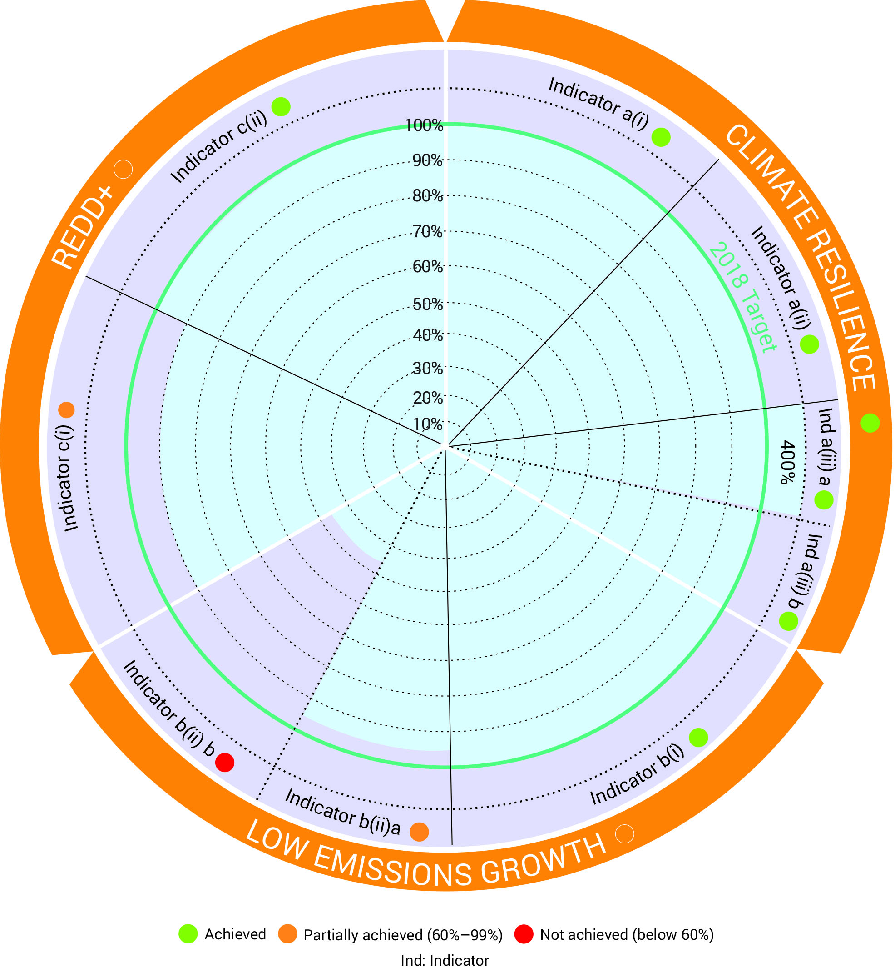

Indicators of achievement
Climate Resilience
(a)i) Increase in the number of countries supported by UNEP with institutional arrangements in place to coordinate national adaptation plans
(a) ii) Increase in the number of countries that have technical capacity to integrate ecosystem-based management into national adaptation plans
a) iii) Increase in the number of countries that are ready to access or that have accessed climate change adaptation finance to implement adaptation plans

Low-Emission Growth
b) i) Increase in the number of countries supported by UNEP that make progress in adopting and/or implementing low greenhouse gas emission development plans, strategies and/or policies
b) ii) Increase in climate finance invested by countries or institutions for clean energy, energy efficiency and/or amount of decarbonized assets
- Dollar amount invested by countries or institutions for clean energy, energy efficiency
- Dollar amount of decarbonized assets

REDD+
c) i) Increase in the number of countries that have secured finance, including performance-based finance, for the implementation of REDD-plus policies and measures
c) ii) Increase in the number of countries that demonstrate quantifiable social and environmental (non-carbon) benefits generated through the implementation of policies and measures

Climate Resilience: Equipping more countries to adapt to climate change

According to the Intergovernmental Panel on Climate Change 1.5-degree report, human activities are estimated to have already caused approximately 1.0°C of global warming above pre-industrial levels. Record economic losses from weather and climate-related disasters in 2017 and high temperatures, heatwaves and wildfires of 2018 all combine to underpin a powerful need to adapt to climate change.

The 2018 Adaptation Gap Report undertook an in-depth assessment of adaptative capacity in the health sector. The report highlights the low capacity of the health sector to respond to changing climate.

UN Environment Programme has been developing key areas of technical work in the following:
- Developing methods and tools to help adaptation planning and decision-making;
- Supporting developing countries to access finance through ecosystem-based adaptation project design;
- Improving the science-policy interface in adaptation policies and planning through climate risk assessments and adaptation planning systems;
- Enhancing climate resilience through planning, piloting and testing ecosystem-based adaptation;

Our support strategy has been to ensure countries create the right enabling environment for adaptation as well as to support partner governments piloting adaptation approaches. This includes technical and institutional capacity to adapt to climate change through managing their ecosystems and planning in a manner that contributes to their overall resilience, including in the health sector.

By December 2018, we supported 5 countries to create institutional arrangements and 5 countries to establish technical capacity for implementing ecosystem-based and other adaptation approaches.

During 2018, we also supported 8 countries to obtain direct access to financial mechanisms and to build project pipelines. Two countries, Bahrain and Mauritania, received approvals for their adaptation projects.

Thus, we have fully met the 2018 targets set out in the programme of work for adaptation.

As an example of our 2018 engagement in this area, UN Environment Programme and its partners supported Antigua and Barbuda to develop a comprehensive strategy for adapting facilities of public utilities so that they can maintain structural, electrical and water supply integrity under different disaster scenarios. Outputs of the process included site plans, retrofit diagrams and cost estimates for 34 strategic public facilities. A Green Climate Fund proposal is now in the making.

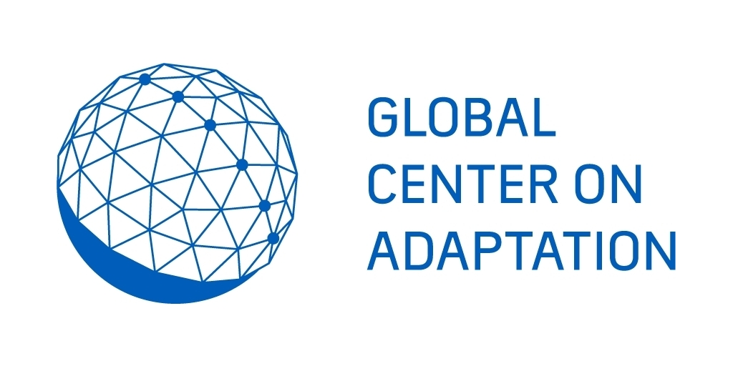Furthermore, to help advance adaptation understanding and ensure that it is delivered effectively, UN Environment Programme through its Global Adaptation Network, facilitates the Lima Adaptation Knowledge Initiative in collaboration with UNFCCC. The Initiative has improved access to data, information and knowledge for adaptation practitioners. UN Environment Programme and partners also organized the Global Adaptation Futures and Global Adaptation Network forums and conferences, which drew a combined participation of more than 3000 participants combined. The World Adaptation Science Programme which promotes increased research on adaptation was also launched in December 2018.

In 2018, the Global Commission on Adaptation and the Global Center on Adaptation were established to accelerate adaptation action and support to enable societies across the world to become more resilient to climate-related threats.

Going forward, UN Environment Programme will work to enhance performance measures of the impact and socioeconomic returns of adaptation efforts and to un-lock investments for resilience from public budget allocations and private sector.

Low-Emission Growth: Promoting renewables and improving energy efficiency

Our work on low-emission growth focuses on decarbonizing our energy systems, industries, transport and infrastructure, such as buildings, by providing guidance on policy, technology and help accessing finance.

Global progress on renewables is steady and inspiring. As an example, more solar photovoltaics (PVs) were installed in 2017 than the combined net capacity additions of fossil fuels and nuclear power. Global installations of renewable energy have doubled in the last 10 years. The progress made within the energy sector, where solutions are tested and are economical and feasible, is, however, not enough to limit climate change to 1.5 or even 2-degrees.

Furthermore, the 2018 Emissions Gap Report highlights the significant gap between Nationally Determined Contributions and the emissions reductions that are needed for achieving the long-term objective of the Paris Agreement. A three-fold increase in the current ambition is required to limit warming to 2-degrees, whereas a five-fold increase is what is required to achieve the 1.5-degree trajectory. Governments should increase their uptake of renewable energy and accelerate the decommissioning of polluting energy and transportation systems as well as decarbonization of their economies.

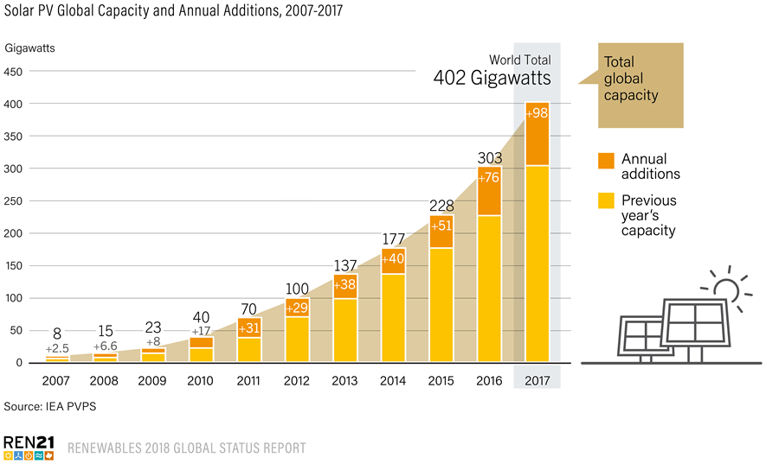

Global Trends in Renewable Energy Investment

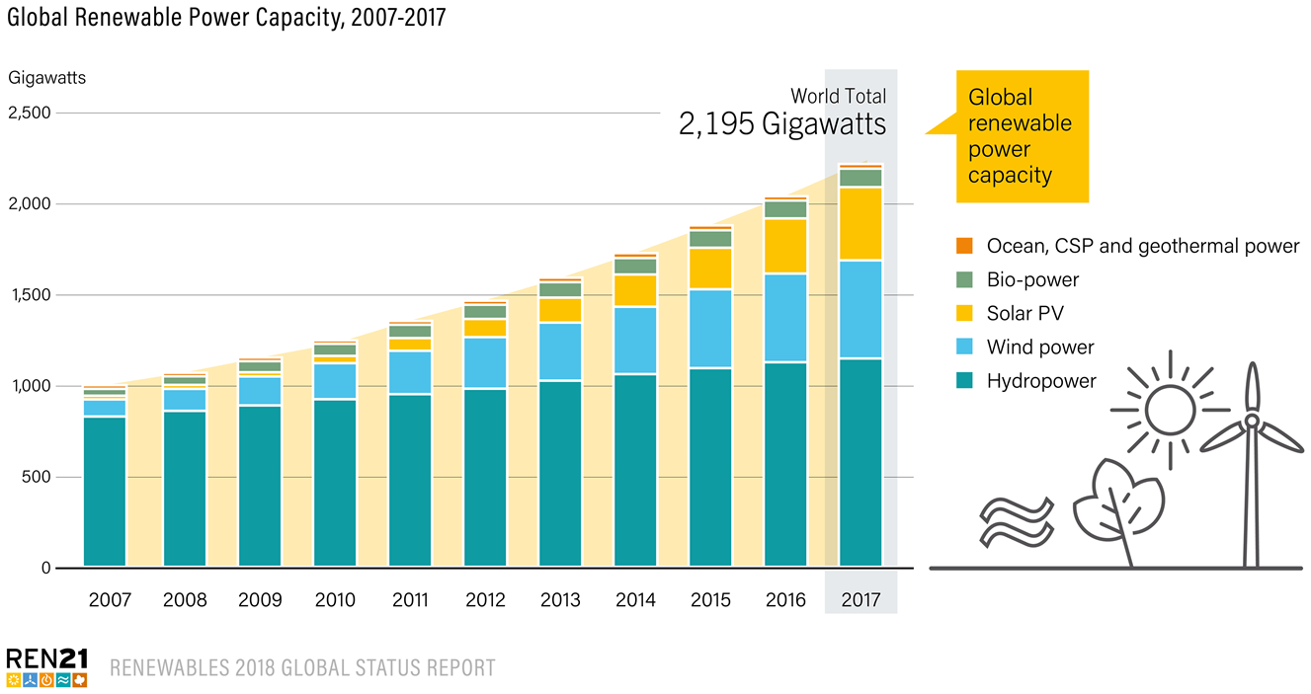

In 2018, 14 countries – as well as ASEAN as a group – adopted or implemented their low-emissions strategies, plans and policies, with the support of UN Environment Programme. We thus meet the targeted delivery of 15 countries. In terms of UN Environment Programme’s support for facilitating investments in clean energy and energy efficiency we influenced investments of US$47.9 million. Sadly, this was slightly short of our end-of-2018 target of US$50 million. Our target for supporting decarbonization of assets under management achieved progress of 48%, which is equivalent to US$23.79 billion of assets that are managed under a low carbon mandate. We believe that the December 2019 target of US$100 billion is within reach as it is anticipated that more members of the Portfolio Decarbonization Coalition will finalize their annual reports. The achievement of this target will be supported further by the Secretary-General’s Climate Summit in September 2019, during which UN Environment Programme and some of the largest investments groups in the world are aiming for a headline announcement.

The Emissions Gap Report 2018 promoted record engagement with over 13,000 downloads from UN Environment Programme's website, and 46,000 views of data visualizations from the report. The reach from media coverage totaled 19.6 million after 6 weeks with strong distribution across key G20 countries including the US, UK, Australia, Germany, India and Canada. Multiple references to the report were made by Heads of States at the UN Climate Convention Conference of Parties in Katowice, Poland with social media being a key amplifier. The combined reach of social media posts was above 1.4 million and the short social videos on the report's highlights received over half a million views, a very positive result for a new tactic introduced this year. Total media exposure year on year experienced a six-fold increase.

Through major partnership initiatives, such as the Clean Air and Climate Coalition and the Climate Technology Centre and Network, we broadened our reach and expanded our impact. The key challenge for these initiatives is to increase the space and capability of partners and countries to translate technical assistance into forward looking policies and bankable investments projects. In 2018, UN Environment Programme and its partners introduced a tool called the Long-range Energy Alternatives Planning System (LEAP)-Integrated Benefits Calculator to 100 countries. The tool supports estimation of health and economic benefits from the reduction of short-lived climate pollutants.

Since the start of the BreatheLife campaign, over 40 cities, regions and countries have engaged in the initiative, meaning that the campaign has reached 79 million citizens. Peru established a new fuel tax to discourage the consumption of polluting fuels and encourage use of cleaner technologies. Similar laws and regulations were developed or adopted in Colombia, Mexico, Nepal and Pakistan. In Tanzania, the Tanzania Renewable Energy Association was supported to develop course curriculum and a solar photovoltaic accreditation training programme for technicians and installers throughout vocational institutes in Tanzania.

Some of the largest bus manufacturers in the World (Scania, Cummins, Volvo and BYD) signed the Global Industry Partnership on soot-free clean bus fleets and Istanbul, Santiago, Mexico City and Sao Paulo committing to soot free urban bus fleets.

MAJOR PARTNERSHIPS ARE LEVERAGING ACTION AND TRANSPARENCY ON CLIMATE CHANGE
Portfolio Decarbonization Coalition | Launched at the UN Secretary-General’s Climate Summit in 2014, this initiative encourages institutional investors to decarbonize their portfolios. The target is to decarbonize US$100 billion worth of investment portfolios by 2020. To date, all Coalition members have taken substantive action to decarbonize their investment portfolios and members have now shifted USD24.79 billion to low carbon mandates.
The Climate and Clean Air Coalition | This multi-stakeholder partnership has grown to 132 partners, including 61 governments. Eleven high-impact initiatives are being implemented to catalyse and scale-up action to reduce black carbon and methane and to avoid hydrofluorocarbon in agriculture, brick production, cooking, heating, diesel vehicles, oil and gas production, and municipal solid waste.
The Climate Technology Centre and Network | The Centre, which UN Environment Programme manage in partnership with the UN Industrial and Development Organization (UNIDO), is the operational arm of the Climate Change Convention’s Technology Mechanism. It provides technical assistance to countries on their climate technology challenges. As of December 2018, 79 countries had or were taking advantage of the technology assistance through 137 projects.
UNEP DTU Partnership (UDP), Centre on energy, climate and sustainable development, hosted by the Technical University of Denmark (DTU) | Through its Collaborating Centre (UDP) the UN Environment Programme provides technical support on clean energy and climate policy to developing countries. This includes projects such as UNEP-GEF Global Technology Needs Assessment, which is implemented in close collaboration with the United Nations Framework Convention on Climate Change (UNFCCC) Technology Mechanism. The Project supported 26 countries between 2014 and 2018 and its third phase which started mid 2018 will support 23 countries, mainly include Least Developed Countries and Small Island Developing States.  Through UDP, UN Environment Programme is also contributing to the implementation of the enhanced transparency framework, by implementing the Initiative for Climate Action Transparency (ICAT). ICAT supports improved transparency and capacity building under the Paris Agreement by providing policymakers around the world with guidance and support to measure and assess the impacts of their climate actions. Working initially with 21 developing countries, ICAT is helping governments build capacity to measure the effects of their policies and report progress publicly. This will foster greater transparency, trust and ambition in climate policies worldwide.  UN Environment Programme UDP and UNDP are jointly supporting the Capacity Building Initiative for Transparency (CBIT), operationalized by the Global Environment Facility (GEF). UN Environment Programme and UDP are supporting more than 20 countries to develop project proposals and subsequently implement projects and to develop their institutional and technical capacities for enhanced transparency.

Reducing emissions from deforestation and forest degradation and helping countries seize investment opportunities

The Paris Climate Agreement recognizes the central role of forests in achieving the goal of keeping temperatures well below 2-degrees through mitigation options that aim to reduce emissions from deforestation and forest degradation and enhancement of forest carbon stocks.

The UN-REDD Programme, jointly implemented by UN Environment Programme, the Food and Agricultural Organization of the UN and the UN Development Programme, is supporting 64 countries to prevent deforestation and forest degradation, in order to realize emission reductions. UN Environment Programme has focused on the application of safeguards to REDD+, private participation and financing, and communications and knowledge management. With many strategies or action plans already completed and formally endorsed, UN-REDD technical assistance in 2018 continued to focus on developing and supporting complementary investment plans to enable the implementation of REDD+ strategies and to attract REDD+ financing. This year, UN-REDD consolidated the knowledge and technical assistance stream on REDD+ funding mechanisms to help impact investors align their investment strategies with national REDD+ strategies, especially in selected countries in Latin America.

Over the past 10 years, the UN-REDD Programme has supported, directly (through technical assistance) or indirectly (through facilitating South-South knowledge exchange), 36 countries with their approaches to meeting UNFCCC safeguards requirements.

UN-REDD PROGRAMME 2018 ACHIEVEMENTS

Nine countries made progress with their summaries of information. Côte d’Ivoire, Viet Nam and Zambia started and completed drafting their first summaries of information within the year. Argentina, Myanmar and Peru initiated processes to produce their first summary of information. In addition, Colombia submitted its second summary of information to the UNFCCC, Chile its first, and Mexico’s first summary of information (2017) was uploaded in the REDD+ Info Hub.

Six countries made progress in designing or operating their national Safeguard Information System (SIS). Chile, Côte d’Ivoire, Mongolia and Zambia produced SIS design documents; Myanmar started a SIS design process, which will conclude in 2019. Viet Nam’s SIS became operational and is now online. Figure YY presents a snapshot of global progress with SIS.

Knowledge of how to meet UNFCCC safeguards requirements was exchanged between countries in Africa and Latin America and the Caribbean regions.

As part of the UNEP-wide sustainable land management portfolio, UN Environment Programme in partnership with Rabobank established a US$1 billion finance facility to channel public and private capital to deforestation-free commodity production. To complement the support provided to countries to develop and implement national REDD+ strategies, UN Environment Programme is pressing ahead with new innovative partnerships for transformative land management. The Tropical Landscapes Finance Facility (TLFF), a partnership between UN Environment Programme, World Agroforestry Centre, ADM Capital and BNP Paribas was announced in February 2018, with its inaugural landmark Sustainability Bond transaction of US$95 million. The Bond will help finance a sustainable natural rubber plantation on heavily degraded land, employing 10,000 people in two provinces in Indonesia. The project incorporates extensive social and environmental objectives and safeguards and planted areas will serve as a buffer zone to protect a threatened national park from encroachment. The project is almost fully privately funded, with limited public funding in the form of capital guarantees and small grants. This Partnership exemplifies a new option for achieving sustainable development, in the spirit of Sustainable Development Goal 17.

UN Environment Programme also helped the Government of Andhra Pradesh India to launch a new programme for shifting 6 million small-holder farmers towards natural farming by 2024. The ‘Zero Budget Natural Farming’ methodology aims to increase profits for small-holder farmers, diversify the economy, and phase out all synthetic pesticides and fertilizers. Project partners include UN Environment Programme, BNP Paribas, World Agroforestry Centre, World Wide Fund for Nature (WWF) and others.

FINANCIAL OVERVIEW

- Out of the planned Environment Fund budget for 2018 of US$16 million, only US$8.1 million was received. This was part of an overall trend whereby UN Environment Programme received a smaller amount of Environment Fund contributions than originally projected.
- For this reason, Trust Fund and Earmarked contributions have been used, to some extent, to compensate for the Environment Fund shortfall. The subprogramme received US$113.4 million (against a planned budget of US$56.3 million). However, some of this amount represents multi-year contributions only part of which can be counted against 2018.
- Overall expenditure therefore stands at US$139 million, which is 156 per cent of the target budget of US$88.8 million.
The heat is on: UN Environment Programme fights to cut heating and cooling emissions
In 2018, expert advice to countries on energy efficiency under UN Environment Programme’s climate change subprogramme helped 23 countries to build their capacity on energy efficiency issues. In warm climates, 20 percent of domestic electricity is used to power air conditioners and the global air conditioner stock is expected to increase from 660 million units to more than 1.5 billion units by 2030. The Refrigeration and Air Conditioning sector, as a major energy consumer, plays a vital role for every country to reach both climate change mitigation and adaptation targets. Without international control, improved efficiency and upscaling of new solutions, continuing growth of chlorofluorocarbons (CFCs) will be responsible for 0.1°C temperature rise in 2050, with potential of increasing up to 0.5°C by 2100.
The activities contributed to reduced greenhouse gas emissions and saved consumers and businesses money on their electricity bills. Many municipal governments are financially strained by inefficient fossil fuel energy systems. Heating, cooling and hot water represent 60 per cent of energy demand in cities. As most of this energy is supplied by fossil fuels, there is an urgent need to reduce demand – through building and appliance efficiency improvements – and to shift to low-carbon energy sources.
Evidence of the result includes progress in Banja Luka’s district heating (DH) network, the second largest in Bosnia and Herzegovina. The heating system relied on high cost crude oil and experienced significant energy losses during transmission and end-use. This caused major costs to the city and the district heating company, and unnecessary GHG emissions. Boilers used in the heating system were on average 35 years old and lost up to 60% of generated heat, while poor insulation means up to 40% of supplied heat was lost in the district’s buildings prior to UN Environment Programme’s support.

RESILIENCE TO DISASTERS AND CONFLICTS

Our work on disasters and conflicts focuses on three areas:

- RISK REDUCTION: The first is to encourage best practice environmental management in ways that reduce the risks and impacts of natural hazards, industrial accidents and armed conflict. This includes initiatives to identify, monitor and highlight current and emerging environment-related risks.
- RESPONSE: The second is to support countries and international partners to understand and address urgent environmental priorities in the event of armed conflicts, natural disasters, and industrial accidents.
- RECOVERY: The third is to assist countries in the process of post-crisis recovery to (re)instate appropriate environmental policies and institutions.

By December 2018, we achieved or exceeded 4 indicator targets, and partially achieved 1 indicator target.

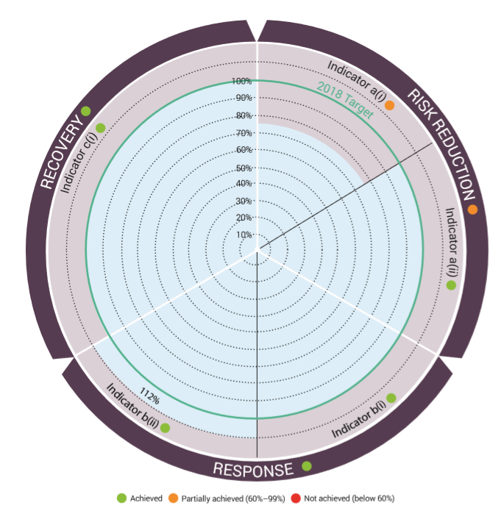

Indicators of achievement
REDUCING ENVIRONMENTAL RISK
(a) (i) Increase in the proportion of countries in which environmental issues are addressed in national disaster risk reduction strategies.
(a) (ii) Increase in the number of international partners’ policies on risk reduction that integrate best practices in sustainable natural resource management advocated by UNEP.

CRISIS RESPONSE AND INFLUENCE
(b) (i) Percentage of country requests for emergency response met by UNEP.
(b) (ii) Percentage of post-crisis recovery plans by Governments or international partners that integrate UNEP assessment recommendations.

REDUCING IMPACT, BUILDING RESILIENCE
(c) Percentage of countries emerging from crisis progress along the country capacity framework with UNEP support.

Risk Reduction
During 2018, UN Environment Programme supported 14 countries to reduce the risks of natural disasters, industrial accidents and conflicts. This was done through the delivery of conflict and disaster risk assessments, guidance on policy and best practices, the provision of training and capacity building and preparedness on environmental emergencies which could have serious environmental and economic impacts.

Our work in Sudan is building resilience in communities and institutions. We assisted with flood and drought management in Burkina Faso, Thailand and Uganda. We delivered country-level environmental governance support in South Sudan. This included the country’s first-ever state of the environment report. It is hoped that this will form a key pillar for post-conflict environmental recovery and sound environmental governance.

Influencing policies, programmes and training courses (related to Expected Accomplishment 2.a – Indicator ii)
What we influenced | What we did | Why it is important
Major capacity building exercise on environmental security that has reached nearly 10,000 participants across the world | UN Environment Programme contributed to a pioneering Massive Open Online Course (MOOC) on Environmental Security and Sustaining Peace developed by the SDG Academy in New York. Other partners included the Environmental Law Institute, the Environmental Peacebuilding Association, and the Universities of Columbia, Duke and California at Irvine. | The MOOC attracted a diverse group of participants from 170 countries and all of the main stakeholder groups including NGOs, Private sector, Government, International Organizations, Academic and others. It also had an excellent gender distribution, with 53% women and 47% men. Over 90% of the participants surveyed found the course to be relevant, valuable and high quality.
The Joint Programme on Women, Natural Resources and Peace have influenced UN Women and UNDP’s programming in Sudan and Colombia to address the gender dimensions of natural resource use for conflict prevention and peacebuilding. | Programme work on Gender NRM and Peacebuilding to impact country-level programming in Sudan and Colombia. | In Sudan, our programme led to more inclusive, gender-responsive environmental peacebuilding approaches being adopted in UNDP’s large Community Security and Stabilization (C2SP) Programme, which is active in several states in Sudan.  In Colombia, our programme is supporting a process whereby, for the first time, UN Women is leading natural resource programming in its peace and security work.

Response and Recovery

During 2018, we helped 12 countries respond, and 7 countries recover from a variety of natural disasters, industrial accidents and armed conflicts.

This includes rapid response, medium-term recovery work and longer-term support as measured by our country capacity indicator, currently applied in Afghanistan, Haiti, South Sudan and Sudan, and to which Colombia will be added during the biennium.

MORE COUNTRIES RESPOND TO EMERGENCIES IN 2018 WITH UNEP SUPPORT (related to Expected Accomplishment 2.b – Indicators I and ii)
Country | Our Support | Result
Papua New Guinea | A 7.5 magnitude earthquake hit Papua New Guinea on 26 February 2018. Its epicentre was in Southern Highlands province. The earthquake triggered landslides and flash floods, affecting an 544,000 people. A number of industrial/mining facilities were located in the affected area, with potential risk of cascading disasters. An environmental expert was deployed to integrate a United Nations Disaster Assessment and Coordination (UNDAC) team dispatched by OCHA. | The mission identified key priorities for action to mitigate risks on human health and livelihoods deriving from soil and water contamination. The integration of environmental expertise in the UNDAC team ensured the early and timely identification of environmental risks. It also supported liaison with OCHA and its key role in coordination, including through the Cluster system in the country. Finally, it ensured follow-up on the mission findings, particularly in the area of water, sanitation and hygiene (WASH). According to the latest dashboard published by OCHA in October 2018, significant progress in addressing WASH issues resulting from the earthquake had been made, with 85,848 people having been reached out of 270,000 targeted.
Colombia | Starting on 2 March 2018, an oil spill occurred in the Santander Department of Colombia. The spill primarily affected La Lizama and Sogamoso river ecosystems, as well as a tributary of the Magdalena River, Colombia’s largest source of water. In coordination with the UN Resident/Humanitarian Coordinator and OCHA, a joint environment/United Nations Disaster Assessment and Coordination (UNDAC) team was dispatched between 11 and 26 April 2018. The team also included three oil spill experts mobilized by the UN Environment Programme/OCHA Joint Unit. | The experts provided neutral and independent advice to national authorities. The assessment concluded that environmental recovery could take place within one year following-on from the event. It also provided recommendations on the restoration process and for the establishment of an independent monitoring process. Preliminary findings and recommendations were shared with the Ministry of Environment, and a complete technical report was subsequently delivered to the Minister of Environment in June 2018. Further to the mission, the National Environmental Licensing Authority (ANLA) declared that the situation was under control. In November 2018, the Humboldt Institute confirmed that the environmental damage was under control and that the recovery process had started, with fish and algae reappearing in the affected streams, confirming the mission findings.
Iraq | Working with UN Habitat, UNEP helped authorities in Mosul plan how debris removal in that devastated city can be performed in a structured manner. UN Environment Programme is also accompanying UNDP and IOM in providing technical guidance in designing and implementing debris recycling projects in collaboration with Mosul’s authorities. | This work has helped change the way Mosul municipality and UN agencies deal with debris. Whereas before it was dumped in an uncontrolled manner, the rubble is now recycled to support Mosul’s reconstruction and create better conditions to support the return of those displaced by the fighting. There is growing interest to scale-up rubble recycling in other cities impacted by ISIL, and in October 2018 UN Environment Programme organized a regional workshop in Ramadi to support local authorities in the most damaged cities of Anbar Governorate (Ramadi, Haditha, Hit, Qaim and Kubaisa) develop their own debris management plan. A similar workshop is planned with the UN Assistance Mission in Iraq (UNAMI) for Kirkuk municipal authorities in 2019.
Colombia | The Hidroituango dam is an earth-core, rock-filled dam still under construction on the Cauca river in the Antioquia Department of Colombia. Following heavy rains in April-May 2018, two tunnels which divert water to the Cauca River collapsed. After ordering the evacuation of downstream areas, the Minister of Environment of Colombia requested technical assistance from UN Environment Programme. On the same day, the UNEP/OCHA Joint Unit alerted the Environmental Emergencies Roster. A team of five led by a UN Environment Programme team leader was subsequently deployed to provide technical advice to national authorities on real-time dam operations. | The experts provided real-time daily advice on operations to the Ministry of Environment, as well as a comprehensive set of overall recommendations upon mission completion. A 135-page technical report was delivered to the Minister of Environment in June 2018. The experts concluded that it was necessary to reinforce the structure to meet international standards, implement measures to control the water level in the reservoir to reduce the risk of landslide-induced overtopping, strengthen monitoring by national authorities, including through the establishment of an independent panel of experts to advise until work completion, and enhance risk communication to the local population, among key recommendations. The mission findings were endorsed by the President of the Colombian Board of Engineers. The National Environmental Licensing Authority (ANLA) subsequently followed up on the mission recommendation to strengthen monitoring by national authorities, including through the establishment of an independent panel of experts. The Authority also requested a proposal from UN Environment Programme for advisory services for the implementation of the longer-term, follow-up recommendations identified in the mission report. The French Committee on Large Dams and the US Army Corps of Engineers, both involved in the response, expressed their interest in establishing formal agreements with the UNEP/OCHA Joint Environmental Unit (JEU) for support with environmental emergency response.
Nigeria | Since the end of August 2018, serious flooding has affected at least 12 states in Nigeria, with rural areas most vulnerable. The increasing impacts of flooding have caused mass displacements, deaths and destruction of homes and communities. As a result, the Federal Government of Nigeria on 17 September declared a national emergency state in four worst-affected states including Kogi, Delta, Niger and Anambra, and welcomed support from the international community. Flooding incidents in eight other states were also closely monitored. In September 2018, the National Emergency Management Authority (NEMA) accepted to deploy a United Nations Disaster Assessment and Coordination (UNDAC) team to Nigeria to support with response. An environmental expert was mobilized to integrate the team and look at the impacts of the floods, with a primary focus on water and sanitation (WASH) issues. | Environmental findings from the mission were included in the UNDAC report delivered by OCHA to national authorities upon mission completion. The National Emergency Management Authority subsequently requested a second wave of support from UNDAC, integrating once again environmental expertise.
India | UN Environment Programme visited the Indian state of Kerala where environment and ecosystem-based approaches were put high on the political agenda. We took part in a Post-Disaster Needs Assessment, estimating the damage and loss to the environment caused by flooding and making recommendations for recovery. The report was handed to the Chief Minister on 29 October 2018. | The State Government of Kerala is now actively exploring the implementation of the recovery recommendations.

Our Disasters and Conflicts work is relevant to the achievement of all 17 Sustainable Development Goals, as external shocks such as natural disasters, industrial accidents and especially armed conflict have proven to be extremely strong barriers to development and progress. However, the organization in particular aims to deliver on Sustainable Development Goal 1 (poverty), 11 (cities), 13 (climate action), 16 (peace) and 17 (partnerships).

FINANCIAL OVERVIEW

- For an Environment Fund budget originally planned at US$10.8 million for 2018, US$12.3 million was received.
- Overall, the subprogramme received US$24.8 million (against a planned budget of US$5.2 million) from Trust Fund and Earmarked contributions. However, this amount also includes multi-year contributions.
- Overall expenditure for 2018 stands at US$19.9 million. This represents 79 per cent of the target budget of US$25 million.
Rising from the rubble: helping Mosul deal with war debris
In 2018, UN Environment Programme was the lead agency conducting the Mosul debris study. After liberation from the Islamic State and the Levant (ISIL) following several months of intense fighting, the northern Iraqi city was left grappling with debris from widespread destruction of infrastructure. Consequently, residents and the Government of Iraq are working tirelessly to clean-up their city. UN Environment Programme supported this process by providing leading technical expertise on clearing up the debris.
The UN Environment Programme, UN-Habitat, Mosul Municipality and specialized debris management experts started to assess the volume of the rubble in July 2017. Using satellite image analysis and field surveys, the assessment estimated that the city has around eight million tons of conflict debris - equivalent to three times the Great Pyramid of Giza. UN Environment Programme and UN Habitat hosted a workshop in Mosul to plan how debris removal can be done in a structured manner. The workshop brought together over 50 experts from key government departments implementing efforts to remove the debris created by the conflict, which is highly contaminated with unexploded ordnance, booby-traps and other potentially hazardous materials. This contributed to the result, which was to change the way Mosul municipality and UN agencies deal with debris from dumping it in an uncontrolled manner to recycling the rubble to support Mosul’s reconstruction, the livelihoods of its citizens, and reduce resource extraction. More importantly, it offers a chance of return for the city’s pre-conflict population of 1.4 million.
Evidence of the results include preparations by the United Nations Development Programme and the International Organization for Migration, with technical assistance from UN Environment Programme to set-up the first two debris recycling centres in Mosul. The centres will be operational in the first quarter of 2019.

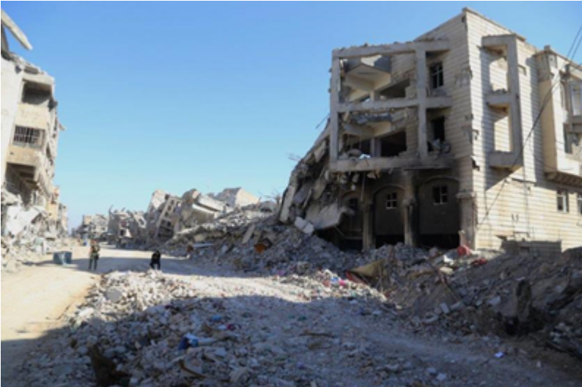

(to add caption, Mosul, Iraq)

HEALTHY AND PRODUCTIVE ECOSYSTEMS

In our work on healthy and productive ecosystems, we focus on achieving results in the following areas:
- Institutionalization of ecosystems in education, monitoring and cross-sector and transboundary collaboration frameworks, where we help countries to institutionalize the health and productivity of marine, freshwater and terrestrial ecosystems.
- Inclusion of ecosystems in economic decision-making, where we assist policymakers in the public and private sectors.

By December 2018, we have exceeded all our 6 indicator targets.

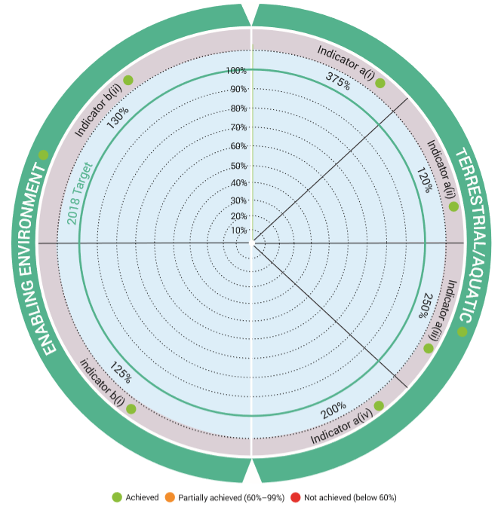

Indicators of achievement
Terrestrial and aquatic
(a) (i) Increase in the number of countries and transboundary collaboration frameworks that have made progress to monitor and maintain the health and productivity of marine and terrestrial ecosystems.
(a) (ii) Increase in the number of countries and transboundary collaboration frameworks that demonstrate enhanced knowledge of the value and role of ecosystem services.
(a) (iii) Increase in the number of countries and groups of countries that improve their cross-sector and transboundary collaboration frameworks for marine and terrestrial ecosystem management.
(a) (iv) Increase in the number of education institutions that integrate the ecosystem approach in education frameworks.

Enabling environment
(b) (i) Increase in the number of public sector institutions that test the incorporation of the health and productivity of marine and terrestrial ecosystems in economic decision-making.
(b) (ii) Increase in the number of private sector entities that adjust their business models to reduce their ecosystem-related risks and/or negative impacts on marine and terrestrial ecosystems.

The number of indicators has significantly decreased as compared with the Programme of Work 2016-2017. In the Programme of Work 2018-2019, the indicators were reduced to 6 in order to better reflect the results and achievements of the expected accomplishments. Expected accomplishment A now has 4 indicators, whereas Expected Accomplishment B has 2 indicators.

The programme increased its focus on long-term change processes by (a) embedding ecological considerations in financial decision-making by public and private sector entities and (b) by aiming to influencing knowledge and behaviour among future professionals through capacity building activities.

UN Environment continues to promote knowledge on biodiversity, economics of ecosystems and the role of ecosystems as key enablers in cross-sectoral ecosystem management for human well-being. This builds on a rapidly expanding global knowledge base on the role and functioning of ecosystems.

Institutionalization of Ecosystems in Education, Monitoring and Cross-Sector and Transboundary Collaboration Frameworks

To help countries institutionalize ecosystems into education, monitoring and cross-sectoral transboundary collaboration frameworks, we supported entities to: (i) improve the monitoring and maintain the health and productivity of marine and terrestrial ecosystems; (ii) mainstream the economics of ecosystem services into national decision-making through enhanced capacity for valuing and accounting of ecosystem services, (iii) improve their cross-sector and transboundary collaboration frameworks for marine and terrestrial ecosystem management; and (iv) integrate the ecosystem approach in education frameworks.

By the end of 2018, twelve countries and three transboundary collaboration frameworks had made progress in monitoring and maintaining the health and productivity of marine and terrestrial ecosystems. Seven countries demonstrated enhanced knowledge of the value and role of ecosystem services. Nine countries demonstrated improvement in the institutional set-up for cross-sector collaboration for terrestrial ecosystem management. Eight education institutions and learning platforms integrated the ecosystem approach into their educational frameworks.

To achieve these results, we delivered various assessments, tools and services to countries in 2018:

UN Environment Programme’s Regional Seas Programme is the main vehicle that we use to help countries progress in monitoring and maintaining the health and productivity of marine and coastal ecosystems.

In response to UNEA Resolution 2/12, UN Environment Programme, through an advisory group, initiated a review process of the global and regional governance and policy frameworks on coral reefs. As a result of our support, the 33rd General Meeting of the International Coral Reef Initiative (ICRI), held on 5-7 December in Monaco, provisionally adopted the implementation and governance plan of the Global Coral Reef Monitoring Network.

We also supported the development of the Pacific Regional Action Plan on Marine Litter 2018-2025. This Action Plan sets out the policy context and key actions required to minimize marine litter across the Pacific Island Countries and Territories.

UN Environment Programme facilitated the development and adoption of the Coordinating Body on the Seas of East Asia (COBSEA) Strategic Directions (2018-2022) at the Second Extraordinary Intergovernmental Meeting of COBSEA, held in Bangkok, Thailand on 25-26 April 2018. The Strategic Directions guide COBSEA participating countries and the COBSEA Secretariat on action for the development and protection of the marine environment and coastal areas of East Asian Seas. It leverages COBSEA as an intergovernmental policy mechanism for planning, implementing and tracking delivery of ocean-related SDGs, in line with the global “Regional Seas Directions 2017-2020”.

With GEF support, we helped six countries strengthen institutional capacities on testing of Living Modified Organisms (LMO) in order to enhance national decision making.

UN Environment Programme helped countries to standardize valuation and accounting of ecosystem services and goods and incorporate natural capital in sustainable development monitoring systems, including in inclusive wealth accounting. By the end of 2018, six countries had initiated experimental testing of ecosystem Accounting via the System of Environmental-Economic accounting (SEEA).

One country, India, conducted an economic valuation of biological resources at the local, state and national levels to determine benefit sharing and support implementation of the Biological Diversity Act and Rules. The evaluation focused on access and benefit sharing provisions and informed national decision makers on prioritization of conservation action.

In June 2018, we launched the Economics of Ecosystems and Biodiversity for Agriculture and Food (TEEBAgriFood) comprehensive evaluation framework for food systems. The framework helps decision-makers to compare different policies and market trends in order to value food more accurately.

UN Environment Programme supported countries to improve their institutional set-up for cross-sector collaboration for terrestrial ecosystem management. For example, South-South collaboration between the governments of Democratic Republic of the Congo, the Republic of Congo and Indonesia enabled countries to improve their understanding and management of Peatland ecosystems:
In March 2018, the Democratic Republic of Congo, the Republic of Congo and Indonesia signed the Brazzaville Declaration to protect tropical peatland ecosystems within the framework of the Global Peatlands Initiative. As part of its implementation of the Brazzaville Declaration, the Republic of Congo decided to set up a high-level scientific committee to enable the country to improve its understanding of this biodiversity-rich ecosystem. The Democratic Republic of Congo, Republic of Congo, Indonesia and Peru established the International Tropical Peatland Center, which demonstrates their commitment to work together to protect and sustainably manage tropical peatlands.

The Interfaith Rainforest Initiative (IRI) is being launched in Colombia, Peru, Indonesia and the Democratic Republic of Congo, which together account for 70% of the remaining tropical forests in the world. The initiative intends to connect communities of faith, indigenous communities living in the rainforest, religious leaders, governments, NGOs and businesses, to assist in a transition that would prevent the destruction of the tropical rainforests.
In terms of assisting countries to increase the number of education institutions that integrate the ecosystem approach in their education frameworks, UN Environment Programme has recently completed the development of a new strategy in response to UNEA Resolution 2/3 and SDG 4.7 on Education for Sustainable Development, focused on: (a) supporting the integration of Environmental Education into a wide range of curricula of Universities and Technical and Vocational Education and Training (TVET), in order to increase student awareness, behavioural change and employment opportunities; and (b) the creation and diversification of public-private, non-formal and other relevant partnerships and initiatives in environmental education and education for sustainable development and sustainable lifestyles.
UN Environment Programme has been working on the development of Massive Open Online Courses (MOOCs) with numerous institutions and stakeholders, including UNDP, the SDG Academy, the Open University and Columbia University among others, in order to create several of the open courses that focus on key environmental issues. Topics include marine litter; disaster risk reduction; environmental security and REDD+ among others.

Inclusion of Ecosystems In Economic Decision-Making

Longer term, we will put more emphasis in our work, including through partnerships, on how finance is allocated in the public and private sector. This work seeks to substantially shift private financial flow towards improved ecosystems management.

In 2018, five public sector institutions tested the incorporation of the health and productivity of marine and terrestrial ecosystems in economic decision-making at national level. Ten financial institutions adjusted their business models to reduce their ecosystem-related risks and/or negative impacts on marine while considering ecosystems/natural capital in decision making and terrestrial ecosystems.

To achieve these results, we delivered various assessments, tools and services to countries in 2018:

- UN Environment Programme assisted the National Bureau of Statistics of China in piloting ecosystem accounting in Guangxi Zhuang Autonomous Region and Guizhou Province.

- With our support, the National Institute of Statistics and Geography of Mexico produced an Assessment report and update on the National Plan for Natural Capital Accounting.

- In South Africa 3 institutions- Statistics South Africa, South African National Biodiversity Institute (SANBI) and Department of Environmental Affairs completed an Assessment Report for the development of a national strategy to advance environmental, economic and ecosystem accounting in South Africa.

- In November 2018, we launched the Natural Capital Risk Explorer. This is an online tool that links nature to economy. This tool helps financial institutions to analysis risk by linking drivers of change in nature to ecosystem service provision by economic sector.

- Five commercial banks in Colombia, South Africa and Peru piloted the natural capital risk framework that UN Environment Programme developed.

- UN Environment Programme also supported private sector institutions in developing business cases for deforestation-free commodities in various countries. We worked with corporate partners and member states on the removal of regulatory, economic and financial barriers in order to unlock and (re)direct public and private capital to sustainable land use. Our partners included commercial and development banks like the Rabobank and BNP Paribas.

FINANCIAL OVERVIEW

- For an Environment Fund budget originally planned at US$20.9 million for 2018, US$10.2 million was received.
- Overall, the subprogramme received US$47.1 million (against a planned budget of US$5.2 million) from Trust Fund and Earmarked contributions. However, this amount also includes multi-year contributions.
- Overall expenditure for 2018 stands at US$131.2 million. This represents 158 per cent of the target budget of US$83.1 million.
This picture, however, does not show the distribution across projects or the shortfall in certain projects. It does not reflect the need for additional resources to take several interventions to the next and more impactful level, or to implement relevant UN Environment Assembly resolutions.

Vision Award 2018 goes to TEEBAgriFood
In recognition of its work on food, agriculture and biodiversity, TEEBAgriFood received the Vision Award 2018 on 17 October 2018, during World Food Day.
Today, we have a global food-divide in which one billion people are underfed, while more than two billion are overfed. Unsustainable farming practices continue to deplete groundwater, degrade soil, and cause the loss of agricultural biodiversity. Food production generates up to 30 percent of global greenhouse gas emissions, accounts for substantial proportions of land-use change, and contributes to land degradation and global water consumption. Yet, approximately one-third of the food produced in the world for human consumption every year — around 1.3 billion tons — gets lost or wasted.
The world needs urgent action to achieve a sustainable, equitable and healthy food system. Such a system could prevent 11 million deaths every year and help address these challenges. How can economics help us achieve this?
Currently, no macroeconomic indicator captures the global food production, its distribution and consumption system’s environmental costs. What would help is a food system which captures all of these environmental costs or so-called ‘externalities’. But we must also put a monetary value on everything – food and agricultural systems also have emotional, spiritual and cultural values which contribute to our well-being.
The UN Environment-led initiative The Economics of Ecosystems and Biodiversity for Agriculture and Food (TEEBAgriFood) uses a systems approach to provide a potential solutions on how economics can improve the understanding of the relationships between human and planetary health.

ENVIRONMENTAL GOVERNANCE
The Sub-programme objective is to strengthen environmental governance to support the achievement of internationally agreed environmental goals and the implementation of the 2030 Agenda, focusing on the following:
- Policy Coherence, where we aim to help countries, the United Nations (UN) system, international organizations, international forums work together to achieve environmental objectives; and
- Stronger legal frameworks and institutional capacities, where we support national efforts to develop stronger legal frameworks and implementation capacities, the embedding of environmental objectives in sustainable development planning, policy making and budgeting, and the development of partnerships to foster wide participation.
By December 2018, we have met or exceeded 6 of our 8 indicator targets, partially met one indicator target and not achieved one indicator target.

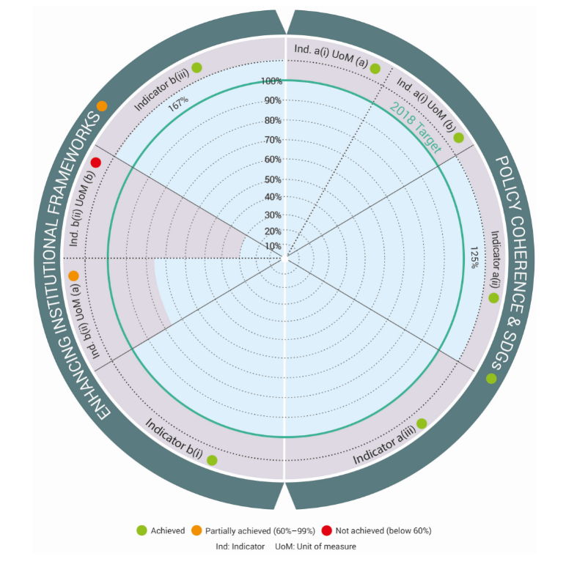

Indicators of achievement
Policy Coherence & SDGs
(a)(i) Increase in the number of United Nations entities, international organizations and forums integrating environmental policy issues or approaches emerging from UNEP policy advice into policy documents, strategies or plans on sustainable development.
(a)(ii) Increase in the uptake of approaches for the coherent implementation of multiple multilateral environmental agreements or other multilateral institutional mechanisms as a result of UNEP support
(a)(iii) Increase in concerted policy action taken by countries on environmental issues of international concern

Enhancing Institutional Frameworks
(b)(i) Increase in the number of countries that have enhanced institutional capacity and legal frameworks to fully implement the multilateral environmental agreements and for the achievement of internationally agreed environmental goals including the 2030 Agenda and the Sustainable Development Goals
(b)(ii) Increase in the integration of the environment in sustainable development planning, including as part of achieving the 2030 Agenda and the Sustainable Development Goals
(b)(iii) Number of partnerships between UNEP and major groups and stakeholders’ representatives to promote the achievement of internationally agreed environmental goals, including the Sustainable Development Goals

Policy Coherence
In 2018, UN Environment Programme made good progress on expected accomplishment A. This is measured through three indicators: (a) focusing on the uptake of UN Environment Programme policy advice by United Nations entities, international organizations and forums at both global and regional levels; (b) the extent of uptake of approaches for the coherent implementation of multilateral environmental agreements by countries, and (c) the number of issues of international concern addressed by Governments through concerted policy action.
UN Environment Programme achieved results in this area mainly by doing the following:
- convening and contributing to international processes;
- supporting interagency efforts, particularly the Environment Management Group, and;
- partnerships with UN agencies, as well as the Greening the Blue initiative.

Uptake of UN Environment Programme Policy Advice
The targets for the first indicator were met for both its global and regional dimensions. On uptake of policy advice at the global level, two global policy making bodies integrated UN Environment Programme policy advice in their deliberations. The Human Rights Council adopted Resolution A/HCR/37/L.19 on Human Rights and the Environment which requested continued cooperation with the Special Rapporteur on Human Rights and the Environment. The High-Level Political Forum adopted a ministerial declaration welcoming the main outcomes of UNEA 3.
On uptake at the regional level, three Ministerial Environment Fora were held (in Africa, Latin America and the Caribbean and West Asia) which resulted in outcomes that will contribute to UNEA and the High-Level Political Forum. Contributions were made to regional sustainable development fora in preparation for the High-Level Political Forum in Africa, Asia, Europe, Latin America and the Caribbean. This key engagement strengthened the environmental dimension of the Sustainable Development Goals at fora that play important roles in the implementation of the 2030 Agenda.
In addition to indicator-specific achievements, progress was made in interagency collaboration, particularly the Environment Management Group. The Group established a new Issue Management Group on Environment in Humanitarian Action and UN coalition to combat sand and dust storms. It initiated work on Law for Environmental Sustainability, scaled-up strategic collaboration for agencies to tackle e-waste and revitalized its work on biodiversity. As a result of the work of the Consultative Process for Environmental and Social Sustainability, the Group released a draft Model Approach to environmental and social standards in UN programming for public comment. The Environment Management Group also held several policy dialogues on SDG-relevant nexus issues.
UN Environment Programme led initiatives for greening the United Nations which resulted in concerted efforts of UN agencies and in specific initiatives by individual agencies. The number of UN organizations that reached climate neutrality grew from 39 (in 2017) to 43 in 2018, including key offices such as the UN secretariat in New York. 14 UN organizations took steps to eliminate or reduce the use of single use plastics as a result of the invitation by UN Environment Programme to UN principals. UN Environment Programme’s “Initial Environmental Guidelines for UN Common Premises” were integrated in the process on Common Premises that is taking place as part of the UN reform.

Coherent implementation of MEAs at the national level
UN Environment Programme provides advisory services to Governments to promote synergies in the implementation of MEAs and other multilateral institutional arrangements, as well as country level support to strengthen capacities for implementing the agreements. In doing so, UNEP places strong emphasis on the linkages with the Sustainable Development Goals.
Although capacities were strengthened in many countries through various programmes, indicator (a) (ii) focuses specifically on the update of coherent approaches in the implementation of multiple agreements or other multilateral institutional mechanisms. Other aspects of capacity development are reflected in indicator (b) (i), on legal frameworks and institutional strengthening.
Four countries have taken up approaches to coherently implement multiple agreement or frameworks. UN Environment Programme and other partners supported Lao DPR in the mainstreaming of Gender and SDG alignment in National Biodiversity Strategies and Action Plan implementation and monitoring. This support resulted in a finalized roadmap. The Solomon Islands introducing a unified environmental portal to make better informed decisions on the environment. Burkina Faso developed a Persistent Organic Pollutant (POPs) regulatory framework strategy. The National Environment Management Strategy of the Marshall Islands integrated synergies approaches.
At the regional level, Pacific Countries have adopted Regional Environmental Impact Assessment Guidelines for Coastal Tourism Development in Pacific Island Countries and Territories. The guidelines aim to support Pacific islands governments in meeting their obligations to undertake EIAs, as specified under multilateral environmental agreements (MEAs) to which they are party. This included the Noumea Convention, the Convention on Biological Diversity (CBD), and the United Nations Framework Convention on Climate Change (UNFCCC).

Concerted policy action at the international level
Through UN Environment Programme support and under the aegis of the Economic Commission for Latin America and the Caribbean (ECLAC), 16 Countries Latin American and the Caribbean adopted the landmark Escazú Agreement, a regional agreement to protect the rights of access to information, public participation and access to justice in environmental matters. The agreement had been under negotiation since 2014. The agreement is a very important step forward for more inclusive environmental governance. Efforts are underway to identify and respond to country needs, with an initial focus on ratification.
Further progress in terms of international concerted action on environmental issues includes the development of a global environmental law programme known as Montevideo Programme V, submitted for adoption by UNEA 4. It was prepared as a result of an assessment of the implementation, effectiveness and impact of the previous version of the programme, the fourth Programme for the Development and Periodic Review of Environmental Law, and with inputs by national focal points.
In May 2018, the UN General Assembly adopted resolution 72/277 Towards a Global Pact for the Environment. The Assembly decided to establish an ad hoc open-ended working group to consider a technical and evidence-based report that identifies and assesses possible gaps in international environmental law and environment-related instruments with a view to strengthening their implementation. The working group has been mandated to present its recommendations to the General Assembly during the first half of 2019, following a series of meetings to take place between 2018 and 2019. UN Environment Programme is providing substantive support to the process.

Institutional Strengthening
In 2018, countries took steps to strengthen their legal or institutional measures either individually or as part of regional or global processes to improve implementation of international environmental goals. Eight countries demonstrated progress in one or more aspects of enhancing institutional capacity and legal frameworks as a result of UN Environment Programme support. This level is slightly below the target for indicator (b) (i). The indicator measures progress by countries in several areas contributing to institutional strengthening the following areas. The contributing results per area of progress are outlined in the table below:
Country | Intersectoral Dialogues | Environmental Legislation | Participatory Mechanisms | Implementation capacities | Participation of Major Groups and stakeholders
Bhutan |  |  |  | ☑
Central African Republic |  | ☑
Eritrea |  | ☑
Gambia |  | ☑
Ghana |  |  |  | ☑
Kenya |  |  |  | ☑
Pakistan |  |  |  | ☑
Sierra Leone |  |  |  | ☑

Further to national progress, global reports were developed, including a global review of Environmental Impact Assessment legislation and environmental law making for SDGs as well as capacity building at the regional level.
UN Environment Programme worked with several UN Country Teams to integrate environmental objectives in their United Nations Development Assistance Framework (UNDAF) or related One UN planning frameworks. These are medium-term strategic results frameworks for UN development operations at country level that describe the collective vision and response of the UN system to national development priorities and results. Nine countries have completed their UNDAFs during 2018 and integrated environment as a result of UNEP’s support. The countries reported represent 23% of the number of UNDAFs expected to be developed during the 2018-2019 biennium. This is slightly below the 30% target for indicator b(ii), unit of measure (a).

Partnerships with major groups and stakeholders
UN Environment Programme entered into five new partnerships with individual organizations covering global regional and national scope.

In Africa, the African Elephant Fund Secretariat partnered with the Paradise Foundation International Rangers Award. This resulted in the selection of 50 Rangers who excelled in their duty of protecting and conserving wildlife from seventeen African countries.
In March 2018, the Wuhan University Environmental Law Clinic was launched through a partnership with Chinese law Firms and the Vermont Law School. The Clinic focuses on training and supporting law students and other stakeholders in the practice and theory of public interest environmental litigation.
In April 2018, UN Environment Programme and the Interparliamentary Union signed a Memorandum of Understanding building on their common objectives on sustainable development. The MoU aims to foster cooperation with a focus on the SDGs related to climate change and the environment and for the implementation of the United Nations Framework Convention on Climate Change and the Paris Agreement.
Following the Mesoamerican Dialogue on the conservation of wild fauna and flora (Dialogo Mesoamericano sobre Conservación de Vida Silvestre) held in Panama in May 2018, UN Environment Programme and the Mesoamerican Alliance for Biodiversity (BPM) committed to promote the participation of the private sector in efforts towards conservation and sustainable use of biodiversity. They signed a memorandum of understanding to promote the integration of biological diversity within the productive sectors; encouraging new partnerships among governments, the private sector and NGOs for conservation, and mobilizing sources of funding and incentives in favour of positive activities for ecosystems and biodiversity.
In April 2018, a partnership agreement was signed with the Responsible Finance and Investment Foundation (RFI) leading to the organization of a global Roundtable meeting on Faith-Consistent Investment and Finance, back-to-back with the Global Responsible Investment Summit. The roundtable resulted in linking Responsible financing to Impact financing by faith-based investment bodies. It discussed faith-consistent investment criteria that integrates environmental stewardship and care for creation.
Linkages with United Nations Environment Assembly
The results highlighted contribute to several UNEA Resolutions focusing on various governance related topics such as the Rio Principle 10, Illegal trade in wildlife, Regional Ministerial Fora, Multilateral Environmental Agreements, the Montevideo Programme, the Agenda 2030 and High-Level Political Forum..

Linkages with the Sustainable Development Goals
Environmental governance is a cross cutting sub-programme focusing on strengthening institutional capacities and governance arrangements to deliver on the environmental dimension of the 2030 Agenda. Its work also contributes to specific goals and targets, with a particular focus on Goals 16 and 17, as well as on specific targets of goal 15.

FINANCIAL overview

- For an Environment Fund budget originally planned at US$17.9 million for 2018, US$10.4 million was received.
- Overall, the subprogramme received US$16.4 million (against a planned budget of US$29.2 million) from Trust Fund and Earmarked contributions. However, this amount also includes multi-year contributions.
- Overall expenditure for 2018 stands at US$29 million. This represents 75 per cent of the target budget of US$38.7 million.

Strengthening wildlife legislation
In 2018, UN Environment Programme assisted several countries in strengthening their legal frameworks to enable them to better address their environmental challenges. One of the areas has been in the effective implementation of the Convention on Illegal Trade in Endangered Species (CITES), including to combat illegal trade in wildlife. UN Environment Programme has done so, encouraged by UNEA resolution 3/3 which requests the Executive Director “to continue to support national Governments, upon their request, to develop and implement the environmental rule of law, and in that context to continue its efforts to fight the illegal wildlife trade and to continue to promote actions, including through capacity-building”. Stronger national legal frameworks will enable countries to prevent illegal trade or unsustainable exploitation of more than 35,000 species of plants and animals listed under CITES. They have a real impact on the countries’ biodiversity and people’s livelihoods and well-being. Eritrea and the Gambia adopted revised legislation with our support. The support consisted of technical legal assistance and financial support to develop and strengthen national legislation that includes the four basic domestic measures required by CITES. It was provided in close collaboration with the Secretariat of CITES. As a result of this support, the Solomon Islands strengthened their Wildlife Protection and Management Act. Eritrea developed the International Trade in Endangered Species Wild Fauna and Flora Proclamation and the Gambia drafted the International Trade in Wild Fauna and Flora Act. The improved legislation will enable the countries to better protect endangered species and to graduate to CITES-category 1, which indicates that the legislation meets the requirements for implementation of CITES. This in turn will have a positive impact on the health of ecosystems and the livelihoods and well-being of people, particularly local communities that live in close association with wildlife.

CHEMICALS, WASTE AND AIR QUALITY

In our work on chemicals, waste and air quality, we focus on achieving results in three areas:
- Chemicals, where we assist countries and other stakeholders implement sound chemicals management and the related multilateral environmental agreements;
- Waste, where we assist countries and other stakeholders to prevent waste and implement sound waste management; and
- Air quality, where we help countries to develop strategies and policies to reduce air pollution.
By December 2018, we met or exceeded eight of our nine indicator targets and have partially attained 1 indicator target.

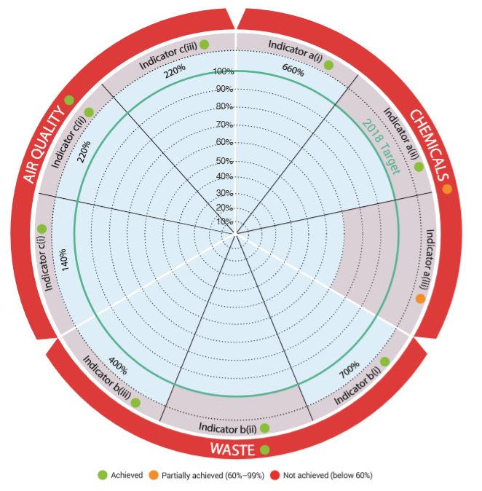
Indicators of achievement
Chemicals
a i) Increase in the number of countries that have used UNEP analysis or guidance, and where possible are applying a multisectoral approach, in developing or implementing legislation, policies or action plans that promote sound chemicals management and implementation of the relevant multilateral environmental agreements and SAICM
a ii) Increase in the number of private companies/industries that have developed or implemented a strategy or specific actions on sound chemicals management using UNEP analysis or guidance
a iii) Increase in the number of civil society organizations that have undertaken action on improving chemicals management using UNEP analysis or guidance

Waste
b i) Increase in the number of countries that have used UNEP analysis or guidance in implementing waste prevention and sound management policies and good practices, in accordance with relevant multilateral environmental agreements, SAICM and other relevant international agreements.
bii) Increase in the number of private companies/industries that have used UNEP analysis or guidance in implementing policies and good practices for waste prevention and sound waste management.
b iii) Increase in the number of civil society organizations that have taken action to enhance waste prevention and improve waste management using UNEP analysis or guidance

Air Quality
c i) Increase in the number of countries that have developed national emission inventories and air quality assessments with publicly accessible monitoring data and information electronically available.
c ii) Increase in the number of countries that have adopted policies, standards, and legal, regulatory, fiscal and institutional frameworks and mechanisms for improved air quality with UNEP analysis or guidance.
c iii) Increase in the number of countries that have raised awareness on the importance of air quality and have made air quality monitoring data and other information publicly available and easily understandable with UNEP analysis or guidance

The indicators show that good progress has been made with countries adopting legislation, policies or action plans for the sound management of chemicals and waste, private sector and civil society taking action with the assistance of UN Environment Programme guidance and tools, and efforts stepped up by governments to improve air quality through better data availability, strategies, standards and awareness raising.

Chemicals

All over the world, hazardous chemicals are used in products and industrial processes, or are released as by-products into the environment. In the absence of sound management of chemicals, workers can suffer exposure during manufacturing, consumers during use and a wide range of other groups during recycling, disposal and other operations. Moreover, poor chemicals management pollutes the environment. One example is how this occurs via wastewater and sewage sludge. UN Environment Programme therefore works with countries, the private sector/industries and civil society to promote the sound management of chemicals and waste.

The indicators show that good progress has been made with countries adopting legislation, policies or action plans for the sound management of chemicals and waste, private sector and civil society taking action with the assistance of UN Environment Programme guidance and tools, and efforts stepped up by governments to improve air quality through better data availability, strategies, standards and awareness raising.

An increasing number of hazardous chemicals are controlled under multilateral environmental agreements, such as the Stockholm Convention on Persistent Organic Pollutants (POPs) and the Minamata Convention on Mercury, as well as by voluntary policy frameworks such as the Strategic Approach to International Chemicals Management (SAICM). With continued support from donors, UN Environment Programme is assisting countries in the ratification of global legally binding instruments to protect human health and the environment from hazardous chemicals, as well as their implementation through, for example, the Global Mercury Partnership, the GEF GOLD programme and the Special Programme. The intention is to support institutional strengthening at the national level for the implementation of the Basel, Rotterdam and Stockholm Conventions, the Minamata Convention and the Strategic Approach to International Chemicals Management.

In 2018:

- 14 more countries ratified/accessed/accepted the Minamata Convention on Mercury bringing the total at the end of the year to over one hundred parties).
- 26 countries updated their National Implementation Plan for the Stockholm Convention.
- 37 countries ratified/approved/accepted the Kigali Amendment to the Montreal Protocol.

With the recent approval of a GEF project that will help address emerging policy issues under SAICM, greater impact is expected in the coming years. This is expected to occur notably in the construction sector, in electronics and toys. The intention is to build on lessons learned from work with the textiles industry. In parallel, we will strengthen our ability to monitor impact of our chemicals work to be better able to report back on results achieved through partnerships, for example with civil society organizations. One of the chemicals of major public health concern is lead – for which no known safe levels of exposure exist. This is particularly harmful for children. Civil society partners continue to play an important role in raising awareness around the issue. One such example occurred at the International Lead Poisoning Prevention Week organized by the Global Alliance to Eliminate Lead Paint and hosted by UN Environment Programme and WHO. Another example of civil society engagement is the legal assistance provided to countries drafting lead paint restrictions by the American Bar Association’s ‘Rule of Law Initiative’ in the context of the global effort led by UN Environment Programme to ban lead paint.

The year 2020 is approaching. This is the date for the attainment of Sustainable Development Goal (SDG) target 12.4 on the sound management of all chemicals and wastes. In this context, stakeholders under the voluntary multisector and multistakeholder Strategic Approach to International Chemicals Management (SAICM) are coming together to discuss how a global governance policy approach should look like beyond 2020. With UN Environment Programme’s support, 9 SAICM consultations and briefings were held in the regions in 2018 to support member states and other stakeholders in their preparations to help shape the chemicals and waste approach beyond 2020. To provide political leadership and impetus to this important process, Sweden and Uruguay launched the Alliance for High Ambition on Chemicals and Waste in July 2018.

Waste

We work with governments, businesses and industries, and civil society organizations to help them develop strategies for environmental management of waste based on the waste hierarchy: prioritizing waste avoidance, prevention, segregation for reuse and recycling, treatment and disposal.

All indicator targets for waste were met during this reporting period. Seven more governments addressed priority waste issues using tools and methodologies provided by UN Environment Programme in 2018. For example, Myanmar developed a national waste management strategy and Varanasi in India a city level one. Uruguay developed waste management strategies at both national and municipal level with guidance from UN Environment Programme. The Parties to the Bamako Convention adopted a decision on the Prevention of electronic hazardous waste and the import and dumping of end-of-life waste electrical and electronic equipment in Africa.

The year 2018 was dominated by waste issues related to marine plastic litter, with World Environment Day focusing on beating plastic pollution. To foster cross-border initiatives and scale up responses to the problem, UN Environment Programme has strongly advocated, including through the Clean Seas campaign, to urgently move from recognizing the problem to acting at all levels to stop the leakage of plastic to the environment, with most of the plastic litter eventually ending up in the ocean. We are unable to cope with the amount of plastic we generate, unless we rethink the way we manufacture, use and manage plastics. The report on “Single-use plastics: a roadmap for sustainability”, launched at World Environment Day, became the top downloaded UN Environment Programme report in 2018. It sets out the latest thinking on how to better manage plastic wastes. In December 2019, we published a global overview on the progress made by countries in passing laws and regulations that limit the manufacture, import, sale, use and disposal of selected single-use plastics and microplastics that have great impact in the production of marine litter.

UN Environment Programme ’s support to civil society is making an impact. It has for example helped raise the profile of the issue of intentionally adding microplastic in cosmetics and personal care products. In 2018, the European Chemicals Agency (ECHA) proposed to phase out microplastic fibres and fragments added to products such as cosmetics, detergents and coatings, starting in 2020. If properly implemented, this will result in a reduction of about 36,000 tonnes of microplastics released into the environment per year. The proposal is part of wider EU efforts to tackle the problem, ranging from taxes and bans on single-use items to investment in modernizing sectors through investment and enhanced recycling.

In response to UNEA resolutions 1/6, 2/11 and 3/7, UN Environment Programme convened two meetings of the Ad-hoc Expert Group on Marine Litter and Microplastics during 2018. These resulted in potential options for further work on the topic, such as on information and monitoring as well as on governance, for consideration by UNEA-4.

Air quality

Our understanding of the impact of air quality on human health has significantly grown over the past years, including impacts on cognitive ability (IQ) and mental health. Dirty air shortens lives and is causing a public health crisis in many parts of the world. This has led to a worldwide movement towards cleaner fuels, including lower sulphur content in diesel. UN Environment Programme has assisted governments at different levels to respond to the situation with technical and advisory support for developing robust and comprehensive air quality monitoring and on clean air policies. Our activities targeted reducing the emission of pollutants from vehicles through the adoption of cleaner fuels and vehicle emission standards, and promoting alternatives and low carbon transport solutions, such as electric mobility, walking and cycling.

Further to the UNEA1/7 and UNEA3/8 resolutions on air quality, UN Environment Programme significantly scaled up its work to offer an integrated menu of services to governments at different levels, combining normative and operational work. This included support to countries in monitoring and assessments, policy and technology support on air quality management in Africa and Asia and strengthening global cooperation on air quality with other international partners.

In 2018, UN Environment Programme, in partnership with the Asia Pacific Clean Air Partnership (APCAP) and the Climate and Clean Air Coalition (CCAC), launched a comprehensive scientific assessment of air pollution in the region. This assessment outlines 25 clean air measures that could achieve safe air quality levels for one billion people by 2030 – with numerous benefits for public health, economic development and the climate. The findings were presented at the WHO Global Conference on Air Pollution and Health in Geneva (30 Oct - 1 Nov).
Some key achievements of our work in 2018

Country(ies) | Achievement
Ukraine | Adopted 10 ppm sulphur in diesel
Peru | Adopted Euro 4 / IV vehicle emissions standards for both light and heavy-duty vehicles and amended the taxation system to favour new passenger vehicles that have some dual fuel mechanism - either gas or electric.
ECOWAS | UN Environment Programme in partnership with the Economic Community of West African States (ECOWAS) Commission held a technical expert meeting for 13 of the 15 ECOWAS member states that developed draft Euro-4 equivalent fuel and vehicle emission standards for the sub-region. Once approved, these standards will have a significant impact on air quality in the West Africa subregion as most countries are currently importing high sulphur fuels and lack any vehicle emission regulations.

As the latest WHO figures show, over 90 per cent of children under 15 worldwide are exposed to dangerous levels of air pollution. The call for campaigns and further awareness raising to change behaviour is growing.

On air quality, we aimed to measure how, with our analysis and guidance, national and local governments have raised awareness on the importance of air quality and have made air quality monitoring data and other information such as policy recommendations publicly available and easily understandable. We exceeded our target for 2018. BreatheLife is a joint campaign of WHO, UN Environment Programme and CCAC on the need to reduce and monitor and reduce air pollution. In 2018, it played a key role in supporting local authorities and national governments in raising public awareness, acting on air pollution and sharing knowledge. By the end of 2018, 43 cities, as well as 173 countries/regions have signed up to the campaign. In total, over 97 million citizens are benefitting. In May 2018, UN Environment Programme, in collaboration with CCAC announced a partnership with the International Association of Athletics in a campaign to raise global awareness about air pollution. Other highlights of our work on health and environment in 2018 follow.

Environment and Health highlights in 2018
- On 10 January 2018, a Memorandum of Understanding was signed between UN Environment Programme and WHO to further cooperation in several of areas, including air, water, biodiversity, antimicrobial resistance, climate change and food and nutrition. Priority for enhanced joint efforts was place on improving air quality.

- UN Environment Programme was a main collaborating partner in the WHO first-ever Global Conference on Air Pollution and Health that took place in Geneva from 30 October to 1 November.

- From 6-10 November, the World Health Organization and UN Environment Programme jointly organized the third Inter-ministerial Conference on Health and Environment in Africa in Libreville, Gabon, resulting in a 10-year strategic action plan on health and environment.

- The US$10.2 million ChemObs project funded by GEF entered its full phase in 2018 to develop an integrated health and environment observatory in 9 African countries.

- WHO, UN Environment Programme and WMO, with the support of CCAC, developed a joint action plan on air quality, climate change and health impacts of poor air quality and of the solutions available to prevent and reduce air pollution – with a focus on countries and cities.

Global cooperation on clean air and the sharing of knowledge on the topic has intensified in 2018. UN Environment Programme and the CCAC collaborated with the Economic Commission for Europe in several events, including a science-policy conference on “Clean air for a sustainable Future”, held in March 2018. We participated in the special session of the Executive Committee of the UNECE- Convention on Long Range Transboundary Air Pollution in December 2018, whose main focus was international cooperation on clean air.

Towards a Pollution-free Planet
The focus of the third UN Environment Assembly was held in December 2017 in Nairobi. It centred on the theme “Towards a Pollution-free Planet”. This provided impetus for the Subprogramme. It also strengthened our mandate to work on chemicals, waste and air quality. The Assembly adopted a resolution on environment and health that called for more work on developing integrated environment and health policies and risk assessments in collaboration with the World Health Organization (WHO) and other relevant stakeholders.

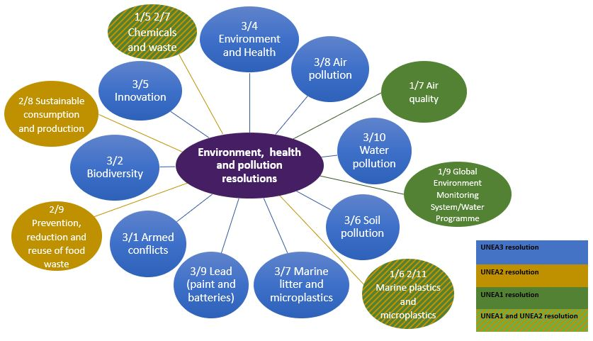

Resolutions related to the environment, health and pollution adopted by member States
at the first, second and third sessions of the Environment Assembly

Interlinkages
Chemicals, waste and air quality issues are inter-related. For example, toxic chemicals in products can pose a barrier to recycling and thus to the transformative change towards circularity. Transparency in the supply chain and improving the monitoring and reporting of hazardous chemicals - especially in developing countries – is of paramount importance. This was also recognized at the Symposium on Sound Management of Chemicals and Waste and the Circular Economy, held from 11-13 September in Chengdu, China. The sound management of chemicals and waste is instrumental ensuring that present and future generations can enjoy a clean, healthy and sustainable environment within the spirit of the 2030 Agenda

FINANCIAL OVERVIEW

- Out of the planned Environment Fund budget for 2018 of US$ 16.2 million, only US$ 8.2 million was received. This is because the UN Environment Programme received a smaller amount of Environment Fund contributions than projected.
- The Trust Fund and Earmarked contributions have been used to some extent to compensate for the Environment Fund shortfall. The subprogramme received US$ 61.5 million (against a planned budget of US$ 19.2 million). However, this amount represents multi-year contributions.
- Overall, expenditure for 2018 stands at US$ 68.1 million, amounting to 38 per cent more than the targeted budget of US$ 49.1 million.

Governments come together to tackle mercury pollution
In 2018, pollution topped the international environmental agenda. The impact on people and the planet is becoming increasingly clear as do the enormous associated social, economic and health costs. During 2002-2018, UN Environment Programme has worked to establish scientific evidence, raise awareness and seek global resolve to tackle one of the world’s key chemicals of major public health concern: mercury.
Shinou Sakamoto sits in her wheelchair, brows furrowed, and eyes squeezed shut with effort as she forced out each word. “I was exposed to mercury pollution when I was in my mother’s womb,” she said. “I was born with foetal Minamata disease in 1956. Many people are still struggling... We must protect women and unborn children from toxic pollution”. Shinou endured a long journey from Minamata to Geneva to deliver her passionate message to the first Conference of the Parties of the Minamata Convention, which takes its name from the worst mercury poisoning incident in history. The Convention entered force in August of 2017, 15 years after UN Environment Programme released the first Global Mercury Assessment. It is now accelerating action on controlling mercury emissions from industry, the use of certain products and processes, and artisanal small-scale gold mining. The objective is to minimize and, where feasible, ultimately eliminate global, anthropogenic mercury releases to air, water and land.
Since 2005, UN Environment Programme’s global work on mercury has helped guide the negotiations and assisted countries in ratifying and implementing the Convention. Governing Council 25/5 specified the UN Environment Programme Global Mercury Partnership as one of the main mechanisms for the delivery of immediate actions on mercury during the negotiation of the global mercury convention. UN Environment Programme continues to support countries through assessments, capacity development and partnerships to sign on to the Minamata Conventions and implement it. As tackling pollution is a joint responsibility and all stakeholders are needed to deliver on the 2030 Agenda – including SDG target 12.4 on the sound management of chemicals and waste – engagement with the private sector and civil society is also actively pursued. The aim is to protect human health and the environment from the release of mercury and its compounds.
There was a concerted effort by the global community to reduce the emissions of mercury worldwide. The result is evidenced by the increase in the number of countries ratifying the Minamata Convention on Mercury. In 2018, UN Environment Programme successfully continued to focus on supporting countries through initial assessments, tools/training and capacity development, to take up the international environmental agreement on mercury and increase the engagement of private sector and civil society in the sound management of chemicals and waste.
The result is evidenced by 16 more countries ratifying the Minamata Convention on Mercury, eight private companies/ industries and two civil society organizations taking specific actions on mercury. With the 16 additional countries signing on to the treaty in 2018, the total number of countries that ratified the Minamata Convention on Mercury has risen that year to 101.

RESOURCE EFFICIENCY
In our work on resource efficiency, we focus on achieving results in three areas:

- Enabling policy environment, where we collaborate with countries to make the transition to inclusive green economies and adopt sustainable consumption and production action plans;
- Sustainability in businesses, where we work with governments, businesses and other stakeholders to make global supply chains more sustainable; and
- Sustainable lifestyles and consumption, where we empower countries, businesses, civil society and individuals to live and consume responsibly and sustainably.
We met or exceeded 7 out of 10 indicators for December 2018.

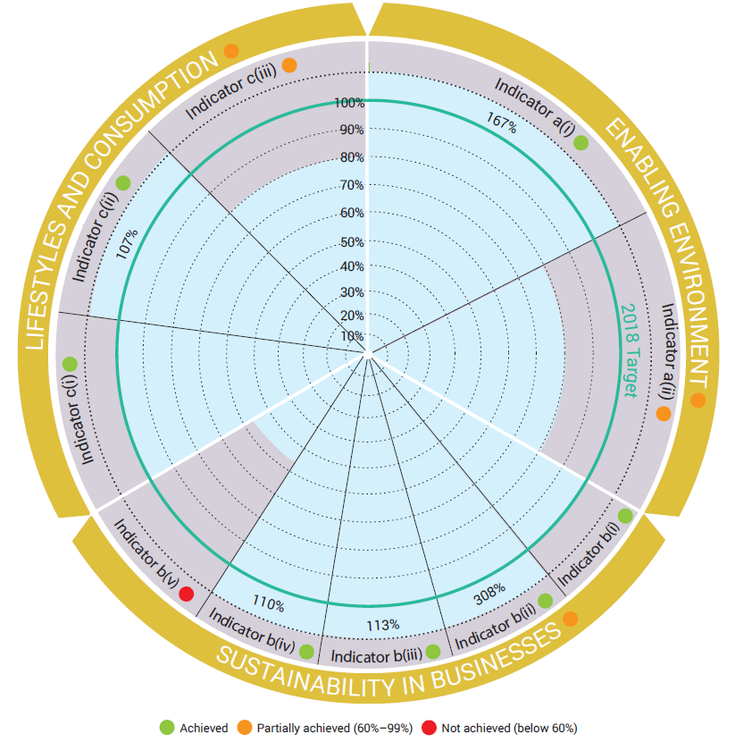

Indicators of achievement
ENABLING POLICY ENVIRONMENT
(a) (i) Increase in the number of countries transitioning to sustainable development through multiple pathways, including through implementing inclusive green economy, sustainable consumption and production, and sustainable trade policies.
(a) (ii) Increase in the number of local governments and cities that measure their resource profiles and report on the sustainable management of resources on the basis of global frameworks.

SUSTAINABILITY IN BUSINESSES
(b) (i) Increase in the number of public and private stakeholders that base their decision-making on life cycle approaches.
(b) (ii) Increase in the number of public and private finance stakeholders that adopt sustainable finance principles, processes and frameworks.
(b) (iii) Increase in the number of countries and businesses that implement sustainable tourism policies.
(b) (iv) Increase in the number of companies that report sustainable management practices they have adopted.
(b) (v) Increase in the number of countries and private sector stakeholders that implement sustainable consumption and production policies in the building and construction sector.

SUSTAINABLE LIFESTYLES AND CONSUMPTION
(c) (i) Increase in the number of countries implementing sustainable public procurement policies.
(c) ii) Increase in the number of countries that implement campaigns, awareness-raising, advocacy and educational initiatives that promote sustainable lifestyles, consumption and production, including gender equality.
(c) iii) Increase in the number of countries that measure food waste at national level using the Food Loss and Waste Protocol.
Under this subprogramme, the number of indicators has significantly increased as compared to the Programme of Work 2016-2017, doubling to 10 indicators for the 2018-2019 period. This was done to better reflect the results and achievements in various sectors. Expected accomplishment A remains with 2 indicators, Expected Accomplishment B has now 5 indicators (up from 2 indicators) and Expected Accomplishment C has now 3 indicators (up from 2 indicators). The focus of all indicators has shifted from adoption to the actual implementation of policies, action plans, raising the ambition of the subprogramme significantly.

Enabling Policy Environment
We support countries and regions in their transition to an inclusive green economy and adoption of sustainable consumption and production action plans at national and sub-national levels. Inclusive green economies are defined as low-carbon, resource-efficient, circular and socially inclusive economies that create decent jobs and enhance human well-being. Country assessments, planning and implementation tools and knowledge platforms enable policymakers and businesses to actively pursue inclusive green economy pathways. The focus is on policy implementation and application of tools and methodologies.
In 2018, 1 region, 2 countries, and 2 counties started to implement regional, national or municipal plans integrating green economy objectives with our support, exceeding our annual target. This brings the total to 2 regions, 19 countries, and 2 counties that have started the implementation of sustainable consumption and production action plans or green economy pathways since 2011 with UNEP support. The biennial target of 3 additional regions, countries, or cities has been exceeded. In addition, 4 cities started measuring their resource profiles in 2018 - bringing the total number to 9 cities that created their resource profiles with our support.

Regions, countries, counties and counties/cities implement policies for greener economies 2011-2018
Regions  (2018) | Pan-European countries implement a Strategic Framework for Greening the Economy
Regions  (2011-2017, baseline) | Mediterranean countries implement a regional Action Plan on Sustainable Consumption and Production
Mauritius, Senegal  (2018) | These countries implement Sustainable Consumption and Production National or Green Economy Action Plans or Policies
Barbados, Bhutan, Brazil, Burkina Faso, China, Egypt, Ghana, Indonesia, Israel, Jordan, Malaysia, Mongolia, Palestine, Rwanda, Uganda, Viet Nam, Zambia  (2011-2017, baseline) | These countries implement Sustainable Consumption and Production National or Green Economy Action Plans or Policies
Counties, sub-national entities (2018) | Mombasa and Nakuru counties (Kenya)
To achieve these results, we delivered various assessments, tools and services to countries in 2018:

In 2018, the International Resource Panel produced several flagship resource assessments that provide countries with scientific evidence on resource efficiency. The assessments include the following reports: The Weight of Cities: Resource Requirements of Future Urbanization, and Re-defining Value – The Manufacturing Revolution. Remanufacturing, Refurbishment, Repair and Direct Reuse in the Circular Economy. The International Resource Panel also provided the Group of 20 (G20) with key messages for their meeting in Argentina in August 2018: Resource Efficiency for Sustainable Development: Key Messages for the Group of 20. International Resource Panel reports continued to attract significant attention in 2019. Its reports continue to be increasingly referenced by academia, international organizations, non-governmental organizations, and the public and private sector. Every report features a summary for policymakers that highlights key findings, messages and policy options.
Mauritius and Senegal received support from the Partnership for Action on Green Economy (PAGE) in developing and implementing their national plans and policies integrating green economy objectives. 2 counties in Kenya (Mombasa and Nakuru) started implementing their sub-national green economy plans, and the Pan-European Strategic Framework for Greening the Economy is under implementation with UNEP support as evidenced by its mid-term review.
Five countries joined the Partnership for Action on the Green Economy in 2018, taking the total to 18 beneficiaries and 8 funding partner countries. The Partnership provided multi-year support for national planning and policy reforms to 18 countries, while capacity building activities have benefited more than 3000 stakeholders from more than 90 countries.
UN Environment Programme is supporting various other regions, countries and sub-national entities that have not yet reached the implementation phase. The support includes assessments and policy formulation, expected to eventually lead to policy adoption and implementation.
The One Planet network (10-Year Framework of Programmes on Sustainable Consumption and Production) was recognized in 2018 as a key SDG 12 implementation mechanism in the Ministerial declaration of the High Level Political Forum where the “One Plan for One Planet” 2018-2022 strategy was also launched.

Sustainability in businesses
At the core of our work is the enhancement of the capacity of governments, businesses and other stakeholders to adopt sustainable production and management practices in global supply chains in the following sectors: building and construction, food and agriculture, finance and tourism and with small and medium enterprises across a number of manufacturing sectors.
In 2018, with our support, 3 farmers’ cooperatives applied life-cycle approaches to further develop their business practices. 29 banks, 4 insurers and 4 countries adopted and started implementing sustainable finance principles and practices. 34 tourism businesses started implementing sustainable tourism policies and practices, and 11 business improved their sustainability reporting with UNEP support. In total and across 5 indicators 81 institutions and businesses and 4 countries improved management practices or sectoral strategies in their respective sectors in 2018. 4 out of 5 indicators associated with the expected accomplishment have either achieved or exceeded their annual targets.
More countries and businesses adopt practices to improve resource efficiency and sustainability with UN Environment Programme support [selected examples]

Global | Finance Initiative | 4 additional insurers implement the principles for sustainable insurance  29 new members of the UNEP finance initiative adopt and implement the principles for sustainable finance  4 countries have put sustainable finance frameworks in place
Global | Corporate Sustainability Reporting | 11 additional businesses report on their sustainability practices
India | Life-cycle Initiative | 3 farmers’ cooperatives base and implement their sustainability policies and practices on life-cycle approaches
Dominican Republic and Philippines | Sustainable Tourism | 34 hotel and tourism operators adopt and implement sustainable management practices

These results were delivered with the following supporting products and services:
UNEP Finance Initiative’s biennial Global Roundtable, held in November 2018, brought together over 1,000 leaders and practitioners from financial institutions. 28 major banks, jointly representing 10% of the global banking sector, launched the draft Principles for Responsible Banking, which aim to shape the banking industry’s role in meeting society’s needs as defined by the Sustainable Development Goals, the Paris Climate Agreement and relevant national and regional frameworks.
Life-cycle-based approaches have been promoted across sectors, including food, tourism, and building and construction sectors. Life cycle thinking has also underpinned UNEP’s work in the plastics sector through the New Plastics Economy Global Commitment, which is expected to lead to growing results in the coming years. The New Plastics Economy Global Commitment, with over 250 signatories at the launch, will be a major driver towards a circular plastics economy. The Life Cycle Initiative has provided key scientific support to combatting plastic pollution, including marine plastics pollution through the following assessments and reports: Mapping of Global Plastics Value Chain and Plastics Losses to the Environment, and Addressing Marine Plastics: A Systemic Approach, Stocktaking Report. The Sustainable Consumption and Production Hotspot Analysis Tool enables policy makers and businesses to identify the hotspots areas of unsustainable production and consumption to support setting priorities in national sustainable consumption and production as well as climate policies.
43 businesses from the tourism sector have committed to reduce greenhouse gas emissions, improve resource efficiency performance and improve sustainable tourism practices. Out of these, 26 companies are based in Philippines and 17 in Dominican Republic (mostly large chains with several other individual hotels). Two tools to support businesses in their monitoring of resource use, estimation of greenhouse emissions, and the identification, comparison and evaluation of mitigation measures have been developed and deployed. Out of the 43 businesses in the tourism sector, 34 have already started implementing sustainable policies and practices, that have been informed by application of these tools.

Lifestyles and Consumption
We aim to provide enabling conditions for the promotion of sustainable consumption choices and lifestyles. Progress on this front is demonstrated by the number of public and private sector institutions that put in place policies and measures that are conducive to more sustainable consumption patterns. Supporting sustainable public procurement is one way to stimulate demand for, and supply of, sustainable products. In 2018, we supported 8 countries on advancing sustainable public procurement policies at national level. 4 of those countries are already implementing sustainable public procurement action plans and policies in close coordination with the relevant 10-Year Framework Programme on Sustainable Public Procurement. In total, we have supported 18 countries since 2011 on Sustainable Public Procurement.
Companies increasingly improve product sustainability information to increase competitiveness

Twenty-eight road testers from across the world, including 12 companies, self-assessed the way they communicate with consumers about sustainability against the 10 principles of the Guidelines for Providing Product Sustainability Information. This exercise helps businesses to improve their communication practices and provide better product sustainability information to consumers.

Education and awareness-raising are important enabling conditions for more sustainable lifestyles.
In 2018, 9 countries, 5 counties/provinces and 1 city started to implement campaigns, awareness raising, advocacy and educational initiatives that demonstrate the benefits of the sustainable lifestyle, consumption and production.
The #SolveDifferent, #Think Beyond, and #LiveWithin campaign focuses on sustainable living and innovation. It is the key tool to communicate sustainable lifestyles during the 4th session of the UN Environment Assembly and beyond. Good Life Goals (GLGs) have been developed and translate the Sustainable Development Goals animated, action-oriented education and communication tool that will reach millions of readers in 2019. In addition, 14 events and activities were supported: 1 urban Project (Morocco) and 2 World Environment Day lifestyle themes (Barbados, Peru). In 2018 urban guidelines were produced for developing sustainable living and lifestyles initiatives which will be the foundation of country urban roll out in 2019 and beyond. 4 additional countries have started measuring their food waste at national level in 2018.

FINANCIAL STATUS

- Out of the planned Environment Fund budget for 2018 of US$19.8 million, only US$10.3 million was received. This is because the UN Environment Programme received a smaller amount of Environment Fund contributions than projected.
- The Trust Fund and Earmarked contributions have been used to some extent to compensate for the Environment Fund shortfall. The subprogramme received US$57.1 million (against a planned budget of US$20.5 million). However, this amount includes multi-year contributions.
- Overall expenditure is at US$41.3 million, which is 95 per cent of the target budget of US$43.5 million.
- This picture, however, does not show the distribution across projects or the shortfall in certain projects. It does also not indicate the need for additional resources to take several interventions to the next and more impactful level, particularly initiatives addressing our work on food waste or the One Planet Network/10-Year Framework of Programmes on Sustainable Consumption and Production among others. Additional funding is required to take several initiatives to scale and to implement relevant UN Environment Assembly resolutions.
Wasting Food can no longer be an option!
In 2018, the UN Environment Programme, in partnership with the Food and Agriculture Organization of the United Nations and several key global expert partners, developed the indicator methodology for the food waste element of Sustainable Development Goal target 12.3., which is focused on cutting food waste by 50% by 2030.
One-third of all food produced in the world – approximately 1.3 billion tonnes – is lost or wasted every year. Food waste is responsible for over 7% of the world’s greenhouse gas emissions, making it a key challenge in tackling climate change and reaching the Sustainable Development Goals. At the same time Some 795 million people in the world do not have enough food to lead a healthy active life. That's about one in nine people on earth.
The UN Environment Programme took the lead in developing the methodology and building in-house expertise gained from both the development of related Sustainable Development Goal indicators and on-going activities on food waste prevention and reduction. UN Environment Programme was able to ensure that the proposed indicator is statistically robust, related to other on-going data collecting activities by member states and solution -based in nature.
The deliverables contributed to the result, which is a draft methodology that was presented to the Inter-agency Expert Group (IAEG) in late 2018, and that has been piloted in November 2018. Methodologies to measure both food loss (Food Loss Index) and food waste (Food Waste Index) are now globally coherent. Member states will now be able to identify the amount and sources of food waste at the national level in a coherent and comparable manner which is essential to develop and implement effective polices to reduce food waste in the supply chain and at the consumption level. This will result in more resource efficiency and a reduction of greenhouse gases both during the production and the supply chain of the food but also reducing methane emissions as food waste sent to landfill would decline. This will also be a key enabler for the implementation of effective awareness raising campaigns that would save people money and increase the general availability of food.

ENVIRONMENT UNDER REVIEW

In our work to keep the environment under review, we focus on bridging the gap between the producers and consumers of environmental information, so that evidence-based policymaking is informed by robust data and assessments. We provide results in the following areas:

- Assessments – where we support global, regional and national policy-making using environmental information accessible on open and shared knowledge platforms.
- Early warning – where we provide information on emerging environmental issues of global importance.
- Information anagement – where we strengthen the capacity of countries to generate, access, analyze, use and communicate environmental information and knowledge, and address the environmental dimensions of the Sustainable Development Goals.

During 2018, we met or exceeded all our seven targets.

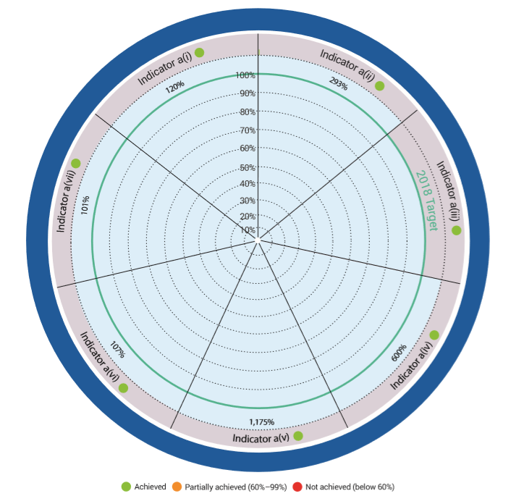
INDICATORS OF ACHIEVEMENT
- Increase in the number of tagged and maintained datasets available in the United Nations system data catalogue enabling systematic user access to relevant data on the environmental dimension of the Sustainable Development Goals.
- Increase in the number of countries reporting on the environmental dimension of sustainable development through shared environmental information systems with country-level data made discoverable through UN Environment Programme.
- Strengthening of the science-policy interface by countries based on the use of data, information and policy analysis in the areas of air quality, water quality, ecosystems, biodiversity, waste and hazardous chemicals, the marine environment and emerging issues.
- Increase in the number of indicators to measure the environmental dimension of sustainable development made through UN Environment Programme Live that are disaggregated by vulnerable groups, especially by gender, geography and age.
- Increased number of people belonging to different major groups and stakeholders acknowledging the relevance and usefulness of data and environmental information made available by UNEP.
- Increase in the number of relevant global, regional and national forums and institutions using data on environmental trends identified through UN Environment Programme for environmental assessment, early warning on emerging issues and/or facilitation of policy action.
- Level of accessibility and ease of use of UN Environmental Programme environmental information through open platforms measured against internationally recognized standards for open access to information.

Our goal for 2018 was to align 15 United Nations data sets to the environmental dimensions of the Sustainable Development Goals. We achieved 18, thereby increasing the capacities of member states to develop indicators to report on SDGs and the state of the environment.

Environment Live is now valued as a global knowledge-sharing platform. To make environmental information available and widely accessible, shared environmental information system principles are used to report on global environmental goals/targets or other indicators relevant to the environment. This makes country-level data discoverable.

To strengthen national reporting systems, we have joined up with the UN Statistics Division, the UN’s regional economic commissions and other key UN entities. Our joint work focuses on developing the capacity to deliver environmental statistics and report on the Sustainable Development Goals.

Our Environment Live: Science and Data for People platform has exceeded all expectations. During 2018, a total of 235 women and men from major groups and stakeholders were involved in the generation of environmental information made available through the UN Environment Programme Community of Practice (CoP) or used this information for driving policy actions. This is more than 10 times higher than our original target, an overshoot that indicates the need for improved target setting.
One of our flagship reports is the Emission Gap Report. In 2018, the report was influential in shaping the decision of the Court of Appeal in the Netherlands, which ordered the government to further reduce greenhouse emissions by at least 25 percent from 2020 compared with 1990 levels. Urgenda, an environmental group, brought the original case to court in 2015 on behalf of 900 Dutch citizens.

In addition, our flagship Global Environment Outlook (GEO) report captured and conveyed information and analysis for the Latin America and Caribbean regions, presenting examples of innovative tools to reduce information gaps and to improve environmental monitoring and reporting.

Collecting environmental data disaggregated by sex and age is challenging. Through a conscious effort, we managed to exceed what was planned, by measuring the environmental dimension of sustainable development through Environment Live. The data is disaggregated according to vulnerable groups (notably gender), geography and age. On Progress for Every Child, the data addresses a full range of issues, including environmental ones, relating to children’s rights and welfare – all anchored in the 2030 agenda’s explicit aim to “leave no one behind”.

Our trajectory to continuously enhance our engagement with major groups and stakeholders is starting to pay off. In 2018, we exceeded our target in terms of the number of people in this category who acknowledged the relevance and usefulness of data and environmental information made available by UN Environment. Access to publicly available information has never been made easier with our Environment Live platform.

The Environment Live platform currently has 16 themes, with data flows from various sources and among them is tracking the global biomass as depicted in the picture below.

Moreover, we are celebrated in the academic world where authors and academics acknowledge the utility of our publications. This reflects recognition of our scientific relevance and ability to keep abreast of emerging issues on the environment. For example, our emerging issues identified the growing antimicrobial resistance (AMR) linked to the discharge of drugs and specific chemicals into the environment as one of the most worrying health threats today. Indeed, experts view the promotion of antibiotic resistant bacteria as “by far the greatest human health risk” posed by the presence of pharmaceutical residues in the environment. They note that, in addition to fostering the spread of resistant pathogens, antibiotic residues can also turn harmless environmental bacteria into carriers of resistance.

The level of accessibility and usability of the Environment Live platform is of paramount importance. We have improved accessibility to Environment Live by 86 percent over the course of 2018, through usability tests and web statistics, complemented with user satisfaction surveys.

Overall, our products and services include a range of thematic assessments, delivering environmental indicators, and improving access to data and knowledge through Environment Live. Our flagship assessment Global Environment Outlook will be finalised and Member States will negotiate on the Summary for Policy Makers in 2019. The report is intended to enable more Member States, UN entities and other partners to use this information and institutionalize the use of our assessment reports in shaping decisions. We need to inspire policy-maker, citizen and private sector participation in generating information, sharing their knowledge through open platforms and using it to bring about social, economic and environmental improvements and impacts to help shape the 2030 development journey.

FINANCIAL OVERVIEW

- Out of the planned Environment Fund budget for 2018 of US$14.7 million, only US$8.4 million was received. This is because the UN Environment Programme received a smaller amount of Environment Fund contributions than projected.
- The subprogramme received US$8.4 million (against a planned budget of US$7.2 million with a multi-year appropriation. Although the earmark contributions were slightly more than the approved budget, the shortfall in the environment fund was still not covered.
- Overall expenditure is at US$ 17.6 million, which is 66 per cent of the target budget of US$ 26.8 million.

BUDGET PERFORMANCE
Science and Data for People
Effective sustainable development policies and programmes are not created in a vacuum, which is why UN Environment Programme has for years been providing cutting-edge science to governments to assist them in bridging the science-policy gap.

Despite our best efforts, access to quality data and sound knowledge has been constrained by many factors, including lack of investment and mechanisms for regular data sharing. To change this situation, we have developed Environment Live. This is a cutting-edge, dynamic platform to share environmental science and research in a timely manner.

Environment Live uses global services combined with regional, national and local data to identify key and emerging environmental issues and support integrated assessments and policy analysis. It is tailored to a wide audience: policy-makers, researchers, citizens. Since its launch, both content and level of accessibility have dramatically improved. If you are looking for information on the countries, regions, and globally, go to the World Situation Room. If you are interested in emerging issues, take a dive into the Foresight Briefs. If you are passionate about environmental statistics and SDGs, Environment Live houses the numbers.

Our projected overall budget for the year 2018 was US$398 million. This budget comprised the UN Regular Budget including United Nations Scientific Committee on the Effects of Atomic Radiation (UNSCEAR) and UN Development Account allocations, the Environment Fund and Trust and earmarked funds.

As in previous years, a significant part of the income received was earmarked for specific projects. This creates an imbalance in the delivery of the approved Programme of Work 2018-2019, with often more focus on some areas than others. The total 2018 income was US$433.3 million (including multi-year contributions to be applied against future years). Total 2018 expenditure was US$479.6 million. Total available resources stood at US$770.3 million.

INCOME ANALYSIS

Core resources from the UN Regular Budget and Environment Fund, both of which are annual funds, amounted to 21% of total income received. The Trust and earmarked income received comprised all other contributions from the Member States, Global Environment Facility, Green Climate Fund, European Commission, foundations, private sector and other UN sister organisations. The amounts received were for both 2018 and, in the case of multi-year contributions, future years.

UN Regular Budget: The UN Regular Budget covers substantive support to the Governing Bodies, coordination of environmental programmes in the UN system and ensuring effective cooperation with relevant global scientific and professional communities. There are no gaps between the budget and income because the budget approved by the General Assembly is followed by disbursements from the assessed contributions of the UN Member States. Because it provides only 5% of the total income which does not adequately provide for core functions such as servicing the Environment Assembly, it needs to be supplemented by contributions from both the Environment Fund and earmarked contributions.

The Environment Fund: The Environment Fund finances the essential capacity needed for the efficient delivery of UN Environment’s Programme of Work approved by the 193 Member States. It enables the organisation to lead science-policy solutions, identify emerging environmental threats and innovate to address them, advocate and raise awareness, build capacity, and ensure robust oversight and accountability. Despite its critical role for providing direction for the organisation, it received only 50% of the approved annual budget from 81 member states and amounted to only 16% of the Organisation’s income.

Trust and earmarked contributions: Trust and earmarked contributions enable scaling up and replication of results of the core work including capacity building in more countries with more partners. Earmarked income received, including for future years, exceeded the annual budget for this income stream, by 54%. With its significant share of the total income, 79%, the earmarked income tends to skew the programme delivery towards priorities of specific partners. Earmarked contributions were provided by the Global Environment Facility (37%), Member States (26%), UN sister organisations (14%), private sector including Finance Initiative (9%), Green Climate Fund (8%) and European Commission (6%).

We extend our deepest appreciation to all the contributing Member States and other funding partners for their commitment and support to the organisation, especially the 15 largest funding partners that continue to contribute for over 90% of the Environment Fund and Earmarked Funds. UN Environment Programme is determined to provide value for money by delivering results and financial performance, partnering for increased impact, responding to global, regional and local challenges, and ensuring robust oversight and accountability. We aim to provide a return on your investment in the planet and in UN Environment Programme.

Top 15 Contributors to Environment Fund |  |  |  | Top 15 Contributors to Earmarked Funds
 | Member States | US$ |  |  | Funding Partners | US$
1 | Netherlands | 9.1 |  | 1 | Global Environment Facility (GEF) | 126.7
2 | Germany | 8.9 |  | 2 | UN Sister Organisations | 48.4
3 | France | 7.6 |  | 3 | Private Sector | 26.6
4 | United States of America | 6.1 |  | 4 | Green Climate Fund | 26.4
5 | Sweden | 5.1 |  | 5 | European Commission | 21.4
6 | Belgium | 4.6 |  | 6 | Denmark | 16.7
7 | United Kingdom | 4.3 |  | 7 | Norway | 15.4
8 | Switzerland | 3.8 |  | 8 | Sweden | 10.0
9 | Norway | 3.0 |  | 9 | Japan | 9.8
10 | Canada | 2.4 |  | 10 | Germany | 8.2
11 | Japan | 2.4 |  | 11 | France | 6.6
12 | Finland | 1.7 |  | 12 | Luxembourg | 3.4
13 | China | 1.5 |  | 13 | Finance Initiative | 3.0
14 | Russian Federation | 0.9 |  | 14 | Italy | 2.8
15 | Ireland | 0.6 |  | 15 | Switzerland | 2.5

Expenditure Analysis

Total expenditure for the year-2018 was US$479.6 million, against an available resource amount of US$770.3 million. These expenditures were recorded against all funding sources.

Regular Budget: The initial allotment amounted to US$23.3 million for the year 2018 including US$3.8 million allocation from UN Development Account. This allotment was revised in December 2018 to cater for additional staff costs bringing the available resources to US$24.9 million against which US$21.8 million worth of expenditures were incurred as at 31 December 2018.

Environment Fund: The authorized budget for the year 2018 was US$135.6 million. However, the approved allocation was US$70.4 million based on the projected income at the beginning of the year. The total utilization of the funds as at 31 December 2018 is US$64.5 million on core capacity and general operating expenses in support of the programme implementation.

Programme Support Costs (PSC): The authorized budget for 2018 was US$16.5 million with expenditure recorded as at 31 December 2018 of US$12.9 million.

Trust and Earmarked Funds: The authorized budget for 2018 was US$152.6 with available resources as at 31 December 2018 amounting to US$346.2 million including balances from prior years and cover multi-year activities. The total expenditure recorded as at 31 December 2018 is US$184.5 million. Within this overall umbrella, as regards GEF Trust Funds, the authorized budget for actual expenditure for 2018 was US$70 million with available resources covering multi-year projects as at 31 December 2018 equal to US$311.7 million. The total expenditure including funds committed as at 31 December 2018 is US$195.9 million.

https://www.ipcc.ch/sr15/
http://web.unep.org/ganadapt/publication/adaptation-gap-report-2018
Benin, Comoros, Kenya, Myanmar, Tanzania.
Albania, Antigua and Barbuda, Comoros, Madagascar, Tanzania.
Brazil, Honduras, Madagascar, Mauritius, Mongolia, Niger, South Sudan, Swaziland.
https://gca.org/global-commission-on-adaptation
https://gca.org/
http://wedocs.unep.org/bitstream/handle/20.500.11822/26895/EGR2018_FullReport_EN.pdf?sequence=1&isAllowed=y
Available at http://www.ren21.net/gsr-2018/ Published by REN21, the global renewable energy policy multi-stakeholder network hosted by UN Environment Programme
Argentina, Chile, China, Colombia, Ghana, Kenya, Mexico, Mongolia, Myanmar, Nigeria, Pakistan, Peru, Sri Lanka and Ukraine
ASEAN calculated as one entity in the progress measure.
http://ccacoalition.org/en
www.ctc-n.org
Brazil, Colombia, Costa Rica, Dominican Republic, Ecuador, Mexico, Peru, Trinidad and Tobago, Ghana, Kenya Morocco, Mozambique, Rwanda, Senegal, Tanzania, Cambodia, India, Indonesia, Philippines, Sri Lanka and Thailand.
Antigua and Barbuda, Argentina, Chile, Costa Rica, Dominican Republic, Honduras, Panama, Peru, Burkina Faso, Côte d'Ivoire, Ghana, Lebanon, Liberia, Sierra Leone, Togo, Uganda, South Africa, Azerbaijan, Georgia, Lao People’s Democratic Republic, Pakistan, Cambodia, Mongolia, Papua New Guinea
https://www.unenvironment.org/news-and-stories/story/doing-rubber-differently-win-win-solution-people-and-planet
Afghanistan, Burkina Faso, Cameroon, Colombia, Haiti, Iraq, Kenya, Mozambique, Nigeria, Palestine, South Sudan, Sudan, Thailand and Uganda.
Brazil, Colombia, Guatemala, India, Iraq, Lebanon, Nigeria, Papua New Guinea, Sudan, South Sudan, Turkey and Vanuatu.
Afghanistan, Colombia, Haiti, Palestine, Somalia, South Sudan and Sudan.
Angola, Democratic Republic of Congo, Indonesia, Lesotho, Madagascar, Malaysia, Malawi, Mozambique, Solomon Islands, Sri Lanka, Timor-Leste and Vanuatu.
Coordinating Body on the Seas of East Asia (COBSEA); International Coral Reef Initiative (ICRI); Pacific Island Countries and Territories.
China, India, Mexico, Tanzania, Thailand, Georgia.
Democratic Republic of Congo, China, Colombia, India, Indonesia, Peru, Republic of Congo, Sri Lanka, Vietnam.
Open University Netherlands, Concordia University, Asian Disaster Preparedness Center, SDG Academy, Landscape Academy, REDD+ Academy; Institutions of Higher Education and Training in Swaziland.
Ecuador, Denmark, India, Philippines, Senegal, United States of America
Banorte, Industrial and Commercial Bank of China (ICBC) Ltd, Itaú, Caixa Econômica Federal, Santander, Trust Funds for Rural Development (FIRA); Citigroup, Piraeus Bank, BNP Paribas
http://ap.ohchr.org/documents/dpage_e.aspx?si=A/HRC/37/L.19
http://www.un.org/ga/search/view_doc.asp?symbol=E/HLS/2018/1&Lang=E
https://papersmart.unon.org/resolution/uploads/4.6_note_on_regional_preparatory_meetings_for_the_fourth_session_of_the_un_environment_assembly.pdf
www.unemg.org
http://www.greeningtheblue.org/
Antigua and Barbuda, Argentina, Bolivia, Brazil, Costa Rica, Ecuador, Guatemala, Guyana, Haiti, Mexico, Panama, Paraguay, Peru, Dominican Republic, Saint Lucia, Uruguay (https://observatoriop10.cepal.org/en/treaties/regional-agreement-access-information-public-participation-and-justice-environmental)
http://wedocs.unep.org/bitstream/handle/20.500.11822/26801/1stDraft_Monte_V.pdf?sequence=1&isAllowed=y
Bhutan, Central African Republic, Eritrea, Gambia, Ghana, Kenya, Pakistan, Sierra Leone.
These include: Institutionalization of intersectoral dialogues focusing on the environment among sectoral national institutions; General and sectoral environmental legislation adopted or strengthened to address countries’ environmental objectives and implement multilateral environmental agreements; Participatory mechanisms on environment integrated in national legislation; Clear mandate, budget and trained personnel in place for enforcement of national legislation; Evidence of participation of major groups and stakeholders in institutional decision-making processes (for example, as part of environmental impact assessments), as reflected in footnote 45 of the approved programme of work and budget for the biennium 2018-2019.
UN Environment developed a Global Review of Legislation on Environmental Impact Assessment which provides an overview of the current status of national legislation and institutional arrangements of relevance to Environmental Impact Assessments (EIAs) and Strategic Environmental Assessment (SEAs) across the globe
https://wedocs.unep.org/bitstream/handle/20.500.11822/25494/EnvLaw_SD.pdf?sequence=1&isAllowed=y
The regional measures were the Maputo Declaration agreed by African chief justices to support sustainable judicial training programmes on environmental matters in their countries and the Entebbe Plan of action on integrating environmental crime management into curricula of police and prosecutor education programmes in Africa
UNDAFs were developed for Benin, Bolivia, Burkina Faso, Egypt, Kenya, Malawi, Namibia, Nepal and Rwanda
However, the baseline used for this calculation is based on current plans and may be adjusted based on the number of UNDAFs or equivalent planning documents that will actually be developed during the biennium overall.
Cameroon, Central African Republic, Democratic Republic of Congo, Ethiopia, Gabon, Kenya, Liberia, Malawi, Mozambique, Nigeria, Rwanda, Senegal, South Africa, Tanzania, Uganda, Zambia, Zimbabwe http://www.pfi.org.cn/en/mission/2018-ranger-awards
Here is a list of the most relevant resolutions implemented primarily through the environmental governance subprogramme: 1/11 – Coordination across the United Nations system in the field of the environment, including the Environment Management Group; 1/12 – Relationship between the United Nations Environment Programme and multilateral environmental agreements; 1/13 – Implementation of Principle 10 of the Rio Declaration on Environment and Development; 2/2 – Role and functions of the regional forums of ministers of the environment and environment authorities; 2/5 – Delivering on the 2030 Agenda for Sustainable Development; 2/16 – Mainstreaming of biodiversity for well-being; 2/17 – Enhancing the work of the United Nations Environment Programme in facilitating cooperation, collaboration and synergies among biodiversity-related conventions; 2/18 – Relationship between the United Nations Environment Programme and the multilateral environmental agreements for which it provides the secretariat; 2/19 – Midterm review of the fourth Programme for the Development and Periodic Review of Environmental Law (Montevideo Programme IV); 2/25 – Application of Principle 10 of the Rio Declaration on Environment and Development in the Latin America and Caribbean Region; 3/2 – Pollution mitigation by mainstreaming biodiversity into key sectors; 3/3 – Contributions of the United Nations Environment Assembly to the high-level political forum on sustainable development; 3/11 – Implementation of paragraph 88 (a)–(h) of the outcome document of the United Nations Conference on Sustainable Development, entitled “The future we want”.
GEF GOLD is a global programme funded by the Global Environment Facility to address "The Global Opportunities for Long-term Development "GOLD" in the artisanal small-scale gold mining (ASGM) sector, including provisions to address mercury pollution from the sector.
Lithuania, Cuba, Nigeria, Belgium, Dominican Republic, United Kingdom of Great Britain and Northern Island, Iceland, India, Paraguay, Suriname, Chile, Portugal, Sao Tome and Principe, Vanuatu, Guinea-Bissau and Tonga.
Ratification: Belgium, Cuba, Dominican Republic, Iceland, India, Lithuania, Nigeria, United Kingdom of Great Britain and Northern Ireland; Accession: Ireland, Sao Tome and Principe; Acceptance: Chile, Portugal, Suriname, Tonga,
Afghanistan, Argentina, Armenia, Angola, Benin, Burundi, Cabo Verde, Chile, China, Denmark, Georgia, Guinea-Bissau, Greece, Jordan, Lithuania, Niger, Paraguay, Sao Tome and Principe, Sri Lanka, Sweden, The former Yugoslav Republic of Macedonia, Tunisia, United Kingdom of Great Britain and Northern Ireland, Uruguay, Vietnam, Zimbabwe.
Ratification: Austria, Barbados, Belgium, Bulgaria, Burkina Faso, Costa Rica, Croatia, Czech Republic, Ecuador, Estonia, European Union, Greece, Grenada, Hungary, Ireland, Japan, Kiribati, Latvia, Mexico, New Zealand, Niger, Niue, Panama, Portugal, Samoa, Senegal, Slovenia, Switzerland, Tonga, Uganda, United Kingdom of Great Britain and Northern Ireland , Vanuatu, Zimbabwe ; Approval: France ; Acceptance: Gabon, Netherlands, Togo.
Myanmar, Tanzania, St Lucia, India (Varanasi), Kyrgyzstan, Nepal
Benin, Burkina Faso, Chad, Burundi, Cameroon, Cote D'Ivoire, Comoros, Democratic Republic of Congo, Egypt, Ethiopia, Gabon, Gambia, Libya, Mali, Mozambique, Mauritius, Niger, Senegal, Sudan, Tanzania, Togo, Tunisia, Uganda, Zimbabwe
http://wedocs.unep.org/handle/20.500.11822/25496
https://wedocs.unep.org/bitstream/handle/20.500.11822/27113/plastics_limits.pdf
http://www.ccacoalition.org/en/resources/air-pollution-asia-and-pacific-science-based-solutions
https://www.unenvironment.org/news-and-stories/story/cleaner-fuels-and-vehicle-emission-standards-proposed-west-africa
This also includes a country’s participation in international, regional, as well as subnational policies, laws, strategies, action plans and frameworks.
Policies include frameworks, laws, strategies and action plans.
Including subnational governments and public enterprises.
Including strategies and action plans.
Including subnational governments, public institutions and enterprises.
Regions 2018: Pan European Strategic Framework for Green Economy (Eastern Europe/central Asia)
Countries 2018: Mauritius, Senegal
Counties/Sub-national entities 2018: Mombasa county (Kenya), Nakuru county (Kenya)
Regions 2011-2018: Pan European Strategic Framework for Green Economy (Eastern Europe/central Asia), Mediterranean (regional SCP roadmap)
Countries 2011-2018: Barbados, Bhutan, Brazil, Burkina Faso, China, Egypt, Ghana, Indonesia, Israel, Jordan, Malaysia, Mauritius, Mongolia, Palestine, Rwanda, Senegal, Uganda, Viet Nam, Zambia
Counties/Sub-national entities 2011-2018: Mombasa county (Kenya), Nakuru county (Kenya)
Cities 2018: Bartica (Guyana), Cusco (Peru), Medellin (Colombia), Sao Paulo (Brazil)
Cities 2011-2018: Bartica (Guyana), Brussels (Belgium), Cape Town, (South Africa), Cusco (Peru), Dongguan (China), Medellin (Colombia), Sao Paulo and Recife (Brazil), Sorsogon (Philippines)
http://www.resourcepanel.org/reports/weight-cities
http://www.resourcepanel.org/reports/re-defining-value-manufacturing-revolution
http://www.resourcepanel.org/sites/default/files/documents/document/media/thinkpiece_-_resource_efficiency_-_key_messages_for_the_g20_270818.pdf
http://wedocs.unep.org/bitstream/handle/20.500.11822/26745/mapping_plastics.pdf?sequence=1&isAllowed=y
http://wedocs.unep.org/bitstream/handle/20.500.11822/26746/marine_plastics.pdf?sequence=1&isAllowed=y
http://wedocs.unep.org/bitstream/handle/20.500.11822/27257/SCP-HAT_brief.pdf?sequence=1&isAllowed=y
Argentina, Brazil, Kirgizstan, Moldova, Peru, Mongolia, Ukraine, Vietnam
Argentina, Brazil, Peru, Ukraine
Initiation of process, preliminary studies, policy adoption: Belarus, Côte d’Ivoire, Ecuador, India, the Kyrgyz Republic, Maldives, Morocco, Panama, Sri Lanka, Togo; Policy implementation: Argentina, Brazil, Chile, Colombia, Costa Rica, Mauritius, Peru, Ukraine
http://wedocs.unep.org/bitstream/handle/20.500.11822/22180/guidelines_product_sust_info.pdf?sequence=1&isAllowed=y
Barbados, China, Germany, Japan, Morocco, Peru, Sri Lanka, Sweden, Ukraine
China (SAR Hong Kong)
http://www.oneplanetnetwork.org/resource/sustainable-lifestyles-options-and-opportunities
Canada, Germany, Hungary, Norway.
The figures do not include the Multilateral Fund and Conventions and Protocols administered by UN Environment Programme
As per the UN Secretariat interpretation and application of the International Public Service Accounting Standards (IPSAS), Umoja, our financial and administrative management platform, does not enable a breakdown of multi-year contributions in terms of income into annual figures.
These are provisional figures since we await the financial closure of fiscal year 2018.
This includes prior year 2016-2017 funds rephased totalling US$1.5 million.

