 | UNITED  NATIONS

UNEP/SPP-CWP/OEWG.3/2/Add.3/Rev.1

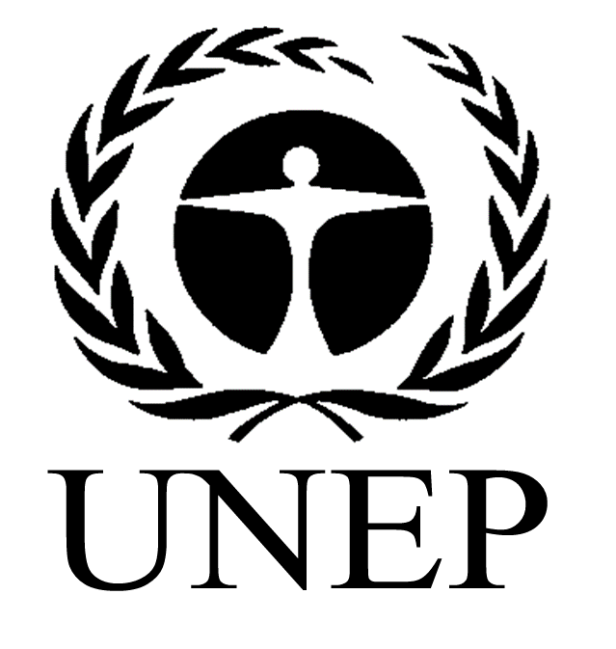 | United Nations  Environment  Programme | Distr.: General  25 March 2024  Original: English

Ad hoc open-ended working group on a science-policy panel
to contribute further to the sound management of
chemicals and waste and to prevent pollution
Third session
Geneva, 17–21 June 2024
Item 4 of the provisional agenda*
Preparation of proposals for the establishment of a science-policy panel
Draft process for determining the work programme, including prioritization
Note by the secretariat
I. Introduction
- The ad hoc open-ended working group on a science-policy panel to contribute further to the sound management of chemicals and waste and to prevent pollution, at its second session, held from 11 to 15 December 2023 in Nairobi, requested the secretariat to prepare draft text for consideration by the ad hoc open-ended working group at its third session, including for the process for determining the work programme, including prioritization.
- The draft process for determining the work programme, including prioritization, builds on the contact group discussions at the second session of the ad hoc open-ended working group and examples of existing processes, in particular those of the Intergovernmental Science-Policy Platform on Biodiversity and Ecosystem Services.
- At its third session, the ad hoc open-ended working group, in finalizing its proposals for the science-policy panel, may wish to consider the draft process for determining the work programme, including prioritization, set out in the present document (and for which annex 3 to section II of document UNEP/SPP-CWP/OEWG.3/2 is a placeholder) for subsequent consideration by the intergovernmental meeting to submit the draft process for determining the work programme, including prioritization, for consideration and possible adoption by the governing body of the panel, once established, at its first session.

II. Process for determining the work programme, including prioritization
[
- The following text is intended to guide the process for determining the work programme of the [full name of panel] (hereinafter the Panel), including the prioritization of issues put to the Panel.
- Governments [, regional economic integration organizations] [, including] [and] [through the governing bodies of] relevant multilateral environmental agreements, [other international instruments] and intergovernmental bodies and processes [related to] [sound management of] [chemicals, waste and pollution prevention] may make submissions, [whether individually or jointly], inviting the Panel to work on specific issues. [Observer input] [on these submissions] [will also be encouraged and taken into account, as appropriate].

- [Submissions from relevant United Nations entities, as determined by their respective governing bodies, are also welcomed.]
- [Submissions by relevant [key] stakeholders, such as international and regional scientific organizations, trust funds, governmental and non-governmental organizations, Indigenous Peoples, local communities, private sector entities and foundations, whether made individually or jointly, will also be encouraged and taken into account, as appropriate.]
- Submissions should, [if possible,] be accompanied by information on:
  - The nature of the proposed issue, including a description of the issue [, its geographic scope] and its associated problems and opportunities and an indication of whether it is cross-cutting or multisectoral;
  - The relevance to the Panel’s [scope and] objective [, work programme] and to [national and regional policy priorities] relevant multilateral agreements, instruments and intergovernmental processes, including the rationale for why the Panel is thought to be best suited to consider the proposed issue;
  - The urgency for action by the Panel in the light of the imminence of the [problems][risks] and opportunities associated with the proposed issue [and the scale of the potential impacts and potential beneficiaries of action related to the issue];

  - The availability [, credibility and neutrality] of existing [scientific literature and] knowledge, data and expertise [to support the work of the Panel] on the proposed issue. [Possible challenges in national or regional capacities to address the proposed issue, including the need for provision of assistance for capacity building and technology transfer]
[d Bis The type(s) of deliverable(s) or modality of the Panel’s activities that may be most useful in addressing the issue or need]
[d Ter Previous or actual work on a similar issue and evidence of remaining gaps]
[d Quater The submission request need to specify to the span of the topic related to the sound management of chemicals and waste and to prevent pollution]
- All submissions should be received by the secretariat [no later than six months] prior to the relevant session of the governing body. The secretariat will compile submissions and make them available on the Panel’s website [for comment by other members and observers]. [Input received on these submissions from other members and observers will also be compiled and made available on the Panel’s website] [at least one month before the relevant session of the governing body]. [To allow for some flexibility to MEAs regarding the deadline for submissions due to their internal meeting schedules,] [Submissions received after the deadline will be considered on an exceptional basis at the request of the Bureau.]

- The Interdisciplinary Expert Committee, supported by the secretariat and additional experts where relevant, will consider and prioritize the submissions on the basis of an analysis of the scientific, technical and policy relevance of the submissions, taking into account the considerations outlined in paragraph 5 above.
- The steps of the prioritization process are as follows:
  - The secretariat clusters the issues received and produces a consolidated list of topics for further consideration and prioritization;
  - The secretariat and the Interdisciplinary Expert Committee conduct an initial screening of the resulting list of topics to ensure that they fall within the scope and objective of the Panel and are not already being, or have not already been, considered by others;
  - The Interdisciplinary Exxpert Committee systematically reviews the topics, consulting additional experts as relevant, and proposes a ranking of topics through the transparent application of a rigorous interdisciplinary review, taking into account the information in the submissions as well as information accessible from publicly available sources;
  - The secretariat, under the guidance of the Interdisciplinary Expert Committee, prepares a report on the top-ranked topics that documents the information and the rationale underpinning prioritization and includes an analysis of the scope and types of outputs that would make the topics suitable for inclusion in the Panel’s work programme.
- The report arising from the prioritization process will be shared with the Bureau.
- On the basis of the outcome of the prioritization process, the secretariat, in consultation with the Interdisciplinary Expert Committee and the Bureau, will prepare a draft work programme that includes such elements as:
  - Objectives and associated deliverables;
  - Timelines for producing the deliverables;
  - Institutional arrangements for the implementation of the work programme;
  - Budgetary implications of implementing the work programme.
- The draft work programme will be submitted to the governing body of the Panel for consideration and adoption.
- The Interdisciplinary Expert Committee may decide to regularly review its process of considering and prioritizing submissions, as needed.
]

* UNEP/SPP-CWP/OEWG.3/1.

