UNITED  NATIONS |  | EP
 |  | UNEP/EA.4/21
 | United Nations  Environment Assembly of the  United Nations Environment Programme | Distr.: General  21 January 2019  Original: English
United Nations Environment Assembly of the
United Nations Environment Programme
Fourth session
Nairobi, 11–15 March 2019
Item 6 of the provisional agenda*
Programme of work and budget, and other administrative and budgetary issues
Global Chemicals Outlook II: summary for policymakers
Report of the Executive Director
Summary
The Executive Director of the United Nations Environment Programme (UNEP) has the honour to present, annexed to the present note, the summary for policymakers of the Global Chemicals Outlook II: From Legacies to Innovative Solutions – Implementing the 2030 Agenda for Sustainable Development, prepared under the guidance of the Steering Committee of the Global Chemicals Outlook II with participation from all regions and a wide range of stakeholders.
The Global Chemicals Outlook II has been prepared in response to Governing Council decision 27/12, adopted in 2013, which requested the Executive Director to continue work on the Global Chemicals Outlook, and United Nations Environment Assembly resolution 2/7, adopted in 2016, which requested the Executive Director to submit an update of the first Global Chemicals Outlook, addressing inter alia the work carried out particularly in relation to lacking or inadequate data to assess progress towards the 2020 goal, the development of non-chemical alternatives, and the linkages between chemicals and waste, in coordination with the Global Waste Management Outlook, and providing scientific input and options for implementation of actions to reach relevant Sustainable Development Goals and targets up to and beyond 2020. Resolution 2/7 included a request to address the issues identified as emerging policy issues by the International Conference on Chemicals Management, as well as other issues where emerging evidence indicates a risk to human health and the environment.
The summary for policymakers, a longer summary and the full Global Chemicals Outlook II will also be made available in due course via the UNEP website and the website of the Strategic Approach to International Chemicals Management.

Annex*
Global Chemicals Outlook II: From Legacies to Innovative Solutions – Implementing the 2030 Agenda for Sustainable Development
Summary for policymakers

Global Chemicals Outlook II: Key Findings

The global goal to minimize adverse impacts of chemicals and waste will not be achieved by 2020. Solutions exist, but more ambitious worldwide action by all stakeholders is urgently required.

 | - The size of the global chemical industry exceeded United States dollars 5 trillion in 2017. It is projected to double by 2030. Consumption and production are rapidly increasing in emerging economies. Global supply chains, and the trade of chemicals and products, are becoming increasingly complex.
 | - Driven by global megatrends, growth in chemical-intensive industry sectors (e.g. construction, agriculture, electronics) creates risks, but also opportunities to advance sustainable consumption, production and product innovation.
 | - Hazardous chemicals and other pollutants (e.g. plastic waste and pharmaceutical pollutants) continue to be released in large quantities. They are ubiquitous in humans and the environment and are accumulating in material stocks and products, highlighting the need to avoid future legacies through sustainable materials management and circular business models.
 | - The benefits of action to minimize adverse impacts have been estimated in the high tens of billions of United States dollars annually. The World Health Organization estimated the burden of disease from selected chemicals at 1.6 million lives in 2016 (this is likely to be an underestimate). Chemical pollution also threatens a range of ecosystem services.
 | - International treaties and voluntary instruments have reduced the risks of some chemicals and wastes, but progress has been uneven and implementation gaps remain. As of 2018, more than 120 countries had not implemented the Globally Harmonized System of Classification and Labelling of Chemicals.
 | - Addressing legislation and capacity gaps in developing countries and emerging economies remains a priority. However, resources have not matched needs. There are opportunities for new and innovative financing (e.g. through cost recovery and engagement of the financial sector).
 | - Significant resources can be saved by sharing knowledge on chemical management instruments more widely, and by enhancing mutual acceptance of approaches in areas ranging from chemical hazard assessment to alternatives assessment.
 | - Frontrunner companies – from chemical producers to retailers – are introducing sustainable supply chain management, full material disclosure, risk reduction beyond compliance, and human rights-based policies. However, widespread implementation of these initiatives has not yet been achieved.
 | - Consumer demand as well as green and sustainable chemistry education and innovation (e.g. though start-ups) are among the important drivers of change. They can be scaled up through enabling policies, reaping the potential benefits of chemistry innovations for sustainable development.
 | - Global knowledge gaps can be filled. This can be achieved, for example, by taking steps to harmonize research protocols, considering health or environmental impact information and harm caused to set priorities, and strengthening the science-policy interface through enhanced collaboration of scientists and decision-makers.

Introduction
- The Global Chemicals Outlook II (GCO-II) is released at a crucial moment. Since publication of the GCO-I in 2013, the global consumption and production of chemicals has continued to grow, with a number of trends that are a cause for concern. This period has also witnessed the adoption in 2015 of the 2030 Agenda for Sustainable Development and its Sustainable Development Goals (SDGs), which include several specific targets related to chemicals and waste (see Table 1). Shortly thereafter, the International Conference on Chemicals Management (ICCM) initiated an intersessional process to prepare by 2020 recommendations regarding the Strategic Approach and the sound management of chemicals and waste beyond 2020.

- In 2002, the World Summit on Sustainable Development had adopted the Johannesburg Plan of Implementation, in which Governments agreed to “achieve, by 2020, that chemicals are used and produced in ways that lead to the minimization of significant adverse effects on human health and the environment […]”. The 2006 Strategic Approach to International Chemicals Management (SAICM) Overarching Policy Strategy built upon this timeline. It referred to the “2020 goal”, a term subsequently used by the ICCM. The 2020 timeline was reiterated at the 2012 Rio plus 20 Summit (referring to chemicals and hazardous waste) and in SDG Target 12.4 (referring to chemicals and all wastes).

Table 1: Chemicals and waste in the 2030 Agenda: SDG Targets 3.9 and 12.4
SDG 3: Ensure healthy lives and promote well-being for all at all ages
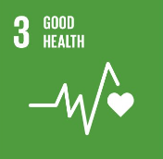 | Target 3.9: By 2030, substantially reduce the number of deaths and illnesses from hazardous chemicals and air, water and soil pollution and contamination.
SDG 12: Ensure sustainable consumption and production patterns
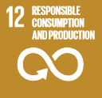 | Target 12.4: By 2020, achieve the environmentally sound management of chemicals and all wastes throughout their life cycle, in accordance with agreed international frameworks, and significantly reduce their release to air, water and soil in order to minimize their adverse impacts on human health and the environment.

Key messages for policymakers: a call for more ambitious action at all levels

The 2020 goal will not be achieved: business as usual is not an option
- Despite global agreement reached at several high-level United Nations (UN) Conferences and significant action already taken, findings of the GCO-II indicate that the sound management of chemicals and waste will not be achieved by 2020. Trends data suggest that the doubling of the global chemicals market between 2017 and 2030 will increase global chemical releases, exposures, concentrations and adverse health and environmental impacts unless the sound management of chemicals and waste is achieved worldwide. Business as usual is therefore not an option. Accelerating progress in order to achieve sound management, and the minimization of adverse impacts, within the context of the 2030 Agenda is, however, possible under a sustainability scenario. This will require more ambitious, urgent and worldwide collaborative action by all stakeholders and in all countries. [Part I, Ch. 1-8; Part II, Ch. 3-5, Part IV, Part V]

A comprehensive global framework is needed, with ambitious priorities and coherent indicators
- To address gaps, a global framework for the sound management of chemicals and waste beyond 2020 needs to be developed that is aspirational and comprehensive, and creates incentives to foster commitment and engagement by all relevant actors in the value chain. Drawing upon lessons learned from the Strategic Plan for Biodiversity 2011-2020, a global common vision, strategic goals, targets and indicators could facilitate linkages across all relevant agreements and initiatives, and make reporting schemes simpler, country-driven and linked to global targets. Under such a scheme, indicators would need to distinguish between outputs (e.g. adoption of legislation) and impacts (e.g. reduction of adverse impacts from hazardous chemicals). [Part II, Ch. 2; Part V, Ch. 2-3]

Implementation of actions up to and beyond 2020
- Responding to the UN Environment Assembly (UNEA) mandate and based on a review of the implementation of the 2020 goal to date, the GCO-II presents a range of options for implementation of actions (hereinafter referred to as “actions”) to reach relevant SDGs and targets up to and beyond 2020. The identified actions are considered of particular relevance for developing and implementing an approach for chemicals and waste management beyond 2020. Equally important, they target policy- and decision-makers around the world and from all stakeholder groups to generate enhanced commitment for implementation. They also cover commitments already agreed internationally which require urgent attention and renewed commitment due to implementation gaps identified in the GCO-II. Examples include implementation of the GHS and the strengthening of basic chemicals and waste management systems. The actions are presented under ten topics which were derived using a back-casting approach, imaging a sustainability scenario, where legacy problems are addressed and future legacies are avoided, including through green and sustainable chemistry innovation and sustainable consumption and production.

 | Develop effective management systems: Address prevailing capacity gaps across countries, strengthen national and regional legislation using a life cycle approach, and further strengthen institutions and programmes.
 | Mobilize resources: Scale up adequate resources and innovative financing for effective legislation, implementation and enforcement, particularly in developing countries and economies in transition.
 | Assess and communicate hazards: Fill global data and knowledge gaps, and enhance international collaboration to advance chemical hazard assessments, classifications and communication.
 | Assess and manage risks: Refine and share chemical risk assessment and risk management approaches globally, in order to promote safe and sustainable use of chemicals throughout their life cycle.
 | Use life cycle approaches: Advance widespread implementation of sustainable supply chain management, full material disclosure, transparency and sustainable product design.
 | Strengthen corporate governance: Enable and strengthen the chemicals and waste management aspects of corporate sustainability policies, sustainable business models, and reporting.
 | Educate and innovate: Integrate green and sustainable chemistry in education, research, and innovation policies and programmes.
 | Foster transparency: Empower workers, consumers and citizens to protect themselves and the environment.
 | Bring knowledge to decision-makers: Strengthen the science-policy interface and the use of science in monitoring progress, priority-setting, and policy-making throughout the life cycle of chemicals and waste.
 | Enhance global commitment: Establish an ambitious and comprehensive global framework for chemicals and waste beyond 2020, scale up collaborative action, and track progress.

Using the Sustainable Development Goals and targets to stimulate integrated action beyond 2020
- In addition to action to meet the SDG targets that directly address chemicals and waste management (SDG 3.9 and 12.4), the 2030 Agenda provides a renewed opportunity to strengthen inter-ministerial coordination mechanisms, and to integrate chemicals and waste considerations into relevant sector policies and actions (see Table 2 for examples). While progress has been made in advancing chemicals and waste considerations in some sectors (e.g. in agriculture, through the International Code of Conduct on Pesticide Management, and in health, through the World Health Organisation (WHO) Chemicals Road Map), other sectors (e.g. housing) have so far received limited international attention. [Part V, Ch. 1-3]

Table 2: Integrating chemicals and waste management, and green and sustainable chemistry innovation, in relevant sectors: some opportunities
Sectors | SDG targets |  | Examples of opportunities for management and innovation
Agriculture and food | 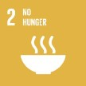 | Target 2.4: sustainable food production | - Scale up integrated pest management and agro-ecological approaches, including development and use of non-chemical alternatives and other good agricultural practices
Health | 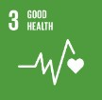 | Target 3.8: safe medicines and vaccines | - Sound management of pharmaceuticals and disinfectants that contribute to antimicrobial resistance
Energy | 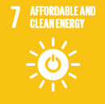 | Target 7.a: clean energy research and technologies | - Improve technologies using resource-efficient, sustainable materials when decarbonizing the energy sector
Housing | 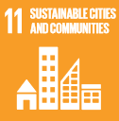 | Target 11.1: safe housing | - Reduce indoor air pollution through safer insulation and replace building materials of concern (e.g. asbestos)
Education | 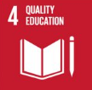 | Target 4.7: education for sustainable development | - Mainstream green and sustainable chemistry into relevant curricula
Finance | 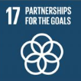 | Target 17.3: financial resources from multiple sources | - Enhance use of green and sustainable chemistry metrics as criteria in investment
The opportunities, targets and sectors in this table are not exhaustive. Other relevant sectors include (but are not limited to) industrial production, technology and innovation, infrastructure development, transport, mining, tourism, labour, trade, development cooperation, and justice.

Enhancing commitment by current stakeholders and increasing engagement by new actors
- The period up to the conclusion of the intersessional process, by 2020, provides a brief but critical window in which to develop an ambitious and comprehensive global framework – as well as to increase engagement by all stakeholders. To facilitate commitment, ownership, mutual accountability and collective tracking of progress to achieve the sound management of chemicals and waste, countries and all relevant stakeholders could develop, implement and share, internationally, results-based action plans and roadmaps. Stakeholders could pledge and showcase their action plans and roadmaps within the beyond 2020 framework and benefit from the input of other stakeholders (which might take different forms, such as peer review). Pledges could be reviewed globally against agreed goals and targets, with adjustments made as appropriate. [Part V, Ch. 1-3]

While many chemicals are important for sustainable development, trends are a cause for major concerns, requiring urgent action

Sound management and innovations in chemistry are essential for sustainable development
- From pharmaceuticals and plant protection products to the production of cars, computers and textiles, many manufactured chemicals have helped improve human health, food security, productivity and quality of life throughout the world. However, many chemicals and wastes have hazardous properties and continue to cause significant adverse impacts on human health and the environment because they are not properly managed. Innovations in chemistry and materials science have the potential to create safer chemicals, increase resource efficiency, and reduce the health and environmental impacts associated with the current global production and consumption system. [Part I, Ch. 1, 7; Part IV, Ch. 1]

The production, use and trade of chemicals are growing in all regions, driven by global megatrends
- In 2018 the total number of industrial chemicals in commerce globally was estimated at 40,000 to 60,000, with 6000 of these chemicals accounting for more than 99 per cent of the total volume. According to 2018 data compiled by European Environment Agency, approximately 62 per cent of the total volume of chemicals consumed in Europe in 2016 were hazardous to health. Between 2000 and 2017, the global chemical industry’s production capacity (excluding pharmaceuticals) almost doubled, from about 1.2 to 2.3 billion tonnes. If pharmaceuticals were included, global sales totalled United States dollars (USD) 5.68 trillion in 2017, making the chemical industry the second largest manufacturing industry in the world. Sales are projected to almost double again from 2017 to 2030 (see Figure 1). Projected growth will be highest in Asia, with China estimated to account for almost 50 per cent of global sales by 2030. High growth rates are also expected in Africa and the Middle East. [Part I, Ch. 1]

Figure 1: Projected growth in world chemical sales (excluding pharmaceuticals), 2017-2030 (European Chemical Industry Council 2018, p. 34)
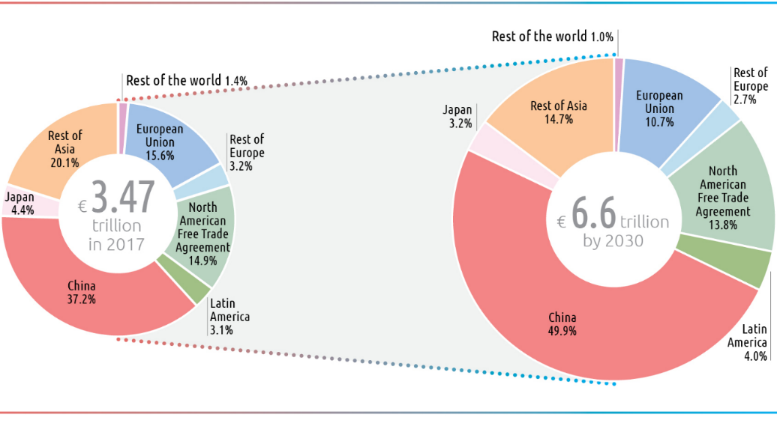

- Megatrends, such as global economic growth and global population dynamics, affect market demand for chemicals, creating both risks and opportunities. Growth in chemical-intensive industry sectors and markets, such as construction, agriculture, electronics, cosmetics, mining and textiles, continues to drive growth in the markets for chemicals used in these sectors. Under a business as usual scenario, the rate of growth of chemical production is projected to exceed that of population growth at least until 2030 (see Figure 2). This means per capita consumption of chemicals is increasing steadily – highlighting the need to achieve sustainable consumption and production, as called for by SDG 12 of the 2030 Agenda. It also reinforces the need to decouple material use from economic growth, enhance resource- and eco-efficiency, advance sustainable materials management, and prioritize source reduction, reuse and recycling, as called for by the waste hierarchy. [Part I, Ch. 1, 3]

Figure 2: Growth of basic chemical production capacity vs. population growth (based on Cayuela and Hagan 2019 and UN Department of Economic and Social Affairs 2018)
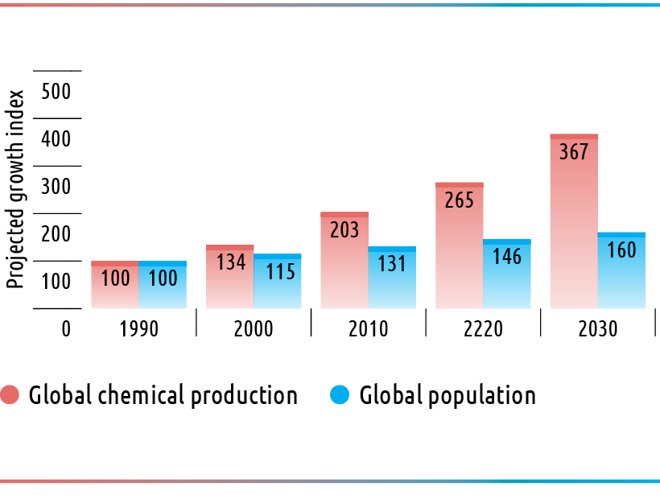
The growth rates of chemical production capacity are derived from past and projected growth rates for basic petrochemical building blocks (ethylene, propylene, butadiene, benzene, toluene, and xylenes).

Chemical-intensive products and complex global supply chains create challenges for circularity
- Modern-day products often contain hundreds of chemicals. Many of these chemicals may have hazardous properties. In addition, unintentional contaminants have been widely detected in a range of products, including toys. Specific challenges are created by the complexity of global supply chains (see Figure 3), the cross-border trade of chemicals and chemical-intensive products, and recycling. Recent research shows that the import of many products does not comply with the chemicals legislation of the importing country. Cross-border e-commerce, growing at 25 per cent annually, adds further complexity. Only 9 per cent of global material resources are recycled and many durable products and buildings, as well as infrastructure and machinery, that contain hazardous chemicals remain in human-made material stocks (estimated to weigh 30 trillion metric tons in 2016) for years to come, creating potential future legacies. Mirroring this trend, less than 9 per cent of the 6.3 billion metric tons of plastic waste generated up to 2015 has been recycled, while 12 per cent was incinerated and 79 per cent was disposed in landfills or in the environment. Full material disclosure of products, sound recycling and waste management, and sustainable product design are important actions to minimize potential future releases from material stocks and products, and to generate secondary raw materials in a circular economy that are safe and sustainable. [Part I, Ch. 4-5]

Figure 3: Illustration of the complexity of global supply chains: the case of an electronic product (Sourcemap 2012)
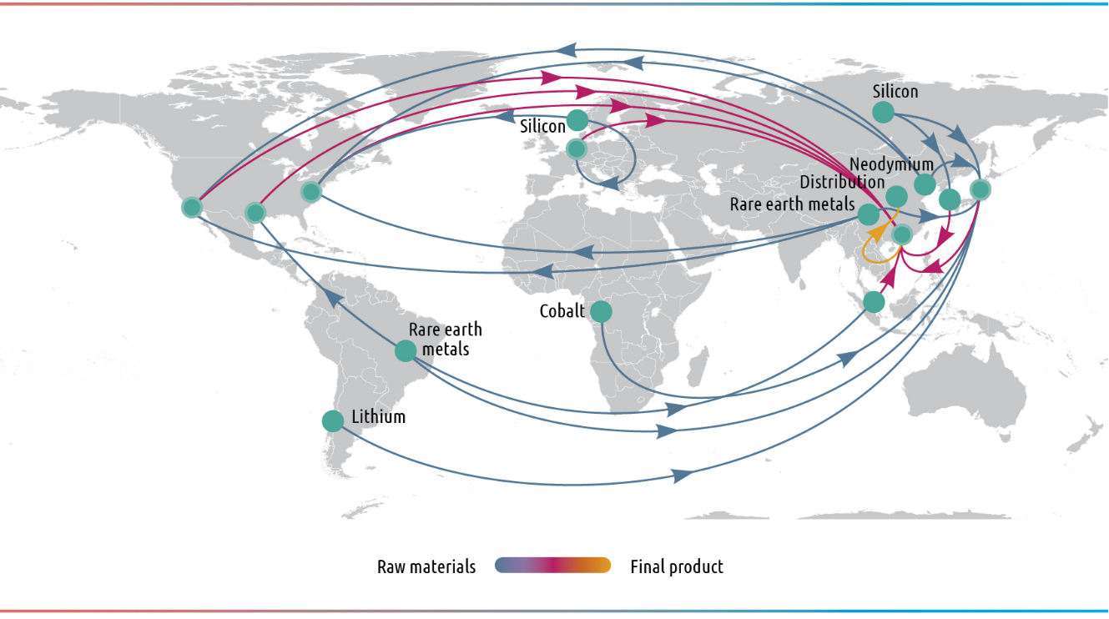

Large amounts of chemical pollutants are released from production, products and wastes, illustrating the inefficient use of resources
- Production processes continue to generate significant chemical releases to air, water and soil as well as large amounts of waste, including hazardous waste. In the production of pharmaceuticals, for example, at least 25 kilograms (kg) of emissions and waste (and at times more than 100 kg) are generated for every kg of product, highlighting resource inefficiencies. Significant amounts of greenhouses gases are also emitted during the production of chemicals. In addition, chemical accidents in industrial facilities continue to release significant amounts of hazardous substances. Moreover, hazardous chemicals are released from chemical-intensive products: for example, microplastics are released to water and phthalates and brominated flame retardants to indoor air. A recent study suggests that releases of chemicals from consumer products (e.g. cosmetics and paints) have become the primary source of volatile organic pollutants from petrochemical sources in some industrialized cities. Developing countries and economies in transition face particular challenges, such as releases of heavy metals from battery recycling and of mercury from artisanal and small-scale gold mining, polluting air, water and soil [Part I, Ch. 4-5]

Chemical pollutants are ubiquitous in the environment and in humans
- Chemical pollutants continue to be detected in air, water and soil and in biota in all regions. Soils throughout the world are contaminated by hazardous chemicals, including polychlorinated biphenyls (PCBs), heavy metals and certain pesticides. Many of these hazardous chemicals, as well as microplastics, are found in food for human consumption. Microplastics, pharmaceutical residues, mercury and many other substances of concern have been detected in water bodies and marine animals, which are often consumed by humans. Concentrations of chemical pollutants are found in some of the most remote and unexpected parts of the planet. For example, PCBs have been detected at high concentrations in animals 10,000 metres deep in ocean sediment, and certain organochlorine pesticides regulated under the Stockholm Convention have been found in the Himalayan glaciers. Chemicals of concern are also routinely detected in humans. Examples are dioxins and furans in breast milk, phthalates in urine, and heavy metals in human blood. Recent studies have detected previously banned flame retardants in the umbilical cord blood of newborn children, indicating one pathway, among others, for the transfer of legacy substances to new generations, which is a typical feature of persistent and bio-accumulative substances. [Part I, Ch. 6]

The burden of disease from chemicals is high, and vulnerable populations are particularly at risk
- The 2017 report of the Lancet Commission on Pollution and Health identified chemical pollution as a significant and “almost certainly underestimated” contributor to the global burden of disease. In 2018, the WHO estimated the disease burden preventable through sound management and reduction of chemicals in the environment at around 1.6 million lives and around 45 million disability-adjusted life years (DALYs) in 2016 (see Figure 4). These are likely to be underestimates, given that they are based only on exposures to chemicals for which reliable global data exist (including lead causing intellectual disability, occupational carcinogens such as asbestos, and pesticides involved in self-inflicted injuries). The 2016 Global Burden of Disease study estimated that 500,000 deaths are attributable solely to lead exposure. In addition, chemical accidents in facilities continue to result in high human fatalities, adverse environmental impacts and large economic costs. [Part I, Ch. 7]

Figure 4: Deaths (total: 1.6 million) attributed to selected chemicals (WHO 2018, page 2)
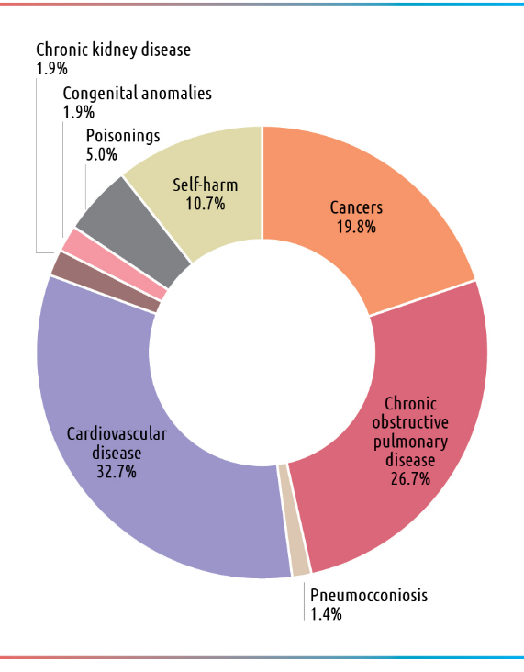
- Workers are typically subject to disproportionally high exposures to hazardous chemicals, particularly in small and medium-sized enterprises (SMEs) in low- and middle-income countries and in the informal economy, where they may not be sufficiently informed and protected. In 2015, almost 1 million workers died from exposure to hazardous substances, including dusts, vapours and fumes, based on estimates released by the International Labour Organisation. Foetuses, infants, children, pregnant women, the elderly and the poor are particularly susceptible to the effects of chemical exposures. The poor may be disproportionally exposed because they frequently live near relevant sources of releases, such as hazardous waste dumpsites and production facilities. Exposures of women and men to chemicals may also differ. For example, women are more likely to be exposed to hazardous chemicals contained in certain cosmetics, while men have significantly higher occupational exposures in certain sectors. [Part I, Ch. 7]

Chemical pollution threatens biota and ecosystem functions
- A range of adverse impacts of chemical pollutants on biota continue to be observed. Examples include lethal and chronic effects on fish from brominated flame retardants; suppression of immune systems in seals and turtles due to exposure to PCBs and per- and polyfluoroalkyl substances; and feminization of male fish due to exposure to synthetic oestrogen. A 2018 study from India indicates that the drug diclofenac continues to adversely affect the health of the vulture population more than a decade after it was banned. Moreover, some pesticides have been found to negatively impact non-target insects and pollinators; excess use of phosphorous and nitrogen in agriculture continues to contribute to ocean dead zones around the world; and some chemicals put pressure on the health of coral reef ecosystems. Studies also indicate that environmental releases of some antimicrobials, heavy metals and disinfectants contribute to antimicrobial resistance. [Part I, Ch. 7]

The costs of inaction and the benefits of action are estimated to be significant, but methods need to be refined
- The costs associated with unsound management of chemicals and waste include productivity losses, health care costs, damage to ecosystems, litigation costs, and reputational damage to businesses. A 2015 study estimated the costs from neurobehavioral deficits caused by certain chemicals to be more than USD 170 billion per year in the European Union alone. Another study estimated the economic costs attributable to childhood lead in low and middle income countries at a total cost of international dollar 977 billion. Some studies estimate costs from environmental chemical exposures to be as high as several percentage points of global gross domestic product, with developing countries and economies in transition bearing the largest costs. Conversely, a 2017 study conservatively estimated the cumulative benefits of chemicals legislation in the European Union “in the high tens of billion Euro per year”. However, since data are still limited, robust socio-economic analysis is challenging and estimation methodologies need further refinement. A global study comparable to the Stern Review on the Economics of Climate Change does not exist. [Part I, Ch. 8]

Multilateral treaties address some chemicals and issues of global concern, but implementation challenges remain
- The international community has taken concerted action through legally binding treaties on some of the most harmful chemicals and on some issues of global concern. Prominent examples include the multilateral treaties shown in Figure 5. These treaties have catalysed selected regulatory actions, raised awareness, and succeeded in reducing some exposures to the targeted chemicals and wastes. However, not all treaties have been universally ratified. Given that treaties are designed to address specific chemicals and issues, many hazardous substances are beyond their scope. While implementation of the Montreal Protocol is a notable success story, the extent to which the objectives of a number of other treaties have been achieved is uncertain. In the case of the Stockholm Convention, the 2016 effectiveness evaluation concluded that “the Convention provides an effective and dynamic framework to regulate persistent organic pollutants throughout their life cycle”. However, it identified areas for further work, such as gaps in regulatory and assessment schemes for industrial chemicals and the large remaining stockpiles of obsolete pesticides and PCBs. Significant progress has also been in the case of other treaties. Nevertheless, further efforts are needed to achieve full implementation, as in the case of the chemicals dimension of the International Health Regulations (2015). [Part II, Ch. 1, 3]

Figure 5: Number of parties to relevant multilateral legally binding treaties (as of 14 January 2019)
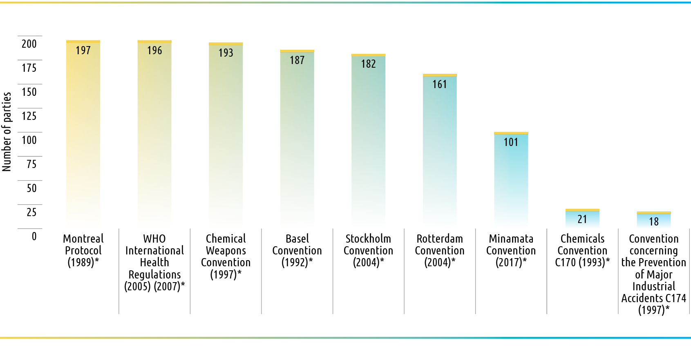
* year of entry into force

Voluntary international instruments cover a broader range of issues, but lack effective implementation
- Several voluntary international instruments adopted by the governing bodies of international organizations address a wide range of chemicals and issues. Prominent examples include the new International Code of Conduct on Pesticide Management, approved in 2013, and the GHS, adopted in 2002. SAICM, adopted by the ICCM in 2006, supports a comprehensive life cycle approach for all hazardous chemicals. A 2018 independent evaluation of SAICM found that it is unique in its ambition as an inclusive multi-stakeholder, multi-sector voluntary policy framework. The evaluation also found that SAICM creates a collaborative space for raising awareness, increasing knowledge and reducing risks. However, it pointed out weaknesses, such as insufficient sectoral engagement; the capacity constraints of national focal points; lack of tools to measure progress; limited financing of activities; and insufficient and uneven advances in substantive areas such as illegal international traffic. The evaluation noted that the identification of, and actions taken on, the eight emerging policy issues (EPIs) and other issues of concern were a major strength. Nevertheless, it found that slow, modest and uneven progress has been made in implementing the EPIs. In light of the UNEA mandate to address EPIs, the GCO-II presents measures to further address existing EPIs. [Part II, Ch. 1, 3-4]

Some countries have taken recent regulatory action based on emerging evidence of risk
- The UNEA also requested that the GCO-II addresses other issues where emerging evidence indicates a risk to human health and the environment. Using as a starting point recent regulatory risk management actions taken by public bodies since 2010 on chemicals or groups of chemicals not addressed at the international level, and to facilitate knowledge-sharing, the GCO-II identified the following eleven chemicals or groups of chemicals and issues associated with them: arsenic, bisphenol A, glyphosate, cadmium, lead, microbeads, neonicotinoids, organotins, polycyclic aromatic hydrocarbons, phthalates and triclosan. [Part II, Ch. 5]

Overall progress towards achieving the sound management of chemicals and waste is uneven across countries, regions and actors
- While significant progress has been made towards achieving the sound management of chemicals and waste, major implementation gaps remain. In each region there is a set of distinct trends, challenges and opportunities. In particular, developing countries and economies in transition, including some with chemical production facilities, still lack basic chemicals and waste management systems, including legal and institutional capacities, Pollutant Release and Transfer Registers, poison centres, and capacities for hazard and risk assessment and risk management. The GHS is not operational in more than 120 countries, mostly developing countries and economies in transition (see Figure 6)_bookmark6. As of September 2018, only 37 per cent of countries had confirmed that they have legally binding controls on lead in paint. Concerning illegal international traffic, chemicals and waste (e.g. electronic waste) are frequently falsely declared while counterfeit products (e.g. pesticides and cosmetics) are traded across borders. While industry is involved through programmes such as Responsible Care®, universal coverage is yet to be achieved. Opportunities exist to review these programmes’ effectiveness through the involvement of relevant stakeholders, as well as to scale up industry responsibility and leadership, drawing upon lessons learned, for example, from the Zero Discharge of Hazardous Chemicals initiative in the textile sector. [Part II, Ch. 3; Part III, Ch. 1-6]

Figure 6: Global GHS implementation status (adapted and updated based on Persson et al. 2017, p. 8)
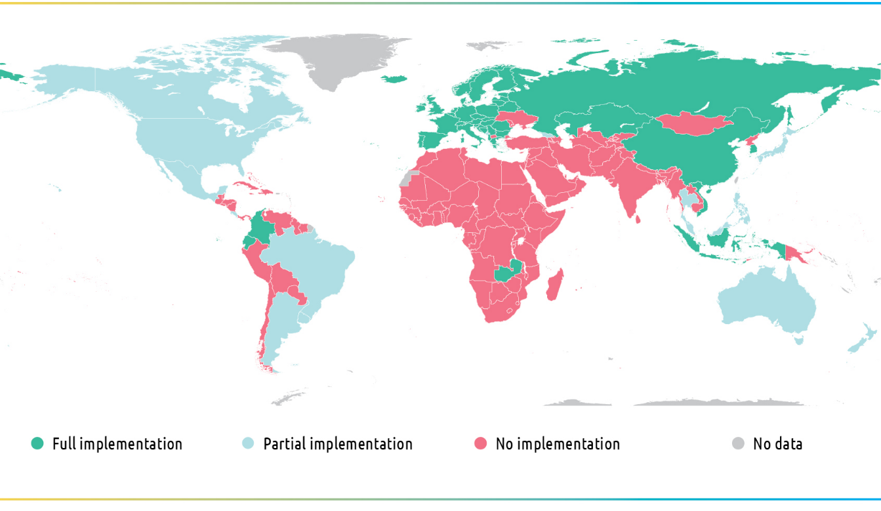

A global coherent results, indicator and reporting framework is lacking
- The current international framework for reporting and measuring progress in the area of chemicals and waste is spread across various treaties, voluntary chemicals and waste instruments, and the 2030 Agenda. A range of different – and not always complementary – indicators have been developed under various international agreements. Reporting rates under several agreements are low, particularly among developing countries and economies in transition. In some cases, reporting rates exhibit a downward trend. The combination of a fragmented indicators framework and low reporting makes it challenging to develop a global baseline, and to track progress in a systematic way. Moreover, the use of activity- or instrument-based indicators alone provides limited insights in assessing impacts achieved. Opportunities therefore exist to put in place a simple and coherent global indicators framework that distinguishes between outputs and impacts, creates linkages across international agreements (including the 2030 Agenda) and is supported by a simple, country-driven reporting scheme. [Part II, Ch. 2]

Solutions exist, but more ambitious, urgent and worldwide action is needed by all stakeholders

Regulatory systems based on a life cycle approach in all countries are critical
- Establishing legal frameworks that address the life cycle of chemicals and waste is critical and a priority. Many countries, including several developing countries and economies in transition, have already made important headway in enacting laws, creating programmes, and implementing policies to achieve the sound management of chemicals and waste. Their success stories create the potential for cooperation, knowledge-sharing and replication. Valuable work has also been undertaken by countries through the development of national chemicals management profiles and plans, often prepared through multi-sectoral and multi-stakeholder collaboration. These initiatives provide a useful starting point for country-level action beyond 2020, taking into account SAICM’s overall orientation and guidance. [Part II, Ch. 3]

Effective implementation requires adequate financing, technology transfer and technical assistance
- The integrated approach to financing. welcomed by the Governing Council of the United Nations Environment Programme in 2013, includes the three components of mainstreaming, industry involvement, and dedicated external financing. Some countries have already integrated chemicals and waste management in their development planning and budgeting; have clarified responsibilities between the public and private sector; have promoted extended producer responsibility and the internalization of costs by industry; and have used fiscal instruments, such as taxing hazardous chemicals. External funding (e.g. through the Global Environment Facility, or the Special Programme to support institutional strengthening) has been significant, but has not matched the need and demand for support, expressed by developing countries and economies in transition for building basic chemicals and waste management systems. Industry involvement has been equally important in mobilizing resources and built capacity, but gaps remain in increasing contributions to match responsibility and the required level of support. Further action is required to achieve full implementation of the integrated approach with respect to all three components. Action is also required in order to explore new opportunities such as sovereign wealth funds, philanthropic finance, and strengthened engagement of the financial sector and investors so as to mobilize and help guide their largely untapped resources to contribute to sustainable development. [Part II, Ch. 3; Part IV, Ch. 6]

Global knowledge-sharing and further harmonization of chemical management approaches can save significant resources
- For many years, Governments, intergovernmental organizations, industry and other stakeholders have been developing and employing a range of approaches to identify chemical hazards, assess exposure and risks, implement risk management actions and assess alternatives, with a view to advancing informed substitution and avoiding regrettable substitutions, including through non-chemical alternatives. Valuable lessons have been learned in the practical application of these approaches. Opportunities have also emerged to enhance their effectiveness and streamline their use, especially by using computer-based estimation methods to replace, where possible, animal testing. Opportunities include the use of generic approaches for risk assessment; shifting the burden of proof from Government to industry; and stimulating assessment approaches which take into account broader sustainability considerations. Proactive and pre-emptive risk management – together with appropriate training – are particularly important in occupational settings, including in SMEs and in the informal sector. Experience shows that resources can be saved through international collaboration, such as sharing and mutually accepting chemical hazard data, assessments and classifications. Advances in this respect would be particularly helpful in developing countries and economies in transition. [Part III, Ch. 1-7]

- Countries may also save significant resources by aligning their approaches with those of other countries of regional bodies (including regional economic integration organizations), or with internationally agreed guidance – while maintaining a high standard of protection. Examples of such guidance include that developed by the Organisation for Economic Co-operation and Development and by the WHO. Altogether, these opportunities point to the value of further global knowledge-sharing and capacity building, building on work already undertaken by intergovernmental organizations and other stakeholders. [Part II, Ch. 3]

Opportunities exists to scale up effective corporate governance and sustainable supply chain management
- A growing number of retailers, product manufacturers and chemical companies have included sustainability objectives, sustainable supply chain management (see Figure 7), and extended producer responsibility in their corporate policies. Industry action to advance the transparent flow of information on chemicals and materials throughout the supply chain is also gaining momentum. Yet universal implementation of these initiatives has not been achieved. Relevant measures to be taken include: scaling up voluntary standard-setting beyond compliance; harmonizing chemical management protocols across industry sectors (e.g. on full material disclosure and labelling of products); using life cycle assessment tools, metrics and reporting to address the sustainability of products throughout their life cycle; and scaling up the design of safer and more sustainable products and production processes. Promoting the engagement of (and developing capacity in) the recycling sector is important, so that secondary raw materials going back into the circular economy are safe and sustainable. It is equally relevant to recognize the role of informal actors at various stages in the supply chain. Unless the measures described above (and others) are put in place, companies may face significant economic risks. For example, multinational companies recently experienced heavy losses in stock values in the range of USD billions, or had to pay significant compensation, due to allegations of lack of diligence or unsound management practices. [Part IV, Ch. 4-5, 7]

Figure 7: Interface of demand and supply in driving the sustainability of chemicals in the supply chain

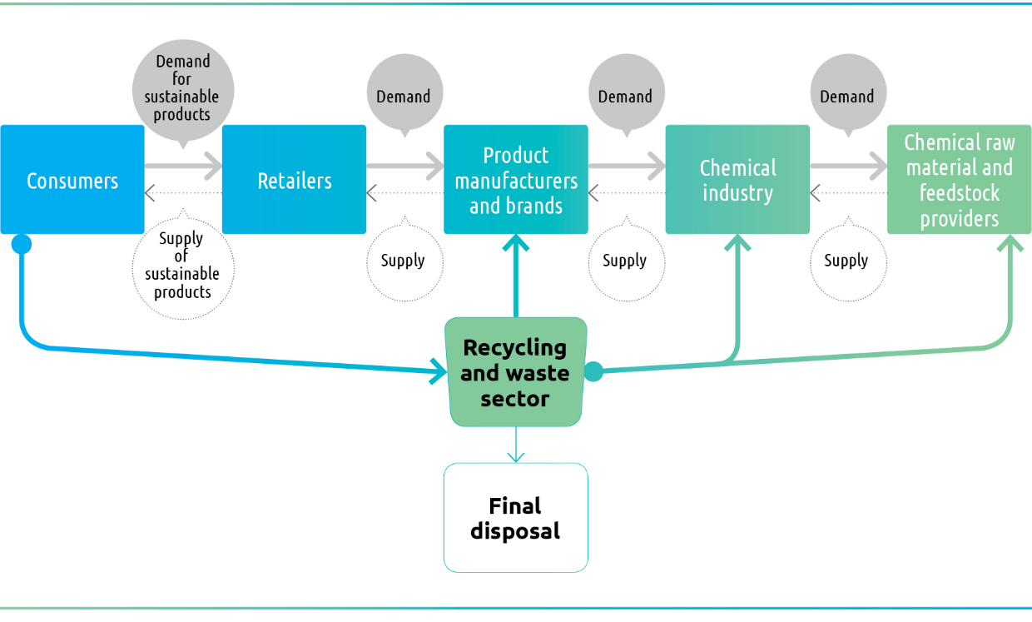

Enhanced transparency is needed to empower workers and citizens and protect the environment
- Providing enhanced access to robust information to workers, consumers and communities as well as to foster understanding thereof is a prerequisite to achieve the sound management of chemicals and waste. Workers can only protect themselves if they have access to chemical hazard and safety information. Providing citizens and consumers with robust information on hazardous chemicals in products allows them not only to protect themselves, but also to shape market demand for safer and more sustainable products. The smartphone app ToxFox, for example, provides information about endocrine disrupting chemicals in cosmetics. It also allows users to submit inquiries about hazardous chemicals. In addition, new and innovative citizen science tools are available that allow citizens and workers to collect and share knowledge e.g. on high levels of occupational exposure. More efforts are needed to promote access to (and understanding of) this information, particularly in developing countries and economies in transition. [Part IV, Ch. 8]

Strengthening the interface of chemicals and waste management and human rights
- In 2012, the UN Human Rights Council (HRC) affirmed “that the way hazardous substances and wastes are managed throughout their lifecycle, including manufacturing, distribution, use and final disposal, may have an adverse impact on the full enjoyment of human rights”. In an August 2018 report to the HRC, the Special Rapporteur on the implications for human rights of the environmentally sound management and disposal of hazardous substances and wastes recommended that “states must ensure that legislation and other practices reflect their duty to respect, protect and fulfil human rights obligations implicated by hazardous substances and wastes […] [and] that victims of the effects of hazardous substances and wastes have access to an effective remedy”, further noting that “the right to information is critical in the context of toxics”. Furthermore, the Special Rapporteur proposed 15 principles to help Governments and businesses better protect human rights with respect to exposure to hazardous chemicals. These measures are relevant to strengthening chemicals and waste management beyond 2020. Some companies, including from the chemical industry, have already committed to respect human rights, along the lines of the UN’s Guiding Principles on Business and Human Rights. Other companies may consider following suit. [Part IV, Ch. 8]

Green and sustainable chemistry education, innovation and sustainable business models can benefit from enabling support
- A number of groundbreaking innovations in chemistry and materials science – for example fast-charging solid-state batteries, or the use of water to replace toxic solvents in production – have been achieved or are on the horizon, illustrating the potential of chemistry to solve societal challenges. The concepts of green and sustainable chemistry seek – and have the potential – to help advance innovation towards more efficient and safer chemicals, production processes and products throughout the life cycle. Sustainable chemistry criteria, if further developed internationally, may provide valuable guidance for verifying whether innovations in chemistry are fully compatible with sustainable development. Scaling up green and sustainable chemistry education, research and innovation requires enabling policies, programmes and financing. This includes curricula reform to integrate toxicology, green chemistry and sustainable chemistry at all levels in order to foster a new generation of chemists. Green and sustainable chemistry research and innovation can be incentivized through public funding, awarding of subsidies, and blended financing (including through start-up companies). Similarly, policy and fiscal incentives can help nurture and scale up sustainable business models, such as chemical leasing. [Part IV, Ch. 1-4]

Filling knowledge gaps through strengthening the science-policy interface
- Although a wealth of data and knowledge has been generated, many data gaps and unknowns remain. They include, for example, chemical hazard data for many chemicals in commerce; environmental, health and safety data; outdoor and indoor chemical releases; exposures and concentrations in humans and the environment; and the adverse impacts of chemicals (e.g. on health). Disparities remain in data collection and availability across time and countries, making the identification of baselines, trends, and emerging issues and priorities challenging. Industry has a critical role and responsibility in generating and disseminating relevant data. Opportunities exist to provide better and more coherent scientific information for policy-making. This can be achieved, for example, by taking steps towards cost effective harmonization of data generation and collection, and respective research protocols (e.g. on releases and biomonitoring), strengthening monitoring and surveillance capacities (including those of medical professionals), and sharing data more systematically at all levels [Part I, Ch. 1, 5-9; Part II, Ch. 1, 3; Part III, Ch. 2-3]

- Further approaches and mechanisms could be developed to strengthen two-way communication, support and collaboration between the scientific community and policymakers, and to develop a problem-solving oriented research agenda and protocols on priority topics. Stakeholders could find value in further exploring methodologies that facilitate more systematic identification of future priorities at the international level, for example by using information on health and environmental impacts and harm caused, and by drawing on information from risk assessments. Improved science-policy interaction can also help in identifying issues early on, priorities, as well as the corresponding specific and measurable targets that guide their implementation. [Part I, Ch. 9; Part II, Ch. 3-4; Part III, Ch. 2-3]

Annex: Actions up to and beyond 2020 identified though GCO-II
As a contribution to strengthening implementation of the sound management of chemicals and waste and minimizing their adverse impacts, the GCO-II identified the following actions, grouped under 10 topics. They have been derived based on a review of the implementation of the 2020 goal to date and responding to the UNEA mandate to provide options for implementation of actions to reach relevant SDGs and targets up to and beyond 2020.

- Develop effective management systems: Address prevailing capacity gaps across countries, strengthen national and regional legislation using a life cycle approach, and further strengthen institutions and programs by promulgating, aligning and enforcing legislation and policies, including full implementation of the GHS, promulgating legislation for industrial and consumer products, and taking measure to address illegal international traffic; developing national and regional chemicals and waste management action plans and programmes, linked to globally agreed targets and priorities; and integrating chemicals and waste considerations into national and sectoral policies (e.g. agriculture, housing, transport and energy) to implement specific SDG targets.
Main actors: Governments, Inter-Organization Programme for the Sound Management of Chemicals (IOMC), international and regional economic integration organizations
- Mobilize resources: Scale up adequate resources and innovative financing for effective legislation, implementation and enforcement, particularly in developing countries and economies in transition, by scaling up efforts to integrate chemicals and waste management into national and sectoral budgets; facilitating adequate external technical assistance, financial support and technology transfer to address issues causing greatest harm, including through new and innovative financing (e.g. fiscal incentives, cost recovery instruments, green bonds, venture capital); and strengthening the integrated approach to financing through assessing its effectiveness and renewed commitment across all three components (mainstreaming, industry involvement, and dedicated external financing).
Main actors: Governments, the private sector, civil society, the financial sector and investors
- Assess and communicate hazards: Fill global data and knowledge gaps, and enhance international collaboration to advance chemical hazard assessments, classifications and communication by sharing existing hazard data and assessments globally, and increasing the mutual acceptance of testing data and hazard assessments across countries based on accepted methods and scientific criteria; developing a global database of assessed and classified chemicals for information-sharing and promoting harmonization of classifications; and setting targets to fill data gaps to fully understand globally the hazards of substances in commerce, and assessing progress.
Main actors: Governments, the private sector, IOMC, international and regional organizations, academia
- Assess and manage risks: Refine and share chemical risk assessment and risk management approaches globally to promote safe and sustainable use of chemicals throughout their life cycle by sharing knowledge on existing risk assessment and management approaches and tools (e.g. exposure scenarios) more widely; further developing and refining exposure, risk assessment and life cycle assessment methods; and taking into account and benefiting from opportunities for accelerated and effective risk management, such as placing the burden of proof on producers, advancing informed and non-regrettable substitution of chemicals of high concern, and using generic risk-based approaches, when possible.
Main actors: National and regional agencies, IOMC, academia, the private sector
- Use life cycle approaches: Advance widespread implementation of sustainable supply chain management, full material disclosure, transparency and sustainable product design by promoting wide implementation of corporate sustainability and sustainable procurement policies; developing harmonized approaches across sectors to share chemical information and to advance full material disclosure across supply chains, including chemical-intensive industry sectors and the recycling/waste sector; strengthening collaboration by all actors in the supply chain in designing and using safer chemicals and sustainable products; and promoting the integration of chemicals and waste considerations into corporate sustainability metrics and reporting.
Main actors: The private sector, Governments, IOMC, international organizations
- Strengthen corporate governance: Enable and strengthen chemicals and waste management aspects of corporate sustainability policies, sustainable business models, and reporting by encouraging private sector frontrunner action to further develop voluntary standards that exceed basic compliance, and reviewing their effectiveness through interested stakeholders; promoting sustainable business models, such as chemical leasing and eco-industrial parks; and enhancing systematic use by investors of corporate sustainability and chemical footprint reporting, covering chemicals and waste management performance.
Main actors: The private sector, Governments, international organizations, the financial sector and investors
- Educate and innovate: Integrate green and sustainable chemistry in education, research, and innovation policies and programs by reforming chemistry curricula in tertiary, secondary, primary and professional education; scaling up research initiatives, and technology innovation policies and programmes, that advance green and sustainable chemistry, particularly for start-up companies; and facilitating a better global understanding of green and sustainable chemistry concepts.
Main actors: Governments, academia, international organizations, green and sustainable chemistry networks, the financial sector and investors, civil society, the private sector
- Foster transparency: Empower workers, consumers and citizens to protect themselves and the environment by disclosing robust and understandable information about hazardous chemicals in the supply chain to workers, consumers, citizens and communities; scaling up innovative programmes and technology applications to facilitate a better understanding by individuals of chemical and waste risks, and engaging citizens in data collection through citizen science; promoting and supporting meaningful and active participation by all actors of civil society, particularly women, workers and indigenous communities, in regulatory and other decision-making processes that relate to chemical safety; and taking action so that citizens have ready access to justice.
Main actors: Governments, the private sector, civil society, citizens, workers, consumers
- Bring knowledge to decision-makers: Strengthen the science-policy interface and use of science in monitoring progress, priority setting, and policy making throughout the life cycle of chemicals and waste by taking steps to harmonize scientific research protocols (e.g. for biomonitoring); developing science-based criteria to identify emerging issues at the international level, taking into account harm (e.g. using health impact information) and monitoring their implementation; providing research funding to fill identified gaps and priorities; and developing a study on the global costs of inaction, and benefits of action, on chemicals and waste management, comparable to the Stern Review on the Economics of Climate Change; and developing and improving institutional mechanisms to improve knowledge generation and management.
Main actors: Governments, academia, IOMC, international organizations
- Enhance global commitment: Establish an ambitious and comprehensive global framework for chemicals and waste beyond 2020, scale up collaborative action, and track progress by developing an aspirational, overarching and widely owned global framework that encourages engagement by all relevant stakeholders; developing global targets, milestones and indicators that distinguish between outputs and impacts; providing opportunities for sharing internationally, and for input or peer reviews, action plans and roadmaps by stakeholders under a beyond 2020 framework; considering how corporate sustainability metrics and reporting can play a stronger role in measuring progress in a beyond 2020 framework; and monitoring, tracking and reviewing collective action and progress and making adjustments in regard to ambition, as needed.
Main actors: All stakeholders participating in the intersessional process on beyond 2020

References
Amec Foster Wheeler, Brunel University, Economics for the Environment Consultancy and Peter Fisk Associates (2017). Study on the Cumulative Health and Environmental Benefits of Chemical Legislation. Brussels: European Commission. https://publications.europa.eu/en/publication-detail/-/publication/b43d720c-9db0-11e7-b92d-01aa75ed71a1/language-en.
Attina, T.M. and Trasande, L. (2013). Economic costs of childhood lead exposure in low- and middle-income countries. Environmental Health Perspectives. 121(9), 1097-1102. https://dx.doi.org/10.1289/ehp.1206424.
Cayuela, R. and Hagan, A. (2019). The Chemical Industry Under the 4th Industrial Revolution: The Sustainable, Digital and Citizens One. Not yet published. Hoboken, NJ: Wiley-VCH Verlag GmbH.
European Chemical Industry Council (2018). 2018: Facts & Figures of the European Chemical Industry. http://www.cefic.org/Documents/RESOURCES/Reports-and-Brochure/Cefic_FactsAnd_Figures_2018_Industrial_BROCHURE_TRADE.pdf.
European Environment Agency (2018). Consumption of hazardous chemicals, 7 December. https://www.eea.europa.eu/airs/2018/environment-and-health/production-of-hazardous-chemicals#tab-related-interactive-charts. Accessed 19 January 2019.
Forouzanfar, M.H., Afshin, A., Alexander, L.T., Anderson, H.R., Bhutta Z.A., Biryukov S. et al. (2016). Global, regional, and national comparative risk assessment of 79 behavioural, environmental and occupational, and metabolic risks or clusters of risks, 1990-2015: a systematic analysis for the Global Burden of Disease Study 2015. The Lancet 388(10053), 1659-1724. https://doi.org/10.1016/S0140-6736(16)31679-8.
Hämäläinen, P., Takala, J. and Kiat, T.B. (2017). Global Estimates of Occupational Accidents and Work-Related Illnesses. Singapore: Workplace Safety and Health Institute. http://www.icohweb.org/site/images/news/pdf/Report%20Global%20Estimates%20of%20Occupational%20Accidents%20and%20Work-related%20Illnesses%202017%20rev1.pdf.
Landrigan, P.J., Fuller, R., Acosta, N.J.R., Adeyi, O., Arnold, R., Basu, N.N. et al. (2018). The Lancet Commission on Pollution and Health. The Lancet 391(10119), 462-512. https://doi.org/10.1016/S0140-6736(17)32345-0.
McDonald, B.C., de Gouw, J.A., Gilman, J.B., Jathar, S.H., Akherati, A., Cappa, C.D. et al. (2018). Volatile chemical products emerging as largest petrochemical source of urban organic emissions. Science 359(6377), 760-764. https://doi.org/10.1126/science.aaq0524.
Nambirajan, K., Muralidharan, S., Roy, A.A. and Manonmani, S. (2018). Residues of diclofenac in tissues of vultures in India: a post-ban scenario. Archives of Environmental Contamination and Toxicology 74(2), 292-297. https://doi.org/10.1007/s00244-017-0480-z.
United Nations Human Rights Council (2012). Report of the Human Rights Council on its Eighteenth Session. https://documents-dds-ny.un.org/doc/UNDOC/GEN/G12/177/56/PDF/G1217756.pdf?OpenElement.
Persson, L., Karlsson-Vinkhuyzen, S., Lai, A., Persson, Å. and Fick, S. (2017). The Globally Harmonized System of Classification and Labelling of Chemicals: explaining the legal implementation gap. Sustainability 9(12), 2176. https://doi.org/10.3390/su9122176.
Secretariat of the Strategic Approach to International Chemicals Management (2018). Independent Evaluation of the Strategic Approach from 2006-2015 Draft Report. http://www.saicm.org/Portals/12/documents/meetings/IP2/IP_2_4_Independent_Evaluation.pdf.
Sourcemap (2012). IPhone 5. https://open.sourcemap.com/maps/57d28966df2ac24b524c8ffb. Accessed 19 January 2019.
United Nations Department of Economic and Social Affairs (2018). World population prospects 2017. https://population.un.org/wpp/. Accessed 18 December 2018.
United Nations Environment Programme and Secretariat of the Stockholm Convention (2017). Report on the Effectiveness Evaluation of the Stockholm Convention on Persistent Organic Pollutants. Geneva: Secretariat of the Stockholm Convention. http://chm.pops.int/TheConvention/ConferenceoftheParties/Meetings/COP8/tabid/5309/Default.aspx.
United Nations Human Rights Council (2018). Report of the Special Rapporteur on the implications for human rights of the environmentally sound management and disposal of hazardous substances and wastes. http://www.srtoxics.org/wp-content/uploads/2018/09/2018-HRC-report-on-Workers-Rights-EN.pdf.
World Health Organization (2018). The public health impact of chemicals: knowns and unknowns: data addendum for 2016. http://apps.who.int/iris/handle/10665/279001. Accessed 21 January 2019.

* UNEP/EA.4/1/Rev.1.
UNEP/GC.27/12.
UNEP/EA.2/Res.7.
* The annex has not been edited by the UNON Division of Conference Services.
The term “chemicals” is understood throughout this document to include pharmaceuticals, unless otherwise noted.
To facilitate better understanding of the term “adequate” in this context, further analysis and international dialogue are needed on certain topics such as sustainability of funding.

