# | Rank per category | Country | Artwork | Link to the picture | Title of the artwork | Applicant Name
 |  |  | ADULT DRAWING
 | 1st | Sri Lanka | 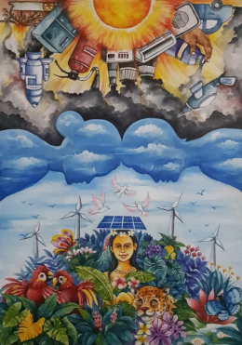 | LINK | SAVING THE OZONE LAYER MEANS SAVING LIFE ON EARTH | I. P. Asanka Somajeewa
 | 2nd | Thailand | 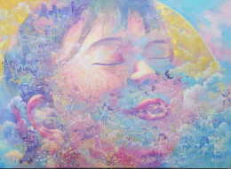 | LINK | We all are one | Wigavee Rattamanee
 | 2nd | Cambodia | 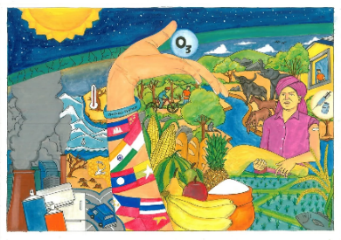 | LINK | Ozone for Environment | Mr. Lean Sokleap
 | 3rd | Viet Nam | 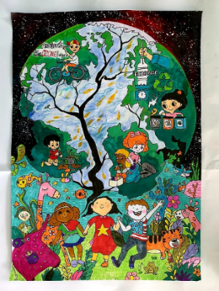 | LINK | Children share hands to keep the continuingly cool planet! | Thảo Nguyễn
 | 3rd | Malaysia | 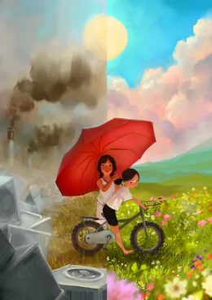 | LINK | Depleting of The Ozone Layer | Hannah Low Tain Yan
 | 3rd | Mongolia | 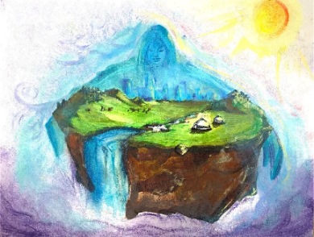 | LINK | Altansukh Badrakh | Altansukh Badrakh

 |  |  | ADULT GRAPHIC DESIGN
 | 1st | Indonesia | 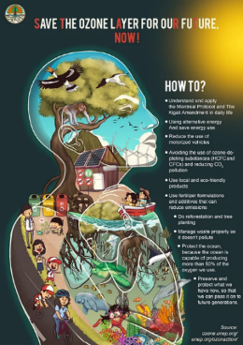 | LINK | START NOW! | Aprizal Yogi Syaputra
 | 2nd | Myanmar | 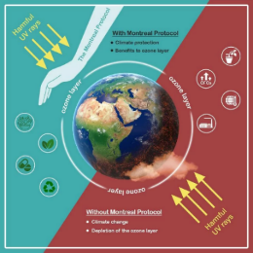 | LINK | The importance of Montreal Protocol | Mr Ye Htet Lwin
 | 2nd | China | 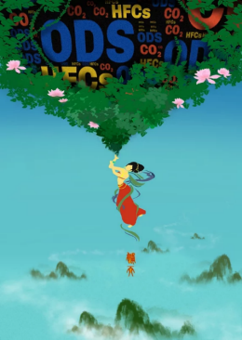 | LINK | Patching-up the Sky | Youyou LI
 | 3rd | Thailand | 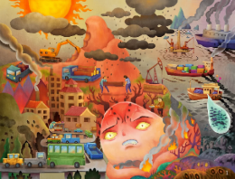 | LINK | Reunite with the Nature | Sutat Palama
 | 3rd | Viet Nam | 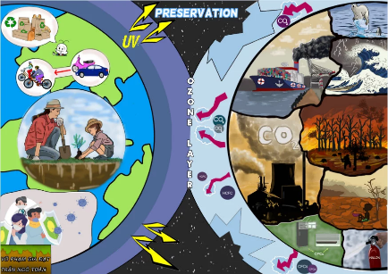 | LINK | Stop destroying and start protecting | Lý Tự Trọng- Bình Định
 | 3rd | Philippines | 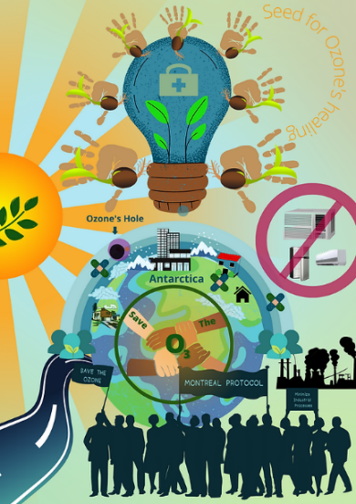 | LINK | Seed Of Hope: Together We Can Make A Difference | Khaytel Cabanlong

 |  |  | ADULT PHOTOGRAPHY
 | 1st | Malaysia | 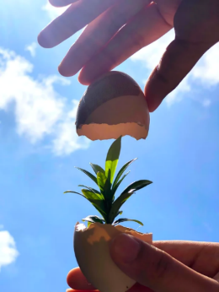 | LINK | Welcome, 2050 | Hooi Ka Yi  Shekinah Zoe Ng
 | 2nd | Republic of Korea | 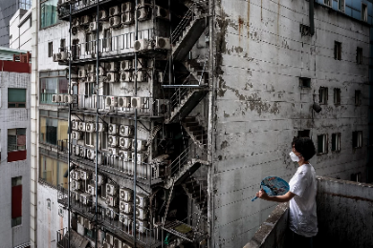 | LINK | a vicious circle | Yoonjun Park
 | 2nd | Cook Islands | 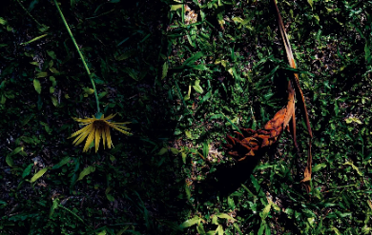 | LINK | Before and After | Vaevae Nanai
 | 3rd | China | 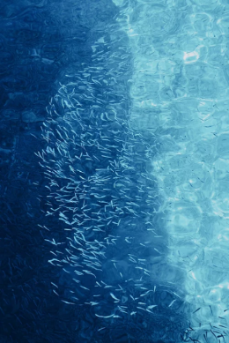 | LINK | Serendipity of Nature | Yuyang ZENG
 | 3rd | Indonesia | 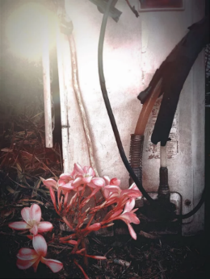 | LINK | Coexist with Earth's Extinction | Rezky Heryudhanto
 | 3rd | Thailand | 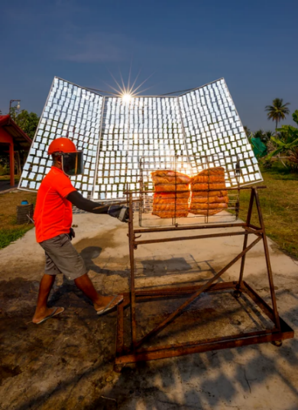 | LINK | Sun-dried (preserving) food without harming the ozone layer and climate | Sukrit Hirunsaraphong
 |  |  | YOUTH DRAWING
 | 1st | Philippines | 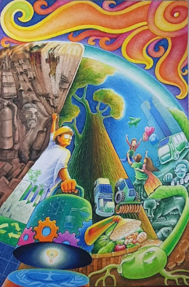 | LINK | Let there be shield on earth | Adrianne Nicole Sitjar
 | 2nd | Malaysia | 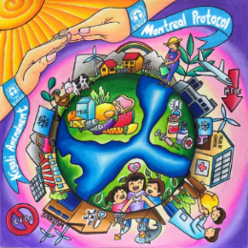 | LINK | The Ozone Rescuers | Ooi Zi En
 | 2nd | Indonesia | 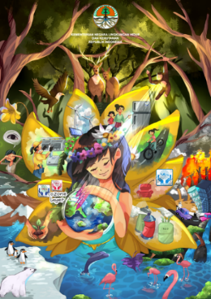 | LINK | Protect Ozone As Your Mother Protects You | Aisha Baby Joanna
 | 3rd | India | 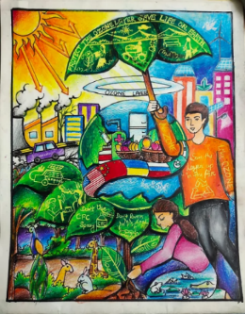 | LINK | Earth without Ozone is like a Tree without Leaves | Somesh Satapathy
 | 3rd | Sri Lanka | 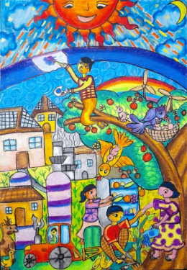 | LINK | Let's heal the ozone layer | Theertha Weeraratne
 | 3rd | Maldives | 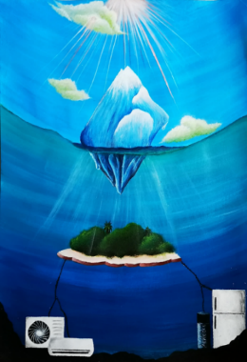 | LINK | OUT OF TIME | Nooraan Binthi Mohamed
 |  |  | YOUTH GRAPHIC DESIGN
 | 1st | Philippines | 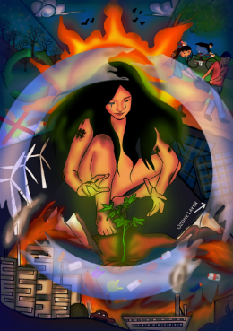 | LINK | A Seed of Hope | Shaina Akmad
 | 2nd | India | 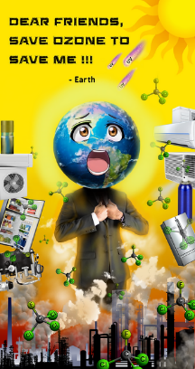 | LINK | Save Ozone to Save Earth | Baibhaba Moharana
 | 2nd | Thailand | 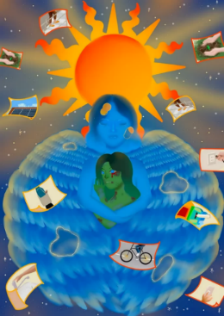 | LINK | Gaia�s Pain | Sirikron Longsuwan
 | 3rd | China | 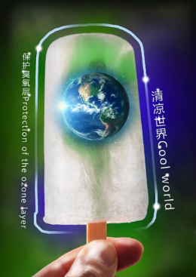 | LINK | The Earth Wrapped in Popsicle | Fanna MENG
 | 3rd | Iran | 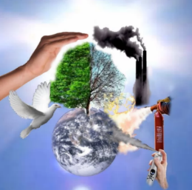 | LINK | Ozone is for us | Amirhosein Babazadeh
 | 3rd | Viet Nam | 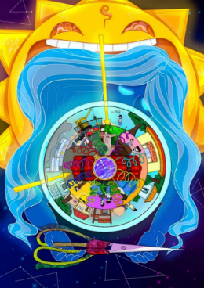 | LINK | Protecting Ozone Mother | Ngô Huỳnh Bảo Ngọc
 |  |  | YOUTH PHOTOGRAPHY
 | 1st | Malaysia | 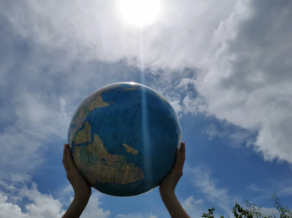 | LINK | Ozone Layer And Climate Protection | Chan Chenmy
 | 2nd | Bangladesh | 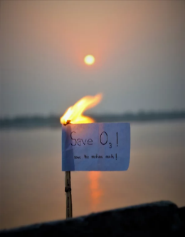 | LINK | Save O3, save the Earth. | Enayet Abir Ismail
 | 2nd | Thailand | 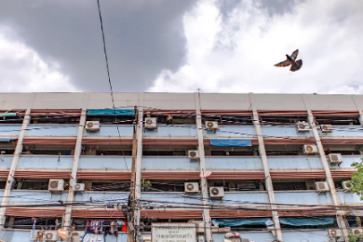 | LINK | Pollution | Kwankhaow Charoenchainoppakul
 | 3rd | Solomon Islands | 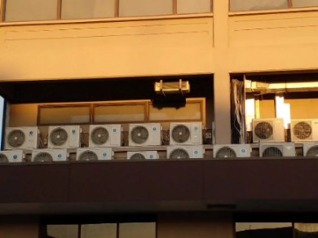 | LINK | Air Conditions | Scurllet Pentani
 | 3rd | Pakistan | 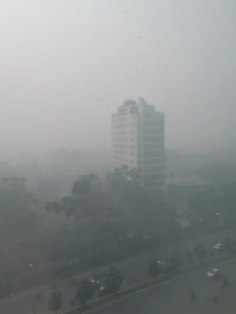 | LINK | I can't see anything | Qamar Abbas
 | 3rd | Iran | 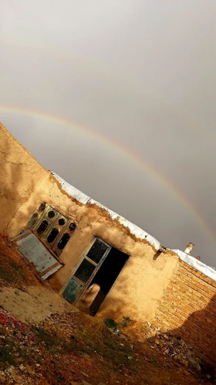 | LINK | Save the ozone layer | Fatemeh Azari far

