Asia Environmental Enforcement Awards - 2021
Theme: Fighting Transboundary Environmental Crime

Information Note

Deadline for applications is 30 June 2021

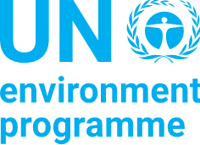

In partnership with:
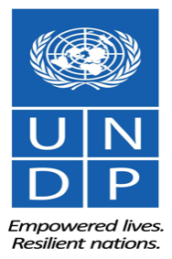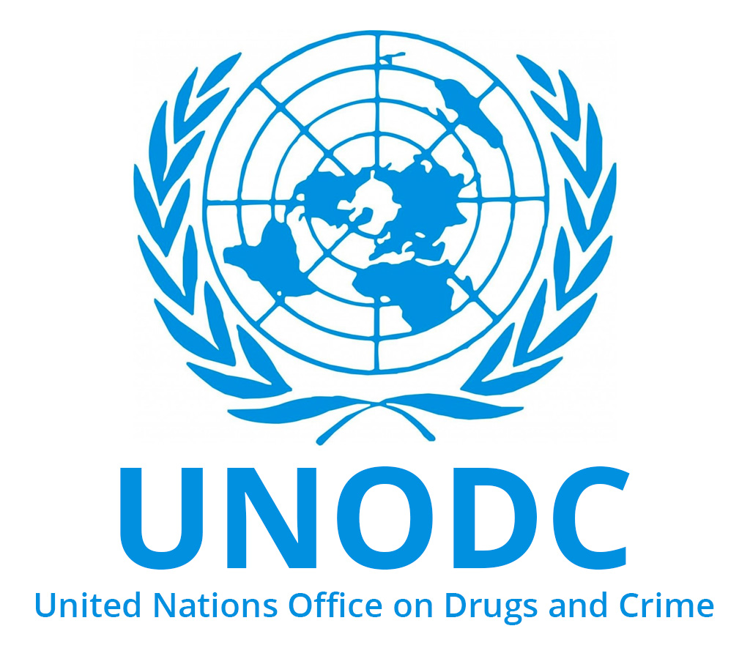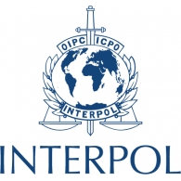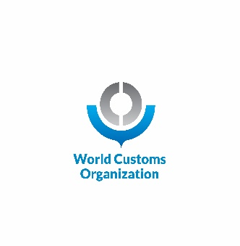

Contents
About the Asia Environmental Enforcement Awards 2
2021 Awards theme: fighting transboundary environmental crime 2
Eligibility for nomination 2
Criteria for selection 3
Time period for activities 4
Selection process 4
How to nominate 4
Award Ceremony 4
Nomination Form – Asia Environmental Enforcement Awards 2021 5

About the Asia Environmental Enforcement Awards
The Asia Environmental Enforcement Awards (hereafter the ‘Awards’) publicly recognize and celebrate excellence in enforcement by government officials and institutions or teams combating transboundary environmental crime. The Awards are given to individuals and/or government organizations/teams that demonstrate excellence and outstanding leadership in enforcement of national laws to combat transboundary environmental crime. The thematic scope of the Awards covers any transboundary environmental crimes, such as illegal trade in wildlife, illegal trade in chemicals or waste, including plastic.

This is the sixth time the Awards will be given, and this year’s Awards will be given to recipients who demonstrate excellence and leadership in one or more of the following categories: collaboration; impact; innovation; integrity; and gender leadership. There will be also a separate category for Africa-Asia cooperation in the area of illegal trade in wildlife. The 2021 Awards will be given by the United Nations Environment Programme (UNEP) in partnership with the United Nations Development Programme (UNDP), the United Nations Office on Drugs and Crime (UNODC), the Secretariat of the Convention on International Trade in Endangered Species of Wild Fauna and Flora (CITES), the International Criminal Police Organization (INTERPOL), and the World Customs Organization (WCO).

The category for Africa-Asia cooperation in the area of illegal trade in wildlife is sponsored by UNDP.

2021 Awards theme: fighting transboundary environmental crime
Transboundary environmental crime presents a serious threat in the region. Illegal trade in wildlife undermines conservation efforts, harms economies, devastates livelihoods, and compromises ecosystems on which humans depend. It also takes place on the routes between Africa and Asia at significant scale. The Asia region is as well one of the main destinations for illegally traded chemicals and waste. Particulaly, there are concerns over the significant increase of trade in plastic waste in recent years. Millions of tonnes of hazardous waste, plastic waste and harmful chemicals are transported to and within Asia, having disastrous effects for human health and the environment. Governmental authorities working on environmental enforcement issues are on the front-line of efforts to combat transboundary environmental crime. The 2021 Awards will recognize and celebrate their critical role in doing so.

Eligibility for nomination

Are you a government official or team fighting against environmental crime? Do you work closely with government officials/teams from another country? Let us know about your work and let us learn from your success!

Any government official and/or government institution or team working on fighting transboundary environmental crime in Asia or on fostering Africa-Asia cooperation in the area of illegal trade in wildlife for that category, is eligible to be nominated. Relevant agencies and individuals may include, for example: customs, police, wildlife and forestry authorities, environmental agencies, multi-agency taskforces, specialized agencies, judges and/or public prosecutors. Teams within government institutions (e.g. units, branches, divisions etc.) are also eligible. Recipients may be awarded in their individual capacity or as representatives of institutions/teams. Self-nomination is permitted.

Individuals or entities that are not formally affiliated with a Government institution – e.g. non-governmental organizations, volunteering associations, private sector companies, international organizations, etc. - are NOT eligible.

The Awards, for the categories of collaboration, impact, innovation, integrity and gender leadership, are limited to nominees from Asian countries geographically served by the UNEP Regional Office. These are: Afghanistan, Bangladesh, Bhutan, Brunei Darussalam, Cambodia, China, Democratic People's Republic of Korea, India, Indonesia, Iran (Islamic Republic of), Japan, Lao People's Democratic Republic, Malaysia, Maldives, Mongolia, Myanmar, Nepal, Pakistan, Philippines, Republic of Korea, Singapore, Sri Lanka, Thailand, Timor-Leste and Viet Nam.

For the category of Africa-Asia cooperation in the fight against illegal wildlife trade, the applicant needs to nominate an individual and/or department in each Country (both in Africa and in Asia) where successful cooperation occurred. Applications that identify nominee in one country only will not be taken into consideration.

Criteria for selection
The criteria outlined below will be used in selecting Award recipients. It is not necessary to meet all criteria. Excellence and leadership in one or more criteria will be considered by the Selection Panel. Awards may be given for specific criteria categories (e.g. Innovation Award) depending on nominations received and, in the judgement, and decision of the Selection Panel.

Categories | Explanation | Indicative examples
- Collaboration | Investigations and/or enforcement activities that have succeeded through cooperation with counterparts from other countries either in the preparation, execution or follow-up phase.  Applicants need to identify nominees in two countries at least | - Handover of relevant information leading to a successful operation in another country.  - A successful controlled delivery across countries.
- Impact | Law enforcement operations that have resulted in successful disruption of criminal networks beyond the mere confiscation of contraband. | - Arrest of high-level traffickers through financial investigations.  - Operations that results in prosecution/conviction of high-level trafficker.
- Innovation | Law enforcement interventions that demonstrate technological, intelligence-led, science-based approaches resulting in successful arrests, prosecutions and convictions. | - Identification of traffickers through forensics analysis (e.g. phones, DNA, etc.).  - Seizures through effective profiling based on risk indicators.
- Integrity | Law enforcement actions that have identified and acted upon cases of collusion of public officials or that have resisted pressure from other bodies of the governments. | - An investigation resulting in the arrest of public officials facilitating the smuggling of contraband.  - The arrest of senior public officials or other influential figures.  - A situation where public officials have resisted bribes or other corrupt attempts and investigations for bribery have been launched.
- Gender leadership and Women’s Empowerment | Leadership in advancing gender equality through concrete actions in combating transboundary environmental crime.  Women’s leadership in directing collaborative and successful operations against transboundary environmental crime | - An enforcement agency establishes a network of female enforcement officers to advance gender equality.  - Positive actions are taken to ensure women are promoted to leadership positions.  - A complex operation coordinated and led by one or more women
- Africa-Asia cooperation in the fight against illegal trade in wildlife | Joint investigations and/or enforcement activities facilitated by collaborative action between counterparts from Asia and Africa resulting in successfully addressing transnational wildlife crime.  Applicants need to identify nominees in two countries at least (one in Africa and on in Asia) | - A successful exchange of information or intelligence that leads to the arrest of key individuals involved in a smuggling operation across continents  - A coordinated enforcement operation in Asia and in Africa leading to the disruption of a transnational syndicate  - A controlled delivery between the 2 continents  - A successful exchange of evidence through mutual legal assistance

Time period for activities
The eligible period concerning activities justifying the nomination must have taken place within the period June 2020 – May 2021.

Selection process
Nominations will be reviewed, and recipients will be selected by a Selection Panel comprised of representatives from each of the participating organizations outlined above. A first-stage screening process will be conducted in-house by UNEP to review against eligibility criteria. UNEP will then forward all eligible nominations to the Selection Panel to review nominations and recommend the winners based on the eligibility criteria. Shortlisted nominations will be subjected to a thorough due diligence process to confirm eligibility for the award including background checks and, as necessary, consultations with their affiliated entities and other relevant agencies. There is no minimum or maximum number of Awards that will be given. Only worthy recipients will be given awards, as determined by the Selection Panel and based on the criteria for selection.

How to nominate
Nominations must be made online, using the nomination form which is available at this link. The deadline is on 30 June 2021 at midnight (Bangkok time or GMT+7).

Award Ceremony
Recipients of the Award will be informed in September 2021. They will be invited to an award ceremony to be held in late 2021. The awards ceremony may be held virtually at the discretion of the partner agencies. Relevant updates regarding the Awards will be posted on UNEP’s Asia and the Pacific office website: https://www.unenvironment.org/regions/asia-and-pacific.

Nomination Form – Asia Environmental Enforcement Awards 2021
Mandatory questions:
- Is the nominee a government official or team working to combat environmental crime through their official duties and functions? Yes/ No
- Is the nominee based in one of the Asian countries geographically served by the UNEP’s Regional Office for Asia-Pacific? Yes/No (This question is not applicable to nominees for the category on Africa-Asia cooperation in the fight against illegal trade in wildlife)
- For the category on Africa-Asia cooperation in the fight against illegal trade in wildlife, does the nomination identify nominees from at least one country in Africa and another in Asia? Yes/No
- Does the nominated activity fall within the eligibility period of June 2020 – May 2021? Yes/No

1. | Nominee and contact details as follows:  Name  Affiliation  Position  Email address  Telephone:  - Office  - Mobile | [Enter full title of government institution or team you are nominating. If the nominee is an individual only, then enter full name of nominee. Self-nomination is possible. Please provide contact details so we can contact nominee if they are selected for an Award].
2. | Reason for nomination | [Please provide a short description of why the nominee deserves an Award]. (Maximum of 500 words)
3. | Assessment against the selection criteria | [Please provide a justification for the nomination. Whenever possible provide evidence (including links to news article, etc.) to corroborate your nomination. You can provide justification for one category or for more categories. However, the same example (a case, arrest, prosecution, seizure, etc.) cannot be provided for different categories. (Maximum of 250 words for each category – excluding links)
a. | Collaboration  Investigations and/or enforcement activities that have succeeded through cooperation with counterparts from other countries either in the preparation, execution or follow-up phase | Yes ☐ No ☐ | [Description] (Maximum of 250 words)
b. | Impact  Law enforcement operations that have resulted in successful disruption of criminal networks beyond the mere confiscation of contraband | Yes ☐ No ☐ | [Description] (Maximum of 250 words)
c. | Innovation  Law enforcement interventions that demonstrate technological, intelligence-led, science-based approaches resulting in successful arrests, prosecutions and convictions | Yes ☐ No ☐ | [Description] (Maximum of 250 words)
d. | Integrity  Law enforcement actions that have identified and acted upon cases of collusion of public officials or that have resisted pressure from other bodies of the governments | Yes ☐ No ☐ | [Description] (Maximum of 250 words)
e. | Gender leadership  Leadership in advancing gender equality through concrete actions in combating transboundary environmental crime | Yes ☐ No ☐ | [Description] (Maximum of 250 words)
f. | Africa-Asia Cooperation (Wildlife trafficking)  Joint investigations and/or enforcement activities facilitated by collaborative action between counterparts from Asia and Africa resulting in successfully addressing transnational wildlife crime. | Yes ☐ No ☐ | [Description] (Maximum of 250 words)
4. | Please attach any relevant documentation to support this nomination (e.g. media reports, photos etc.) | [Please attach relevant documentation]
5. | Please provide your name and contact details

