Asia Environmental Enforcement Awards - 2018
Theme: Fighting Transboundary Environmental Crime

Nomination Form and Information Note

Deadline for applications is 15 July 2018

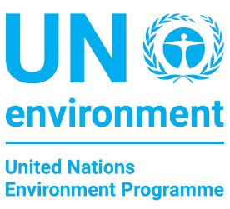

In partnership with:
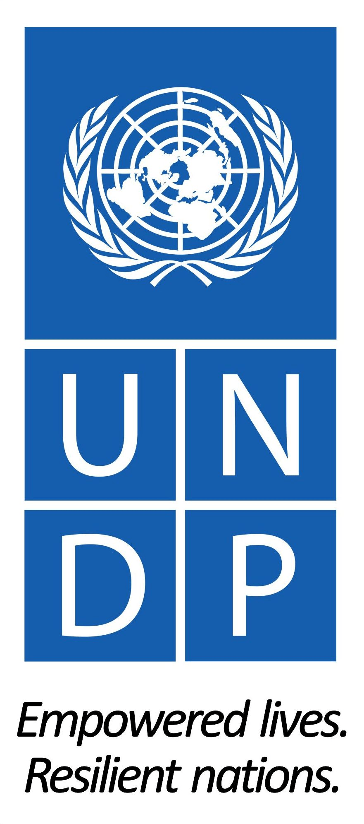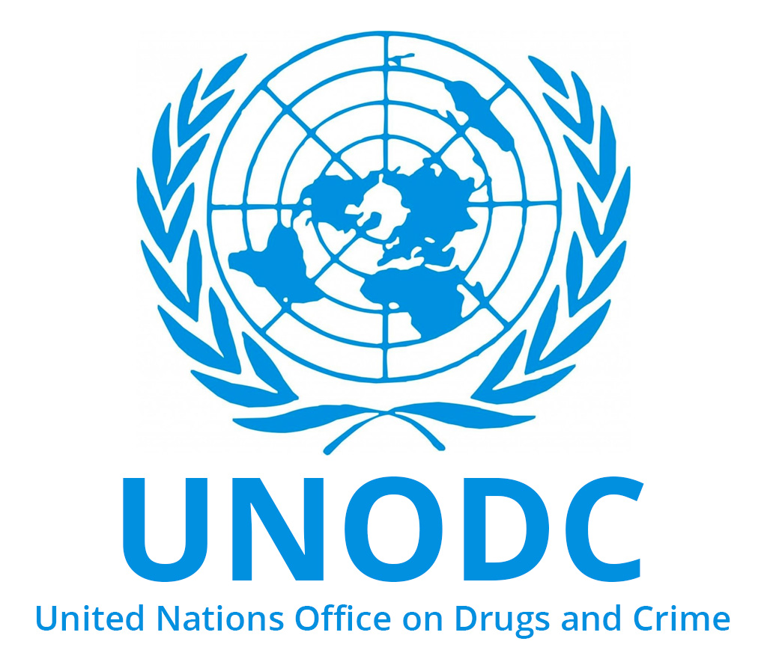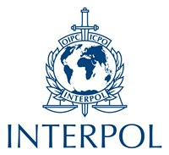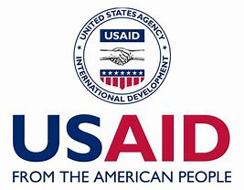

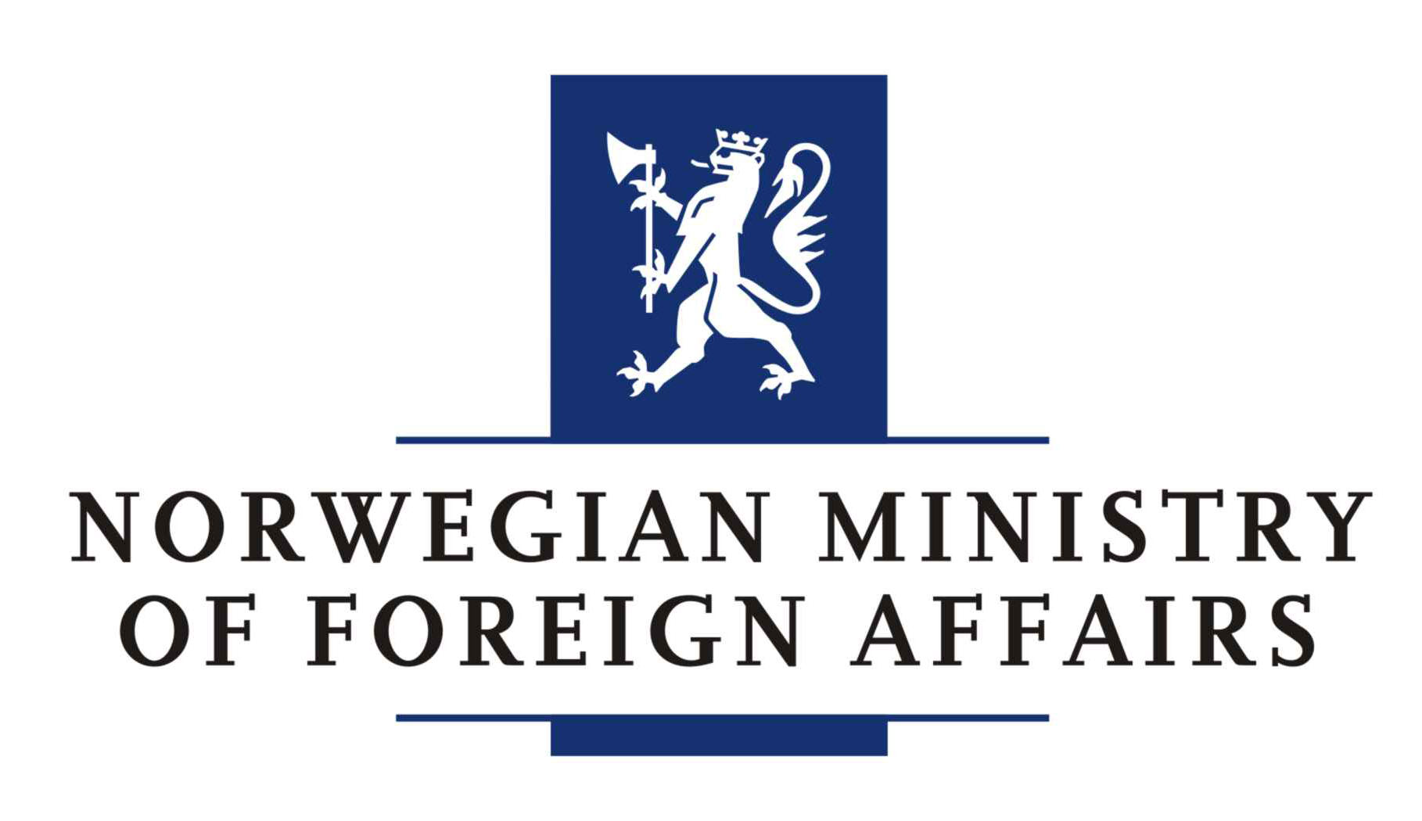

Contents
About the Asia Environmental Enforcement Awards 2
2018 Awards theme: fighting transboundary environmental crime 2
Eligibility for nomination 2
Criteria for selection 3
Time period for activities 3
Selection process 3
How to nominate 4
Award Ceremony 4
Nomination Form – Asia Environmental Enforcement Awards 2018 5

About the Asia Environmental Enforcement Awards
The Asia Environmental Enforcement Awards (hereafter the ‘Awards’) publicly recognize and celebrate excellence in enforcement by government officials and institutions/teams combating transboundary environmental crime in Asia. The Awards are given to outstanding individuals and/or government organizations/teams that demonstrate excellence and leadership in enforcement of national laws to combat transboundary environmental crime. The thematic scope of the Awards covers any transboundary environmental crimes, including illegal trade in wildlife, and illegal trade in chemicals or waste.

This is the third time the Awards will be given, and this year’s Awards will be given to recipients who demonstrate excellence and leadership in one or more of the following four eligibility criteria areas: collaboration; impact; innovation; and integrity. For the first time, there will also be a separate award available for gender leadership. The 2018 Awards will be given by UN Environment in partnership with the United Nations Development Programme, the United Nations Office on Drugs and Crime, INTERPOL, USAID, Freeland Foundation, and the Government of Sweden.

Financing for the Awards is being supported by different partners, including generous support from the Government of Norway.

2018 Awards theme: fighting transboundary environmental crime
Transboundary environmental crime is a serious and growing problem in the region. Illegal trade in wildlife is the fourth largest illegal trade globally (after drugs, counterfeiting and human trafficking). It undermines food security, harms economies, devastates livlihoods, fuels terrorism, and compromises ecosystems on which humans depend. Asia also remains one of the world’s largest dumping grounds for illegally traded chemicals and waste. Millions of tonnes of hazardous waste and harmful chemicals are transported to and within Asia, having disastrous effects for human health and the environment. Public officicals and institutions/teams working on environmental enforcement issues are on the front-line of efforts to combat transboundary environmental crime. The 2018 Awards will recognize and celebrate their critical role in doing so.

Eligibility for nomination
Any government official and/or government institution or team working on fighting transboundary environmental crime in Asia is eligible to be nominated. Relevant agencies and individuals working in them may include, for example: customs, police, environmental agencies, environment ministries, justice ministries, multi-agency taskforces, specialized agencies, and/or public prosecutors. Teams within government institutions (e.g. units, branches, divisions etc.) are also eligible. Recipients may be awarded in their individual capacity or as representatives of institutions/teams. NGOs and private sector individuals or institutions are not eligible. Self-nomination is permitted.

The Awards are limited to nominees from Asian countries geographically served by the Regional Office of UN Environment. These are: Afghanistan, Bangladesh, Bhutan, Brunei Darussalam, Cambodia, China, Democratic People's Republic of Korea, India, Indonesia, Iran (Islamic Republic of), Lao People's Democratic Republic, Malaysia, Maldives, Mongolia, Myanmar, Nepal, Pakistan, Philippines, Republic of Korea, Singapore, Sri Lanka, Thailand, Timor-Leste and Viet Nam.

Criteria for selection
The criteria outlined below will be used in selecting Award recipients. It is not necessary to meet all criteria. Excellence and leadership in one or more criteria will be considered by the Selection Panel. Awards may be given for specific criteria categories (e.g. Innovation Award) depending on nominations received and in the judgement and decision of the Selection Panel.

Criteria | Explanation | Indicative examples
- Collaboration | Investigations and/or enforcement activities that have succeeded through cooperation with counterparts from other countries either in the preparation, execution or follow-up phase | - Handover of relevant information leading to a successful operation in another country  - A successful controlled delivery across countries
- Impact | Law enforcement operations that have resulted in successful disruption of criminal networks beyond the mere confiscation of contraband | - Arrest of high-level traffickers through financial investigations  - Operations that results in prosecution/conviction of high-level trafficker
- Innovation | Law enforcement interventions that demonstrate technological, intelligence-led, science-based approaches resulting in successful arrests, prosecutions and convictions | - Identification of traffickers through forensics analysis (e.g. phones, DNA, etc.)  - Seizures through effective profiling based on risk indicators
- Integrity | Law enforcement actions that have identified and acted upon cases of collusion of public officials or that have resisted pressure from other bodies of the governments | - An investigation resulting in the arrest of public officials facilitating the smuggling of contraband  - The arrest of senior public officials or other influential figures
- Gender leadership (separate category) | Leadership in advancing gender equality through concrete actions in combating transboundary environmental crime | - An enforcement agency establishes a network of female enforcement officers to advance gender equality  - Positive discrimination actions are taken to ensure women are promoted to leadership positions

Time period for activities
The eligible period concerning activities justifying the nomination must have taken place within the period January 2017 - June 2018.

Selection process
Nominations will be reviewed and recipients will be selected by a Selection Panel comprised of representatives from each of the participating organizations outlined above, and invited experts. A first-stage screening process will be conducted in-house by UN Environment to review against eligibility criteria. UN Environment will then forward all eligible nominations to the Selection Panel to review nominations and recommend the winners based on the eligibility criteria. There is no minimum or maximum number of Awards that will be given. Only worthy recipients will be given awards, as determined by the Selection Panel and based on the criteria for selection.

How to nominate
Nominations must use the nomination form that is contained in the Annex to this information note. The deadline is midnight (Bangkok time) 15 July 2018.

Completed nomination forms should be e-mailed to Ms. Emeline Pluchon, Environmental Law Specialist, UN Environment at emeline.pluchon@un.org.

Nominations may also be sent by post if needed. The postal address is:

Ms. Emeline Pluchon
UN Environment, UN Building,
Rajadamnern Nok Avenue, Bangkok 10200,
Thailand

Award Ceremony

Recipients of the Award will be informed by the end of September 2018. They will be invited to an award ceremony to be held in a capital city in Asia in late 2018. Travel and participation costs will be paid by UN Environment. Relevant updates regarding the Awards will be posted on UN Environment’s Asia and the Pacific office website: https://www.unenvironment.org/regions/asia-and-pacific.

Nomination Form – Asia Environmental Enforcement Awards 2018

1. | Nominee and contact details | [Enter full title of government institution or team you are nominating. If the nominee is an individual only, then enter full name of nominee. Self-nomination is possible. Please provide contact details so we can contact nominee if they are selected for an Award].
2. | Reason for nomination | [Please provide a short description of why the nominee deserves an Award].
3. | Assessment against the selection criteria | [Please identify any/all selection criteria that are relevant (choose as many as you like, and at least one) and provide a short description].
a. | Collaboration  Investigations and/or enforcement activities that have succeeded through cooperation with counterparts from other countries either in the preparation, execution or follow-up phase | Yes ☐ No ☐ | [Description]
b. | Impact  Law enforcement operations that have resulted in successful disruption of criminal networks beyond the mere confiscation of contraband | Yes ☐ No ☐ | [Description]
c. | Innovation  Law enforcement interventions that demonstrate technological, intelligence-led, science-based approaches resulting in successful arrests, prosecutions and convictions | Yes ☐ No ☐ | [Description]
d. | Integrity  Law enforcement actions that have identified and acted upon cases of collusion of public officials or that have resisted pressure from other bodies of the governments | Yes ☐ No ☐ | [Description]
e. | Gender leadership  Leadership in advancing gender equality through concrete actions in combating transboundary environmental crime | Yes ☐ No ☐ | [Description]
4. | Please attach any relevant documentation to support this nomination (e.g. media reports, photos etc.) | [Please attach relevant documentation]
5. | Please provide your name and contact details

