Lead authors: Pierre Boileau, Edoardo Zandri, Andrea Hinwood and Jason Jabbour.
DRAFT TECHNICAL ASSESSEMENT BY THE SECRETARIAT
REVISED DRAFT RESOLUTION ENTITLED
The Future of the Global Environment Outlook
Tabled by the UNEP Secretariat, as requested by the CPR meeting of December 14th 2021 for Member States’ consideration.
This draft technical note has been prepared by the UNEP Secretariat to facilitate consultations among Member States within the Committee of Permanent Representatives (CPR) on submitted draft resolutions for the resumed session of UNEA-5, as requested in paragraph 31 of the Chair´s Summary of the 8th meeting of the annual subcommittee of the CPR, held 25 - 29 October 2021.
This draft resolution stems from the comprehensive work conducted over the preceding two years by the Inter-governmental Steering Committee on the ‘Future of GEO’ (henceforth referred to as ‘the Committee’) established by UNEA-4 and composed of representatives from 36 Member States, representing all UNEP Regions.
The Committee produced an interim report, submitted to UNEA 5.1, and has now produced a final report on options for the future of GEO, which are supported by a background document, a feasibility study (see list below) and the analysis of two broad consultations conducted with Member States, Stakeholders and Assessment Experts, to validate the results of the Committee’s work. The Committee also provided regular updates on progress of the Future of GEO work to the CPR.
This draft resolution was developed in November 2021 by a ‘Friends of the Chair’ group, formed within the Intergovernmental Steering Committee on the Future of GEO, in consultation with the full Committee. The draft resolution reflects in full the outcome of the work conducted and the associated extensive consultation processes. It has not been signed off by the Committee as such, but was drafted through open informal consultations within the Committee, with the intention to offer a basis for an interested potential ‘sponsor’ of the GEO resolution, at the upcoming resumed session of UNEA 5.2.
The UNEP sub-committee meeting of December 14th, 2021 requested the Secretariat to table the draft text of the resolution as prepared by the Committee, to offer a basis for discussion by Member States prior to the resumed session of UNEA 5.2.
Three additional supporting documents were also submitted by the Committee for consideration by UNEA 5.2, underpinning the draft resolution. These include:
- Working Document: “Options Paper on the Future of GEO” – a 15-page document, available in all six UN Languages, summarizing the outcome of the Steering Committee’s work, laying out the core principles underlying the Future of GEO process, considering the pros and cons of each proposed governance and operational option in detail, thus providing the essential information underpinning this draft resolution Link: <link to be inserted when document will be uploaded in the portal>

- Information Document n. 26: “Feasibility Study on the Future for GEO” - an extensive Background Annex containing a detailed analysis and cost of each option. Link: https://wedocs.unep.org/bitstream/handle/20.500.11822/37692/UNEP.EA5.INF.26.pdf?sequence=1&isAllowed=y

- Information Document n. 27: “Results of the consultations with Members States, stakeholders and experts” – providing additional background data and information feedback from the consultation process. Link: https://wedocs.unep.org/bitstream/handle/20.500.11822/37692/UNEP.EA5.INF.26.pdf?sequence=1&isAllowed=y
The work of the Committee and the results of the initial survey clearly confirmed the demand for a seventh edition of the Global Environmental Outlook (GEO-7) process to begin. The draft resolution seeks to chart the way forward for UNEP to undertake the next cycle of the GEO as an inter-governmental and expert-led assessment process, with important new features being proposed for consideration by UNEA including i.e. regional-global coverage, options for thematic and/or synthesis reports, digitalization and live data streams, capacity development, knowledge generation, policy support to Member States, outreach and awareness raising, etc.
Figure 1 below is extracted from the Working Document (#1 listed above) and provides a schematic summary of governance, assessment and financing alternatives, options and suggestions for the future of GEO as an intergovernmental and expert-led assessment process under the purview of UNEA, situated in UNEP’s science policy interface. Design details and initial cost estimates (as undertaken by the Committee) for each option, are also provided in the Working Document underpinning this draft resolution (ref. document #1 above).
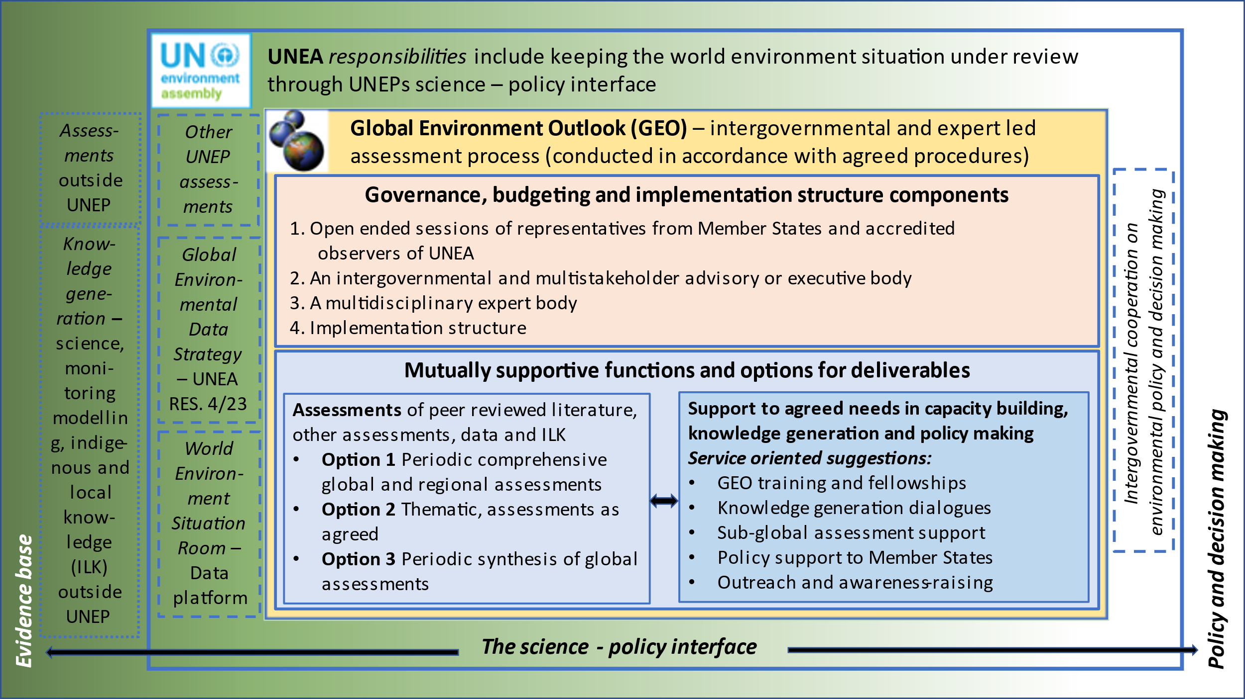
Key Considerations
- The resolution is detailed and comprehensive. The committee deliberately crafted the Working Document (doc #1 above) to include several options for UNEA’s consideration. This approach was intended to not pre-empt the discussion to be held at UNEA among all Member States. This same approach is reflected in the draft resolution on GEO.

- Considering that the nature of the resumed session of UNEA 5.2 may offer limited time for discussion or negotiations on any individual resolution, perhaps a simplified version of the same resolution may be considered by UNEA, providing the necessary basis for the start of the next GEO cycle in a timely fashion, and delegating further decision on the options to a GEO governing body (to be established).

- Link to UNEPs Medium Term Strategy and Programme of Work: This draft resolution is designed to reaffirm the purpose of GEO, establish a well-defined governance structure, develop procedures for deciding on which type of assessment(s) to prioritize at which time and how to conduct them, create rolling work plans and time-bound budgets and provide the necessary mandate for UNEP to undertake the next Global Environmental Outlook (GEO) process. The GEO fulfills several integral parts of UNEP’s core founding mandate (General Assembly resolution 2997 (XXVII)) and is a key component of the MTS’s Foundational Programme on Science-Policy (available here). It is UNEP’s single flagship intergovernmental and expert led assessment process underpinning the foundational science-policy mandate of the United Nations Environment Programme (UNEP) of ‘keeping under review the world environmental situation’, of ‘promoting the contribution of the relevant international scientific and other professional communities to the acquisition, assessment and exchange of environmental knowledge and information’; and on ‘providing policy guidance and recommendations’.

- Legal aspects: the draft resolution proposes options to establish a governance mechanism for the next cycle of the GEO (in Paragraphs 3 and 3alt). Each of these alternatives -all viable- may have different legal and cost implications for UNEP. This aspect of the resolution has been left in brackets for consideration at UNEA 5.2.

- Budget implications: the options for the future of GEO that are identified in the draft resolution are described and costed in detail in the feasibility study and the Working Document mentioned above (ref. documents # 1 and #2 linked above). As a result of the discussion at UNEA or thereafter, it is possible that a combination of one or more options for the future of GEO may eventually be selected by Member States. The budget implications for UNEP may therefore vary significantly, depending on the chosen option(s), or combination of options, selected by Member States. According to the supporting documents underpinning this draft resolution, the Committee estimated an additional annual budget of 2.25M USD to 2.75M USD per year to be required for UNEP to adequately support the implementation of the next GEO cycle, for two to three years (depending on the option(s) and modalities chosen). This is over and above the core budget that UNEP has already confirmed, of around 1M USD per year.

iv) UNEP Contacts for further information on this resolution:
Jian Liu, Science Division Director – jian.liu@un.org
Kelly West, Science Division Deputy Director – kelly.west@un.org
Pierre Boileau, Head of the GEO team, Science Division – pierre.boileau@un.org
Edoardo Zandri, Chief of the BSB (Scientific Assessments) Branch, Science Division – edordo.zandri@un.org

“The Chair also suggested that the secretariat will support our upcoming consultations on the draft resolution by providing technical guidance in writing for each draft resolution, with a technical analysis on the following three aspects: i) Relation to UNEPs Medium Term Strategy and Programme of Work; ii) Legal aspects; and iii) Budget implications”
Interim Report: “Providing options for the future of the Global Environment Outlook” – a 15-page document available in all UN languages assessing the different possible options for the future of the Global Environment Outlook. Link: https://wedocs.unep.org/bitstream/handle/20.500.11822/34993/Doc24K2002774-2.pdf?sequence=1&isAllowed=y; and its associated Background Paper: “The Future of the Global Environment Outlook: Considerations for Positioning and Assessment Design” – a detailed analysis of the history and evolution of the Global Environment Outlook intended to support the deliberations of the Steering Committee. Link: https://wedocs.unep.org/bitstream/handle/20.500.11822/34954/INF18%20UNEP-%20UNEA5%20INF18.pdf?sequence=1&isAllowed=y

