UNITED  NATIONS |  | EP
 |  | UNEP/EA.5/INF/14
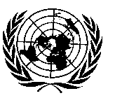 | United Nations  Environment Assembly of the  United Nations Environment Programme | Distr.: General  24 December 2020  English only
United Nations Environment Assembly of the
United Nations Environment Programme
Fifth session
Nairobi (online), 22–26 February 2021*
Item 5 of the provisional agenda**
International environmental policy and governance issues
Information on implementation of resolution 3/10 on addressing water pollution to protect and restore water-related ecosystems***
Note by the Executive Director
Introduction
- In its resolution 3/10 on addressing water pollution to protect and restore water-related ecosystems, the United Nations Environment Assembly of the United Nations Environment Programme (UNEP) requested the Executive Director of UNEP, within the scope of available resources, to cooperate with other relevant organizations, including through UN-Water, to develop a world water quality assessment for consideration by the Environment Assembly at its fifth session. The present report contains further and more detailed information to the update on progress in the implementation of the resolution, provided in the working document UNEP EA.3-20, in particular with regard to the workstreams of the water quality assessment and the World Water Quality Alliance. Executive summaries are provided where there are fully developed reports behind the body of which will be provided via hyperlink.
- In order to address the broad scope of the comprehensive water quality assessment as outlined in the UN-Water analytical brief entitled “Towards a Worldwide Assessment of Freshwater Quality”, and building on the findings of its initial assessment, A Snapshot of the World’s Water Quality: Towards a Global Assessment, UNEP engaged a wide community of practice, comprising UN-Water members and other experts from the science community, the private sector and civil society. The World Water Quality Alliance, which emerged from that process, has brought together expert consortia to deliver the world water quality assessment, and to address current and emerging issues inherent in the global water quality challenge across the Sustainable Development Goals, with considerable focus on the health nexus and the mobilization of resources to implement the mandate set out in resolution 3/10. The Information Document provides insight into the state of the Assessment, an additional detailed insight in the global situation of groundwater and its quality and it elaborates on issues of water and health including links to the Covid 19 Pandemic. Where authors and/or contributing partners are explicitly mentioned those can be found listed under the respective titles in an Annex document hyperlinked under Contributing Authors: UNEA-5 Reporting Documents. The development of the assessment and the work of the Alliance is embedded in subprogramme 7, Environment under review, of the UNEP programme of work.
The World Water Quality Alliance: Progress report on key components
A. The World Water Quality Assessment
1. Rationale
- Increasing pollution of freshwater as a result of rapid economic growth and urbanization in developing countries, and sustained, chronic pollution including long-term legacies in developed countries poses a growing risk to public health, food security, biodiversity and other ecosystem services. The goal of the World Water Quality Assessment is to review the state of freshwater quality and its potential impacts on ecosystems health, human health and food security, in conjunction with pressures and key drivers to overcome the global water crisis in a targeted way.
- The UN Environment Assembly Resolution from 2017, UNEP/EA.3/RES.10, ‘Addressing water pollution to protect and restore water-related ecosystems’ called for an assessment of global water quality. This current document provides a first global display of a water quality baseline as the pilot draft Assessment report to be delivered for UNEA-5 (2021/2022). It results from a networking activity mirroring the competences, interests and resources of the contributors, and does not claim completeness. This Assessment of global water quality will be continued to address the current challenges in terms of gaps in data and to arrive at a comprehensive baseline that can be updated in a more continuous way. It will further require more time to thoroughly address methodological issues facing a global water quality assessment. The innovative pathway chosen builds on experiences made in the Snapshot report and the resulting Analytical Brief setting out key requirements towards a global assessment. The lead principal investigators representing several WWQA working groups will continue to achieve best possible alignment of available in-situ, modelling and remote sensing data to provide a best possible global baseline and scenarios in early 2023 for presentation to UNEA 6 and to feed into the comprehensive mid-term review of the International Decade for Action on Water for Sustainable Development 2018-2028.
- This first global display of water quality gives a versatile picture of the baseline state of global water quality and its impacts on ecosystems health, human health and food security. The results can be used to identify water quality hotspots and help to identify some of the key drivers. The outcome of the Assessment already at this initial demonstration state can provide context in support of the evaluation of reaching the Sustainable Development Goal SDG 6 target 6.3 by focusing on the specific indicator on ambient water quality 6.3.2 and its interlinkages with other targets and goals.
- The key findings from the analysis presented include:
  - Chapter 2 ‘Methods’
    - The Assessment core of innovation, the triangulation approach, aiming to combine in-situ, modelling and remote sensing data can help to overcome the implicit limitations of each data source alone. So far, however, the implementation has been successful on case-by-case only;
    - The DPSIR (Drivers-Pressures-States-Impacts-Responses) causal chain conceptual framework connecting the drivers to pressures and responses opens new horizons of data collection from the three data sources in-situ monitoring, remote sensing and modelling.
  - Chapter 3.1 ‘Water quality impacts on ecosystems health’
    - In 2020, anthropogenic nutrient sources contribute more than 70% to river nutrient loading;
    - Most of the increase of river nutrient loading has been in Asia;
    - Harmful algae blooms are now spreading in many river basins;
    - Curbing global nutrient cycles requires paradigm shifts in food and waste systems;
    - Two large scale European assessments on ca. 2,000 chemicals report chronic effects of (a mixture of) chemicals on aquatic species to be expected at 42%-85% of the studied sites, while 14%-43% of the sites are likely to experience some degree of species loss;
    - Assessments as for Europe cannot be made on a global scale. Neither the measured data nor the information to generate predicted concentrations are available yet;
    - The Human Impact and Water Availability Indicator (HIWAI) can be used to extrapolate results obtained for Europe. This proxy was found to correlate well with the expected loss of aquatic species in European surface waters.
  - Chapter 3.2 ‘Water quality impacts on human health’
    - Modelling has been a prominent approach to derive estimates on human health impacts from contaminated water, the water quality state and the contamination sources;
    - First estimates of human health impacts originating from the pathogen Cryptosporidium (single cell parasite) shows hotspots in areas where surface water is still regularly used for drinking directly and for arsenic hotspots are located in Asia. For most other contaminants to –date still no impact studies are available at the large scale;
    - Concentration hotspots are, for most contaminants, densely populated areas, in particular where wastewater treatment is limited. For groundwater arsenic and surface water salinity concentrations, hotspot areas include India, China and Mongolia.
  - Chapter 3.3 ‘Water quality impacts on food security’
    - First estimates of water quality impacts on food security show hotspots in north eastern China, India, the Middle East, parts of South America, Africa, Mexico, United States and the Mediterranean;
    - Estimates of water quality impacts on food security reveal that over 200,000 km² of agricultural land in South Asia may be irrigated with saline water exceeding the FAO guideline of 450 mg/l and over 154,000 km² show a high probability of groundwater having arsenic concentrations that exceed the WHO guideline value of 10 µg/l, respectively;
    - Aquaculture and mariculture production are important to produce high-quality protein, but both can be at risk because of water pollution such as increased nutrient concentrations;
    - Wastewater reuse in irrigation is an option to overcome water shortages and to close the nutrient cycle, however, the food may become contaminated by pathogens (and faecal coliform bacteria), Antimicrobial Resistant (AMR) microorganisms and chemicals in wastewater that has not been sufficiently treated.
  - Chapter 4 ‘World Water Quality Alliance - Africa Use Cases’ (case studies contributing to the Assessment and stakeholder engagement)
    - Cape Town’s groundwater is vulnerable to water quality impacts from urban development in an area with various land-use activities, posing a risk to the planned potable water supply; hence aquifer protection zones were
co-designed;
    - Implications of water quality and its disturbance at Lake Victoria provide data to the Assessment and led to co-design of information products for the water food nexus with local fisheries stakeholders including a coastal eutrophication assessment, water temperature and stratification dynamics, and sediment chemistry;
    - Water quality related information product options for the Volta basin are initially being explored with local partners including tools to determine the percentage of population vulnerable to poor water quality, and a remote sensing-based groundwater quality assessment.
  - Chapter 5 ‘Digital water quality platforms’
    - A gap exists between the general availability of data, their level of coherent aggregation and synthesis which is required to provide useful information for different policy or management purposes. Appropriately designed platforms can help to overcome this gap;
    - The key to engage platform users is their involvement already early on in the development phases of the platform in a co-design process;
    - Multiple water quality platforms co-exist and target various water quality issues such as arsenic in groundwater or pathogens in African rivers. They should ideally reinforce each other by providing standardized data products to enable cross-platform sharing.
- Water quality hotspots frequently overlap for many of the pollutants under consideration (namely, when natural sources of contamination are far less important than anthropogenic pollution) and located in densely populated areas. For a fully comprehensive global view, however, this Assessment is still in a preliminary stage, facing considerable lack of input data, on state and on impacts for all relevant water types, especially on contaminants/pollutants. Also, for many contaminants relevant for human health, estimates of their current state are still unavailable at the large scale. Response options most often focus on reduction of sources. But their impact has not yet been widely assessed. Also, data that quantitatively link water quality impacts to food security is often lacking at the large spatial scale, leaving efforts towards quantification of impacts at this large dimension difficult.
- It is also evident that the emphasis of this Assessment, that is to encompass large- to
global-scale water quality studies still is on surface waters and data retrieved from modelling. The prospects of the Assessment triangulation approach, speaking to the joint use of data from on-ground (in-situ) monitoring, remote sensing and modelling have been shown exemplarily in Chapter 3 for each of the water quality impact themes. While this is opening promising perspectives to address data scarcity there are still technical, practical and conceptual challenges to be addressed concerning for example inconsistencies in spatial and temporal delineation and variables covered by each method.
2. Major challenges
- To assess water quality in the environment globally data is required with scientifically rigorous coverage across time and space and reflecting a meaningful share of all waterbodies under consideration. As in the past in this requirement still reside the most significant challenges the Assessment aims to address over time. Major data and knowledge gaps identified to-date include:
  - still an urgent need for regularly monitored up-to-date and readily available data to do a thorough evaluation;
  - the further development of methods for integrating different data sources (including
in-situ monitoring, water quality models and remote sensing) for a comprehensive water quality evaluation is required;
  - knowledge gaps on the importance of the environmental fate and transport pathways and which need to be closed, also to test model assumptions on these;
  - that reporting should encompass the state, impacts (also indirect impacts), main sources and response options for all contaminants causing environmental and health risks;
  - that the assessment of water quality impacts in quantitative terms remains difficulties in-situ data and modelling data are lacking (for example to capture the impacts of harmful algal blooms, HABs and hypoxia on fisheries, aquaculture and mariculture as well as pathogen contamination impacts on leafy crops and food safety or on diarrheal diseases);
  - a continued and urgent requirement for innovative regulatory solutions, which include awareness raising among policy makers and all societal actors worldwide;
  - an intrinsic need for better translation of response options to various target audiences by means of strong institutional collaboration across key water quality nexus dimensions and including the integration across water and health/food/ecosystem disciplines to implement effective measures.
- In the next Assessment phase, the baseline water quality state and impact will be further elaborated. What especially requires improving is better integration of all sources of information:
in-situ data, models and remote sensing, across the DPSIR framework. For this the Assessment team needs strengthening in particular concerning competences in the fields of in-situ monitoring and remote sensing but also regarding the water bodies less visible in this report, i.e. groundwater and estuaries. Concerning modelling, the versatile contribution so far lacks especially large-scale results for many pollutants but also the basis required for scenario runs needs attention, as modelling is the only means to perform scenario studies.
- Selected case studies will be carried on to develop in-country partnerships and collaboration, especially with water resource decision-makers in order to continue the co-design of water quality products and services using the WWQA triangle approach needed e.g. to address mitigation options. Here attention will be paid to groups at risk like women because of their frequent usage of water from rivers and lakes for cleaning clothes and collecting water for cooking and drinking in the household, and children because of their play activities in local surface waters and also because they often have the task of collecting water for the household.
- The WWQA triangle approach introduced in this report will trigger new thinking in the scientific community and provide eventually new results to be included in the Assessment. To provide resilient and future-proof response options to decision-makers, the basis must be established for conducting scenario analysis of future development pathways of water quality in the freshwater system in response to future climate change, socio-economic development and response options. For complex new products beyond a pure community effort, such as a comprehensive scenario assessment across all modelling teams, different linked impacts models, or multi-pollutant approaches, additional resources would be required.
- To read the full report on the Assessment please visit: World Water Quality Assessment and Alliance: Key Findings - Status Update - Outlook.
B. The Africa Use Cases
1. Introduction
- The WWQA African Use Cases (UC) comprise three study areas:
  - Cape Town Urban Aquifer Systems: Groundwater systems earmarked for water supply to Cape Town, South Africa;
  - Lake Victoria Basin: Transboundary lake basin shared between Burundi, Kenya, Rwanda, Tanzania, Uganda with a focus on the riparian countries;
  - Volta Basin: Transboundary river basin shared between Burkina Faso (43%), Ghana (42%), Togo (6%), Benin (3%), Mali (3%), Côte d’Ivoire (2%) – with a focus on Burkina Faso and Ghana.
- The Africa Use Case process comprised transdisciplinary engagement with in-country partners through a bottom-up approach aimed at using experience in global problems to support local solutions. This included a moderated in-country stakeholder-driven process to identify and address local needs, linking water quality hotspots to solutions and – at a later stage possibly - to investment priorities They build on a co-design, engagement-based process in-country or in the respective water system and developing products at scale for mid- to long-term operational use. Key to this process is also to explore availability and accessibility and subsequent integration of data from in-situ monitoring (including in future citizen science), remote sensing-based earth observation (RS/EO) and water quality modelling (the triangle approach outlined in the World Water Quality Assessment) to assess the current state of freshwater quality (baseline). This stake-holder dialogue will feed into the science technology platform project GlobeWQ that provides a central element to the global Assessment and which continues into 2022 and 2023 for a fully-fledged global product.
- Requests for stakeholders and/or data for the UC’s were sent to relevant working groups carrying out the global Assessment as case information. Using the contact details received, these stakeholders identified by the World Water Quality Alliance were then in turn also contacted requesting both data and any additional stakeholders (snowball mechanism), which continued as an iterative process. In addition, a thorough literature review of stakeholders and data was conducted. Through this process, available data (in-situ, modelled, RS/EO) for the UC’s was collected and shared with the expert teams in charge of the triangle approach in the World water Quality Assessment (EOMAP, Helmholtz Centre for Environmental Research, and Ruhr University Bochum). In addition, a database of stakeholders and their interest in collaboration was developed, shared with the Alliance community of practice, and enhanced throughout the project.
2. Cape Town urban groundwater
- The Cape Town Aquifer Use Case was built on the existing stakeholder network and structures that were established as part of the groundwater development projects by the City of Cape Town. These projects were initiated or fast-tracked during the recent drought and include the Atlantis Aquifer, Cape Flats Aquifer, and Table Mountain Group Aquifer. Regular committee meetings were held and utilised for the stakeholder engagement and the co-design of the proposed products and services. Due to the interest by the public and concerned organisations in the groundwater development by the city, a wide range of stakeholders are involved in these committees, representing the municipality, regulatory authorities, environmental action groups, non-governmental organisations (NGOs) and academia.
- A very comprehensive database of >30 000 water quality data points for the three aquifers has been established, including historical data (e.g., since 1970s for Atlantis), groundwater and surface water quality data from national and municipal programmes (e.g., landfills, cemeteries and water treatment works), and recent data collected during the groundwater development project execution.
- At the committee meetings earlier this year, the Department of Water and Sanitation (DWS) as regulatory authority suggested the development of a groundwater management plan for each aquifer. Based on the presented water quality data, Scientific Services (a department of the City of Cape Town) and the agricultural users of the Cape Flats Aquifer suggested that an aquifer protection plan is developed to address water quality concerns in the area.
3. Lake Victoria Basin
- In respect to the Lake Victoria UC, there was attendance at the Global Lakes of the World symposium on “Emerging frontiers for African Great Lakes: Promoting Blue Economy, food security and Conservation” in Kisumu, Kenya in August 2019; as well as the Great Lakes African Center for Aquatic Research and Education (AGL-ACARE) organised stakeholder workshop in November 2019 in Entebbe, Uganda titled “African Great Lakes Stakeholder Network Workshop: Strengthening Capacity in Research, Policy, and Management through Development of a Network of African Great Lakes Basin Stakeholders”. The objective of attendance at these events was to assess water quality challenges and associated impacts at Lake Victoria and its catchment; introduce the World Water Quality Alliance concept and its reflection in the Africa Use Cases with key Lake Victoria fisheries research institute Directors and Scientists, develop a stakeholder network, and assess data sources and types associated with Lake Victoria, and any limitations to the sharing of such data. This was enhanced with the past needs’ assessments undertaken by SERVIR-Eastern and Southern Africa (2016a and 2016b). The Africa Use Cases were also presented at the African Center for Aquatic Research and Education, AGL-ACARE, stakeholder workshop. Alliance members, Mr Andrew Gemmell (UNEP/Umvoto Africa) and Dr Tallent Dadi (Helmholtz Centre for Environmental Research) were nominated to the Lake Victoria Working Group (who’s activities continue to date).
- This was followed by on-line workshops (due to the Covid-19 pandemic). In July 2020 the Alliance members met with the Lake Victoria Fisheries Organisation (LVFO), after which formal Requests for Collaboration were to be sent. LVFO is a specialized institution of the East African Community (EAC) whose mandate is to coordinate the management and development of fisheries and aquaculture resources in the EAC region. The composition of the LVFO is made of the Fisheries and Aquaculture Management and Research Institutions, including the Kenya Marine & Fisheries Research Institute (KMFRI), National Fisheries Resource Research Institute (NaFIRRI), and Tanzania Fisheries Research Institute (TAFIRI).
- After the July 2020 workshop, with collaboration agreements formalised between the World Water Quality Alliance and LVFO, the LVFO reached out to country fisheries research institute Directors at KMFRI, TAFIRI and NaFIRRI to introduce the Africa Use Case initiative. The Directors of KMFRI, NaFIRRI and TAFIRI then nominated fisheries specialists within each of their Institutions to act as focal points. Workshops with these individuals were held in August and September 2020 with the aim to re-introduce the concept of the African Use Case as it relates to Lake Victoria and how the Alliance can assist; provide examples of what can be achieved through the alliance; discuss the priority Lake Victoria water quality concerns and hotspots; discuss research and information gaps; and to begin discussions on water quality data and information products and services to be co-developed to target hotspots.
- Through the discussions, various limitations to data sharing (both between Fisheries institutions, and between these Institutions and Alliance) were identified and these are summarised further below. Where water quality databases were available, this had limited spatial and/or temporal extent. As a result, there was a focus on modelled and RS/EO water quality data, validated by in-situ data (i.e., through the data triangular approach that is worked out for global application in the World water Quality Assessment) to derive a water quality baseline. Key water quality challenges agreed upon at Lake Victoria were eutrophication; algal blooms (including cyanobacteria); hypoxia, and siltation/turbidity affecting fish breeding. The water quality data and information products and services agreed to be co-developed were a coastal eutrophication assessment; water temperature and stratification dynamics; and sediment chemistry.
4. Volta Basin
- With regards to the Volta Use Case, there was attendance at two conferences in Accra, Ghana in October 2019: The Conference on Climate Resilience and Waste Management for Sustainable Development, Accra, Ghana; and the Africa Geospatial Data and Internet Conference. The objective of the attendance was to assess the Volta water quality challenges and associated impacts; introduce the Alliance concept and – integral to it – the Africa Use Cases to attendees, develop a stakeholder network, and assess data sources and types and any limitations to the sharing of such data.
- In collaboration with the Institute for Environment and Sanitation Studies (IESS) University of Ghana, who are regional experts in the Volta River water quality, a Stakeholder Engagement Workshop was coordinated in Accra (February 2020) which was attended by 29 representatives from Burkina Faso and Ghana, including participants from government, academia, NGO/IGOs, the UN Resident Coordinator Office, and project partners GEMS/Water and Helmholtz Centre for Environmental Research. The outcomes of the workshop were an enhanced understanding of the key water quality hotspots; the water quality data and information products and services that may be of interest; and the initiation of a bottom-up social engagement process. The key water quality challenges identified by the Stakeholder Engagement Workshop participants were:
  - Poor sanitation (resulting in elevated bacterial contamination, exacerbated in Ghana by community movement into watercourse buffer zones);
  - Mining activities (causing heavy metal and turbidity impacts);
  - Industrial effluent (variable impacts, including plastics and micro-plastics);
  - Agricultural runoff (elevated nutrients and pesticides, leading to increased aquatic alien plants);
  - Aquaculture (including impacts to water quality and impacts from poor water quality; and,
  - The future challenges identified included climate change, population increase, urbanization, and land use change.
- As a result, it was identified that there is an urgent need to understand land use changes and nutrient loadings to watercourses (including watercourse encroachment by communities along the rivers and reservoirs); a need to monitor the spread of invasive aquatic plants; and an assessment of mining impacts.
- Further, there is not a consolidated government department in Ghana mandated to undertake water quality monitoring, with this role currently split between the Ghana Environmental Protection Agency (EPA) and Water Resources Commission (WRC), highlighting the institutional challenges to optimal water quality management in the region. Formal letters were sent to the WRC and Ghana Ministry of Sanitation and Water Resources, introducing the concept of the World Water Quality Alliance-UC projects, requesting collaboration. Through discussions with attendees, two important water quality products were identified, and are currently being pursued with a potential to collaborate with
  - The Ghana National Disaster Management Organization (NADMO) proposed an innovative tool that translates poor water quality severity into impact; and
  - The University of Fada N'Gourma, Burkina Faso on a groundwater quality assessment based on remote sensed data.
C. Limitations to data sharing
- Overall, at both the Lake Victoria and Volta Basin Use Cases, there is a reliance on in-situ measurements that leads to limitations in spatial and temporal resolution of water quality. This is exacerbated by concerns around data sharing by data owners. As a result, there was a need to find and use complementary alternative data sources such as RS/EO, modelling and may be in future also citizen science. In addition, there is a need for improved capacity building, including in data analysis, data management, and data sharing policies.
- Limitations to data sharing were discussed with in-country stakeholders at each of the Use Cases, with the following feedback:
  - A general lack of funding to adequately assess water quality, with a need for sustainable funding and long-term investment;
  - A need to improve the impact of research through more effective science-policy interface, and to better communicate the science via impact stories (solving real-world problems for real impact);
  - A “north-south” divide where data is provided to funded projects, with limited benefit to in-country data providers;
  - Past experiences where collaborators requested data who then went on to use the data without citing or acknowledging the data sources. There were also concerns that shared data is used without permissions, impacting planned publications by the data providers;
  - Some data providers advised that data cannot be shared without payment, thereby limiting organisations such as GEMStat (The Global Freshwater Quality Database, part of the UNEP GEMS/water programme) obtaining data;
  - There is a lack of data sharing policies/protocols, with these sometimes being specific to the country or organisation/institution or limited by clauses in donor-funded projects;
  - There is a general lack of internal databases to store data in an easily accessible format, exacerbated when databases are shared between organisations/ institutions/ countries. Due to a lack of standard formats, there can be data structuring and formatting problems. As a result, there was a consensus that there is need to agree at the start of a project/initiative on a common data-management system, with agreed data types and formats that allows for better collaboration between organisations/ institutions/ countries. At the Volta Use Case, it was noted that there is a need for enhanced data sharing via a central validated repository; however, it was noted that this is currently not incentivised, and that this would need long-term funding to collect and make data available to the database;
  - While databases were developed with useful data, these were noted to be specific to a project with maintenance stopping after the project ended; thereby resulting in a loss of access to data by stakeholders; and,
  - There was a call for in-country capacity building in modelling and RS/EO, as well as data storage, processing and analysis.
D. The Capacity Development Consortium
- The ability and capacity of countries to monitor freshwater quality is fundamental to the generation of water quality data that are needed for water quality assessments at all scales, and to support water resources management globally. The UNEP GEMS/Water programme, through its Capacity Development Centre (CDC) in University College Cork, Ireland, carried out an evaluation of national water quality monitoring capacity globally, including monitoring for SDG indicator 6.3.2, between 2016 and 2019. The study highlighted the lack of capacity in developing parts of the world for all stages of the water quality monitoring and assessment process: defining needs and objectives; planning a monitoring network; selecting and implementing the most appropriate methods (in-situ physical and chemical, remote sensing, ecological, groundwater, etc.); data quality assurance and control; and data management and interpretation. There is, therefore, an urgent need to enhance capacity in a diverse range of activities by providing knowledge and information on options and methods that will enable countries and relevant organisations to make appropriate choices and to develop efficient monitoring strategies. With wide ranging interests and expertise, members of the World Water Quality Alliance have great potential to support UNEP GEMS/Water in this task.
- An invitation was issued to all Alliance members to participate in capacity development activities by the Heads of the UN Environment Programme’s Global Environment Monitoring Unit and the GEMS/Water Capacity Development Centre. This was followed by an on-line meeting of respondents in March 2020 to discuss the concept of a Capacity Development Consortium and to propose initial activities. Following the meeting, a questionnaire was issued to those organisations that expressed interest in contributing to the capacity development activities of the World Water Quality Alliance. The questionnaire determined the capacity development products and activities that are already available, or that could be developed and delivered by organisations using their existing resources (or resources that they can source when required), together with the global reach of these existing activities. It also determined the main topics, the communities to which capacity development is delivered (government bodies, local communities’ groups, educators, researchers, etc.) and the mode of delivery (e.g., in-situ workshops, on-line, blended learning, internships, etc.). The questionnaire was returned by 30 different organisations.
- Analysis of the results of the questionnaire responses was carried out by the GEMS/Water CDC and the findings were used to draft criteria for membership of the Consortium, together with potential Terms of Reference for the Consortium. The responses also highlighted several issues that would need to be clarified for members wishing to join the Consortium. These drafts were presented to the Alliance members who are interested in capacity development at a virtual meeting in November 2020. The anticipated outcome of the meeting and subsequent communications will be an agreed set of Criteria for membership, Terms of Reference and a workplan for 2021.
- Funding has been secured for the GEMS/Water CDC to lead the activities of the Consortium for three years (2021-2023) and to develop a showcase platform for products offered by Consortium members. A catalogue of appropriate activities and products, offered to the consortium and reviewed by the CDC, will be made available on the internet platform. The Centre will collate requests for capacity development support and facilitate interaction with the most appropriate provider. The provider should be able to deliver the support with existing activities or should have the relevant expertise to develop the required capacity development activities. The platform will not finance development or delivery of capacity development activities but, where demand exists for new activities, it may facilitate interaction between the organisations with specific demands, those able to provide appropriate services and those potentially able to fund the development of the new activities.
E. The social engagement platform
1. The concept
- During the course of the 1st World Water Quality Alliance Annual Global Meeting held at the European Commission’s Joint Research Centre in Ispra, between the 16th and 18th of September 2019, the subject of the creation of a Social Engagement Platform was raised. As has been clearly demonstrated since the beginning of the century, there exists a need to promote, disseminate and implement broad supranational policies through regional and perhaps even more importantly, municipal administrations in order to ensure tangible, practicable initiatives and results based on
co-creation at a local level involving all elements of the so-called Quintuple Helix. Local governments have a unique ability to ensure practicable initiatives and progress based on inclusive
co-creation at a local level involving all elements of society. The water challenges which society face are complex. This requires a transformational change in which a true understanding of diverse needs is obtained and appropriate rules which reflect the situation in a particular place are developed. Only in this way can innovative technology and governance be effectively employed. The Alliance through its Social Engagement workflow will promote transparent, multi-stakeholder processes. The objective is to create a mutual trust between all social sectors leading to a broad awareness of global and local water issues. Upon a foundation of trust will be built local collaboration and co-creation of relevant actions which will result in progress along a pathway that is wide enough to encompass the needs of all.
- As a result, a “Plan for the Social Engagement Platform of the World Water Quality Alliance 2020-2023” was presented on the 25th of March 2020 to key members in Geneva. The plan is based on inter-sectoral collaboration, the fostering of Local Solutions for Global Challenges, the implementation of the ConCensus (The council of citizen engagement in sustainable urban strategies) approach to stakeholder engagement. Furthermore, it places emphasis on Knowledge to Action and the RENAISSANCE approach to science-culture-sustainability diplomacy, complex systems translated into simplistic language, data to knowledge and the creation of a Best Practice Repository. The plan was approved by both the Strategic Advisory Committee (SAC) and Technical Advisory Committee (TAC) of the WWQA. A Core Team was created under the direction of Water Europe/EURECAT. A full list of initial members and their institutions is provided with the workplan under the following link Plan for the Social Engagement Platform 2020-2023.
2. Progress
- Following the provisions as identified in the “Plan for the Social Engagement Platform of the World Water Quality Alliance 2020-2023”, the following actions described in Stage 1 – M1-M8 of the work plan are currently being implemented.
  - A municipal recruitment leaflet to be translated into local languages aimed at both local and regional politicians, representatives of inter-municipal and inter-regional communities such as national and international municipal associations is being prepared. Official municipal administration awareness and participation in the actions is extremely important although the original contact point may not necessarily be a member of the local government in question. Different target groups in different geographical locations will require distinct written approaches. The draft document presented to date was based on contributions provided collectively by The Women for Water Partnership, SDC and the Alliance for Water Stewardship. A revised second version will be prepared by the coordinator before the 5th Core Team meeting for finalization in the first week of December 2020. Further appropriately targeted versions of the leaflet will be created by members of the Core Team, a task which may require, for example in the case of youth, the collaboration of experts in Social Media trends. The goal is to distribute the leaflet by e-mail to 100 associations and 500 identified cities in the first implementation phase M6.
  - Recruitment of the first lead municipalities (5 municipalities from 5 Global Areas) is underway. Initial contacts have already been made and municipalities from the five continents have already expressed their interest in becoming involved. On the 4th of November 2020, a first group of municipalities were approved unanimously by the Core team:
Ramallah, State of Palestine – Asia 1, Tiruppur, India - Asia 2, Jerusalem, Israel - Asia 3, Johannesburg, South Africa - Africa 1, Maseru, Lesotho - Africa 2, Nakuru County, Kenya - Africa 3, Cluj-Napoca, Romania - Europe 1, Great Torrington, UK - Europe 2, Pueblo Nuevo (Ica), Peru - Americas 1, Anna Maria Island (Fl), USA -Americas
  - Furthermore, pending approval are Sabadell, (ES) Brasilia, (BR), Timisoara (RUM), Szegad (HUN), Lago Maggiore (IT) and Novi Sad (SER) as well as a few possible municipalities from Iceland, Brazil, Pakistan, Chile, Turkey, Bermuda, South Africa, Canada and Australia. Figure 1 provides and overview of the geographical distribution of approved and approached municipalities across the globe. The suitability of proposed municipalities has been determined according to a number of factors including the type of water-based challenge to be addressed (quality, scarcity, flooding, etc.) and the local social groups affected (women, youth, refugees, the poor, urban populations, rural populations, etc.). There are several possible initial contact stakeholders depending on the idiosyncrasies of the municipality and determined by previously established individual contacts of members of the Social Engagement Platform. These are, in some cases, the municipal government itself, (for example Jerusalem and Ramallah) or it may be the most effective and energetic entities such as women groups, youth-based organisations, or neighborhood associations.
Figure 1
Distribution of municipalities approached
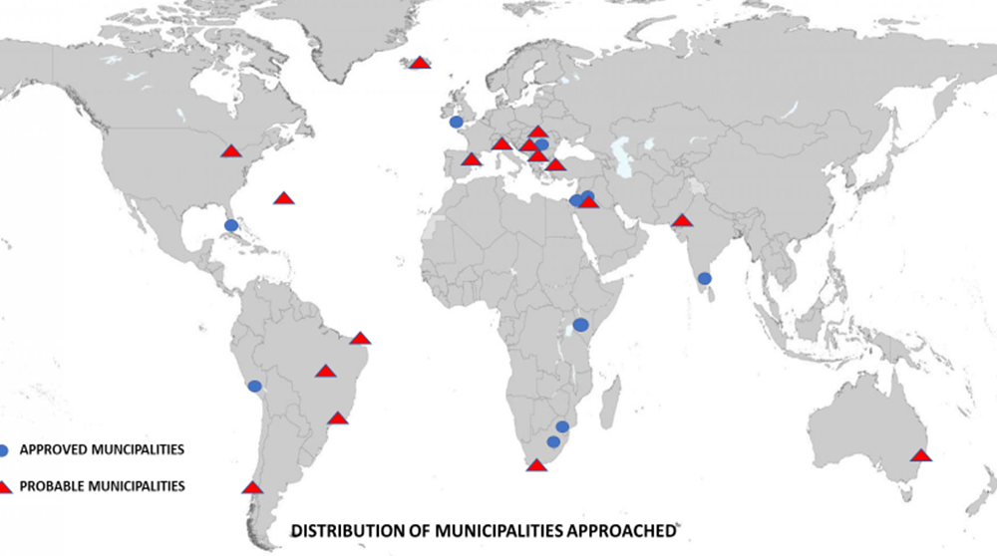
  - With regards to youth-oriented activities it is important to establish different approaches for the following age groups: a) Children through local schools aged, for example, between 10-16, which prove to be extremely effective with regards to the creation of awareness not only concerning the children themselves but also their families; b) High school and University undergraduates aged 16-23 who are potential future game-changers; and then finally c) Young professionals representing diverse sectors (not just water) aged 23-35. It is aimed for having 25 lead cities recruited by the platform before the end of 2021.
  - Emphasis is to be placed on a bottom-up approach. Whilst acknowledging that during the initial stage it is necessary to choose the original 25 municipalities (5 each from 5 Global Areas) from the networking capacities of the members of the Core Team, it is essential that the Social Engagement Workflow rapidly moves to a point where local administrations and/or community groups are approaching the workflow to participate.
  - Initial approaches to relevant Supranational and third-party entities such as the European Commission have begun including a preliminary meeting with the European Commissioner for the Environment, Virginijus Sinkevičius on the 2nd of October 2020. This has been followed by the Secretariat of the Covenant of Mayors, the cabinet of Frans Timmermans who have requested further information and a meeting and the Urban Intergroup of the European Parliament. The need to enter into close collaboration with 3rd parties is paramount. Examples of the more than 50 entities that have been approached so far include the Blue Peace Movement, the 50L Home initiative, Energy Cities, ICLEI, C40, national municipal associations such as the Federación Española de Municipios y Provincias (FEMP), Deutscher Städte-und Gemeindebund, the Regional Environmental Centre for Central Asia (CAREC) and the Organization of American States (OAS). Care must be taken to not make the workflow, European top-heavy.
  - The World Water Quality Alliance Social Engagement Platform was presented at the Stockholm International Water Institute (SIWI) World Water Week 2020. The virtual event was attended by 46 people who have received a follow-up letter. The platform was presented at a second virtual event at the MEDAWEEK organised by the Association of Mediterranean Chambers of Commerce and Industry (ASCAME) held in Barcelona on the 20th of November 2020.
  - An initial study of funding opportunities has been undertaken primarily concerning the European Union Green Deal (Section10-1) and the future clusters of the Horizon Europe for 2021.
3. The future
- The Social Engagement Platform must clearly demonstrate to potential stakeholders what they will gain from becoming involved. This includes them joining a worldwide network and a truly global initiative based on a shared vision for future sustainability, the opportunity to obtain a more integrated, inclusive picture of the causes and effects of water quality issues, the promotion of new local policies within an inclusive decision-making process of cooperation that will increase local support for solutions and measures, access to international technical support from both scientists and other similar groups from around the world and the opportunity to attract international publicity of their progress.
- The RENAISSANCE and ConCensus methodologies will be employed to exemplify and encourage policy co-creation and implementation at a tangible and practicable scale but there exists the additional opportunity to underline the important role of Citizen Science. Nevertheless, and once again to avoid dissipation and contradiction, the Citizen Science approach must be clearly defined and should be implemented in accordance with the application of ConCensus. There exists within the Core Group an awareness of the pros and cons of Citizen Science. The roadmap defined in the plan will be adhered to. Once Stage One has been successfully implemented the following stages will be undertaken.
4. Stage 2
- Lead cities trained to engage the Quadruple Helix in their municipalities regarding the aims and objectives of the UN-World Water Quality Alliance. Emphasis will also be placed on schools and colleges. Each city will be teamed with a local research centre in order to support their work which will be primarily the creation of socio-political awareness regarding water quality. The lead cities will be expected to act as regional catalysts and recruiters of neighboring towns and cities. The platform aims to train 25 lead cities and establish local ConCensus approach in each.
- An open-source Best Practice Repository (BPR) will be established on a suitable Digital Social Platform (DSP). This will offer participating municipalities the opportunity to disseminate their successes regarding water quality whilst also affording them the opportunity to seek external advice from entities who are capable of assisting said municipalities in addressing local water quality challenges. It will further reinforce the concept of a global water quality community aimed at providing mutual support and practical solutions. Here the goal is to establish the Best Practice Repository by the end of 2022 and use the capacities of the UNEP World Environment Situation Room to this effect.
5. Stage 3
- Lead municipalities to recruit national and regional municipal partners – a process in which it is estimated to recruit up to 200 municipalities until 2023.
- The full RENAISSANCE approach is implemented between the participating entities and they are encouraged to contribute to the creation of the SCIENCE STORYBOOK ON WATER QUALITY led by a group of experts, scientists and artists convened by the JRC and EURECAT to be published during 2022.
- Non-Water sectors Water-Energy-Food-Ecosystem + Waste Nexus, Transport, Health, Social Services, ICT, etc. invited to join UN-World Water Quality Alliance Social Engagement Platform. Special attention will be paid to the engagement of health agencies, entities and stakeholders. Some 50non water actors shall be attracted to join before the end of 2023.
F. Friends of Groundwater (FoG)
- This “perspective paper” by the Friends of Groundwater (FoG) group aims to give a compelling argument for the importance of groundwater quality for human development and ecosystem health. It also provides a global overview of the current knowledge, with focus on data coverage, gaps and technological advances. It is a building block towards a future global assessment of groundwater quality as part of the United Nations Environment Programme (UNEP) World Water Quality Assessment.
- Groundwater is an essential global resource and provides the largest store of freshwater, apart from the ice caps. Current groundwater abstraction represents 26% of total freshwater withdrawal globally, to supply almost half of all drinking water and 43% of the consumptive use in irrigation. In arid and semiarid regions, groundwater is the only reliable water resource. In the environment, groundwater makes an important contribution to river flow and groundwater dependent ecosystems. For drinking water supply, one of the advantages of groundwater is that it is naturally protected from many contaminants. With drought and climate change, people in water-scarce areas will increasingly depend on groundwater, because of its buffer capacity and resilience to rapid impacts. However, groundwater quality, as well as quantity, may be impacted by climate change.
- A global groundwater quality assessment is needed because human activities and climate variability increase the pressure on groundwater resources, but it is an invisible resource that remains out of sight and out of mind for most people. Protection of our groundwater resources is necessary for protecting human health, maintaining food supplies and conserving ecosystems. Many regions and countries rely on naturally clean groundwater as advanced water treatment is economically infeasible. Knowing where to source clean groundwater, as well as understanding threats to this resource, is therefore important.
- The principal objectives of this perspective paper are to present the importance of groundwater to meet the Sustainable Development Goals (SDGs), notably SDG2, SDG3 and SDG6, describe the threats to groundwater quality from anthropogenic and geogenic contaminants, discuss the challenges of providing a global overview of groundwater quality, present key messages to summarise current knowledge and capacity and outline a Work Plan to develop a global groundwater quality assessment network, including protection and management of groundwater quality.
- The key messages from this perspective paper are that:
  - Increased attention to water, and specifically groundwater quality, is of utmost importance for the achievement of the Sustainable Development Goals, especially related to water security (SDG 6), health (SDG 3), and food production (SDG 2). Groundwater quality is under increasing pressure due to human development and the impacts of climate change posing risk to human consumption and affecting to a large extent disadvantaged vulnerable groups in society.
  - A dedicated global groundwater quality assessment is necessary and timely. It will provide a comprehensive and coordinated overview of the knowledge base pertaining to groundwater quality, including mapping of main drivers, pressures, trends and impacts, as well as current and prospective management approaches.
  - There is a large variety of anthropogenic and natural (geogenic) chemical and microbiological contaminants that are found or move into aquifers across the globe. The range of characteristics and behaviour in the groundwater systems requires expert knowledge.
  - Groundwater systems are heterogeneous, three-dimensional water reservoirs in porous and fractured rock formations. Groundwater contaminant distributions are therefore particularly challenging to map. Also, contaminant transport and remediation of pollution in these systems often involves long timescales. Hence, groundwater quality is more complex to understand, assess and remediate than surface water quality.
  - Information and data on groundwater quality are very variable across the globe, with often less information available in countries of the Global South. For a comparable global assessment, substantial efforts are needed to i. Improve data collection, ii. Develop the capacity and the knowledge base, with particular focus on developing countries and iii. Develop international standards.
  - Groundwater quality needs to be understood at various scales depending on the key risks, e.g. related to the size and vulnerability of the aquifers and receiving water bodies, the inherent or external pollution loads, land use, waste handling, and the demand on the resource. There is a need to consider groundwater quality for different uses: e.g. drinking water, ecosystems, food (particularly irrigation), energy production and other industries.
  - Groundwater monitoring programmes need to be targeted and designed according to the purpose of the monitoring, e.g. specific contamination tracing and remediation, short-term campaigns to understand local contamination issues, and longer-term larger-scale systematic monitoring programmes to identify general spatial patterns and long-term temporal trends in groundwater quality.
  - Besides traditional groundwater monitoring programmes involving water sampling in wells (points in space), upstream (soils), and downstream (receiving streams, springs, wetlands and coastal areas) need to be considered. Important new technologies and practices are developing, e.g. earth observations and GIS, Citizen Science, machine learning, and numerical modelling of contaminant fate and transport. Due to general lack of in-situ data, the new technologies can help extrapolate knowledge from regions with good data to areas with less information, giving an understanding of potential risks and vulnerabilities. Vulnerability and pollution load mapping are critical factors in tracing potential groundwater pollution and designing monitoring programmes on groundwater quality.
  - Most monitoring programmes for groundwater quality are based on national level legislation and regulations, where these exist. Special attention is required for groundwater quality challenges in transboundary aquifers. To fill knowledge gaps and prepare an improved and fair basis for transboundary cooperation requires development of comparable standards for the aquifers, data sharing and joint capacity development programmes.
  - Local-to-global partnerships and investments in research, capacity development and evidence-based policymaking are required to make the step change required to manage groundwater quality sustainably.
- The Friends of Groundwater (FoG) group has developed this perspective paper with great professional enthusiasm and without a dedicated budget, but the planning of future activities depends on motivation and budget. The FoG specialists are fully aware of the importance of regional and global groundwater quality assessment and this assessment needs to remain a focus of the group. To establish this critical flow of information and feed into the science policy interface assisting countries to achieve SDG 6 targets and namely to address the water related equality dimensions in a gender perspective “leaving no one behind” budget is critical for a global groundwater quality and quantity appraisal, for raising awareness and ensure impact. To leverage the substantial in-kind investment of FoG in the World Water Quality Alliance that enabled this report ; a follow up budget needs to be secured (section 8 of the full perspective paper – see link below). The main objective is to continue this targeted FoG activity and evolve it from setting the stage and scoping towards a full global assessment and an outreach interface to users. Since the FoG activities are a part of the World Water Quality Alliance, and shall contribute to World Water Quality Assessment of UNEP it is expected that the core budget can be raised collectively with Alliance support to enable the implementation of the workplan sketched out in section 8 of the full perspective paper.
- In the Work Plan, the principal short and the long-term activities are:
  - A global Groundwater Quality (GQ) Assessment Portal is already under development. It will be the FoG main window to the world to be a focal point and link to all portals and activities relevant to GQ assessment at the regional/global scale. The portal will include this perspective paper, a reference database, a graphical interface for spatial/geographic presentation, activities of FoG, etc.
  - The global GQ Assessment Network will be progressively developed by including new information and current activities in the portal, through active contributions of the specialists and institutions involved. The network will grow further, alongside development of an overview of national GQ monitoring programmes. This will build on the existing work of GEMS/Water in connection with SDG target 6.3.2.
  - A systematic overview of GQ Monitoring Programmes at national level will be prepared, including institutions, purpose, parameters, methodology, availability and accessibility. This activity will reveal additional information about the state and trends of GQ at national level.
  - Contributing to a World Water Development Report 2022 “Groundwater: Making the Invisible Visible”. The draft annotated Table of Contents was circulated for comment in November 2020 and the call for contributions is expected before the end of the year.
  - Organising and participating in other activities relating to groundwater quality for World Water Day 2022.
  - Contributing to the World Water Quality Assessment under preparation by UNEP with partners for the 6th Session of the United Nations Environment Assembly (Feb 2023) and featuring in the UNGA mandated “midterm comprehensive implementation review of the International Decade for Action, ‘Water for Sustainable Development’ 2018-2028” (UN-Water Conf. NY, March 2023).
  - Assistance to national GW assessment programmes: advocacy through embedding GQ in societal, economic and other environmental issues in water programmes of international, national and UN funding agencies, multinationals, trust funds, etc.; acquisition, preparation and execution of projects; raising awareness and providing incentives through webinars, videos, tailored information and kits for schools, academia, NGOs, etc.; promoting innovative approaches and technologies (e.g. low cost sensors).
  - Upscaling and regionalisation of local assessments are the main FoG research activity. It includes regional/global modelling (e.g. using machine learning), inclusion of “Use Cases” into regional assessment (e.g. case-based reasoning), remote sensing, Citizen Science, etc. When presenting and reporting on GQ at regional scale, distribution of pollutants with depth and possible behaviour in time will be taken into account where possible.
- The FoG Work Plan will be further developed according to budget availability and preferences of FoG members and other specialists to contribute to global groundwater quality assessment.
- The whole Perspective Paper “Assessing Groundwater Quality: A Global Perspective” can be accessed under: Assessing Groundwater Quality: A Global Perspective.
G. SARS-CoV-2 sewer sentinel system
- Wastewater has emerged as a reliable indicator of the presence of the SARS-CoV-2 virus in the population, while being itself not a source of infection. The ability to detect RNA fragments of SARS-CoV-2 in wastewater is increasingly and independently being reported from research groups in nearly all EU Member States and beyond. It became apparent that creating a “Sentinel System” was of interest to a wider audience and under the remits of the WWQA, a Virtual Town Hall Event collectively defined the criteria for representative “use-cases”. Related are water pressures ranging from increased abstraction, discharge of COVID-19 originating plastic litter (masks, gloves), supply chain security issues for critical water treatment chemicals and, wastewater treatment infrastructure as information source for compounds of growing concern (e.g. antimicrobial resistances) (for further information see: EU Short Term Health Preparedness).
H. Antimicrobial resistance (AMR)
- Knowledge gaps still grow particularly around the impacts of emerging water pollutants, such as nitrogen, microplastics and antimicrobial resistance (AMR), the human rejection of antibiotics. AMR is a fast-growing threat, caused by the overuse and indirect consumption and exposure of antibiotics through waterways. As of 2015, 34.8 billion antibiotics were consumed daily, of with
30-90% of them were excreted as active substances into the environment. Today, 700,000 people are dying from drug-resistant infections every year, which is seven-fold the number of deaths from cholera. If no action is taken, this number could reach 10 million people by 2050 and cost up to US$100 trillion. Against this backdrop, the World Economic Forum, in collaboration with the Swiss Agency for Development and Corporation (SDC) commissioned an insight report on the impacts of AMR spread through waterways. The report (still unpublished) explores social, environmental and financial risks that AMR poses to businesses and society at large, including impacts of an AMR driven epidemic scenario, and outlines potential opportunities for action to mitigate such risks, including the importance of greater exchange and collaboration across public, private, and research institutions. The report builds on latest science, expertise of existing initiatives, and is intended to contribute to the ongoing work of the UNEP-convened World Water Quality Alliance to raise awareness and identify key gaps and opportunities for further research.
I. The Knowledge to Practice (K2P) project
1. Introduction
- The mission of the global water Knowledge to Practice (Water-K2P) project is to provide tools that allow access to pathogen data on viruses, protozoa and bacteria to support sanitation safety planning. The project was developed as part of the Global Water Pathogen Project . The GWPP was a joint effort of more than 200 authors led by Prof. Joan Rose of Michigan State University and Dr. Blanca Jiménez Cisneros of UNESCO to replace the key reference point for the development of quantitative guidance for sanitation practices including defining safe and unsafe activities, evaluation of low technology treatment and disposal options and for addressing adequate controls for protection of health: “Sanitation and Disease: Health Aspects of Excreta and Wastewater Management” (Feachem et al. 1983). The new open access book “Sanitation and Disease in the 21st Century: Health and Microbiological Aspects of Excreta and Wastewater Management” was launched in September 2019. The Water-K2P project translated the scientific content of the book into user friendly IT tools to help improve data accessibility, and knowledge translation around pathogens in excreta and sewage. The importance of pathogens for human health has also been highlighted in the current state of the World Water Quality assessment referred to in this information document (Chapter 3.2 – World Water Quality Assessment and Alliance: Key Findings - Status Update - Outlook).
- In the Water-K2P project, funded by the Gates Foundation, an international research group developed two tools to assist sanitation planning. These tools are the Treatment Plant Sketcher Tool (sketcher) and the Pathogen Flow and Mapping (PFM) Tool.
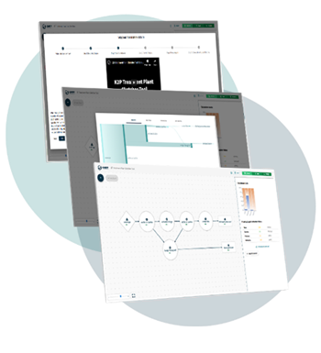
2. Treatment Plant Sketcher Tool
- The GWPP-K2P Treatment Plant Sketcher Tool predicts the effectiveness of a wastewater or fecal sludge treatment system at removing and reducing pathogens (viruses, bacteria, protozoa, helminths). The tool allows users to create a custom “sketch” of a treatment system, specifying how it is configured, designed, and operated. Then, using this information as well as models based on data from scientific literature, the tool estimates the proportion of pathogens reduced by the system and lets you visualize what proportion of the pathogens end up in the liquid effluent vs. the sludge/biosolids. Users can add different treatment unit processes, change the way they are configured, and change their design and operational parameters to understand what impacts these changes have on pathogen reduction.
3. Pathogen Flow and Mapping (PFM) Tool
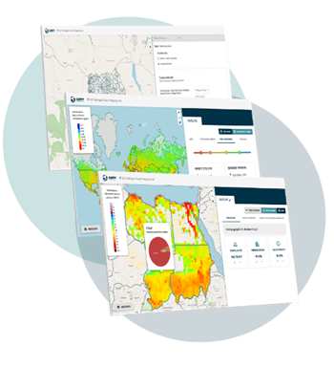
- The purpose of the PFM Tool is to evaluate areas with high emissions of pathogens to surface waters and evaluate the potential impact of changes in population growth, access to improved sanitation facilities, and increased conveyance and treatment of wastewater and fecal sludge. A model that simulates these emissions drives the tool. The model uses input data on population, urbanization, disease incidence and pathogen shedding rates, sanitation technologies, and the treatment of wastewater and fecal sludge. The current global input data for the default run of the tool are described on the tool website and come from sources that are available online, such as the UN Department of Economic and Social Affairs, and the Joint Monitoring Program of the World Health Organization (WHO) and the United Nations’ Children’s Fund (UNICEF). Users of the tool are able to select their geographic area of interest and develop up to three alternative scenarios that can be compared to the baseline. These scenarios can include population changes, interventions, such as eradicating open defecation, emptying and treating more waste from onsite systems, or improving the treatment of wastewater and fecal sludge. The tool produces visualizations that help a user assess the relative differences between scenarios to support decision-making. It is envisaged to also incorporate the tool in the UNEP World Environment Situation Room (WESR).
- The PFM tool is relevant for local and global stakeholders. The tool has several input and output data resolution. A global map can be evaluated with a gridbox resolution of ~50 x 50 km and for more local stakeholders a much higher resolution is available, such as ~1 x 1 km or sub-city administrative boundaries. The tool has been developed together with stakeholders from Uganda. For Kampala we have developed a case study for rotavirus. The Kampala Capital City Authority (KCCA) had questions on the areas of the cities that are at higher risk for pathogens and the drivers of that risk, the importance of open defecation control and the influence of changes in technology to improve pathogen reduction. We concluded that areas with high emissions of rotavirus coincide with areas of high prevalence for cholera. Open defecation is expected to reduce rotavirus emissions to surface waters in some parishes. Lining pits and treating the fecal sludge is expected to reduce pathogen emissions by several log-units. For global stakeholders, the tool is also relevant to compare areas of high emissions (hotspots) and to evaluate generic strategies to reduce the emissions.
Figure 2
Overview of pathogen flow and mapping tool dashboard
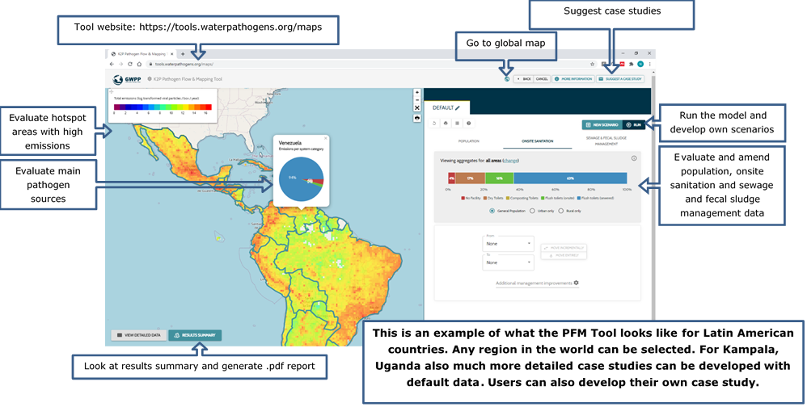

4. Future opportunities
- This tool is the first online water quality tool for waterborne pathogens that enables evaluation of hotspots and scenario analysis. Subject to further funding, the main priority areas for improving and expanding the tool are as follows:
  - Although both tools have been developed for pathogens, we have had regular requests to extend them to nutrients and other water pollutants, such as AMR, microplastics or pharmaceuticals. We hope to extend the tools to incorporate those.
  - Additionally, currently the PFM tool simulates loads to the surface water. These loads are relevant, but it would be even better to link the loads to concentrations in surface water and to health risk due to exposure to the pathogens. This links in extremely well with WHO’s health-based sanitation safety planning. Concentration and health risk models do exist, and we hope to do this implementation.
  - Furthermore, we would like to enable stakeholders to develop their own case studies for the PFM tool. Currently, they can work with the available data and amend those data, and they can suggest a case study that we can help them develop further by offering guidance on how to prepare the data and other technical assistance. We would like to automate this process.
5. Future perspectives on the water quality health focus in the World Water Quality Alliance
- In the wider context of the World Water Quality Alliance’ focus on water quality, environment and health a future collaboration is under exploration expanding the scope to include endocrine disruptors – a first set of scoping exchanges are under way with OECD as lead partner. In the upcoming next Alliance global meeting end of January 2021 this shall be further elaborated.
6. The ecosystem group
- The world’s human population is reliant on freshwater ecosystems. We have long known that population growth, increases in the per capita consumption of resources, and economic development drive demand for clean water whilst simultaneously accelerating the rate and magnitude of their decline through nutrient pollution and climate change. Freshwater biodiversity is vanishing faster than all other ecosystems, in part due to water quality degradation, and the scientific community is united in the call for an Emergency Recovery Plan. The ‘know how’ to deliver significant water quality improvements, for example through nature-based solutions, across sectors and scales is available, and many of the solutions provide multiple benefits. Healthy waters underscore many of the UN Sustainable Development Goals. For example, the control of nutrient pollution is one of the few options with which to off-set climate change effects on freshwater quality, whilst also reducing greenhouse gas emissions and enhancing biodiversity at local and global scales. In taking a multidisciplinary approach to the challenge, it is now possible to create transition plans to deliver both environmental gains whilst also supporting economic development through transition to more sustainable economies. The challenge now lies in mobilising policy makers, investment and public support for change leading to ecosystem-based choices and supporting communities in the protection and restoration of the ecosystems on which they rely. Novel restoration strategies combining
socio-economic and biophysical evidence are needed that embrace existing frameworks of integrated watershed management to support this aim. This necessitates actions that combine restoration of damaged habitats and protection of ecological intact ones. We are now at a critical junction in maintaining a sufficient extent of functioning ecosystems and the services they provide for humanity. Development of novel preventative management in the short term, alleviates the technical and economic burden of restoration in the long-term if economic development continues along an unchecked path.
- The WWQA Ecosystem Task Force was formed to address this need, supporting large-scale restoration initiatives to prevent, halt and redress the destruction of our freshwater ecosystems, focussing initially on water quality management in lakes and their catchments. Our activities are centred on a unifying concept that is not constrained by traditional views of Ecological Restoration. The Task Force will drive the transition from heavily polluting activities towards those that relieve stress on the aquatic environment whilst releasing economic growth. We will develop a Theory of Change to support this transition drawing on outputs from other WWQA Work Streams including Data and Assessment tools from the WWQ Assessment; Capacity Development outputs; Circular Economy and Nature Based Solutions; and Research to Action through the Social Engagement Platform. Learning from our membership’s experiences and building on their networks, the Task Force will set the agenda on global priorities for action, foster new partnerships to support large–scale and transboundary programmes, and deliver evidence to support the delivery of existing and emerging policies and initiatives. For example, we will work to deliver the goals of the UNEP Decade on Ecosystem Restoration and we will act to support the development and transposition of other emerging directives, for example, the European New Green Deal.
7. Overview of outputs
  - Concept note outlining the objectives of the World Water Quality Alliance Ecosystems Task Force (UK CEH; IHE-Delft; JRC; UNEP, and World Bank);
  - Virtual awareness raising activities focussed on Water Quality and Ecosystem Restoration (in collaboration with UK CEH; JRC; World Bank; University of Wageningen; Helmholtz Centre for Environmental Research; OECD; UNEP; WMO; Aarhus University; University of Rio de Janeiro State; University of Rio Grande do Norte; PhosAgro);
  - Network building activities in collaboration, for example, with the African Centre for Aquatic Research and Education (ACARE), the International Institute for Sustainable Development (IISD), World Bank Africa Centre of Excellence in Aquaculture and Fisheries, Lilongwe University of Agriculture & Natural Resources, the Indonesian Centre for Limnology, the Chilean Ministry for the Environment, and the Kenyan Marine and Fisheries Research Institute (KMFRI);
  - On-line courses to support Ecosystem Restoration (IHE Delft; UNU Dresden; Conservation international; UK CEH).
8. Specific achievements and planned outputs
- Establishment of the WWQA – Ecosystems Task Force:
  - Achievements: The Task Force was established following a special session of the 2019 World Water Quality Alliance meeting, Ispra, Italy. The outcomes of this meeting were agreement on the need for an Alliance Task Force to map out freshwater restoration activities globally including contemporary and emerging issues operating at the global scale (e.g., aquaculture, plastics, e-wastes, mining, wastewater, agriculture), identify highly sensitive ecosystems under immediate or impending threat, support current/planned restoration and prevention investments, and seek further collaborations in restoration ‘blind-spots’. The Task Force will set the agenda on global priorities for action targeting large–scale and transboundary programmes and deliver evidence to support existing and emerging policies and initiatives.
  - Planned short-term outputs: Virtual Scoping Workshop (Q4 2020) bringing together Alliance members and key practitioners to review tasks, related activities and plan for future work and events. An output of this meeting will be a White Paper calling for better coordination of action in this area and presenting a Theory of Change. Build and diversify the membership of the group and establishing a formal governance structure within the Alliance.
- Raising awareness of priority and emerging issues on ecosystem restoration:
  - Achievements: World Water Quality Alliance Ecosystems members co-convened in 2020 a virtual session of the World Water Week on Water Quality & Climate Change, a UNEP hosted Webinar demonstrating the need for sustainable phosphorus management in lakes. The Task Force supported the International Conference on Tropical Limnology 2020, part of the Indonesia Science Expo 2020, and hosted by the Research Centre for Limnology (LIPI), Bogor, Indonesia. The theme of the meeting was ‘The role of limnology and its networking: current status and future challenges for the sustainability of the inland aquatic ecosystems regionally and globally’ and the Task Force delivered a plenary presentation on water quality in tropical lakes in relation to their utilisation, highlighting case studies from 5 countries (Mexico, India, Brazil, Kenya, Indonesia and Malaysia), covering uses such as water supply, waste disposal, fish farming and wildlife habitat, and considers the effects of both water use on water quality and water quality on water use.
  - Planned outputs: Create a communication plan and conduct awareness raising activities on the importance of water quality management, biodiversity loss and socio-economic gains. Develop and publish a knowledge-sharing platform through UNEP’s World Environment Situation Room, collating evidence on restoration case studies including the Alliance Use Cases and others (e.g., Bangalore Lakes, Lake Toba, Indonesia; Loch Leven, UK; Lake Villarrica, Chile; Lake Erhai, China), in the form of web-based scrolling stories. We aim to deliver a special session at the Stockholm World Water Week 2021 to raise awareness of the Task Force and its work.
- Supporting freshwater restoration in lakes:
  - Achievements: fostered collaborations with ACARE and its recent partnership with IISD, to support the development of a regional focal point for information on the state of the African Great Lakes. Produced a fully accredited course on Water Quality and the SDGs and a Massive Open Online Course (MOOC) on Freshwater Health to enhance uptake of the Freshwater Health Index. We have worked with Kenya Marine Fisheries Research Institute (KMFRI) in Kisumu, Kenya, to support the sustainable use of the Winam Gulf, Lake Victoria, and the development of a blue economy. Our main aim has been to provide the scientific evidence required to manage the environmental impact of increasing numbers of cage fish farms effectively. With KMFRI, we have developed a range of maps to identify conservation areas, cage farm sites, fish capture sites, water hyacinth hotspots, and levels of pollution. This information will be used to ‘zone’ the Gulf into areas suitable for different activities. In India, we are working with National Institute of Hydrology (Roorkee), IIT Kanpur and IIT Roorkee and ARTREE, and Biome Environment Trust to reduce public health risk from pollution problems, particularly untreated sewage. Our work specifically addresses SDG 6, Target 6.3.2; focussed on Urban Lakes in Bengaluru (Bangalore) and Upper Ganga, Rishikesh to Kanpur. Our objective is to support the transition towards sustainable use of fresh waters for fisheries and other economic and social enterprises (e.g., tourism, recreation, religious bathing). We have co-developed water quality programmes in the two regions of India described below. Members of the Task Force continue to support the development of transition plans for impacted lakes across the world, including Lake Toba, Indonesia (World Bank) and Lake Villarrica, Chile, (UK CEH).
  - Planned outputs: Produce on-line course in 2021 to support ACARE activities, for example including working with KMFRI to develop data and decision support tools to inform sustainable management practices in Lake Victoria; support the development of an African Sustainable Nutrient Platform supporting the development of novel nutrient management plans to reduce stress on freshwater ecosystems.
9. The plastics workstream
- The world demands and produces more and more plastic every year. Once in the environment, and with time, plastic items tend to degrade to smaller particles through natural weathering processes and can become microplastics (commonly defined as less than 5 mm in size). Other microplastics are directly released into the environment. They may have been intentionally added to products, personal care and cosmetic products (PCCPs), or they can result from the abrasion or shedding of objects containing plastic (e.g., tyres and synthetic textiles). Analysis of water and sediments worldwide indicates that macroplastics and microplastics are ubiquitous in aquatic environments, including freshwater and marine ecosystems. Macroplastics have serious environmental, health and economic impacts, including (but not limited to) blocking canals and sewers, creating breeding habitats for mosquitoes, lowering the recreational and touristic value of landscapes, and damaging the airways and stomachs of animals. The risks that microplastics pose to the health of humans, animals and ecosystems are of increasing concern.
- Within the plastic workstream in the World Water Quality Alliance two reports have been elaborated which are now in the final phase of technical checks and production. The first one mainly reviews technical interventions against macro and micro-plastic waste release to water and technical solutions for its treatment, while the second focuses on monitoring freshwater environments, including their sediments and biota.
J. Water pollution by macroplastics and microplastics: A review of technical solutions from source to sea
- Water pollution by plastic debris and microplastics is complex and multidimensional. Managing it effectively requires a range of responses. Solutions need to act on the design, production, consumption and disposal of the plastics that we will still use in the decades to come. This can reduce macroplastic and microplastic pollution at the source. Other responses need to limit the export of plastics from cities and the landscape through the treatment of wastewater and run-off, protect water bodies from pollution loads, restore affected water ecosystems and minimize exposure to populations at risk. All these efforts must be supported by legislation, economic instruments, education and awareness that force real change on the ground. As shown in previous sections of the report, there is a large number of available solutions and policy makers and practitioners need to set priorities and select those that are more cost-effective and suitable for their local context.
- This report reviews some of the most relevant technologies currently in use and supporting solutions that address contamination by macroplastics and microplastics from source to sea (see Figure 3 above). Where data are available, the report looks at the effectiveness, capital expenditure, and operation and maintenance (O&M) costs of different technologies and their suitability under various conditions. This could help enable policymakers and practitioners set priorities and select the technologies that would be most cost-effective and suitable in their local context.
Figure 3
Solutions and technologies for waste management (blue: microplastics only; yellow: microplastics only; green: both macroplastics and microplastics)
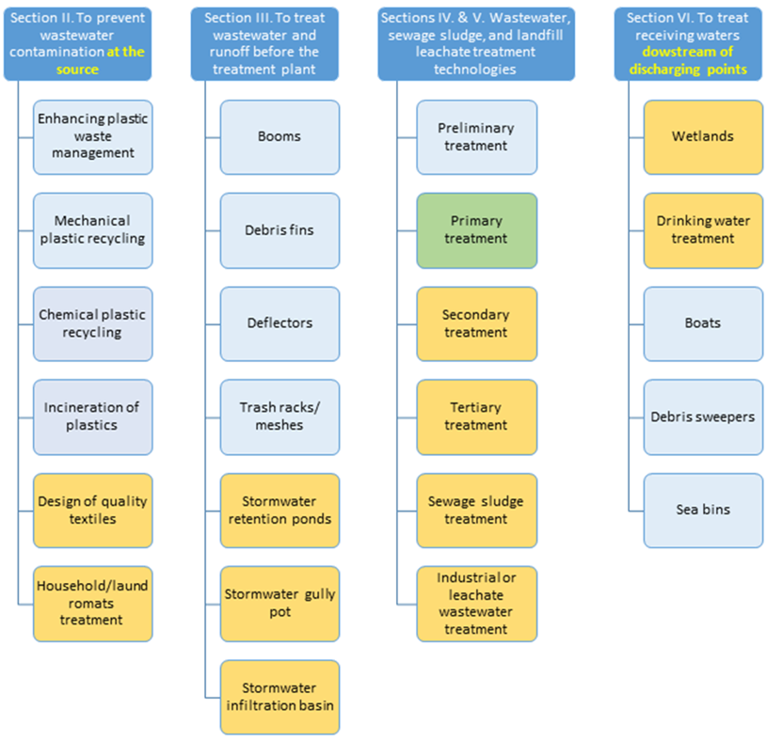
K. Monitoring plastics in rivers and lakes: Guidelines for the harmonization of methodologies
Figure 4
Types of plastic-related assessments in freshwater environments. Light grey: considered less important for the specific purpose. NOEC / LOEC: no observed effect /lowest observed effect concentration
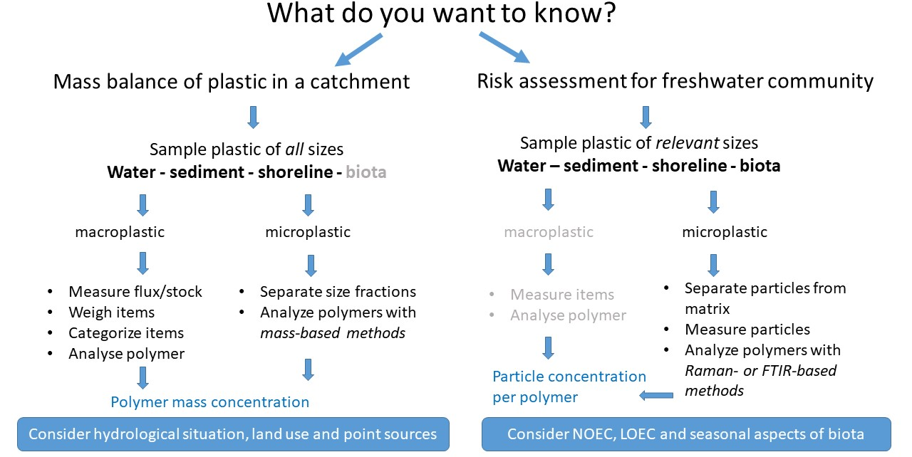

- To date, no regularly operating plastic monitoring programmes exist, and there is no general “off the shelf” solution for establishing a monitoring programme. The design of such a programme must be tied to the monitoring objectives (see Figure 4 below), with consideration of available resources. Plastic concentrations in freshwater systems such as rivers and lakes/reservoirs can be considered highly variable, both in space and time. It is highly recommended to (1) Build around existing sampling and analysis protocols, as well as classification schemes, to ensure consistent data, (2) Integrate plastic monitoring into existing programmes for other substances and make use of available metadata such as river discharge, (3) Carry out frequent, long-term observations rather than high spatial variation, and (4) Carry out sampling and analysis that can use simpler methods, rather than fewer samples needing advanced analysis.
- Ideally, monitoring of freshwater plastics should encompass the entire size range from macroplastics to micro- and even nanoplastics. It is recommended that monitoring programmes initially start with macroplastics if the analytical infrastructure for microplastics is not available or not yet operational. Macroplastic monitoring can be supported by Citizen Science.
Figure 5
Sampling and analysis methods for freshwaters from macro- to microplastics

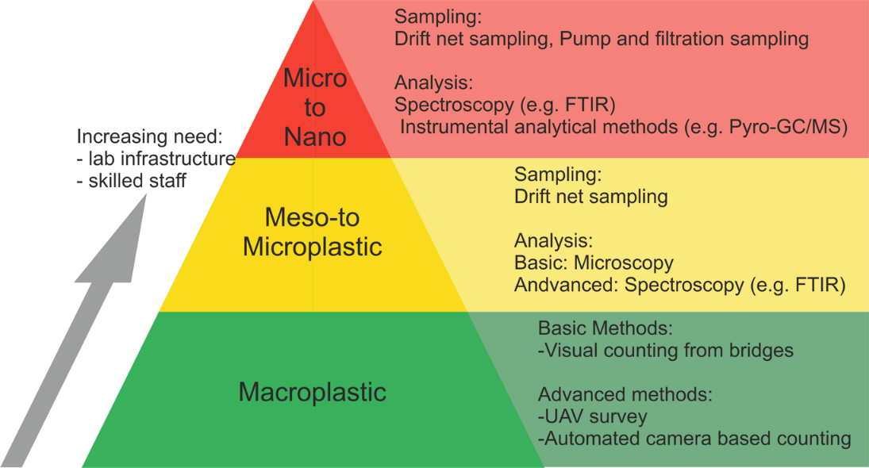
- It is especially recommended to explore possible advances in monitoring methods, and to sample after extreme events like storms and floods. Ambient environmental conditions during sampling need to be recorded. Dams and reservoirs should be included (rather than purposely avoided) in monitoring programmes. Regarding policies for intervention and prevention, the capacities or public authorities are crucial. Responsible public authorities should be guided by integrated nexus thinking. The use of diverse governance instruments (rules/regulations, information/cooperation, economic incentives) to address this complex problem is emphasized.
L. Concluding remarks and future outlook
- The first year of the World Water Quality Alliance has shown the enormous interest of many stakeholders inside the UN System and externally representing all actor groups of society to become part of this transdisciplinary Community of Practice. From within this Alliance working groups have formed that collaborate with the principle investigators to jointly contribute mostly on an in-kind basis and in their respective areas of expertise to the development of the World Water Quality Assessment.
- Milestones for this multidimensional undertaking and facing an unprecedented complexity in aligning data from multiple Assembly resolution on the “Midterm comprehensive review of the implementation of the International Decade for Action”, “Water for Sustainable Development
2018-2028”. (A/RES/73/226).
- Besides the Assessment the Alliance has managed to address several other critical challenges facing society and the environment such as the global groundwater pollution and overuse, and, which became ever more prominent in 2020, the nexus between water quality and health in several facets including the modelling of pathogens in the context of water quality and implications for risk hotspots, the implications of antimicrobial resistance (AMR) for private sector and the utility of wastewater based monitoring innovation (sentinel) concepts to observe viral RNA residuals which is a main effort overseen by the European Commission. Most of these topics are work in progress, reflecting voluntary commitment and expertise of multiple partners and will be continued.
- The current report provides the current state of the art in the different workstreams that associate to and originate from within the Alliance. They are therefore only a glimpse of what is expected to come out of this work and engagement over time. All workstreams have made tremendous and remarkable progress during the short period since their inception. But the majority of the work including of the further development of the innovation components in the Assessment still lie ahead.
- It is envisaged to bring all the current and potentially future workstreams of the World Water Quality Alliance together to compliment and contribute to the development of the first of its kind World Water Quality Assessment but also to enable UNEP to provide a dynamic portal with water quality baseline and risk scenarios in future. Nexus perspectives will be targeted with priority as is already reflected in the first report provided and the same applies to the comprehensive perspective paper on groundwater.
- Sources including modelling and earth observation were to provide a first global demonstration of a water quality baseline for UNEA 5th session. While this is reflected in this Information Document and a full first report provided as Annex, there are challenging steps ahead of the team to come to scientifically rigorous alignment of elements in the data landscape that still have substantial discrepancies in terms of time covers, parameters, resolution and water bodies covered. Meeting these challenges and embarking towards the additional elements of scenario developments and screening options for mitigation, solutions for the global water quality challenge will require more time and effort and continued support. The goal is to provide a full first global assessment by UNE 6th session. Interim results will be feeding into the respective UNEA reporting portal and they will, if appropriate, feature on the UNEP World Environment Situation Room. As much as UNEA, another milestone will be provided for in 2023 following the General
- Two main avenues will require specific attention in consolidating and further developing the efficiency of the Alliance those are: i) to engage all societal groups across gender and age across all ethnic and believe contexts which is currently reflected by the “social engagement platform” and the “Use Cases” – success relies on people to engage and that will finally make solutions of water quality problems applicable and owned across societal actors – the key pillar of “shifting the needle”; ii) relying on data to derive necessary information for action – the paradox of a data rich and information scarce environment applies specifically to water quality and the work in the Alliance and the Assessment so far has highlighted this even stronger. The Alliance fosters new avenues but what we know from decades of experiences in the UNEP Global Environment Monitoring System GEMS/Water programme is that data is still the bottleneck and subject to substantial demand for capacity development and a landscape that is open access and willing to share.
- Both aspects mentioned in conclusion rely on Members States to work closely with the Alliance and the monitoring programmes to achieve those mutually open and beneficial environments for shifting the water quality and sustainability needle.
- The WWQA has received resources by the Swiss SDC to provide seed funding where requested and approved by the SAC in order to further support the work of the various workstreams. The “Use Cases” have been supported by the Swiss Government and the science technology innovation platform supporting the global Assessment is supported by Germany. That in mind and grateful for this substantial support the World Water Quality Alliance is looking forward to work with even more governments and more partners across society to broaden the resource base and supplement the already impressive and generous in kind and cash support mobilized.
Disclaimer
- The designations employed and the presentation of material on maps displayed in this document do not imply the expression of any opinion whatsoever on the part of the Secretariat of the United Nations concerning the legal status of any country, territory, city or area or of its authorities, or concerning the delimitation of its frontiers or boundaries.

* In accordance with the decisions taken at the meeting of the Bureau of the United Nations Environment Assembly held on 8 October 2020 and at the joint meeting of the Bureaux of the United Nations Environment Assembly and the Committee of Permanent Representatives held on 1 December 2020, the fifth session of the Assembly is expected to adjourn on 23 February 2021 and resume as an in-person meeting in February 2022.
** UNEP/EA.5/1/Rev.1.
*** The present document is being issued without formal editing.
UNEP (2016). A Snapshot of the World’s Water Quality: Towards a Global Assessment. United Nations Environment Programme, Nairobi, Kenya. 162pp.
UN-Water (2016). Towards a Worldwide Assessment of Freshwater Quality. A UN-Water Analytical Brief. UN-Water, Genève, Switzerland. 36pp.
The quintuple innovation helix framework describes university-industry-government-public-environment interactions within a knowledge economy
https://tools.waterpathogens.org/sketcher.
https://tools.waterpathogens.org/maps.
Vörösmarty, C.J., et al., 2010. Nature 467(7315): 555–61; Bajželj, B. et al., 2014. Nat. Clim. Chang. 4(10): 924–929.
Tickner, D., et al., 2020. BioScience, 70, 4, 330–342.
World Bank, 2018. Report no. 139829, Washington, D.C
Damania, R., 2019. World Bank. doi:10.1596/978-1-4648-1459-4

