

Supported by
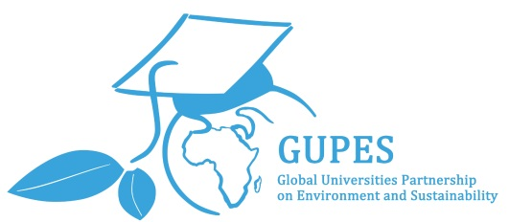
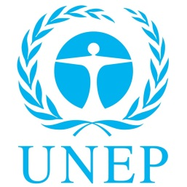

The GUPES Green Gown Awards are now open
GUPES Members are invited to apply for the GUPES Green Gown Awards. Each GUPES region will select one final Award winner under the category that is applicable for the region:

- Africa: Continuous Improvement: Institutional Change
- Asia and the Pacific: Community Engagement
- Europe: Student Engagement
- Latin America and the Caribbean: Community Engagement
- North America: Student Engagement
- West Asia: Continuous Improvement: Institutional Change

The GUPES Green Gown Awards is a joint initiative supported by the United Nations Environment Programme (UNEP) and the Environmental Association for Universities and Colleges (EAUC),that expands the Green Gown Awards further across the globe with an emphasis on profiling and learning from the Southern Hemisphere. This exciting partnership with the Global Universities Partnership on Environment and Sustainability (GUPES) will put universities and colleges as leaders in sustainability as well as being able to continue their learning from global leaders. The GUPES Green Gown Awards are open to GUPES Members across 6 regions (Africa, Asia and the Pacific, Europe, Latin America and the Caribbean, North America and West Asia). The GUPES Green Gown Award Winner from each of the 6 regions will automatically be entered into the International Green Gown Awards contest. All applications are to be in English. Further details on the GUPES Green Gown Awards can be found at http://www.unep.org/training/programmes/gupes.asp. Applications close at 12 noon GMT Tuesday 31 May 2016.

The GUPES Green Gown Awards are open to any tertiary education institution that is a GUPES member – including all post-16 educational institutions such as colleges, universities and learning and skills institutions. Institutions can join GUPES for free at http://www.unep.org/training/programmes/New_Membership.asp.
Exceptions
If your region already has an existing Green Gown Awards programme then you can only apply once to your regional Green Gown Award programme and are NOT eligible to apply for the GUPES Green Gown Awards, regardless of whether you are a GUPES member or not. The following Green Gown Award Programmes exist:
- UK Green Gown Awards – visit www.greengownawards.org.uk
- Australasia Green Gown Awards – visit http://www.acts.asn.au/initiatives/ggaa/
- Les Trophées des campus responsables Francophones (French speaking Europe & Canada) – visit http://www.tropheesdescampusresponsables.com/

Generic criteria applicable to all categories:
To make a strong application please provide facts and figures to support your application and meet all the criteria within your chosen category. You should also include the following generic criteria:
- Demonstrate the impact of any measures taken
- Where relevant and appropriate provide quantitative clear data to support claims being made. For example, where appropriate, metrics such as: carbon savings relative to output/activity.
- Include financial savings made relating to green initiatives (e.g., recycling, reducing wastes, use of renewable energy, etc.)
- Demonstrate the impact of your initiative and show documented outcomes
- Provide evidence of where your initiative has gone over and above requirements
- Document mature projects which have been evaluated and monitored longitudinally. Applications need to go above and beyond standard practice
- Explain clearly how the project includes academic staff and/or professional sector staff/support staff and include numbers of others involved including students. Where students and staff are involved, as well as including the actual numbers, include how they were involved and what impact/influence they have had
- If your initiative is a joint partnership or includes 3rd parties, provide details on the roles of all parties and state who is the main driver
Category Criteria
Community Engagement
Regions: Asia and the Pacific and Latin America and the Caribbean
This category recognises initiatives by tertiary education institutions which create significant benefits for local communities, disadvantaged groups (including disability and accessibility in the broader sense) and/or society as a whole in either their host country or developing countries. As well as specific initiatives, this category includes institutions taking a leading and visionary role in multi-partner activities such as community development or urban regeneration.
Although all applications will be considered on their merits, the judges will particularly be looking for innovative community engagement type of initiatives which have an element of proactive, new, community and social concern and positive impacts, rather than the very worthy and commendable ‘grass roots’ and ‘business as usual’ activities.
Continuous Improvement: Institutional Change
Regions: Africa and West Asia
This category recognises sustained and successful activities to improve the performance of tertiary education institutions, faculties and buildings over a number of years and offers a whole institution approach.
To improve social responsibility and environmental performance through a whole institution approach strategic sustainability activities through four main areas must be achieved:
- Leadership and Governance
- Estates and Operations
- Learning, Teaching and Research
- Partnership and Engagement
Applications are only likely to be successful if they provide considerable quantitative evidence on the nature of the improvements made and also demonstrate a causal relationship between activities undertaken and improvements achieved based on the four areas. Initiatives must have been running for at least five years.
Judges will be looking for key areas where it is felt that the institution is distinctive compared to its peers, and provide supporting evidence. Tangible evidence of high level commitment, and its incorporation into management procedures, will also carry great weight with the judges.
Student Engagement
Regions: Europe and North America
This category reflects that students and staff must work together to achieve goals using “top-down” and “bottom-up grass roots” methods to achieve maximum understanding and engagement across an institution. This in turn aids student progress and allows for opportunities to gain transferable employability skills. It looks at both the student input and the staff commitment and the relationship between the two. It must be clear that initiatives include both staff and students (not just one party) working in partnership.
Where staff and students are involved, as well as including the actual numbers, include how they are involved and what impact/influence they have had.
Examples could include:
- Social media projects
- Awareness and communication campaigns
- Procurement actions
- Sustainability reporting and websites
- Volunteering activities organised by unions, societies and similar organisations within institutions
- Community projects
Applications are equally welcomed from institutions or student bodies.
Visit http://www.unep.org/training/programmes/gupes.asp to apply

The GUPES Green Gown Awards and the International Green Gown Awards are administered by the Environmental Association for Universities and Colleges (EAUC).

