Intergovernmental Network on Chemicals and Waste for
Latin America and the Caribbean

Resource mobilization strategy

2019-2020 Biennium

Version 27 August 2018

Contents
Introduction 2
The Network on Chemicals and Waste and its operation 2
The 2019-2020 biennium action plan 3
The Resource Mobilization Strategy (RMS) for the Network and its objectives 3
Guiding strategic principles of the RMS 4
Resource needs 4
Network operation costs 4
2019-2020 Biennium Action Plan implementation 6
Donors and potential partners 7
Next steps and actions 11
Annexes 13

Introduction

The Network on Chemicals and Waste and its operation

The Intergovernmental Network on Chemicals and Waste for Latin America and the Caribbean was established in 2016 by the Forum of Ministers of the Environment of the region. The Network plays an important role as a coordinating group to strengthen sub-regional and regional cooperation to forward the implementation of the chemicals and waste-related objectives of the 2030 Agenda for Sustainable Development.

The Network operates as per Terms of Reference agreed by the Forum of Ministers, which have been further detailed in a document of Rules of Operation. The Network is comprised of the national governmental focal points nominated by each country of the region and it has a Steering Committee composed of two members representing each of the sub-regions (Mesoamerica, Caribbean, Andean and the Southern Cone) who are nominated for a period of two years. The Network also promotes the participation of other stakeholders in the region, encouraging an intersectorial and multistakeholder approach.

The Steering Committee of the Network meets at least once per quarter by teleconference, and once per year face-to-face. It has the mandate to guide, support, and monitor the planning and implementation of the activities of the Network, including the development, monitoring and reporting on a regional Action Plan, supervised by the Forum of Ministers of Environment. The Steering Committee is also the body to maintain the communication and continued coordination with the focal points in each sub-region. In addition to the meetings of the Steering Committee, all members of the Network are expected to meet face-to-face at least once every two years, subject to available resources.

The operation of the Network is supported by the Secretariat of the LAC Forum of Ministers of Environment, which is in the UN Environment Office for Latin America and the Caribbean. Among its functions, the Secretariat supports the organization and development of the meetings of the Steering Committee and the Network, as well as the preparation of related documents, and the dissemination of information relevant for the purpose and functioning of the Network. The Secretariat also supports the development of the activities of the Network, when required, subject to the availability of resources.

English and Spanish are the working languages of the Network. Efforts are made to ensure that all documents and material related with the Network are developed and circulated in both languages.

The 2019-2020 biennium action plan

In 2017, under mandate by the LAC Forum of Ministers of Environment, the Steering Committee lead the development process of a 2019-2020 Biennium Action Plan, with support of a specialized Working Group, and in coordination with all the Network’s national focal points. The Action Plan is developed to address priority issues on chemicals and waste management identified by national focal points from 28 countries of the region, which answered to a survey prepared with this purpose (representing a 70% response rate).

The draft 2019-2020 Biennium Action Plan of the Network includes six main topics or work areas:

- Governance, coordination mechanisms and international presence
- Knowledge, information and monitoring
- Priority topics under the Strategic Approach to International Chemicals Management (SAICM) Global Plan of Action
- Basel, Rotterdam and Stockholm Conventions
- Mercury and lead
- Waste management

The plan includes 19 priority sub-topics under the main work areas above, which address priority issues identified by national focal points from the region. The action plan is part of the documentation to be presented at the XXI Meeting of the Forum of Ministers of the Environment of Latin America and the Caribbean (Buenos Aires, Argentina, 9-12 October 2018).

The Resource Mobilization Strategy (RMS) for the Network and its objectives

This RMS has been developed under the consultation of the Network´s Steering Committee.

The main objective of this RMS is to ensure sustainable resources streams for an effective implementation of the 2019-2020 Biennium Action Plan of the Network and for the operation of the Network (ordinary and extraordinary meetings, coordination activities, Secretariat tasks, development of material for the Network and for dissemination, translation of documents and simultaneous interpretation of meetings, among others).

The specific objectives of the strategy are:

- To establish the resource mobilization principles for the Network;
- To identify the Network resource needs
- To define the main partners and potential and donors for the Network
- To identify immediate actions by the Network to mobilize resources for the 2019-2020 biennium

Guiding strategic principles of the RMS

The Network’s RMS will comply with the following principles:

Principle 1: Positioning the Network as a key platform in the LAC region on chemicals and waste management
Members will seek to increase the Network’s visibility and positioning it as a key platform in the region to oversee, support and lead implementation of activities under the chemicals and waste management agenda. In order to do so, members of the Network will highlight to donors and partners the important mandate given to the Network by the Forum of Ministers of Environment of the region and the potential of the Network to implement activities on chemicals and waste management through a regionally coordinated and integrated approach. The Network will strive to be a strong coordinating group in the region, aware of the latest situation and developments on chemicals and waste management in the Latin America and Caribbean region, and with a clear action plan to work on chemicals and waste management at the sub-regional and regional levels.

Principle 2: Maximizing all available resources
The Network will explore any kind of resources that can be effectively used to move forward the Network’s agenda. Whenever there is availability of in-kind resources by governments, partners and donors, the Network will use them effectively and maximize their application, in order to be able to implement more with less resources in support of all the countries of the region.

Principle 3: Cooperation
The Network is a group of focal points that agree to work jointly on advancing the chemicals and waste management agenda in the region. A key element for resource mobilization by the Network will be the promotion of south-south cooperation, facilitating the exchange of knowledge, technologies and resources among the countries in the region. Many of the resources needed in the region are already present in it.

Resource needs

Network operation costs

The network operates at three levels:
- Its Steering Committee
- Its network of national focal points and members
- The Secretariat

The following Table 1 provides details of what are the estimated costs of operation of the Network for a two-years period.

Table 1 – Estimated costs of operation of the LAC Chemicals and Waste Network (two years)

Operation activities | Quantity | Resources needed | Year 1  (USD) | Year 2  (USD) | Sub-totals  (USD)
Meetings
Quarterly Steering Committee Teleconferences | 4/per year | GoToWebinar platform (see below) | N/A | N/A | N/A
Annual Steering Committee face-to-face meeting | 1/per year | Air tickets, DSA, lunch, coffee breaks, meeting room, interpretation services | 20,000 | 0 | 20,000
Face-to-face meeting of national focal points | 1 every two years | Air tickets, DSA, lunch, coffee breaks, meeting room, interpretation services | 0 | 80,000 | 80,000
Working group meetings (teleconference or face-to-face tbd) | tbd | tbd | tbd | tbd | tbd
Sub-total |  |  | 20,000 | 80,000 | 100,000.00
Personnel
Network's technical coordinator (part-time) | 24 months, 50% | Personal | 30,000 | 30,000 | 60,000
Chemicals and Waste Regional Coordinator | 15% | In-kind UNEP ROLAC | 0 | 0 | 0
Sub-total |  |  | 30,000 | 30,000 | 60,000.00
Communication
Network's online platform | N/A | In-kind UNEP ROLAC | 0 | 0 | 0
Online platform's management and maintenance | N/A | In-kind UNEP ROLAC | 0 | 0 | 0
Content administration | N/A | Personal | 2,000 | 2,000 | 4,000
Newsletter | N/A | In-kind UNEP ROLAC | 0 | 0 | 0
Publications | N/A | Upon demand
GoToWebinar platform (webinars) | N/A | Co-funding UNEP ROLAC | 200 | 200 | 400
Translations | N/A | Third-party | 3,000 | 3,000 | 6,000
Design, edition services (newsletter, etc) | N/A | Third-party | 1,000 | 1,000 | 2,000
Sub-total |  |  | 6,200 | 6,200 | 12,400.00
Total |  |  | 56,200 | 116,200 | 172,400.00

2019-2020 Biennium Action Plan implementation

The following Table 2 provides a summary of the type activities that are expected to be implemented under the 2019-2020 Biennial Action Plan, the related resources and estimated costs.

Table 2 – Summary of activities and estimation of resources needed under the 2019-2020 Biennial Action Plan

Type of activity | Resources needed | Estimated sub-totals
Webinars | GoToWebinar platform  Countries willing to share their experiences | Costs included under technical coordinator and GoToWebinar platform costs in Table 1
High-level presentations during Forum of Ministers | Event logistics  Travel of regional coordinator and Chair of the Steering Committee | 12,000 USD per event
Project proposals to different funds and donors | Consultancy resources to develop the proposal and moving it forward | 4,000 USD per proposal
Regional face-to-face trainings and workshops | Event logistics  Participants’ travel and DSA  Trainers’ travel, DSA and honorariums  Simultaneous translation  Translation of documents | 80,000 USD per training/workshop
Regional in-depth trainings (5 days or more) | Event logistics  Participants’ travel and DSA  Trainers’ travel, DSA and honorariums  Simultaneous translation  Translation of documents | 100,000 USD per training
Development and dissemination of a post-graduate in-depth technical training | Resources to design the training programme.  Resources to deliver the training | 15,000 USD
To hold public educational and awareness-raising campaign | Resources to design and implement the campaign | 6,000 USD per campaign
Development of awareness-raising material | Resources to design, develop and upload the material  Network website | 4,000 USD per material package
To adapt international guidelines to the region | Resources to work on adapting the guidelines | 10,000 USD
Development of national and regional assessments | Resources to develop the assessments  Resources to disseminate the assessments | 25,000 USD

According to the estimations above, the overall funding to implement the activities included in the current draft of the regional action plan would be around US$ 678.800. The detail of the resource estimates needed for the different actions and sub-themes in the current version of the Plan can be seen in Annex I. It is important to note that the detailed planning of each activity will require appropriate adjustments in the cost estimate.

Donors and potential partners

While the Network will strive to maximize in-kind contributions and South-South cooperation within the region to cover several of its costs, a parallel effort to find external funding from relevant donors will be crucial to deliver all activities planned for the biennium and to ensure the operation costs of the Network are fully covered. Similarly, the support by different partners from the United Nations and other sectors will be crucial on providing important in-kind technical guidance and tools to the Network that are needed to address priority issues in the region to move forward the chemicals and waste-related goals of the 2030 Sustainable Development Agenda.

Trust Funds: GEF, Special Programme, Specific International Programme (Minamata)

Global trust funds are available to support implementation of the MEAs on chemicals and waste. For instance, the Global Environment Facility (GEF) works as a financial mechanism for, among others, the Stockholm Convention on Persistent Organic Pollutants (POPs) and the Minamata Convention on Mercury. The GEF-7 Programming Guidelines should provide details about what the Focal Area Strategies are for the new replenishment period starting in 2018.
GEF-7 Programming Directions should provide details by then on what are the GEF Focal Area Strategies for the new period.

The Chemicals and Waste Focal Area Strategy currently (GEF-6) supports 6 programs. According to the GEF’s current objectives and what may be the objectives for the next financing period, the Network could prepare various project proposals to the GEF on the following topics:
- risk evaluation for chemicals (including POPs and Mercury),
- creating chemical registers (including POPs and Mercury),
- development of inventories on new POPs,
- implementation of the BAT and BEP under the Stockholm Convention,
- regional sound management of mercury, electronic and other waste; and
- alternatives to amalgamation with mercury in Artisanal and Small-scale Gold Mining (ASGM).

In parallel, the Special Programme (SP) is a trust fund that focuses on supporting institutional strengthening at the national level to promote policy measures to support all aspects of the sound management of chemicals and wastes and implementation of the Basel, Rotterdam and Stockholm Conventions, the Minamata convention and the Strategic Approach to International Chemicals Management (SAICM).The 2019-2020 biennium regional action plan includes a work area on governance, which includes various activities on institutional strengthening. The Network could seek support from the Special Programme on mainstreaming, strengthening of national coordination groups on chemicals and waste management, and to strengthen capacities at the national level to negotiate under the international conventions on chemicals and waste. The SP could also support initiatives by the Network on addressing policy issues related to the control of chemicals illegal trade in the region.

Within the framework of the Minamata Convention on Mercury, a trust fund has also been established for the Specific International Programme, to support capacity-building and technical assistance in accordance with article 13. Pledges and contributions are already taking place, which will contribute to implement the programme of work adopted by the Minamata COP1, and synergies could be identified with priority actions of the Network on mercury.

Bilateral cooperation

While many donor countries contribute financially to the chemicals and waste management agenda through global trust funds as those mentioned above, there is also bilateral support directly provided from these countries through their specialized agencies. Such is the case of the Swedish Chemicals Agency (KEMI), the Swiss Agency for Development and Cooperation, the German Federal Environment Agency (UBA), the Spanish Cooperation Agency, the Japan International Cooperation Agency (JICA), the United States Environmental Protection Agency (USEPA), the United States Agency for International Development (USAID), the DG Environment and the EuropeAid.

All these agencies have historically contributed generously to specific activities on chemicals and waste management in different countries and regions. The Network could receive important financial and technical support from these agencies to implement specific projects from the action plan. In addition, these agencies could be interested in supporting the operation of the Network if it is presented as a full programme to facilitate the sound management of chemicals and waste in the LAC region, according to their cooperation objectives. This might cover also operation costs of the Network.

Development Banks

Beyond multilateral and bilateral national and regional agreements, the Network could also seek support from key development banks. The World Bank, for example, has considerable experience in assisting countries to address the sound management of chemicals, as it has acted as a GEF implementing agency since the adoption of the Stockholm Convention on POPs. Other donors could be explored, such as the Development Bank of Latin America (CAF), the Central American Bank for Economic Integration (BCIE) or the Caribbean Development Bank (CDB). Although these banks do not have historically hosted portfolios on chemicals and waste management, they could be interested to support certain initiatives under programmes such as the community disaster risk reduction initiatives or the public-private partnerships.

IOMC and other UN agencies

Key partners to implement the 2019-20120 Biennium Action Plan are the member agencies of the Inter-Organization Programme for the Sound Management of Chemicals (IOMC). Comprising the United Nations Food and Agriculture Organization (FAO), the International Labour Organization (ILO), the United Nations Development Programme (UNDP), UN Environment, the United Nations Industrial Development Organization (UNIDO), the United Nations Institute for Training and Research (UNITAR), the World Health Organization (WHO), the World Bank and the Organisation for Economic Co-operation and Development (OECD), the IOMC has the purpose of promoting coordination of policies and activities on chemicals management supported by all member agencies.

Each member agency from the IOMC has broad experience on several aspects of chemicals and waste management. The Network would benefit from partnering with these agencies to receive technical guidance and support. Examples of some of the specific topics supported by these agencies are:

- FAO works with many countries on the sound management of POPs waste to reduce stocks of obsolete pesticides. It also builds capacities in countries for a correct pest management to achieve improved agriculture productivity but in a sustainable and ecologically sound manner.

- The PanAmerican Health Organization (PAHO) is the WHO regional office for the Americas. As part of its broad agenda of programmes on human health, this agency supports capacity-building activities in countries to understand chemical risks to human health. For example, PAHO recently launched an online course on exposure to chemicals and human health, which provides guidance on methodologies for assessing risks to human health due to chemical exposure in contaminated areas. The online platform by PAHO to train different stakeholders on chemical risks could be a valuable tool for the Network. PAHO and WHO also work with countries on understanding and training health personnel on the roles of the health sector under the Minamata Convention.

- UNDP’s programme on mainstreaming, which supports countries to integrate chemicals management priorities into national environmental and poverty reduction planning frameworks using the UNDP SMC mainstreaming methodology. UNDP also supports countries on POPs and mercury waste management.

- UN Environment supports various capacity-building activities in countries as part of its Chemicals and Waste Programme. In addition, UN Environment hosts the Secretariats for the Basel, Rotterdam, Stockholm and Minamata Conventions. Each Secretariat has several capacity-building programmes and activities specific to the technical aspects of each convention. In addition, the Basel and Stockholm Secretariats are supported by regional coordinating centers in each region of the world, which provide close and practical technical support to countries. As host of these chemical conventions, UN Environment supports, for example, capacity-building activities on implementing BAT and BEP in industry, development of inventories of chemicals of concern, such as mercury and POPs, the sound management of hazardous waste in general, among many others.

- UNIDO has worked in many initiatives on mercury management, and more specifically on introduction of mercury-free technologies in ASGM. Knowledge and lessons learned from this agency would be valuable to the ASGM work of the Network. As per its main mandate, this agency also works closely with the industry sector to improve practices towards a sound management of chemicals and waste. It has strong knowledge on public-private partnerships.

- Through its Pollutant Release and Transfer Registers (PRTRs) programme, UNITAR supports countries into a step-by-step methodology to create an open-access database of releases and transfers of harmful chemicals to the environment. OECD also supports the implementation of PRTRs through its PRTR Working Group, which could provide valuable technical guidance on designing this kind of register.

Beyond the IOMC, there are other organizations with specific areas of work on chemicals and waste management, such as the United Nations Economic Commission for Europe (UNECE). This agency hosts the Secretariat of the Globally Harmonized System of Classification and Labelling of Chemicals (GHS) and the Kiev Protocol on Pollutant Release and Transfer Registers (PRTR), both key areas in the Network’s action plan.

NGOs

The Network can also seek support from non-governmental organizations, such as Health Care without Harm and the International POPs Elimination Network (IPEN). Each of these, under its own scope of work, supports many activities on the sound management of chemicals. Being non-governmental organizations, these agencies can support work with a strong civil society presence, including awareness-raising campaigns.

Private sector

Industry involved on chemicals production or import is a partner that could be highly interested in supporting the Network’s scope of work and its initiatives, in case this could contribute to its environmental and social responsibility programs. There are different multinational chemical facilities in the region, as well as other smaller local enterprises, which the Network could approach to propose a joint regional chemicals management, under a public-private partnership spirit. Some examples of potential partners from this sector are Braskem, Mexichem, ALPEK, Oxiteno, among others. Suitable partners might be chemical industry associations, such as ABIQUIM (Brazil), ANIQ (Mexico), CIQYP (Argentina), or CropLife, who might support capacity building activities. Others may include the Latin American Network on Chemicals (RELAQ) and the Latin American Petrochemical and Chemical Association (APLA).

Network Trust Fund

It is important to note that in order to cover its operation costs, the Network could also discuss a potential Trust Fund, as a scheme of financial contributions by its member countries. The Trust Fund could partially cover operating costs, depending on the contributions by the Network’s member countries. This mechanism already operates for the regional network on Environmental Education, which was also established by the LAC Forum of Ministers of Environment.

Next steps and actions

Considering the resource needs identified in this document for the operation of the Network and the implementation of its action plan, as well as the potential donors and partners, the following actions are proposed for the Network:

- Discuss and decide on potential funding scenarios – donor based vs. trust fund or both
- Define a visual identify of the Network (for communication purposes)
- Invest in communications to introduce the Network to donors and partners
- To map and contact donors potentially interested in supporting or “sponsoring” the Network, contributing to its operating costs and specific chemicals and waste management events and activities included within the Biennium Action Plan
- Provide guidance to the members of the Network for the development of subregional and national projects for the GEF and the Special Program, on activities related to the Action Plan (in coordination with the implementing agencies, and executing agencies, such as the regional centers of the Basel and Stockholm Conventions, as appropriate);
- Contact IOMC agencies, regional centers and other partner agencies to have technical support and guidance on different activities of the 2019-2020 Biennium Action Plan
- Promote bilateral or sub-regional agreements on technical and regulatory cooperation among the countries of the region, through the relevant authorities and respective national cooperation agencies.

Annexes
- Estimation of resources required for actions of the Action Plan 2019-2020.

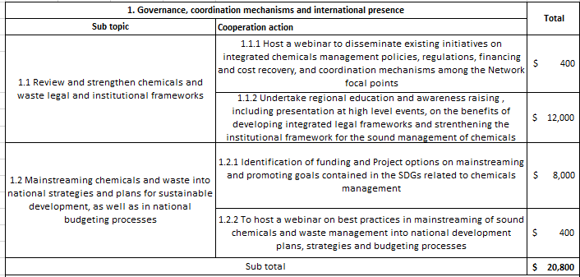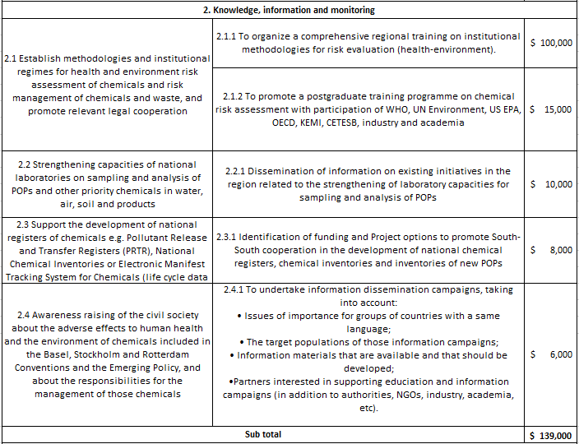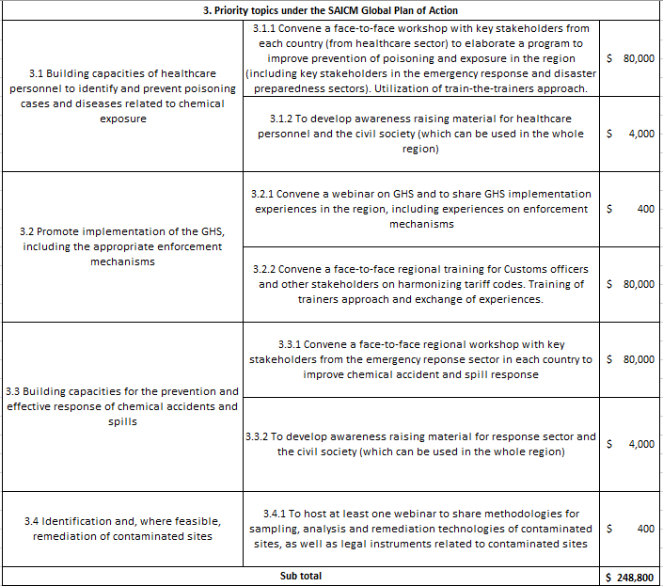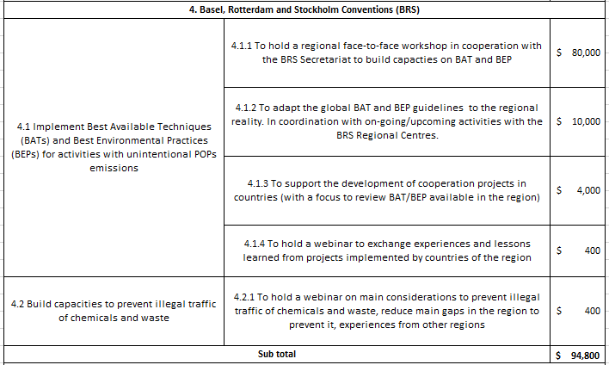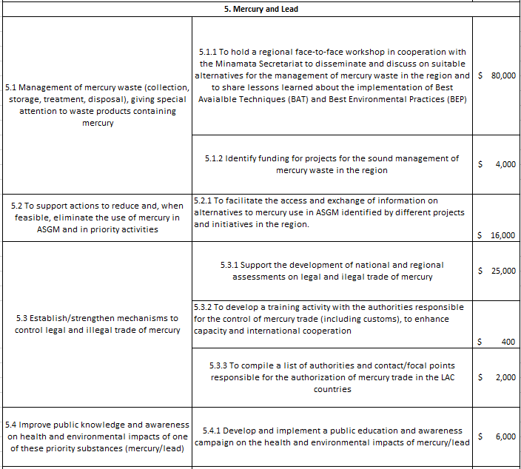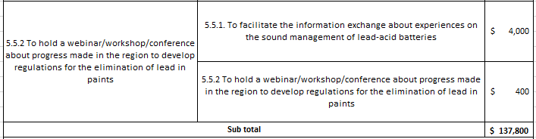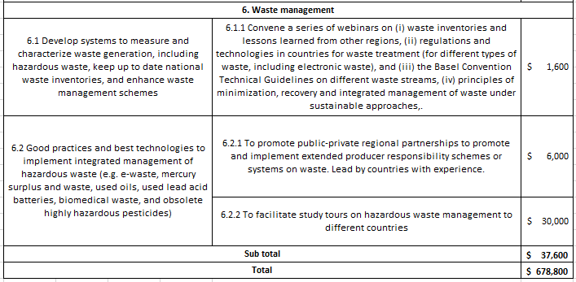

https://www.thegef.org/events/gef-7-replenishment
https://www.thegef.org/documents/gef-6-programming-directions
http://web.unep.org/chemicalsandwaste/special-programme/overview

