Working to

WESTERN

MOROCCO TUNISIA
SAHARA
ALGERIA
LIBYA
EGYPT
implement the

THE GAMBIA

MAURITANIA

SENEGAL

MALI

BURKINA

NIGER

CHAD

SUDAN

ERITREA
GUINEA-BISSAU
GUINEA
FASO

TOGO

BENIN NIGERIA

CENTRAL

SOUTH

ETHIOPIA
DJIBOUTI
SIERRA LEONE
LIBERIA
COTE GHANA
D’IVOIRE
CAMEROON
AFRICAN REPUBLIC
SUDAN
African Elephant
EQUATORIAL GUINEA

GABON CONGO

DEMOCRATIC REPUBLIC
OF THE CONGO
UGANDA KENYA

TANZANIA

SOMALIA
ANGOLA
ZAMBIA
MALAWI
Action Plan

NAMIBIA

ZIMBABWE BOTSWANA

LESO

MOZAMBIQUE
SWAZILAND
MADAGASCAR
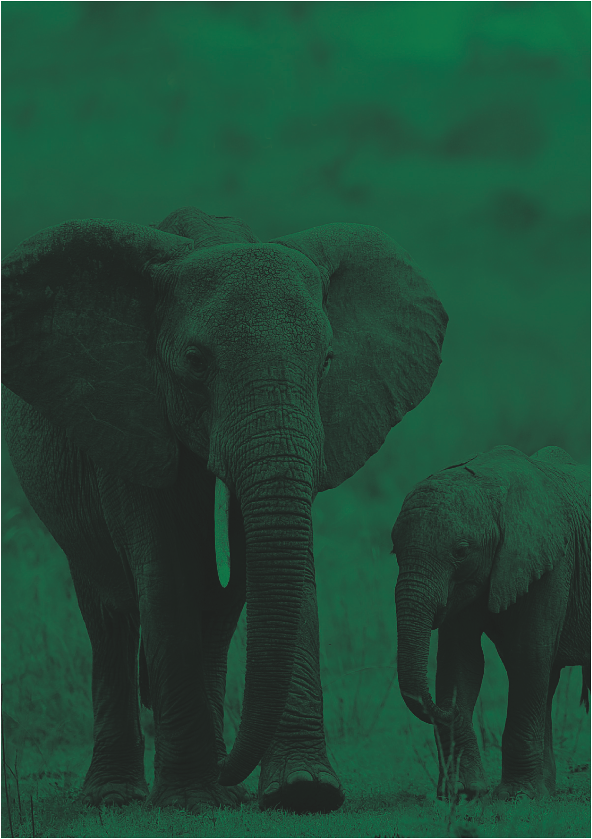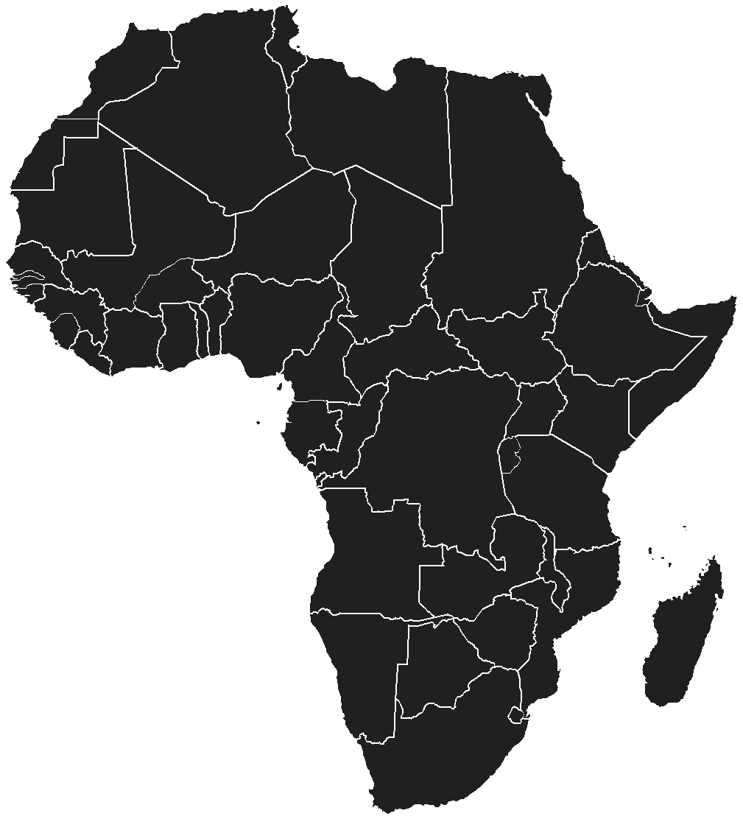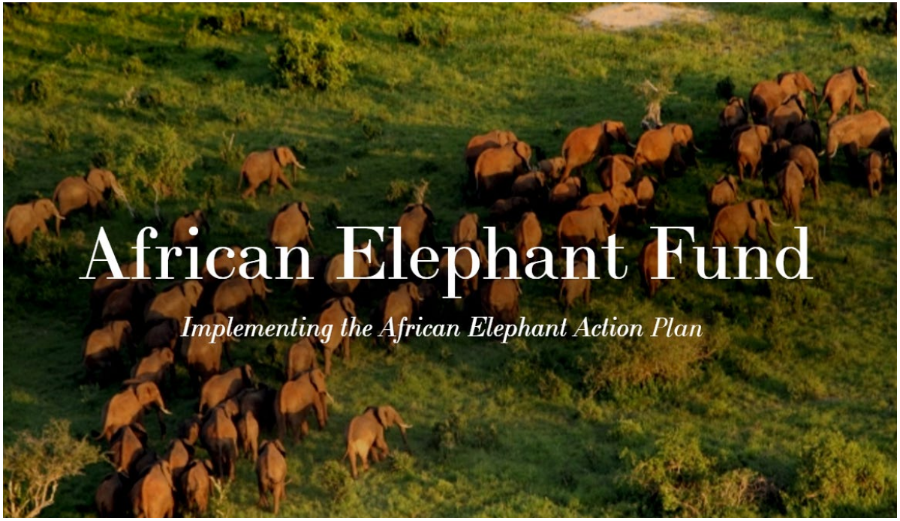AFRICA

The African Elephant Fund is a funding mechanism for implementing the African Elephant Action Plan (AEAP) to ensure the secure future of African elephant populations and their habitat. The AEAP was adopted in March 2010 at the 15th meeting of the Conference of the Parties to the Convention on International Trade in Endangered Species (CITES CoP15). The Plan was developed in response to Decisions 14.75 to 14.79 of CITES CoP14 which envisioned a plan and a fund to assist with its implementation.

The AEAP is fully owned and managed by the African elephant range States. It outlines the actions that must be taken in order to effectively conserve elephants in Africa across their range. It is not intended to be an exhaustive analysis of the status of elephant populations and their conservation across Africa. Rather, the AEAP is a concise and clear statement of those activities that must be implemented and most urgently require funding if Africa’s elephants throughout their range are to be protected from the multiple serious threats they face. The AEAP is the only document that has consensus among all African elephant range States

The AEAP has eight objectives:
1. To reduce illegal killing of elephants and illegal trade in elephant products;
2. To maintain elephant habitats and restore connectivity;
3. To reduce human-elephant conflict;
4. To increase awareness on elephant conservation and management of key stakeholders that
include policy makers and local communities among other interest groups;
5. To strengthen range States knowledge on African elephant management;
6. To strengthen cooperation and understanding among range states;
7. To improve local communities cooperation and collaboration on African elephant conservation;
8. To effectively implement the African Elephant Action Plan.

In implementing the AEAP, the African Elephant Fund works in 38 range states to secure and restore where possible, sustainable elephant populations throughout their present and potential range in Africa.

The range States currently involved
in implementing the AEAP are:
Angola, Benin, Botswana, Burkina Faso, Cameroon, Central African Republic, Chad, Democratic Republic of Congo, Republic of Congo, Côte d’Ivoire, Equatorial Guinea, Eritrea, Ethiopia, Gabon, Ghana, Guinea, Guinea-Bissau, Kenya, Liberia, Malawi, Mali, Mozambique, Namibia, Niger, Nigeria, Rwanda, Senegal, Sierra Leone, Somalia, South Africa, Sudan, South Sudan, Swaziland, United Republic of Tanzania, Togo, Uganda, Zambia, and Zimbabwe.

Governed by a Steering Committee, the African Elephant Fund Steering Committee (AEFSC), the Fund enables range States to implement activities of the AEAP.

Projects intended to work within States may be submitted to the AEFSC for selection and consideration to receive supplementary provisions to implement activities for the conservation of elephant populations.

Project templates may be downloaded from the AEF website at www.africanelephantfund.org

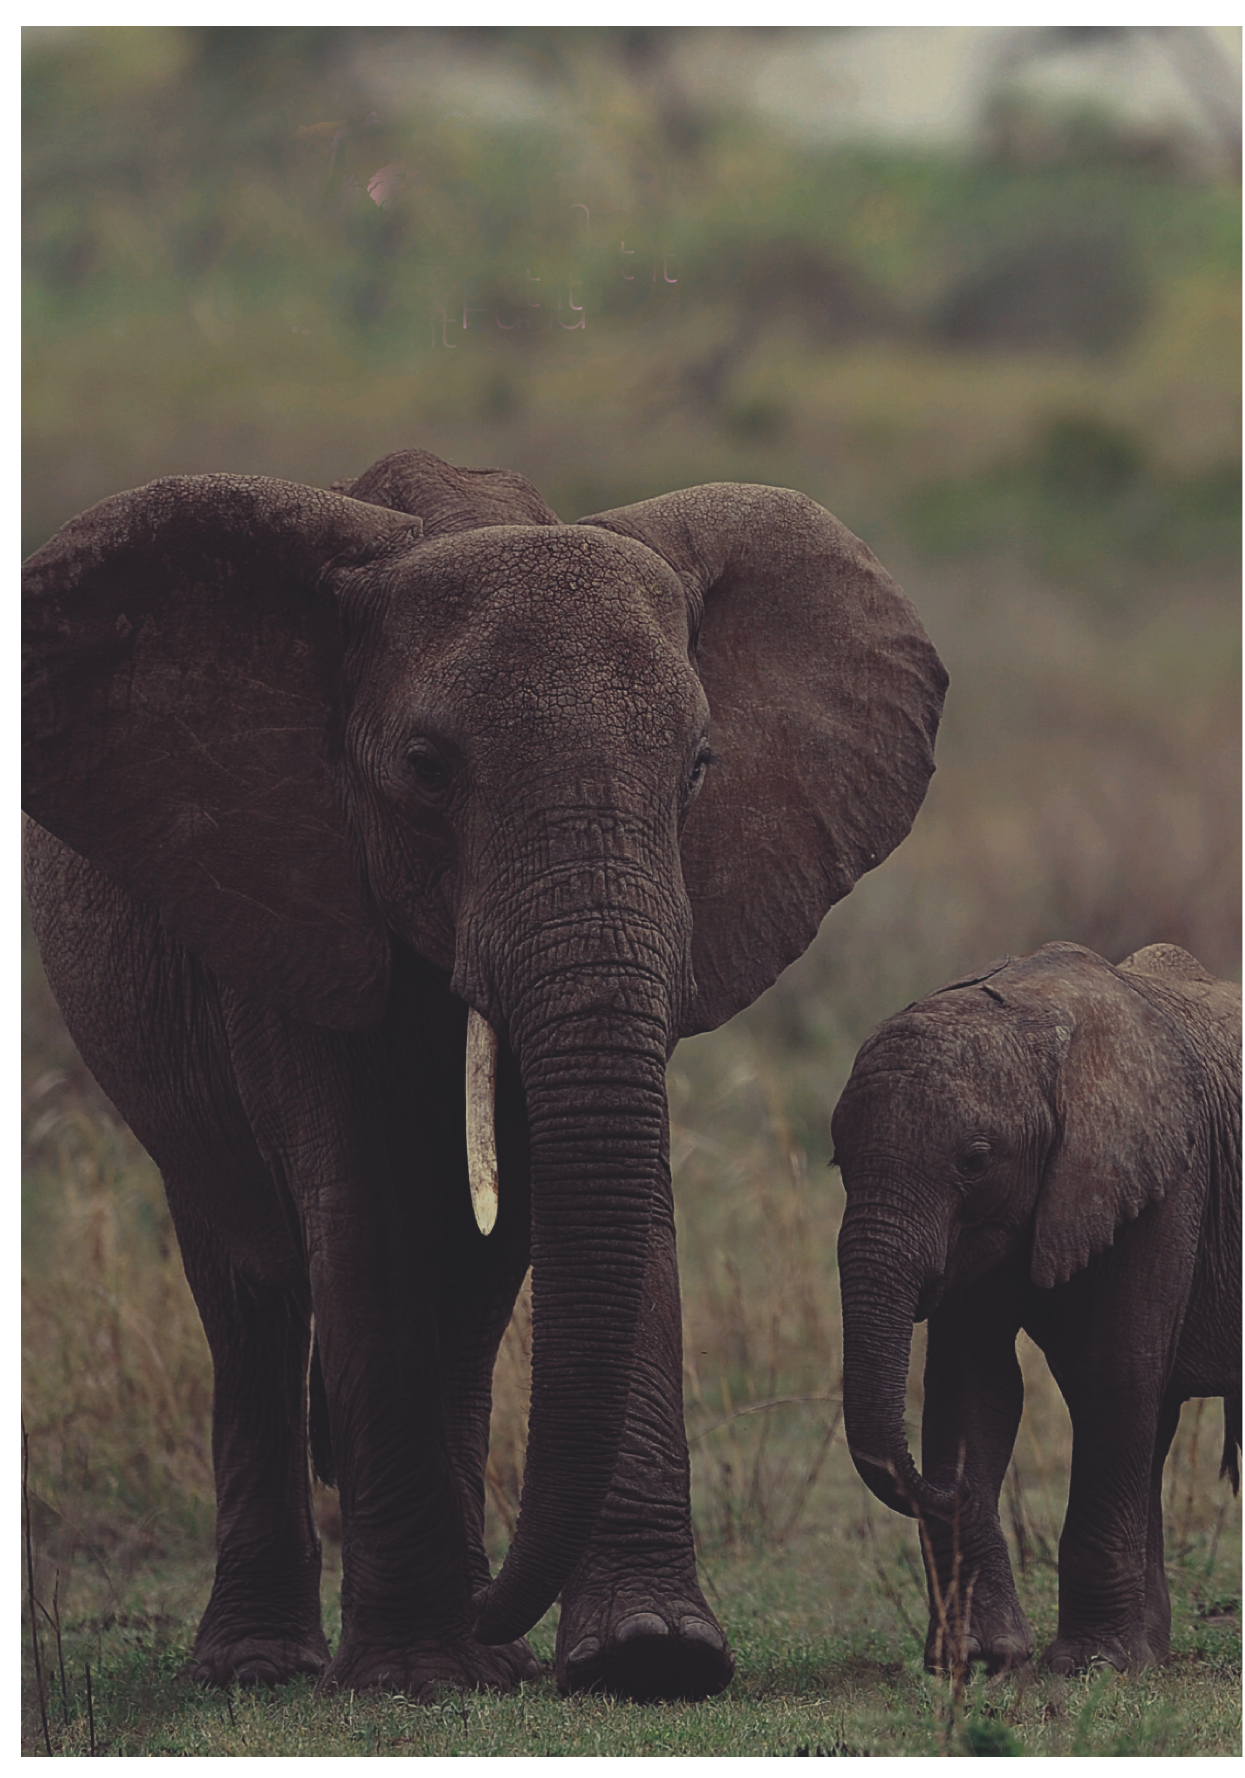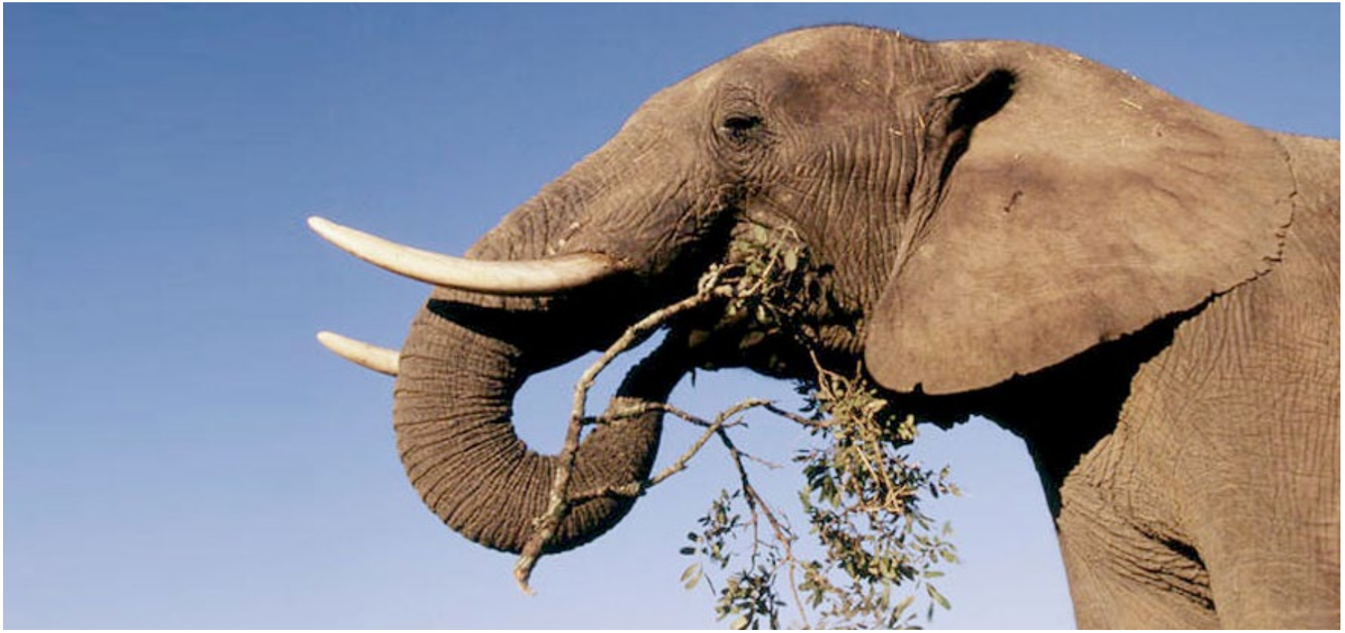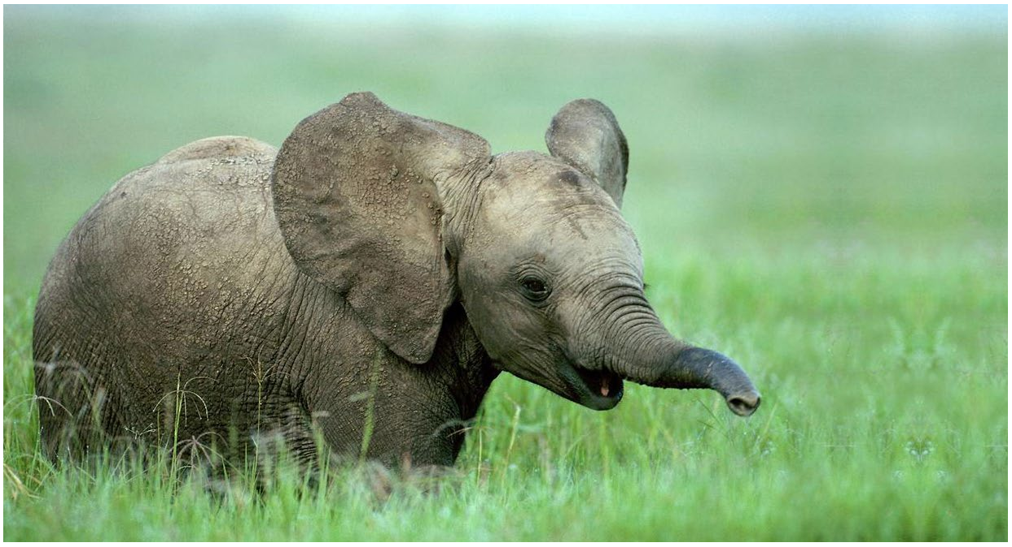Basic Principles for Evaluation and Selection of
Proposals to the AEF
1. Impartiality: Each proposal shall be evaluated without bias and based on merit.

2. Sustainability: The project proposal must demonstrate how it can be sustained in the long term, i.e. beyond the funding period. This must encompass long-term socioeconomic and ecological aspects.

3. Transparency: The AEFSC will send a summary communication to all applicants explaining in clear terms why a proposal has been accepted or rejected. Where appropriate, advice will be offered to guide applicants in improving future applications. For the proposal, it should demonstrate stakeholder involvement. For example, it may indicate communities that may be affected, NGOs and other organisations that are involved in the project or stakeholders to be informed about the project and their role in the project, the proposal should indicate the role each stakeholder will play.

4. Quality: Priority will be given to proposals that demonstrate potential to produce high quality outputs that meet the Priority Objectives outlined in the African Elephant Action Plan.

5. Source of Proposal: Priority will be given to proposals submitted by the designated Competent Authority (CA) of one (or more in the case of joint proposals) African Elephant Range State. Proposals may be submitted by the CA in collaboration with other stakeholders.
6. Independent Advice: The Steering Committee may at its discretion, seek the independent advice of relevant experts in the evaluation of certain proposals.

7. Earmarked Funds: Funds that have been donated to the AEF for a specific region or a specific purpose will be deployed by the Steering Committee according to the instructions of the donor.

8. Uniqueness, innovation and replicability: Projects that are unique, and may result in new innovations relating to elephant management, as well as those that can be replicated in other range States will be prioritised. This could include proposals aimed at addressing a fragile population or unique ecosystems to be conserved to ensure the conservation of the specific population of African elephants.

9. Good governance: The project proposal should demonstrate that good governance systems are in place or provided for, including financial management; monitoring and evaluation; and reporting. Proposals adequately reflecting this information will be prioritised.
Implementing the African
Elephant Action Plan

CHAD

CENTRAL AFRICAN REPUBLIC

Central Africa Projects
GABON
CONGO
DEMOCRATIC REPUBLIC
OF THE CONGO

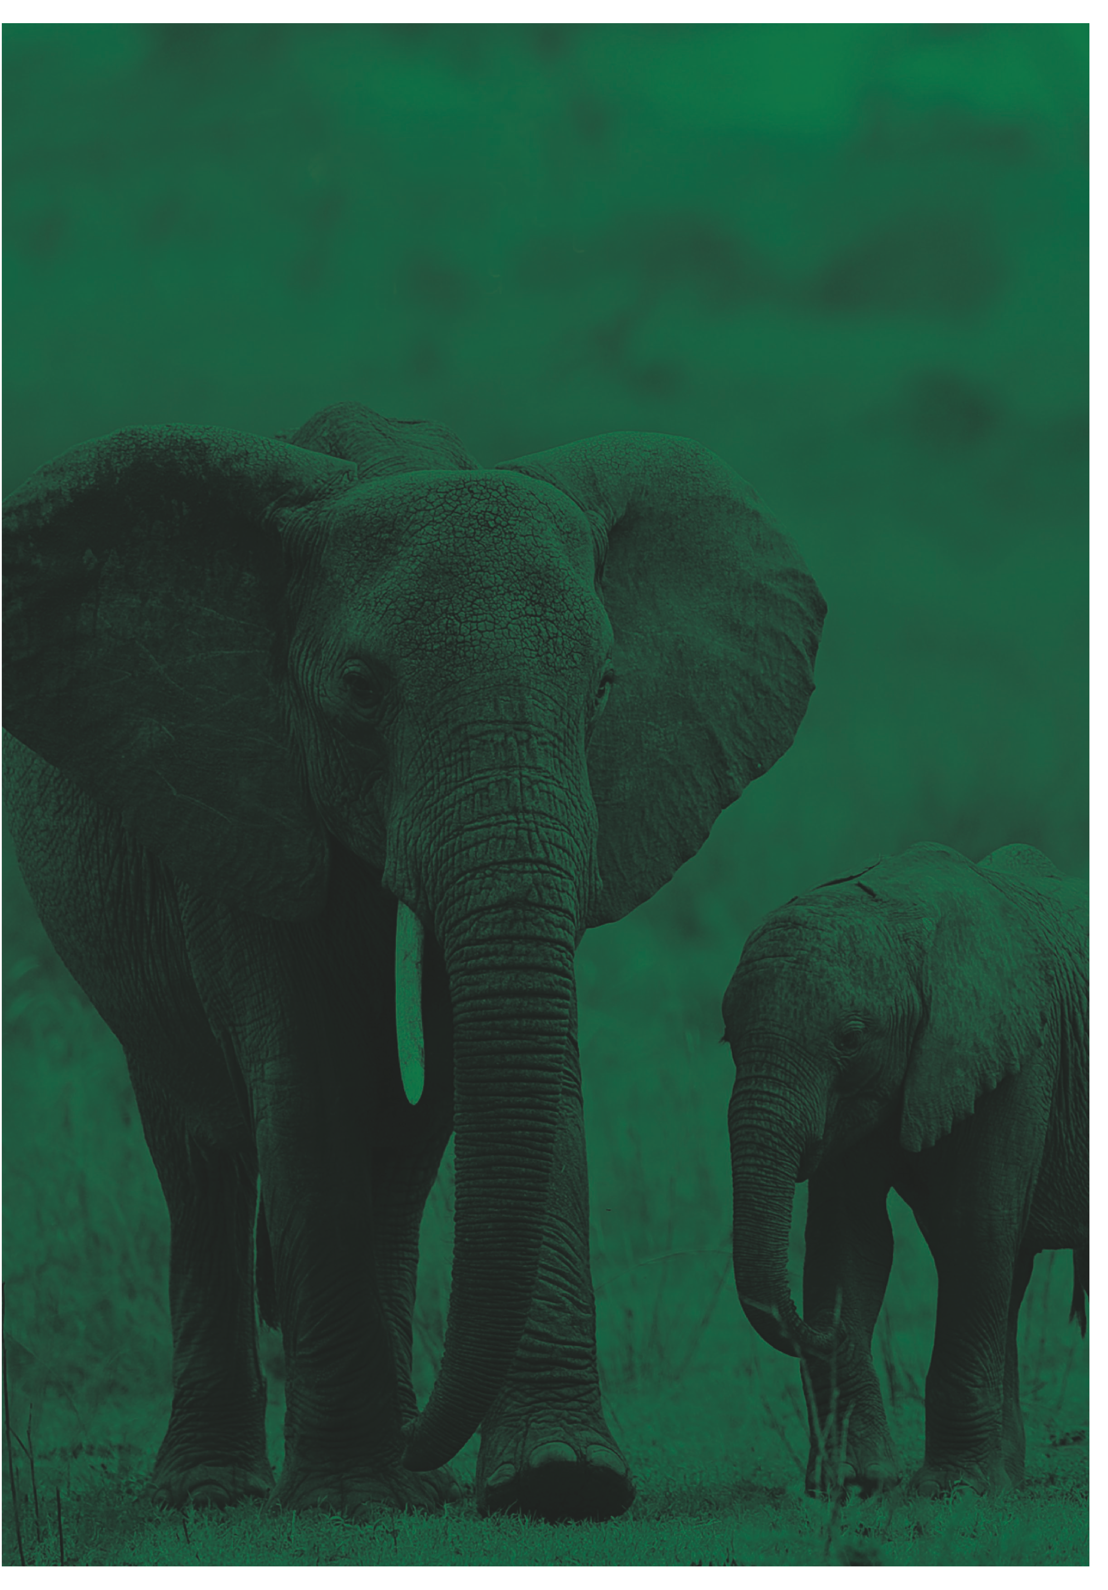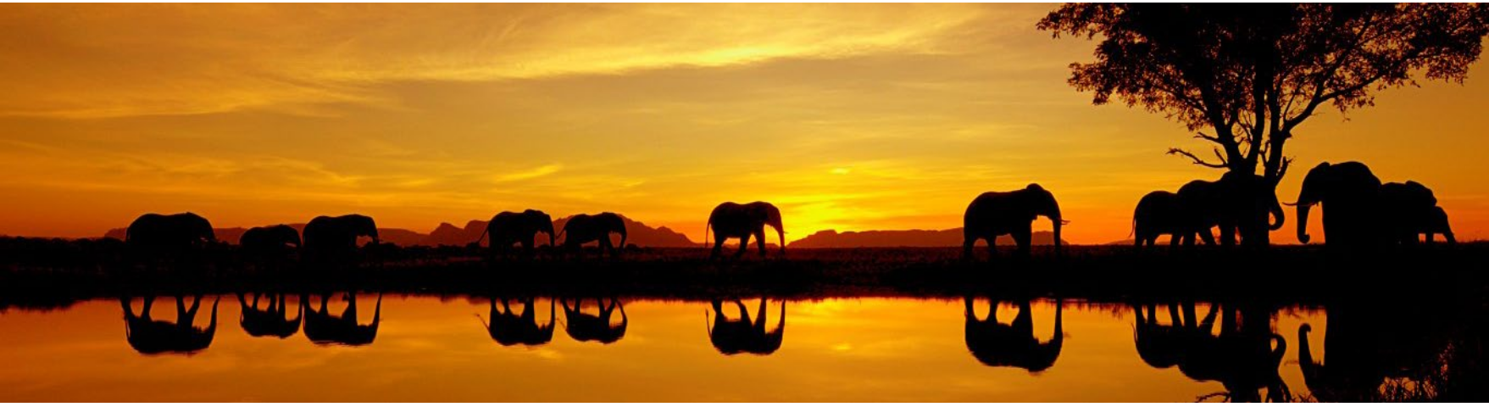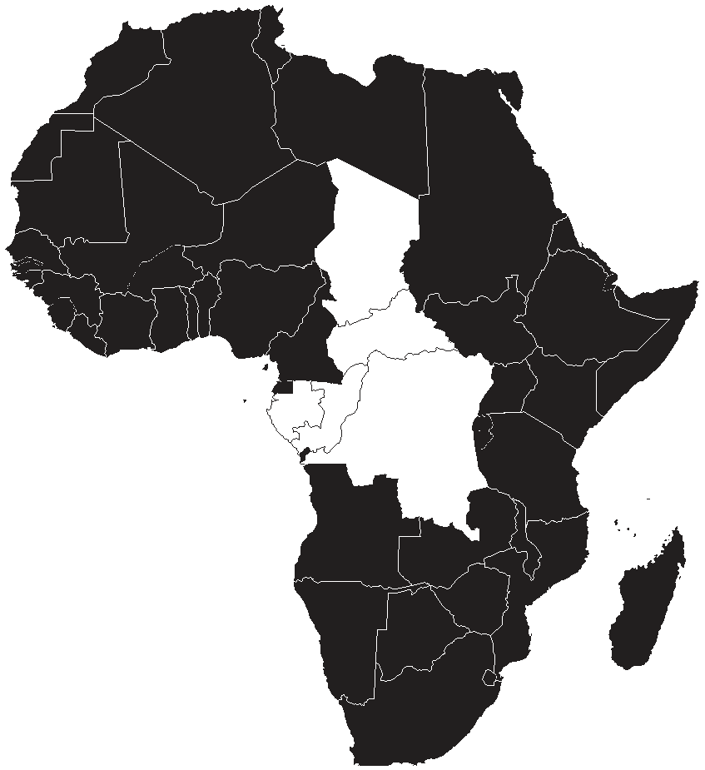Central African Republic
Contribution to the protection of elephant populations’ victims of political and military crisis in Central African Republic
The overall objectives of this project in protection of the elephant population in the Central African Republic are to strengthen the operational capacity of the anti- poaching teams, to strengthen the capacity of staff and local people to manage the human-elephant conflict, and to raise awareness on the political and social factors contributing to wildlife crime and poaching of elephants.

Congo, Cameroon and Central African Republic
Strengthening law enforcement capacity to combat elephant poaching and ivory trafficking in Central Africa
This project seeks to strengthen law enforcement by enhancing regional and international cooperation among range states working to address elephant poaching and illegal ivory trade. This will be done by establishing a regional training workshops for wildlife law enforcement officers in the Sangha Trinational Site (TNS,) a transboundary conservation ecosystem in the North- western Congo Basin for Cameroon, the Central African Republic and the Republic of Congo.

Congo
Reinforcement of operational capacities in the fight against the illegal trafficking of elephant products and sub-products
Objectives of the project are to establish an intelligence network to combat illegal trade in ivory, and to organize meetings for local communities and stakeholders to
increase awareness on elephant conservation and management.

Gabon
Genetic Traceability of Ivory for Law Enforcement in
Gabon
The aim of the project is to reduce illegal trade in ivory by working to establish autonomy for Gabon on traceability analysis of ivory, to determine the geographical origin of the ivories of the Gabonese national stock, and to develop an operational database to compare seized ivory and carcasses discovered in Gabon.

Developing a Quadcopter and Infrared Camera System to Monitor and Track the African Forest Elephant
Proponent hopes to develop new techniques for field monitoring of elephants, and to train and equip wildlife officers and local communities on appropriate human elephant conflict management approaches. The goal is to improve monitoring systems and to strengthen law enforcement capacity in combating poaching and illegal trade in ivory and mitigate HEC.

Military training for Gabon’s Park Rangers
This project aims to assist the Gabon’s Nation Parks Agency (ANPN) with provision for rations, equipment and cover training costs for rangers while they undertake training from British military personnel. This is aimed at enhancing their patrolling, tracking, first aid, military tactics, firing range and mission planning techniques in order to strengthen their capacity to combat poaching and illegal trade in ivory.
Implementing the African
Elephant Action Plan

SUDAN

SOUTH SUDAN

ERITREA

ETHIOPIA

East Africa Projects
UGANDA KENYA

TANZANIA
SOMALIA

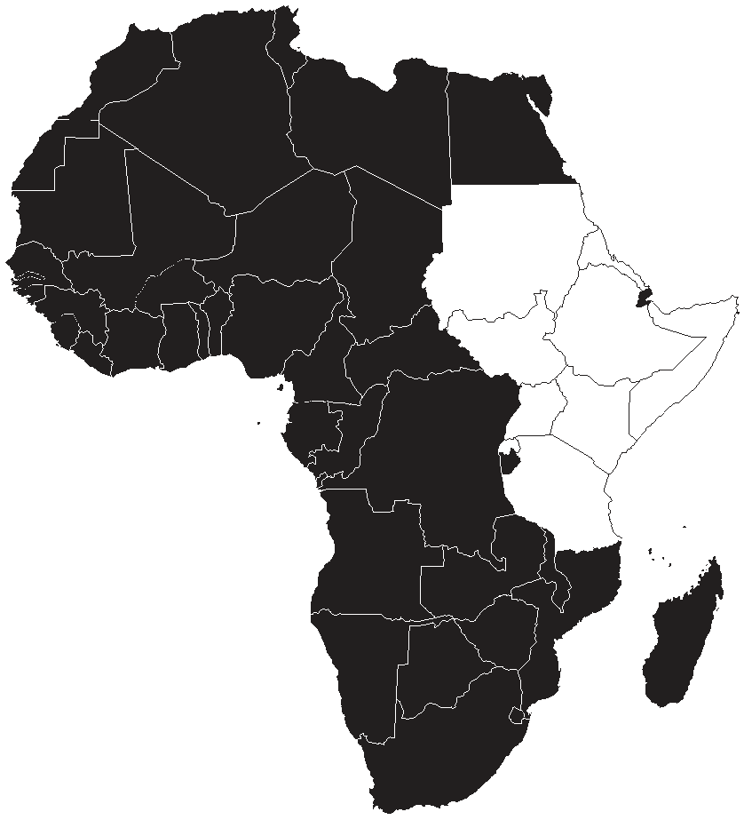Ethiopia
Improving field intelligence and investigation capacity for ivory and other wildlife crimes in Ethiopia
The project aims at introducing modern field intelligence methods to combat the increasingly professional wildlife crime through capacity building of intelligence networks, intelligence gathering, improving methods to secure evidence at crime sites, and enhancing evidence-handling and prosecution methods.

Combating the Illegal killing of elephants and regional trade of ivory in Southwest Ethiopia
As a key ivory transit hub between Africa and Asia, this project in Ethiopia is working to tackle issues in poaching and ivory trade by strengthening field patrolling, strengthening community support to save the elephants, and improving training of regional customs/enforcement/ judiciary officials at key sites and trade routes.

Law enforcement operation, workshop and capacity building in Southern Ethiopia
The project intends to conduct trainings for enforcement officers in the management of parks in the highest risk areas involved in illegal trade in ivory and hold workshops to engage and enhance capacity of officers to investigate and prosecute criminals involved in wildlife crime.

Kenya
Building capacity and developing tools for elephant censoring and elephant mortality monitoring in tropical mountain and forest habitats in Kenya

This project is working to strengthen range states’ knowledge on African elephant management by training staff on navigational skills, safety and survival skills in forested habitats, and to improve monitoring and tracking of elephant population.

The impact of poaching on elephants and threats to elephants in Tsavo-Mkomazi ecosystem.
The primary objective of the project is to conduct aerial monitoring and tracking of elephant populations in the Tsavo-Mkomazi ecosystem to accurately identify size and distribution of the population, to determine the
impact of poaching, and to map human activities around the protected areas to effectively enhance elephant management and conservation.

Kenya, Rwanda, South-Sudan, Tanzania, Uganda

Enhancing cooperation in combating elephant poaching and illegal ivory trade in East Africa
The proponent is working to establish bilateral mechanisms (Kenya/Tanzania, Kenya/Uganda, and Uganda/South-Sudan) on cross border wildlife law enforcement for elephant protection to increase cooperation and resources for combating elephant poaching and illegal ivory trade in the region.

Tanzania
Human-elephant conflicts mitigation around Kilimanjaro
National Park in Tanzania

The project endeavors to collect data on elephant crop damage and elephant movement patterns as well as to use bee fencing as a HEC mitigation measure.

Reinforcement of anti-poaching patrols to reduce illegal trafficking of ivory and other wildlife products at entry and exit points

The proponent aims to establish new inspection offices at border points, procure equipment and to train enforcement officers at entry and exit points, namely Dar es Salaam and Kilimanjaro international airports, Dar es Salaam and Tanga sea ports and Umoja bridge.

Uganda
Strengthening law enforcement against elephant poaching
and illegal ivory trade in Uganda

The aim of the project is to improve capacity in surveillance and intelligence gathering, to equip officers with investigation kits, and to establish a canine department to strengthen law enforcement efforts in conservation of elephants.
Implementing the African
Elephant Action Plan

SENEGAL

MALI

BURKINA

NIGER
GUINEA

SIERRA
GUINEA

COTE
FASO
TOGO
BENIN
NIGERIA
D’IVOIRE GHANA
CAMEROON

West Africa Projects
EQUAT

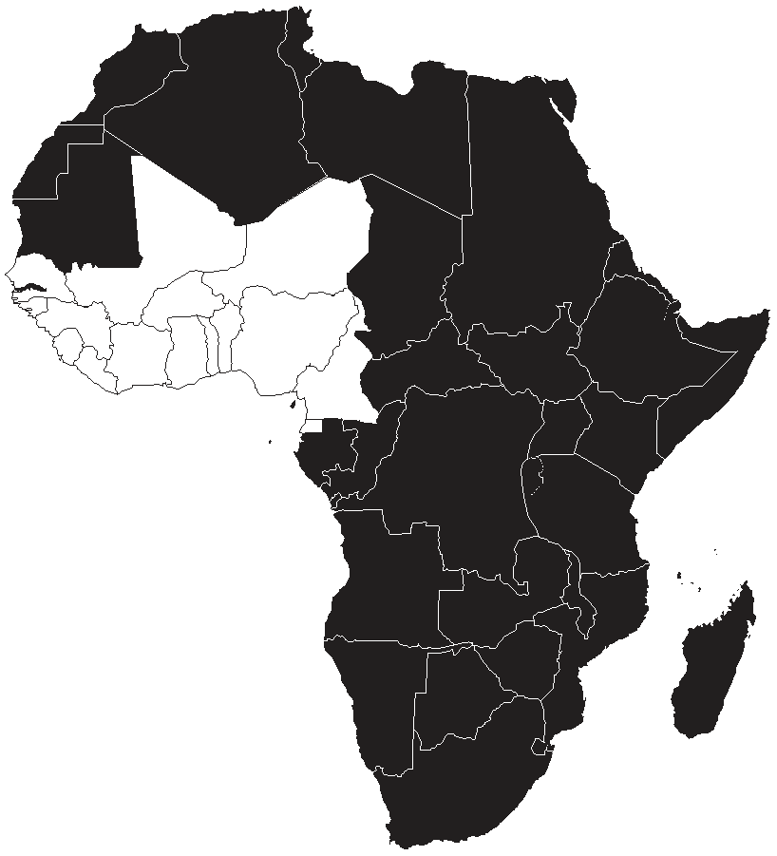Benin
Understanding of commercialization channels of ivory and ivory based products between Cote d’ivore, Benin, Burkina Faso, Niger and Togo

The proponents seek to study the ivory market channels in Ivory Coast, Benin, Burkina Faso, Niger and Togo, and to develop national and joint strategic action plans to reduce illegal trade in ivory.

Burkina Faso
Reinforcement of the human-elephant conflict management capabilities in Burkina Faso
The primary goal of the project is to assess HEC incidents in order to develop HEC prevention strategies that can be adopted in all affected areas to reinforce prevention capabilities.

Burkina Faso/Benin/Niger
Awareness projects for the fight against elephants’ poaching in the cross-border biosphere of the W Reserve (PSLAB/RBTW)
The project aims at developing awareness raising campaigns and engagement forums to enhance sub-regional cooperation between local communities and authorities on anti-poaching, preservation and the restoration of the ecosystem for sustainable development.

Ghana
Elephant conservation through law enforcement and stakeholder engagement in Mole National Park and its corridors

This project seeks to monitor and safeguard movement of the elephant within the Mole National Park and to collaborate with local communities on mitigation strategies for reducing human-elephant conflicts.

Reducing HEC through improved monitoring, stakeholder engagement and law enforcement
To reduce human-elephant conflicts and increase awareness on elephant conservation and management this projects seeks to build capacity of farmers to safeguard crops and develop alternative cropping systems to enhance stakeholder engagements and law enforcement practices on the management of elephant populations.
Ivory Coast
Improvement of knowledge of the elephants involved in the conflicts with men
The project is working to monitor radio collared elephants involved in conflicts to strengthen range states’ knowledge on management of injured elephants and improvement of protection and conservation of populations.

Mali
Contributions to human-elephant conflicts management in the surrounding ecosystem of the Gourma elephants.
The proponent is working to address the HEC incidences in Gourma by implementing awareness raising campaigns, conducting anti-poaching missions, and educating farmers on crop and livestock management to enhance harmonious cohabitation between elephants and locals.

Strengthening law enforcement capacity in close collaboration with local communities to protect the Gourma elephants
The primary objective of the project is to strengthen law enforcement capacity in Gourma by providing equipment to rangers and facilitating collaboration between rangers and local communities in patrolling and conducting anti-poaching missions.

Nigeria
Supporting SMART ranger patrols at Yankari Game Reserve to strengthen law enforcement and reducing elephant poaching
The purpose of the project is to reduce illegal killing of elephants by providing resources for continued management of existing protected areas.

Using satellite collars to provide more effective elephant protection and reduce human-elephant conflict at Yankari Game Reserve
The primary objective of the project is to research and pilot different mitigation strategies to reduce HEC incidences as well as provide satellite collars to monitor prioritized populations within and amongst range states.

Strengthen law enforcement and reducing elephant poaching at Yankari Game Reserve by providing rangers with basic field equipment
The aim of the project is to provide all rangers with basic field equipment to strengthen the capacity of law enforcement to improve anti-poaching to reduce the illegal killings of elephants and illegal trade in ivory and other elephant products.
Implementing the African
Elephant Action Plan

Southern Africa Projects
ANGOLA ZAMBIA
MALAWI

SWAZILAND
NAMIBIA
ZIMBABWE MOZAMBIQUE
BOTSWANA
SOUTH AFRICA

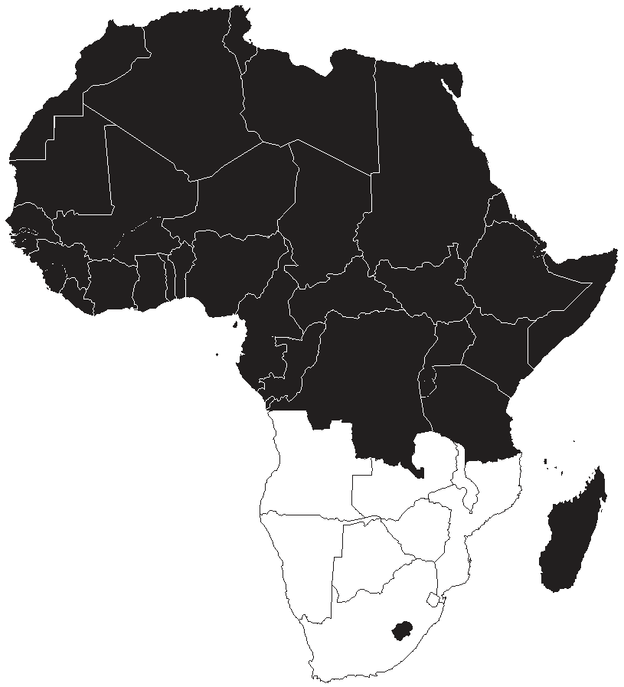Angola
Resolution of the human-elephant conflict
The proponent seeks to address the HEC incidents in the country by establishing training workshops and meetings between local community and authorities, producing and disseminating awareness raising publications, developing mechanisms for the management of HEC and organizing a national seminar on techniques for HEC management.

Botswana
Spatial and behavioral analyses of elephant roaming outside
expected ranges using modern monitoring tools
The primary mission of the project is to strengthen range state knowledge on African elephant management by enhancing understanding of factors influencing space use by elephants outside regular home ranges and improving operational capacity in data collection and interpretation in relation to elephant populations outside regular home ranges.

Malawi
Extension of an electric fence to reduce Human elephant conflicts
The primary purpose of the project is to erect a 30km solar powered electrical fence to reduce HEC and combat poaching by preventing elephants from leaving the Thuma Forest Reserve and Dedza-Salima Escarpment SOS.

Improving protection of elephants and enforcement of wildlife laws in Kasungu National Park
To bolster efforts to combat poaching in Kasungu National Park, this projects seeks to train law enforcement personnel in CITES and elephant conservation management as well as equip law enforcement staff with necessary equipment for elephant protection efforts.

Mozambique
Elephant ivory stockpile management and conservation in
Mozambique
The objective of the project is to strengthen range states knowledge on African elephant management by enhancing their monitoring and conservation capacities
in cataloguing stockpiles, reinforcing their patrolling efforts on the domestic ivory market and boosting their cooperation efforts in intelligence and enforcement to monitor illegal trade in ivory.

Namibia

Aerial Survey of elephants in the Northwest of Namibia
This project seeks to conduct a survey combining total, block and sample count techniques to improve monitoring of elephant population in the region to estimate the population density and distribution of the elephant populations in Northwest Namibia.

Zambia
Enhancing effectiveness of law enforcement monitoring and analysis systems in Zambia’s elephant range areas
By introducing Spatial Monitoring and Reporting Tool (SMART), this project seeks to enhance data collection systems to enable rangers to effectively monitor elephant range areas in Zambia.

Human-elephant conflicts vulnerability assessment and mitigation tools in Zambia
This project aims to assess the livelihoods of the people in Lupande and Chiawa Game Management Areas affected by HEC in order to mobilize community support in the implementation and promotion of strategies to help reduce HEC incidents.

Strengthening law enforcement capacity to combat illegal killings of elephants in Zambia

The project is determined to enhance the capacity of the Zambia Wildlife Authorities law enforcement by offering specialized intelligence and investigations training for wildlife law enforcement officers to impart knowledge and skills aimed at countering annihilation of elephants and improved trafficking strategies within and outside the protected areas.
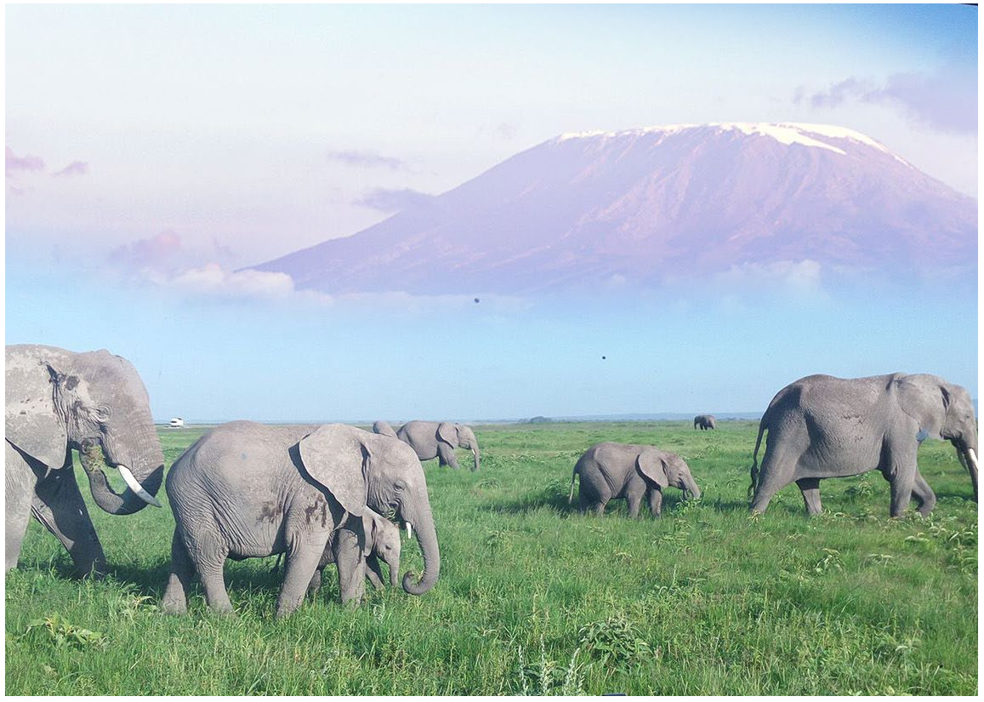How to get involved

Proponents looking to submit proposals can communicate with the regional representatives in the AEF Steering Committee to receive assistance on development of proposals or get more information on how they can benefit from the Fund.
CITES SECRETARIAT
Tom de Meulenaer | Tel: +41 22 917 8139 / 40  Email: Tom.De-Meulenaer@cites.org
Julian Blanc | Tel: +254 20 762 5174  Email: Julian.Blanc@unep.org;  julian.blanc@cites.org

EAST
Kenya | Patrick Omondi | Tel: +254 20 6000800/ 237 9407/8  Cell: +0735 663421/ +0726610508/9, 0775-563642  Fax: +254 20 6103792  Email: pomondi@kws.go.ke
Ethiopia | Dawud Mume Ali | Tel:+251 0 913493466/ 938407749  Email: dawudmume@gmail.com
CENTRAL
Congo | Roger Albert Mbete | Tel: +242 06 665 56 00 / 05 665 56 00  Email: rogermbete@gmail.com
Gabon | Lee White | Tel : +241 04 233 113  Email: lwhite@uuplus.com ; lwhite@parcsgabon.ga
WEST
Burkina Faso | Benoit Doamba | Tel: +226 76 66 33 02 / 70 09 71 77 / 78 28 73 28  Email: faunechasses@fasonet.bf; benoitdoamba@hotmail.com
Ghana | Kofi Nana Adu-Nsiah | Tel : +233 28 911 54 99;+233 24 410 71 43  Email: info.wd@fcghana.org adunsiah@yahoo.com
SOUTH
Botswana | Cyril Taolo | Tel: + 267 3973097, Fax: + 267 391 23  Email: ctaolo@gov.bw
South Africa | Thea Carroll | Tel: +27 12 310 35 75, Fax: +27 12 320 70 26  Email: tcarroll@environment.gov.za
DONORS
Belgium | Miet Van Looy | Tel:+02 524 74 21 | Fax: +02 524 74 49  Email: miet.vanlooy@milieu.belgie.be
Germany | Frank Barsch | Tel: +49 228 99305-2633 , Fax: +49 228 9910305-2633  Email: Frank.Barsch@bmub.bund.de
Netherlands | Marcel Van Nijnatten | Tel: +31 70 378 4093 ; +31650611677  Email: m.j.h.vannijnatten@mineleni.nl

AEF SECRETARIAT
Mamadou Kane | Tel: +254 20 762 5046  Email: Mamadou.Kane@unep.org
Barbara Matu | Tel: +254 20 762 5625  Email: Barbara.Matu@unep.org

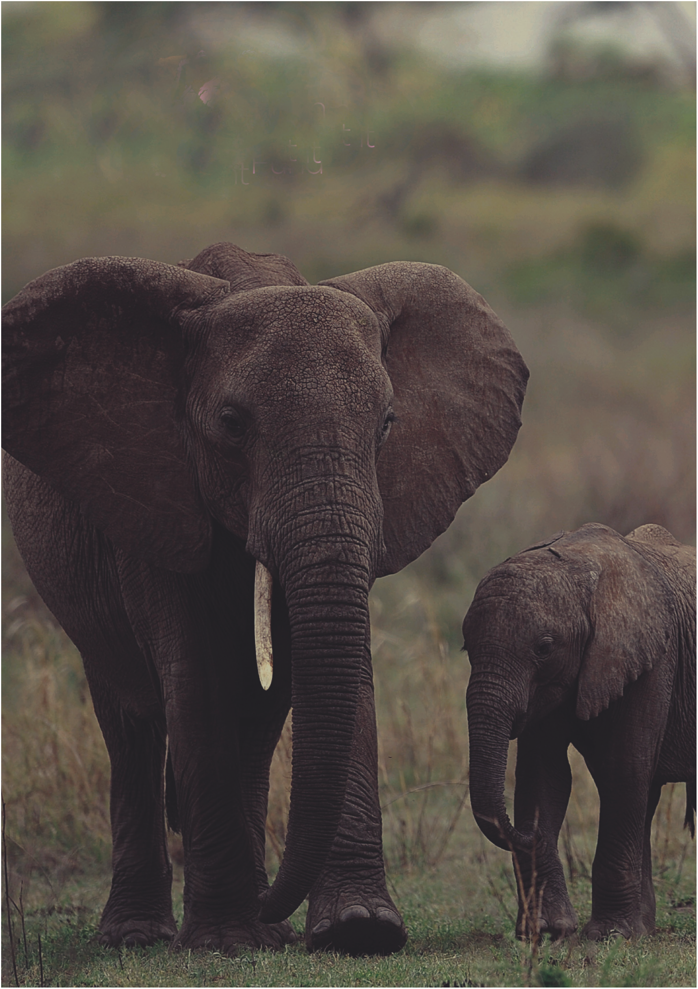The African elephant range States continue to work towards protecting, restoring and managing the African elephant populations and their habitat across their range. With the help of the AEF many projects are underway in the States and the threatened existence to elephants posed by poaching, illegal trade, human elephant conflicts, local overpopulation and loss and fragmentation can be prevented, reduced and ultimately, eradicated. Killings, illegal trade, increasing human population, and space are areas that the AEF is working to address, and in which range states are cooperatively delivering results to ensure the future of the world’s most charismatic, majestic, and largest terrestrial mammal, the African elephant, (Loxodonta africana).

To find out more on the ongoing projects funded by the AEF, how you can contribute to the Fund or how you can get involved, please visit our webpage at: www.africanelephantfund.org, email:africanelephantfund@unep.org, Tel: +254 20 762 5046; +254 20 762 5625, or visit us at: United Nations Environment Programme, United Nations Avenue, Gigiri, Nairobi, Kenya. P.O Box 30552-00100, Nairobi, Kenya.

