UNITED  NATIONS |  | EP
 |  | UNEP/EA.5/3/Add.1
 | United Nations  Environment Assembly of the  United Nations Environment Programme | Distr.: General  7 December 2020  Original: English
United Nations Environment Assembly of the
United Nations Environment Programme
Fifth session
Nairobi (online), 22‒26 February 2021*
Item 6 of the provisional agenda**
Programme of work and budget and other administrative and budgetary issues
For people and planet: the United Nations Environment Programme strategy for 2022–2025 to tackle climate change, loss of nature and pollution
Addendum
The present addendum contains, in the annex, the United Nations Environment Programme programme of work and budget for 2022‒2023, as a supplement to the medium-term strategy for 2022‒2025 (UNEP/EA.5/3).

Annex
Programme of work and budget for 2022‒2023

Contents
Introduction 4
I. UNEP results framework for 2022‒2023 5
A. A set of integrated results on the road towards climate stability, living in harmony with nature and a pollution-free planet 5
1. Science-policy as a foundation 9
2. Environmental governance as a foundation 10
3. Finance and economic transformation as an enabler 11
4. Digital transformation as an enabler 12
B. UNEP performance measures: indicators that take programme integration one step further 13
1. Three thematic subprogrammes to support the strategic objectives of climate stability, living in harmony with nature and a pollution-free planet 17
2. Two foundational subprogrammes at the core of UNEP work to inform its engagements and catalyse its actions: science-policy and environmental governance 24
3. Two enabling subprogrammes to deliver more sustainable patterns of consumption and production and systematize, integrate and democratize environmental data, knowledge and insight for new collaboration opportunities and enhanced impact: finance and economic transformations and digital transformations 27
II. …enhanced by UNEP executive leadership, coherent policy-setting, and efficient programme management and support... 31
A. Executive direction and management 31
B. Policymaking organs 33
C. Programme management and support 35
III. …and supported by a focused budget 37
A. Planning assumptions and budget envelopes 37
B. Overview of resources 38
1. Environment Fund 38
2. Earmarked funds, global trust funds and programme support costs 39
3. Regular budget 40
4. Resource requirements for all funding sources 40
C. Resource mobilization 42
1. Environment Fund 42
2. Regular budget 43
3. Funding partners 43
4. Human resources 43
Appendices
I. Evaluation plan for the period 2022‒2023 45
II. Audited financial statements of the United Nations Environment Programme for the year ended on 31 December 2019 and recommendations of the United Nations Board of Auditors (A/75/5/Add.7) 48
III. Organization chart 49

Introduction
- This document presents the programme of work for the United Nations Environment Programme (UNEP) for the 2022‒2023 biennium, along with the associated budget. The programme of work sets out the UNEP results framework for the biennium, focused on the three strategic objectives outlined in the medium-term strategy.
- Section I of the document describes the UNEP results framework in terms of a set of integrated interventions measured by relevant indicators, in line with the medium-term strategy. It sets out a theory of change for each of the three strategic objectives of the medium-term strategy, “climate stability”, “living in harmony with nature” and “towards a pollution-free planet”. The results framework sets out the core UNEP areas of work, consisting of three principal areas of action (encapsulated in the climate action, nature action and chemicals and pollution action thematic subprogrammes) supported by two foundational subprogrammes (science-policy and environmental governance) and two enabling subprogrammes (finance and economic transformations and digital transformations). These thematic, foundational and enabling are interdependent, designed to work together to support the achievement of the global goals of the 2030 Agenda for Sustainable Development and other internationally agreed frameworks.
- Overall, the programme of work shows how the UNEP thematic subprogrammes (supported by the enabling and foundational subprogrammes) will drive the transformational shifts targeted by the medium-term strategy for 2022‒2025; outlines the means of measuring the effectiveness of UNEP in its direct, enabling and influencing roles; and defines a time-bound trajectory that aligns the organization with the 2030 Agenda. The three thematic subprogrammes will work towards a set of 2025 outcomes, supported by relevant indicators for measuring the results achieved in an integrated and focused manner that takes into account the contributions of the foundational and enabling subprogrammes to sustainable consumption and production.
- Section II underlines how the executive leadership of UNEP, coherent policy-setting and efficient programme management and support will drive the organization forward from the inside towards greater focus and effectiveness of results on the outside. Building on lessons learned from the UNEP transformation process launched in 2019, these elements will guide UNEP efforts to deliver more impactful results.
- Section III presents the UNEP budget for the 2022‒2023 biennium. An overview of UNEP resources for the biennium is followed by more detailed data regarding allocations by subprogramme and funding source, as well as a snapshot of UNEP efforts to increase resource mobilization and optimize its human resources practices. The final section is followed by three appendices that provide the evaluation plan for 2022–23, audited financial statements for the year ended on 31 December 2019 and an organization chart for UNEP.

I. UNEP results framework for 2022‒2023
A. A set of integrated results on the road towards climate stability, living in harmony with nature and a pollution-free planet
- Three strategic objectives will drive the UNEP results framework. The programme of work for 2022‒2023 articulates the UNEP results framework around three strategic objectives that will contribute to the UNEP vision for the 2030 Agenda and the decade of action to deliver the Sustainable Development Goals (figure 1). The three strategic objectives are “climate stability”, “living in harmony with nature” and “towards a pollution-free planet”.
Figure 1
UNEP medium-term strategy for 2022‒2025 – on the road to 2030

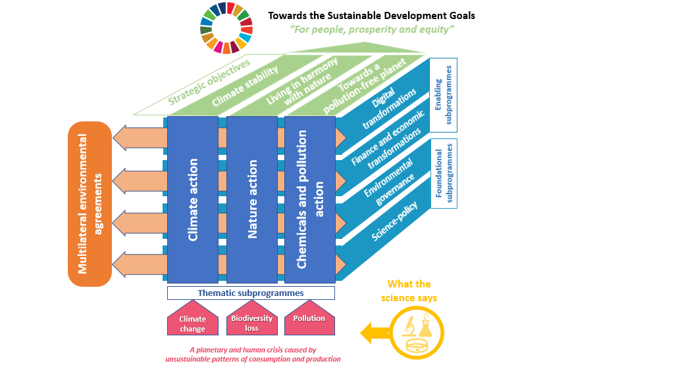

- The programme of work demonstrates how the UNEP subprogrammes come together in an integrated manner to deliver interconnected and mutually beneficial results. Building on
pre-existing work, with an integrated approach that leverages partnerships and cross-sectoral initiatives such as the 10-Year Framework of Programmes on Sustainable Consumption and Production Patterns, UNEP will accelerate and scale up transformational shifts towards sustainable patterns of consumption and production while targeting the drivers of, and proposing solutions to, the challenges of climate change, biodiversity loss and pollution.
- UNEP interventions will aim to benefit from the comparative advantage of each subprogramme to improve cost-effectiveness and have a greater, more strategic impact. Enhanced coordination and greater focus on the strategic linkages among UNEP subprogrammes will secure greater efficiency and effectiveness, optimize resources and generate consistent results that benefit from the supporting actions of the foundational and enabling subprogrammes to achieve multiple outcomes for the three UNEP thematic subprogrammes.
- The theories of change shown in figures 2, 3 and 4 map out a path for UNEP to its strategic objectives of climate stability, living in harmony with nature and towards a pollution-free planet. Each theory of change follows an integrated approach with a causal pathway that:
- Connects the 2025 outcomes of the UNEP thematic subprogrammes with the UNEP vision for the 2030 Agenda, the decade of action and beyond, as outlined in the medium-term strategy, setting out a trajectory for UNEP for the period 2026‒2029 through intermediate outcomes;
- Encompasses a set of direct outcomes that show how the interventions across the UNEP thematic, foundational and enabling subprogrammes come together in an integrated manner; each theory of change highlights direct outcomes supported by one or more of the seven subprogrammes, with foundational interventions under the leadership of the science-policy and environmental governance subprogrammes and enabling interventions under the leadership of the finance and economic transformations and digital transformations subprogrammes, while thematic interventions are led by the climate action, nature action and chemicals and pollution action subprogrammes;
- Outlines the assumptions, drivers and external risks that UNEP will take into account to achieve its strategic aspirations.

Figure 2
Climate stability ‒ theory of change
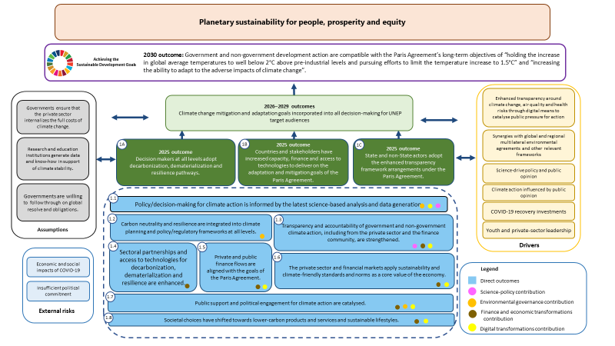

Figure 3
Living in harmony with nature ‒ theory of change

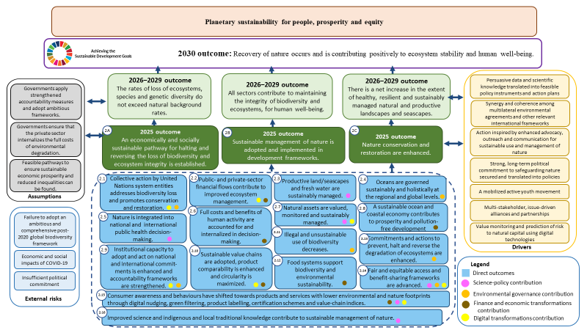

Figure 4
Towards a pollution-free planet ‒ theory of change
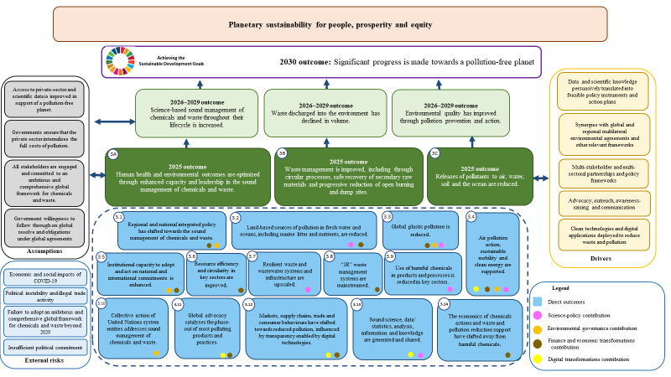

- The integration of the UNEP thematic, foundational and enabling subprogrammes is highlighted by the attribution of the direct outcomes of the thematic subprogrammes to foundational and enabling interventions under the science-policy, environmental governance, finance and economic transformations and digital transformations subprogrammes, as shown in tables 1 to 4 and as explained below.
1. Science-policy as a foundation
- The science-policy subprogramme will empower Governments and other stakeholders to make evidence-based decisions through environmental assessments, identification of emerging issues and fostering of policy action towards the achievement of the outcomes for the climate action, nature action and chemicals and pollution action subprogrammes. As the custodian agency for 26 of the Sustainable Development Goal indicators, UNEP will be actively involved in the development and refinement of data collection methodologies, particularly for environmental indicators that remain without internationally established methodologies and standards. UNEP will create the enabling conditions for countries to institutionalize environmental indicator monitoring, data calibration and reporting. It will continue to strengthen the science-policy interface through, among other things, servicing other subprogrammes in policy-relevant assessments and analyses informed by regional priorities and strong partnerships with expert networks and scientific bodies. UNEP will also deploy innovative and targeted publications to ensure that information and data reach key target audiences and are freely accessible.
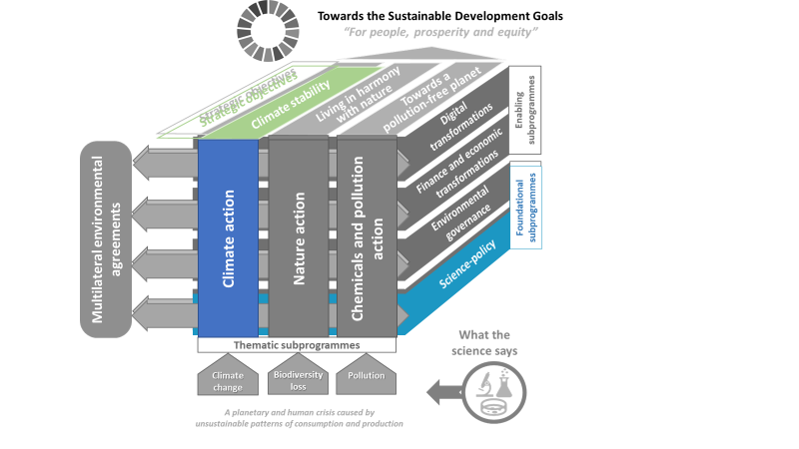
Table 1
Science-policy support for climate action, nature action, and chemicals and pollution action
The science-policy subprogramme will provide the foundation for the following direct outcomes of the climate action, nature action and chemicals and pollution action subprogrammes:
Climate action
- Policy/decision-making for climate action is informed by the latest science-based analysis and data generation.
- Transparency and accountability of government and non-government climate action, including from the private sector and finance community, is strengthened.
Nature action
- Productive land-/seascapes and fresh water are sustainably managed.
- Nature is integrated into national and international public-health decision-making.
- Natural assets are valued, monitored and sustainably managed.
- Improved science and indigenous and local traditional knowledge contribute to sustainable management of nature.
- Fair and equitable sharing of the benefits arising out of the utilization of genetic resources, including by appropriate access to genetic resources and appropriate transfer of relevant technologies, is advanced.
- Consumer awareness and behaviours have shifted towards products and services with lower environmental and nature footprints through digital nudging, green filtering, product labelling, certification schemes and value-chain indices.
Chemicals and pollution action
- Sound science, data/statistics, analysis, information and knowledge are generated and shared.
- Air pollution action, sustainable mobility and clean energy are supported.
- Global plastic pollution is reduced.
- Resilient waste and wastewater systems and infrastructure are upscaled.
- Use of harmful chemicals in products and processes is reduced in key sectors.
- Land-based sources of pollution in fresh water and oceans, including marine litter and nutrients, are reduced.
2. Environmental governance as a foundation
- The environmental governance subprogramme will support countries in developing and implementing the environmental rule of law and in identifying integrated legal and policy responses that promote participatory and effective environmental decision-making. UNEP will support institutional strengthening and the development and effective implementation of appropriate legal frameworks and policies. Through flagship programmes such as the Programme for the Development and Review of Environmental Law (Montevideo Programme) and initiatives to support and partner with the secretariats of multilateral environmental agreements, UNEP will support countries in applying environmental law, including multilateral environmental agreements, and achieving the Sustainable Development Goals and other internationally agreed environmental goals and commitments, including by integrating them into national policies, legal frameworks and action. UNEP will also support countries in working together in an integrated manner to address specific environmental issues that cut across national borders with effective environmental law and governance solutions.

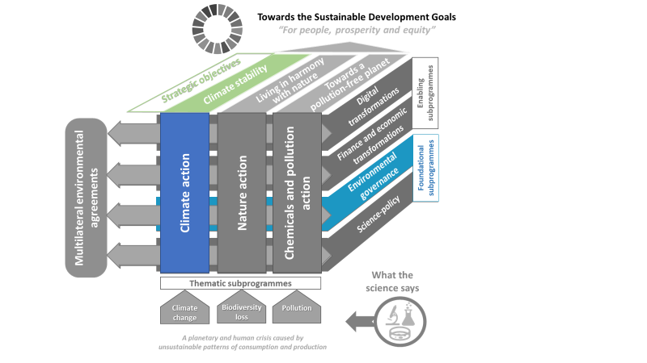
Table 2
Environmental governance support for climate action, nature action and chemicals and pollution action
The environmental governance subprogramme will provide the foundation for the following direct outcomes of the climate action, nature action and chemicals and pollution action subprogrammes:
Climate action
- Public support and political engagement for climate action are catalysed.
- Carbon neutrality and resilience are integrated into climate planning and policy/regulatory frameworks at all levels.
- Policy/decision-making for climate action is informed by the latest science-based analysis and data generation.
Nature action
- Collective action by the United Nations system entities addresses biodiversity loss and promotes conservation and restoration.
- Institutional capacity to adopt and act on national and international commitments is enhanced and accountability frameworks are strengthened.
- Illegal and unsustainable use of biodiversity is decreased.
- Oceans are governed sustainably and holistically at the regional and global levels.
- Commitments and actions to prevent, halt and reverse the degradation of ecosystems are enhanced.
Chemicals and pollution action
- Collective action of United Nations system entities addresses sound management of chemicals and waste.
- Regional and national integrated policy has shifted towards the sound management of chemicals and waste.
- Institutional capacity to adopt and act on national and international commitments is enhanced.
- Air pollution action, sustainable mobility and clean energy are supported.
- Global plastic pollution is reduced.
3. Finance and economic transformation as an enabler
- The finance and economic transformations subprogramme will leverage business value chains, private finance and consumer behaviours and enhance economic policies to support the achievement of climate, nature, and chemicals and pollution outcomes. UNEP will support transformed economic policies, including trade policies, to accelerate the shift to more sustainable patterns of consumption, production, investment and equity. In addition, UNEP will support principles and standards that enable private finance and business and their value chains to improve environmental sustainability. UNEP information- and knowledge-sharing work will inform more sustainable consumer behaviour.
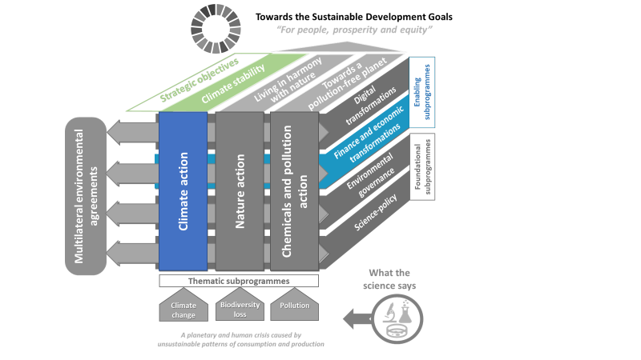
Table 3
Finance and economic transformations support for climate action, nature action and chemicals and pollution action
The finance and economic transformations subprogramme will enable the following direct outcomes of the climate action, nature action and chemicals and pollution action subprogrammes:
Climate action
- Private and public finance flows are aligned with the goals of the Paris Agreement.
- Transparency and accountability of government and non-government climate action, including from the private sector and finance community, is strengthened.
- The private sector and financial markets apply sustainability- and climate-friendly standards and norms as a core value of the economy.
- Sectoral partnerships and access to technologies for decarbonization, dematerialization and resilience are enhanced.
- Public support and political engagement for climate action are catalysed.
- Societal choices have shifted towards lower carbon products and services and sustainable lifestyles.
Nature action
- Full costs and benefits of human activity are accounted for and internalized in decision-making.
- Food systems support biodiversity and environmental sustainability.
- A sustainable ocean and coastal economy contributes to prosperity and pollution-free development.
- Public- and private-sector financial flows contribute to improved ecosystem management.
- Sustainable value chains are adopted, product comparability is enhanced and circularity is maximized.
- Consumer awareness and behaviours have shifted towards products and services with lower environmental and nature footprints through digital nudging, green filtering, product labelling, certification schemes and value-chain indices.
Chemicals and pollution action
- Regional and national integrated policy has shifted towards the sound management of chemicals and waste.
- Land-based sources of pollution in fresh water and ocean, including marine litter and nutrients, are reduced.
- Air pollution action, sustainable mobility and clean energy are supported.
- Institutional capacity to adopt and act on national and international commitments is enhanced.
- “3R” waste management systems are mainstreamed.
- Resource efficiency and circularity in key sectors are improved.
- The economics of chemicals actions and waste and pollution reduction support have shifted away from harmful chemicals.
- Global advocacy catalyses the phase-out of most polluting products and practices.
- Markets, supply chains, trade and consumer behaviours have shifted towards reduced pollution, influenced by transparency enabled by digital technologies.
- Global plastic pollution is reduced.
4. Digital transformation as an enabler
- The digital transformations subprogramme will support digital guidelines, architecture and governance, as well as enhanced digital literacy, to encourage transformative use of environmental digital public goods and accelerate progress towards environmental sustainability. UNEP will work to integrate datasets, analysis and digital public goods associated with climate, nature and pollution into an inclusive digital ecosystem for people and the planet. It will push to bridge the digital divide by enhancing the environmental digital literacy of citizens and diverse stakeholders through inclusive digital capacity-building, policy dialogue, education curricula, social collaboration, open innovation and new communities of practice. UNEP will leverage environmental digital public goods and assess the risk and benefits of digital technologies through partnerships, platforms and networks to amplify and accelerate progress towards the internationally agreed environmental goals and a circular economy.
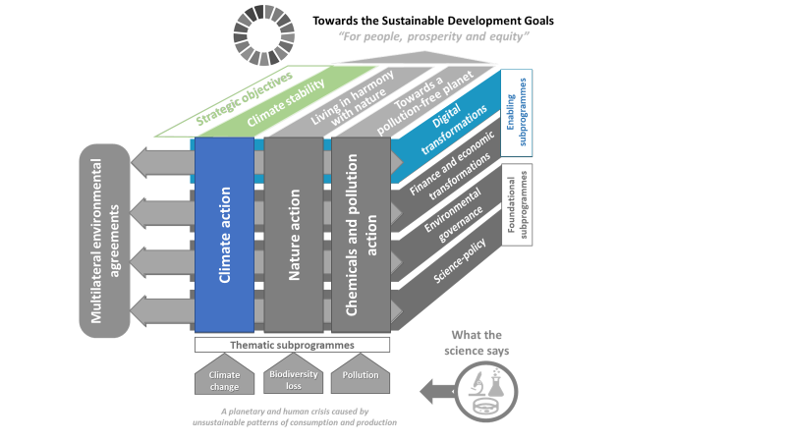
Table 4
Digital transformations support for climate action, nature action, and chemicals and pollution action
The digital transformations subprogramme will enable the following direct outcomes of the climate action, nature action, and chemicals and pollution action subprogrammes:
Climate action
- Policy- and decision-making for climate action is informed by the latest science-based analysis and data generation.
- Transparency and accountability of government and non-government climate action, including from the private sector and finance community, is strengthened.
- Private and public finance flows are aligned with the goals of the Paris Agreement.
- The private sector and financial markets apply sustainability- and climate-friendly standards and norms as a core value of the economy.
- Societal choices have shifted towards lower carbon products and services and sustainable lifestyles.
- Public support and political engagement for climate action are catalysed.
Nature action
- Collective action by the United Nations system entities addresses biodiversity loss and promotes conservation and restoration.
- Institutional capacity to adopt and act on national and international commitments is enhanced and accountability frameworks are strengthened.
- Natural assets are valued, monitored and sustainably managed.
- Public- and private-sector financial flows contribute to improved ecosystem management.
- Fair and equitable sharing of the benefits arising out of the utilization of genetic resources, including by appropriate access to genetic resources and by appropriate transfer of relevant technologies, is advanced.
- Sustainable value chains are adopted, product comparability is enhanced and circularity is maximized.
- Consumer awareness and behaviours have shifted towards products and services with lower environmental and nature footprints through digital nudging, green filtering, product labelling, certification schemes and value-chain indices.
Chemicals and pollution action
- Sound science, data/statistics, analysis, reporting and knowledge are shared.
- Transparency in value chains is enhanced by digital technologies, influencing markets, supply chains and consumer behaviours.
- Air pollution action, sustainable mobility and clean energy are supported.
- Institutional capacity to adopt and act on national and international commitments is enhanced.
- Regional and national integrated policy has shifted towards the sound management of chemicals and waste.
- Global advocacy catalyses the phase-out of most polluting products and practices.
B. UNEP performance measures: indicators that take programme integration one step further
- The UNEP results framework explains how the performance of the subprogrammes covered by this programme of work will be measured. Indicators are the backbone of the system for monitoring progress towards the outcomes set out in the theories of change. The results framework turns the theories of change into an accountability and management tool that underpins the development of implementation strategies and measures progress towards sustainable development. The outcomes of each thematic subprogramme, as shown in the theories of change in figures 2, 3 and 4, are accompanied by a set of indicators that together reflect the integrated nature of the subprogrammes. This approach allows for accountability at the subprogramme level, as well as measurement of the contribution of the foundational and enabling subprogrammes to the achievement of the strategic objectives of climate stability, living in harmony with nature and towards a
pollution-free planet.
- UNEP will measure how its interventions contribute to achieving its strategic objectives at three levels, as results framework described in figure 5. The highest level of control rests at the direct outcome level, where results can be directly associated with the intervention and UNEP can exercise the most direct control over results. Impact at this level is measured using quantitative indicators. The contribution from UNEP becomes less direct when results occur because of enabling and influencing activities and by partnering with other organizations, governments and the private sector, as external factors start playing a role. Impact at these levels is primarily measured using qualitative indicators. In addition, impact stories for each subprogramme will deliver examples that capture the results of UNEP interventions to provide evidence of change that occurred after a specific intervention.
Figure 5
Three levels of intervention

attribution/control contribution/influence
Transformational change

- Programme integration paves the way for transformational change. The intervention pathway in the three theories of change identifies the changes for which UNEP is directly accountable (towards the 2025 outcomes of the thematic subprogrammes), as well as where UNEP will act as an enabler and influencer (towards the 2030 outcome of the thematic subprogrammes) towards achieving relevant Sustainable Development Goals indicators. The results for which UNEP is directly accountable will be captured by quantitative indicators.
- Indicators must meaningfully capture key changes. Each indicator has one or more targets (progress expected) depending on the units of measure. The targets present the expected progress after one and two years, respectively, so as to cover the two-year period under this programme of work and the first two years under the medium-term strategy. Subsequent targets, for years three and four of the strategy, will be developed in the programme of work for 2024‒2025.
- The purpose of the UNEP results framework is twofold: to measure the results of UNEP work and to guide the design of projects and programmes. This ensures that all activities contribute to the achievement of the 2025 outcomes and direct outcomes set out in the theories of change. The results framework presented in the programme of work measures, the highest level of results for implementation of the medium-term strategy for 2022‒2025, and the indicators and targets presented in the framework measure results at all levels of UNEP.
- The targets for each quantitative indicator represent the expected results of UNEP direct support where UNEP has a degree of control. To create a more comprehensive picture of the different levels of results delivered by UNEP, quantitative reporting on the indicators will be accompanied by qualitative reporting and impact stories focusing on the enabling and influencing role of UNEP, including with regard to the uptake of its normative and standard-setting work, as described in table 5.
Table 5
Capturing UNEP results at different levelsª
Level of results | Reporting structure
UNEP direct support | Quantitative indicators for each subprogramme (results within the control of UNEP)
UNEP enabling interventions | Qualitative indicators and selected impact stories for each subprogramme (focus on the influence and uptake of the normative and standard-setting work of UNEP)
UNEP influencing interventions
ª This approach is aligned with the guidance provided by the General Assembly through the annual resolution on programme planning, which sets out the legal foundation for the reporting of the Secretary General on the annual proposed programme budgets for secretariat entities. See in particular General Assembly resolutions 71/6 and 74/251.
- The results framework is designed to underpin the integrated approach described in the medium-term strategy. Integrated implementation of the subprogrammes is central to the
medium-term strategy. Indicators for the thematic subprogrammes measure change for multiple 2025 outcomes and direct outcomes, while the indicators for the enabling and foundational subprogrammes measure performance for the direct outcomes. Intrinsically, performance and achievement for each of the 2025 outcomes and direct outcomes will be measured by assessing indicators from various subprogrammes, as outlined in the results framework.
- Tables 6 to 13 list the UNEP indicators by subprogramme, showing the outcomes with which the indicators are associated, as well as baselines and targets, units of measure, sources of data and relevant Sustainable Development Goal indicators.

Table 6
UNEP results framework
UNEP results framework
Planetary sustainability for people, prosperity and equity
UNEP strategic objectives that drive the results framework:
Climate stability: Countries increasingly transition to low-emission economic development pathways and enhance their adaptation and resilience to climate change
Living in harmony with nature: Recovery of nature occurs and contributes positively to ecosystem stability and human well-being
Towards a pollution-free planet: Significant progress made towards a pollution-free planet
Sustainable Development Goal indicators linked to the three strategic objectives.  Recognizing that all 17 Sustainable Development Goals are interconnected, UNEP focuses on contributing to the implementation of a number of Sustainable Development Goal Target through its global influence in the generation and dissemination of science, advocacy, campaigns and normative work. ª | 1.1.1 | Proportion of the population living below the international poverty line by sex, age, employment status and geographic location (urban/rural)
 | 2.4.1 | Proportion of agricultural area under productive and sustainable agriculture
 | 3.6.1 | Death rate due to road traffic injuries
 | 3.9.1 | Mortality rate attributed to household and ambient air pollution
 | 3.9.3 | Mortality rate attributed to unintentional poisoning
 | 4.7.1 | Extent to which (i) global citizenship education and (ii) education for sustainable development are mainstreamed in (a) national education policies; (b) curricula; (c) teacher education; and (d) student assessment
 | 5.1.1 | Whether or not legal frameworks are in place to promote, enforce and monitor equality and non-discrimination on the basis of sex
 | 6.3.1 | Proportion of domestic and industrial wastewater flows safely treated
 | 6.3.2 | Proportion of bodies of water with good ambient water quality
 | 6.4.2 | Level of water stress: freshwater withdrawal as a proportion of available freshwater resources
 | 6.5.1 | Degree of integrated water resources management
 | 6.5.2 | Proportion of transboundary basin area with an operational arrangement for water cooperation
 | 6.6.1 | Change in the extent of water-related ecosystems over time
 | 7.2.1 | Renewable energy share in the total final energy consumption
 | 7.3.1 | Energy intensity measured in terms of primary energy and GDP
 | 8.4.1 | Material footprint, material footprint per capita, and material footprint per GDP
 | 9.4.1 | CO₂ emission per unit of value added
 | 11.6.1 | Proportion of municipal solid waste collected and managed in controlled facilities out of total municipal waste generated, by cities
 | 11.6.2 | Annual mean levels of fine particulate matter (e.g., PM2.5 and PM10) in cities (population weighted)
 | 12.2.1 | Material footprint, material footprint per capita, and material footprint per GDP
 | 12.2.2 | Domestic material consumption, domestic material consumption per capita, and domestic material consumption per GDP
 | 12.3.1 | (a) Food loss index and (b) food waste index
 | 12.4.2 | (a) Hazardous waste generated per capita; and (b) proportion of hazardous waste treated, by type of treatment
 | 12.5.1 | National recycling rate, tons of material recycled
 | 12.6.1 | Number of companies publishing sustainability reports
 | 12.8.1 | Extent to which (i) global citizenship education and (ii) education for sustainable development are mainstreamed in (a) national education policies; (b) curricula; (c) teacher education; and (d) student assessment
 | 12.c.1 | Amount of fossil-fuel subsidies per unit of GDP (production and consumption)
 | 14.1.1 | (a) Index of coastal eutrophication; and (b) plastic debris density
 | 14.2.1 | Number of countries using ecosystem-based approaches to managing marine areas
 | 14.3.1 | Average marine acidity (pH) measured at agreed suite of representative sampling stations
 | 15.1.1 | Forest area as a proportion of total land area
 | 15.3.1 | Proportion of land that is degraded over total land area
 | 15.4.2 | Mountain Green Cover Index
 | 15.b.1 (b) | Revenue generated and finance mobilized from biodiversity-relevant economic instruments
 | 17.2.1 | Net official development assistance, total and to least developed countries, as a proportion of the Organization for Economic Cooperation and Development (OECD) Development Assistance Committee donors’ gross national income (GNI)
 | 17.18.1 | Statistical capacity indicator for Sustainable Development Goal monitoring
2025 outcomes: climate stability |  |  | 2025 outcomes: living in harmony with nature | 2025 outcomes: a pollution-free planet
Outcome 1A  Decision-makers at all levels adopt decarbonization, dematerialization and resilience pathways. |  |  | Outcome 2A  An economically and socially sustainable pathway for halting and reversing the loss of biodiversity and ecosystem integrity is established. | Outcome 3A  Human health and environment outcomes are optimized through enhanced capacity and leadership on the sound management of chemicals and waste.
Outcome 1B:  Countries and stakeholders have increased capacity, finance and access to technologies to deliver on the adaptation and mitigation goals of the Paris Agreement. |  |  | Outcome 2B  Sustainable management of nature is adopted and implemented in development frameworks. | Outcome 3B  Waste management is improved, including through circular processes, safe recovery of secondary raw materials and progressive reduction of open burning and dump sites.
Outcome 1C  State and non-State actors adopt the enhanced transparency framework arrangements under the Paris Agreement. |  |  | Outcome 2C  Nature conservation and restoration are enhanced. | Outcome 3C  Releases of pollutants to air, water, soil and the ocean are reduced.
Abbreviation: GDP – gross domestic product.
ª
1. Three thematic subprogrammes to support the strategic objectives of climate stability, living in harmony with nature and a pollution-free planet
Table 7
Climate action subprogramme
UNEP indicators, baselines and targets, units of measure, data sources and relevant Sustainable Development Goal indicators for the climate action thematic subprogramme
Indicator | Indicator | Indicator | Indicator | Indicator | Indicator | Indicator
- Number of national, subnational and private-sector actors that adopt climate change mitigation and/or adaptation and disaster risk reduction strategies and policies with UNEP support | 1A, 1B, 2A, 2B, 3A | 1.1, 1.2, 1.4, 1.8, 1.9 | December 2021 baseline: (tbc)  Progress expected by December 2022 +15  Progress expected by December 2023: +40 | Number of national, subnational and private-sector actors that have adopted climate change mitigation and/or adaptation and disaster risk reduction strategies and policies with UNEP support | - UNEP Climate Change Adaptation Unit  - Global Environment Facility  - United Nations Collaborative Programme on Reducing Emissions from Deforestation and Forest Degradation in Developing Countries (UN-REDD)  - Climate and Clean Air Coalition  - Climate Technology Centre and Network  - Global Alliance for Buildings and Construction  - Crisis Management Branch  Sendai Framework monitor | 1.5.3  11.b.1/2  12.1.1  12.2.1  12.2.2  13.2.1  13.b.1
- Amounts provided and mobilized in $ per year in relation to the continued existing collective mobilization goal of the $100 billion commitment through to 2025 with UNEP support | 1A, 1B, 1C, 2C, 3B, 3C | 1.4, 1.5, 1.6, 1.9 | (a) December 2021 baseline: (tbc)  (b) December 2021 baseline: (tbc)  Progress expected by December 2022:  - +50 million  - +50 billion  Progress expected by December 2023:  - +150 million  +150 billion | - United States dollars per year invested by countries or institutions for climate action  United States dollars of decarbonized assets | - UN-REDD  - Seed Capital Assistance Facility  - Mediterranean Investment Facility  - UNEP Climate Change Adaptation Unit  - United Nations-convened Net Zero Asset Owners Alliance  - UNEP Finance Initiative  Global Environment Facility and Green Climate Fund/approval letters from funding institutions | 13.a.1
- Number of national, subnational and private-sector actors reporting under the enhanced transparency arrangements of the Paris Agreement with UNEP support | 1B, 1C | 1.3, 1.7 | December 2021 baseline: (tbc)  Progress expected by December 2022: +20  Progress expected by December 2023: +40 | Number of reports produced by national, subnational and private sector actors for the United Nations Framework Convention on Climate Change or in accordance with the guidelines of the United Nations Framework Convention on Climate Change or another multilateral environmental agreement | Publicly available reports and data sets | 12.6.1  17.16.1
Qualitative indicators
The qualitative indicators will capture the influence and uptake of UNEP normative and standard-setting work. Together with the impact stories, they complement the quantitative indicators, which mainly capture the impact of direct intervention by UNEP, and provide a more complete picture of UNEP results for the three thematic subprogrammes.
- Positive shift in public opinion, attitudes and actions in support of climate action as a result of UNEP action | 1A, 1B, 1C | 1.1, 1.2, 1.3, 1.8 | - Knowledge, attitude and practices studies  - National public opinion surveys (e.g., Eurobarometer)  - Pew Research Centre research  - Yale Program on Climate Change Communication  - UNEP Finance Initiative  - Climate and Clean Air Coalition reports  - Climate Technology Centre and Network reports |  |  | 4.7.1  12.8.1  13.1
- Positive shift among private sector actors in support of climate action as a result of UNEP engagement
ª Will be disaggregated by gender to the extent possible when baselines are developed.

Table 8
Nature action subprogramme
UNEP indicators, baselines and targets, units of measure, data sources and relevant Sustainable Development Goal indicators for the nature action thematic subprogramme
Indicators | 2025 outcomes | Direct outcomes | Baselines and targetsª | Unit of measure | Data source |  | Relevant Sustainable Development Goal indicator
- Number of national or subnational entities that, with UNEP support, adopt integrated approaches to address environmental and social issues and/or tools for valuing, monitoring and sustainably managing biodiversity | 2A, 2B | 2.5, 2.6, 2.7, 2.8 | December 2021 baseline: (tbc)  Progress expected by December 2022: +8  Progress expected by December 2023: +30 | - Number of national or subnational entities that adopt or adapt economic, regulatory or decision-support tools for valuing, monitoring and sustainably managing biodiversity  - Number of, national and subnational entities that adopt integrated approaches to addressing environmental and social issues, including through health | - UNEP surveys of countries/subnational entities  - Country reporting, policy or strategy documents  - Media reports  - National statistics databases and websites  - Data and information protocols  - National ecosystem assessments  - Policy and planning process documents and reports on:  - Global Wildlife Economy initiative  - One Health programme  - Sustainable blue economy finance initiative  - System of Environmental-Economic Accounting |  | 14.2.1  14.7.1  15.9.1  17.14
- Number of financial, public- and private-sector entities whose financial decisions and risk management frameworks take biodiversity and ecosystem services into consideration, and the increase in financial flows towards ecosystem management as a result of UNEP support | 1B, 2A | 2.2, 2.10, 2.11, 2.13 | December 2021 baseline: (tbc)  Progress expected by December 2022:  - +19  - 0  Progress expected by December 2023:  - +42  - 200 million | - Number of financial institutions that have a set of biodiversity targets for their impact  - Number of public- and private-sector entities that consider biodiversity and ecosystem services in their financial decision-making and risk management frameworks  - Increase in inclusive wealth of countries, and in particular natural capital, as a result of public and private investment in nature  - United States dollars unlocked for investment in support of sustainable ecosystem management and/or restoration | - UNEP surveys of private-sector entities  - UNEP Finance Initiative reports  - Financial institution databases  - Company reporting, partner sources  - Policy or strategy documents, media reports, project records  - Sustainable blue economy finance initiative  - UNEP inclusive wealth accounting statistics  - Public- and private-sector participant reports for private-sector financing flows towards ecosystem management (e.g., the Global Fund for Coral Reefs and the Restoration Seed Capital Facility)  - Global Wildlife Economy initiative documents/reports |  | 12.6.1  15.a.1  15.b.1(b)
- Number of countries and national, regional and subnational authorities and entities that incorporate, with UNEP support, biodiversity and ecosystem-based approaches into development and sectoral plans, policies and processes for the sustainable management and/or restoration of terrestrial, freshwater and marine areas | 1A, 2B, 2C | 2.1, 2.3, 2.4, 2.5, 2.9, 2.11, 2.12, 2.13, 2.14, 2.15, 2.16 | December 2021 baseline: (tbc)  Progress expected by December 2022: +40  Progress expected by December 2023: +97 | - Number of countries, national, regional and subnational authorities and United Nations agencies, funds and programmes (bilateral, multilateral, global, regional and local) that use common approaches to mainstreaming biodiversity in their development and sectoral plans, policies and processes;  - Number of countries national, regional and subnational authorities that use ecosystem-based approaches to sustainably manage terrestrial, freshwater and marine areas, including those making commitments in support of ecosystem restoration;  - Number of countries and national, regional and subnational authorities that use ecosystem-based approaches to disaster risk reduction interventions for enhanced resilience;  - Number of consumers reached via social media or other channels regarding reducing the biodiversity footprint of consumption patterns. | - The framework of the ecosystems restoration, monitoring and the Digital hub under the United Nations Decade on Ecosystems Restoration  - UNEP and United Nations agency, fund and programme databases  - United Nations system decisions on biodiversity reports/briefings  - Official Sustainable Development Goal reporting by Member States on indicators 6.3.2, 6.5.1 and 6.6.1, supported by UNEP as custodian agency  - Project website and database  - UNEP website and online and social media evidence  - Other partner sources, articles and statements  - Project implementation reports for the Global Environment Facility Biodiversity and Land Degradation and International Waters portfolios  - Regional seas programme reports and documents.  - One Health programme  - Global Wildlife Economy initiative documents/reports  - Official communications, briefings |  | 6.3.2  6.5.1  6.6.1  11.5  12.2  13.1  14.2.1  14.5.1  15.1.1  17.14.1
- Increase in territory of land-/seascapes that is under improved ecosystem conservation and restoration | 2C | 2.3, 2.13 | December 2021 baseline: (tbc)  Progress expected by December 2022: 0 ha  Progress expected by December 2023: 1,440,000 ha | Number of hectares of terrestrial and marine area reported as being under improved management | - Partnership framework of the United Nations Decade on Ecosystems Restoration  - UNEP and United Nations agency, fund and programme databases  - Official Sustainable Development Goal reporting by Member States  - Project website and database  - UNEP website and online and social media evidence  - UN-REDD reports  - Other partner sources, articles, statements  - Project implementation reports for the Global Environment Facility Biodiversity and Land Degradation and International Waters portfolios  - GEF International Waters blue carbon activities  - Global Fund for Coral Reefs reports and briefings  - Restoration Seed Capital Facility reports and briefings  UNEP Land Use Finance Programme report “The state of finance and investment |  | 15.1.1  15.3.1  15.4.2
Qualitative indicators
The qualitative indicators will capture the influence and uptake of UNEP normative and standard-setting work. Together with the impact stories, they complement the quantitative indicators, which mainly capture the impact of direct intervention by UNEP, and provide a more complete picture of UNEP results for the three thematic subprogrammes.
- Positive shift in public opinion, attitudes and actions in support of biodiversity and ecosystem approaches | 2A, 2B, 2C | 2.2, 2.13, 2.15, 2.16 | Progress expected by December 2023: The public takes action and has a positive attitude in support of biodiversity and ecosystem approaches. |  |  | - Surveys on public opinion  - Formal and informal educational curricula  - UNEP Finance Initiative reports  - UNEP Land Use Finance Programme report on the state of finance and investment into nature-based solutions  - UNEP Land Use Finance Programme briefings
- Positive shift in the private sector in support of biodiversity and ecosystem approaches | 2A, 2B, 2C | 2.2, 2.13, 2.15, 2.16 | Progress expected by December 2023: The private sector takes impacts on biodiversity and ecosystem services into consideration in decision-making.
ª Will be disaggregated by gender where possible when baselines are developed.

Table 9
Chemicals and pollution action subprogramme
UNEP indicators, baselines and targets, units of measure, data sources and relevant Sustainable Development Goal indicators for the chemicals and pollution action thematic subprogramme
Indicators | 2025 outcomes | Direct outcomes | Baseline and targetsª | Unit of measure | Data source | Relevant Sustainable Development Goal indicator
- Number of Governments that, with UNEP support, are developing or implementing policies, strategies, legislation or action plans that promote sound chemicals and waste management and/or the implementation of multilateral environmental agreements and the existing framework on chemicals and waste | 1A, 3A | 3.1, 3.5, 3.9, 3.10, 3.12, 3.13 | December 2021 baseline: (tbc)  Progress expected by December 2022: +55  Progress expected by December 2023: +55 | Number of Governments developing or implementing relevant policies, strategies, legislation or action plans with UNEP support | - Official government correspondence and documents  - Project portfolios supporting implementation of multilateral environmental agreements and other chemicals and waste frameworks | 2.4.1  3.9.3  8.8.1  12.4.1
- Number of Governments developing or implementing policies, strategies and mechanisms to prevent or reduce waste and ensure environmentally sound waste treatment or disposal, including in the context of disaster or conflict-related environmental emergencies, with UNEP support | 1A, 3B | 3.3, 3.6, 3.7, 3.8, 3.9, 3.11 | December 2021 baseline: (tbc)  Progress expected by December 2022: +5  Progress expected by December 2023: +7 | Number of Governments developing or implementing relevant policies, strategies and mechanisms, including in response to humanitarian and environmental emergencies, with UNEP support | - Government communications, policies, strategies and mechanisms on waste reduction, wastewater, waste management and circularity portfolios  - UNEP Crisis Management Branch  - Joint Environment Unit of UNEP and the Office for the Coordination of Humanitarian Affairs | 8.4.1  11.6.1  12.3.1  12.4.1  12.5.1
- Number of policy, regulatory, financial and technical measures developed with UNEP support to reduce pollution in air, water, soil and the ocean | 1B, 3C | 3.2, 3.3, 3.4, 3.8, 3.14 | December 2021 baseline: (tbc)  Progress expected by December 2022: +14  Progress by December 2023: +33 | Number of air pollution, soil pollution and freshwater and marine pollution reduction measures developed with UNEP support, including gender and social measures | - Official correspondence, documents and surveys, pollution and health portfolio | 3.9.1  6.3.1  6.3.2  11.6.2  14.1.1
- Reduction in releases of pollutants to the environment achieved with UNEP support | 2C, 3C | 3.2, 3.3, 3.5, 3.9 | December 2021 baseline: (tbc)  Progress expected by December 2022: +1,200  Progress expected by December 2023: +1,100 | Fewer tons of harmful pollutants and waste, including those covered under multilateral environmental agreements | - Global Environmental Facility project implementation reviews  - Official communications and disposal certificates | 3.9.3  6.3.2  12.4.2  14.1.1
Qualitative indicators
The qualitative indicators will capture the influence and uptake of UNEP normative and standard-setting work. Together with the impact stories, they complement the quantitative indicators, which mainly capture the impact of direct intervention by UNEP, and provide a more complete picture of UNEP results for the three thematic subprogrammes.
Change in action by the private sector and civil society on pollution prevention and control as a result of UNEP action  Progress in the chemicals- and pollution-related aspects of the 2030 Agenda on which UNEP focuses its work | 3A, 3B, 3C | 3.1, 3.2, 3.3, 3.4, 3.5, 3.6, 3.7, 3.8, 3.9, 3.10, 3.11, 3.12. 3.13, 3.14 | - Progress expected by December 2022: Knowledge of pollution status, trends and impacts and available response options is shared.  - Progress expected by December 2023: Stakeholders step up pollution commitment and action. |  | - Voluntary commitments on pollution  - Voluntary national reviews  - Scorecards for common country analysis | 3.9.1  3.9.3  6.3.1  6.3.2  11.6.2  12.3.1  12.4.1
 | 3A, 3B, 3C |  | - Progress expected by December 2022: Methodologies developed and pilot tested for analysing real-world situation/progress on pollution dimension of the 2030 Agenda.  - Progress expected by December 2023: Results narratives are generated for three impact indicators related to releases of pollutants to the environment. |  | - Common country analysis/United Nations Sustainable Development Cooperation Frameworks  - Progress reports on Sustainable Development Goal indicators | 12.4.2  12.5.1  12.6.1  12.8.1  14.1.1  17.1.2  17.7.1  17.16.1
ª Will be disaggregated by gender to the extent possible when baselines are developed.

2. Two foundational subprogrammes at the core of UNEP work to inform its engagements and catalyse its actions: science-policy and environmental governance
Table 10
Science-policy
Science-policy
Indicator measuring the scientific underpinning of climate, nature and pollution outcomes | Direct outcomes | Baseline and targetsª | Unit of measure | Data source | Relevant Sustainable Development Goal indicator
- Number of countries and national, regional and subnational authorities that, as a result of UNEP support, have strengthened capacity to develop sound environmental data, statistics, scientific assessments and early warning systems | Climate action: 1.3  Nature action: 2.16  Chemicals and pollution action: 3.13 | December 2021 baseline: (tbc)  Progress expected by December 2022: +10  Progress expected by December 2023: +15 | Number of countries and national, regional and subnational authorities (bilateral, multilateral, global, regional and local) that have developed sound environmental data, statistics, scientific assessment and early warning systems with UNEP support | - Country/regional and subnational websites/platforms and reports  - UNEP Sustainable Development Goal database  - World Environment Situation Room and other UNEP online platforms | 1.5.3  4.7.1  11.b.1/2  12.1.1 13.2.1  12.8.1, (b), (c) and (d) 12.6.1  13.a  13.b.1  17.16.1
- Number of relevant global, regional and national forums, institutions and Governments using data, statistics, scientific assessments and early warning and foresight systems provided by UNEP for catalysing policymaking and action | Climate action: 1.1  Nature action: 2.15, 2.3, 2.7, 2.14  Chemicals and pollution action: 3.3 | December 2021 baseline: (tbc)  Progress expected by December 2022: +10  Progress expected by December 2023: +10 | Number of countries and national, regional and subnational authorities (bilateral, multilateral, global, regional and local) that use data, statistics, scientific assessments and early warning and foresight systems made available through UNEP platforms | - Survey of Member States and stakeholders (including global, regional and national forums and institutions. | 6.5.1  6.5.2  6.6.1  14.2.1  15.3.1
- Number of United Nations agencies and multilateral environmental agreement secretariats using data/statistics on environmental trends and assessments identified through UNEP to catalyse policy recommendations | Chemicals and pollution action: 3.2, 3.4 | December 2021 baseline: (tbc)  Progress expected by December 2022: +5  Progress expected by December 2023: +10 | Number of United Nations agencies and multilateral environmental agreement secretariats using data/statistics on environmental trends and assessments identified through UNEP to catalyse policy recommendations | - Survey of United Nations agencies and multilateral environmental agreement secretariats  - United Nations agencies and multilateral environmental agreement secretariats | 6.6.1  11.6.1  11.6.2  11.b.1  12.4.1  12.4.2  12.6.1  12.8.1  14.1.1  14.2.1  15.9.1
- Number of United Nations country teams using data/statistics on environmental trends and assessments identified through UNEP to catalyse policy recommendations | Climate action: 1.1  Nature action: 2.3, 2.7, 2.14, 2.16  Chemicals and pollution action: 3.2, 3.13 | December 2021 baseline: 15  Progress expected by December 2022: +30  Progress expected by December  2023: +60 | Number of United Nations country teams using data/statistics on environmental trends and assessments identified through UNEP to catalyse policy recommendations | - Survey of United Nations country teams | 2.4.1  6.6.1  11.6.1  11.b.1  12.1.1  12.4.2  12.5.1  12.6.1  13.2.1  13.2.2  14.1.1  14.2.1  15.1.2  15.9.1  17.14.1  17.18.1
ª Will be disaggregated by gender to the extent possible when baselines are developed.

Table 11
Environmental governance
Environmental governance
Indicators measuring governance support to deliver climate, nature and pollution outcomes | Direct outcomes | Baseline and targetsª | Unit of measure | Data source | Relevant Sustainable Development Goal indicator
- Number of countries supported by UNEP under the Montevideo Programme in developing and implementing environmental rule of law and related technical and institutional capacities to address internationally agreed environmental goals | Climate action: 1.7, 1.8  Nature action: 2.4, 2.9, 2.13  Chemicals and pollution action: 3.5 | December 2021 baseline: (tbc)  Progress expected by December 2022: +36  Progress expected by December 2023: +28 | Number of countries (including vulnerable disaster and conflict-affected Member States) supported by UNEP to strengthen environmental institutions | - Country reporting, policy or strategy documents  - Media reports  - Project records | 15.9.1  16.10.2  17.14.1
- Number of international legal agreements or instruments advanced or developed with UNEP support to address emerging or internationally agreed environmental goals | Climate action: 1.1  Nature action: 2.11  Chemicals and pollution action: 3.4 | December 2021 baseline: (tbc)  Progress expected by December 2022: +1  Progress expected by December 2023: +2 | Number of international legal agreements and instruments advanced or developed with UNEP support to address emerging or internationally agreed environmental goals | - Conference of the Parties/Meeting of the Parties Documents  - General Assembly  - Environment Assembly and other international bodies | 17.14.1  17.16.1
- Number of plans, approaches, strategies, policies, action plans or budgeting processes of entities at the national, regional and global levels that include environmental goals as a result of UNEP support | Climate action: 1.1, 1.2  Nature action: 2.9  Chemicals and pollution action: 3.1. 3.3 | December 2021 baseline: (tbc)  Progress expected by December 2022: +35  Progress expected by December 2023: +30 | Number of plans, approaches, strategies, policies, action plans and budgeting processes of entities at the national, regional and global levels that include environmental goals as a result of UNEP support | - Country reporting, policy and strategy documents  - Media reports  - Project records  - Decisions, strategies and reports of intergovernmental bodies | 17.16.1
- Number of entities at the national, regional or global levels that UNEP has supported in developing integrated approaches and tools for enhanced coordination, cooperation and synergies for the coherent implementation of multilateral environmental agreements | Climate action: 1.3  Nature action: 2.1  Chemicals and pollution action: 3.10 | December 2021 baseline: (tbc)  Progress expected by December 2022: +15  Progress expected by December 2023: +25 | Number of entities developing integrated approaches and tools for enhanced coordination, cooperation and synergies for the coherent implementation of multilateral environmental agreements, with UNEP support | - Country reporting, policy and strategy documents  - Media reports  - Project records and tools  - Decisions, strategies and reports of intergovernmental bodies | 5.a.2  12.4.1  13.2.1  15.6.1  15.8.1 16.10.2  17.14.1
ª Will be disaggregated by gender to the extent possible when baselines are developed.
3. Two enabling subprogrammes to deliver more sustainable patterns of consumption and production and systematize, integrate and democratize environmental data, knowledge and insight for new collaboration opportunities and enhanced impact: finance and economic transformations and digital transformations
Table 12
Finance and economic transformations
Finance and economic transformations
Indicator measuring support on policies, business models and consumers to accelerate sustainable patterns of consumption and production in support of climate, nature and chemicals and pollution outcomes | Direct outcomes | Baseline and targetsª | Unit of measure | Data source | Relevant Sustainable Development Goal indicator
- Number of economic, finance, industry and trade policies, practices, partnerships and initiatives put in place or implemented to enable just transitions | Climate action: 1.3, 1.4, 1.5  Nature action: 2.2, 2.12  Chemicals and pollution action: 3.1, 3.2, 3.3, 3.4, 3.5, 3.6, 3.8, 3.11, 3.12 | December 2021 baseline: (tbc)  Progress expected by December 2022: +20  Progress expected by December 2023: + 20 | Number of economic, finance, industry and trade policies, practices, partnerships and initiatives | - Country reporting, policy or strategy documents  - Media reports  - Project records  - Websites, databases and portal (e.g., One Planet Network, Life Cycle Initiative, International Resource Panel, Green Growth Knowledge Platform, Partnership for Action on Green Economy) | 1.1.1; 2.4.1;  4.7.1/13.3.1;  5.c.1; 6.4.1;  7.2.1; 7.3.1;  7.a.1; 7.b.1;  8.4.1; 8.4.2;  9.1.1; 9.a.1;  9.4.1; 10.5.1;  11.6.1; 11.a.1;  12.1.1; 12.3.1;  12.4.1; 12.7.1;  12.8.1; 12.a.1;  12.c.1; 13.a.1;  14.6.1;  17.10.1
- Number of business alliances, principles, practices, standards or frameworks established or adopted with UNEP support to enhance environmental sustainability | Climate: 1.3, 1.4, 1.5, 1.6  Nature Action: 2.2, 2.6, 2.10, 2.12  Chemicals and pollution action: 3.2, 3.3, 3.6, 3.8, 3.11, 3.12, 3.14 | December 2021 baseline: (tbc)  Progress expected by December 2022: +15  Progress expected by December 2023: +15 | Number of relevant business alliances, principles, practices, standards and frameworks (disaggregated by industry sector and size)^{b} | - Country reporting, policy or strategy documents  - Media reports  - Project records  - Websites, databases and portal (e.g., One Planet Network, Life Cycle Initiative, International Resource Panel, Green Growth Knowledge Platform, Partnership for Action on Green Economy) | 12.5.1  12.6.1  15.b.1(b)
- Number of consumer information tools and measures, educational approaches and advocacy and awareness-raising events and products that inform decision-making, choices and changes in behaviour towards enhanced environmental sustainability, developed with UNEP support | Climate action: 1.7, 1.8  Nature action: 2.15  Chemicals and pollution action: 3.11, 3.12 | December 2021 baseline: (tbc)  Progress expected by December 2022: +30  Progress expected by December 2023: +20 | Number of relevant consumer information tools, measures, educational approaches and advocacy and awareness-raising events and products that inform decision-making, choices and changes in behaviour | - UNEP and project websites (e.g., International Resource Panel, Green Growth Knowledge Platform, Life Cycle Initiative)  - Online and social media evidence  - Partner sources, articles, statements, surveys | 8.4.1  12.2.1  8.4.2  12.2.2  12.4.1  12.8.1  15.9.1(b)  17.18.1  17.19.1
ª Will be disaggregated by gender to the extent possible when baselines are developed.
^{b} Industry sector based on the International Standard Industrial Classification of All Economic Activities (ISIC) (first level classification) and size based on the United Nations Global Compact definitions for small and medium-sized enterprises (fewer than 250 employees) and large companies (250 employees or more). Disaggregated to the extent possible.

Table 13
Digital transformations
Digital transformations
Indicator measuring support to scale environmental change through an effectively governed and inclusive digital architecture in support of climate, nature and chemicals and pollution outcomes | Direct outcomes | Baseline and targetsª | Unit of measure | Data source | Relevant Sustainable Development Goal indicator
- Number of digital platforms deployed as a result of UNEP support for automatically monitoring global progress against climate, nature and chemicals and pollution targets to support transparency, predictive analytics and risk identification | Climate action: 1.1, 1.3  Nature action: 2.1, 2.7  Chemicals and pollution action: 3.12 | December 2021 baseline: (tbc)  Progress expected by December 2022: +4  Progress expected by December 2023: +2 | Number of relevant digital platforms deployed | - UNEP website  - Third-party online platforms  - Social media evidence | 17.18.1
- Number of business alliances, partnerships and networks leveraging environmental data and digital transformation approaches to incentivize environmental sustainability and a circular economy within financial markets. | Climate action: 1.5, 1.6, 1.8  Nature action: 2.2, 2.10, 2.15  Chemicals and pollution action: 3.4, 3.11 | December 2021 baseline: (tbc)  Progress expected by December 2022: +3  Progress expected by December 2023: +2 | Number of relevant business alliances, partnerships and networks | - UNEP website  - Third-party online platforms  - Social media evidence | 17.16.1  9.4.1
- Number of digital applications and engagement platforms created with UNEP support to support electronic governance and enhance public participation in environmental monitoring, consensus-building, decision-making and digital transformation linked to climate, nature and chemicals and pollution actions, including the reduction of environmental digital technology inequalities in impact chains, consumer behaviours and policymaking | Climate action: 1.7  Nature action: 2.9, 2.14  Chemicals and pollution action: 3.13 | December 2021 baseline: (tbc)  Progress expected by December 2022: +4  Progress expected by December 2023: +2 | Number of relevant digital applications and engagement platforms | - UNEP website  - Third-party online platforms  - Social media evidence | 16.10.2  9.C.1
ª Will be disaggregated by gender to the extent possible when baselines are developed.
- Each subprogramme will develop a project portfolio that is synergistic with other subprogrammes. The project portfolios are building blocks that enable the achievement of results as set out in the theories of change in an integrated way. The project portfolio will outline the concepts of projects to be implemented over the four-year period of the medium-term strategy. Project data will be collected for the indicators in the programme of work to ensure that the results provided for in the framework are achieved. The sum of projects will contribute to the 2025 outcomes and direct outcomes of the three thematic subprogrammes in an integrated way.

II. …enhanced by UNEP executive leadership, coherent
policy-setting, and efficient programme management and support...
A. Executive direction and management
- UNEP executive direction and management encompasses UNEP leadership, management and oversight in delivering results. The Executive Office, with support from the Evaluation Office, provides executive direction and management, including on strategic, programmatic and administrative matters. This includes accountability for the delivery of the medium-term strategy and its related programmes of work, as mandated by the Environment Assembly and set out in the compact between the Executive Director and the Secretary‑General.
- The Executive Office will focus on elevating systemic changes that have been identified through an internal transformation process aimed at further strengthening UNEP efficiency and effectiveness. The Executive Office will:
  - Build collaboration and partnerships with governments, the private sector, finance institutions, civil society and other stakeholders;
  - Invest in integrated capability development;
  - Create a coherent strategic leadership;
  - Deliver operational excellence;
  - Create a team with aligned entrepreneurship.
These five dynamics will enable UNEP to meet the challenges ahead..
- The Evaluation Office plays a critical role in the independent oversight and accountability functions. The Evaluation Office falls within the purview of executive direction and management in recognition of its functional independence from the rest of the programme and the importance attached to using evaluation findings to improve UNEP planning, implementation and performance. As an independent unit, the Evaluation Office reports directly to the Executive Director and is responsible for implementing the evaluation work plan by conducting and managing independent evaluations. Thus, it will continue to play a critical oversight role by evaluating the extent to which UNEP has achieved its planned results for the medium-term strategy and programme of work and will provide recommendations, lessons and advice based on evaluation findings. To maintain transparency, the evaluation findings will be communicated through the Executive Director to the Committee of Permanent Representatives and the Environment Assembly, in accordance with the UNEP Evaluation Policy.
- In line with the pledge by UNEP to increase responsiveness to issues of gender equality, as outlined in the medium-term strategy, the indicators for executive direction and management include a cross-cutting gender indicator. Applied to all UNEP interventions, the indicator will measure UNEP performance in implementing the United Nations System-wide Action Plan on Gender Equality and the Empowerment of Women (UN-SWAP).
Table 14
Expected outcomes for the biennium and performance indicators: executive direction and management
Executive direction and management
Outcome 1: UNEP achieves coherent delivery and integrated implementation of environmental policies and priorities within the United Nations system through United Nations reform
Performance indicator | Baseline and target ª | Unit of measure | Data source
- Uptake of environmental policy issues or approaches by United Nations entities emerging from UNEP policy advice and/or support | December 2021 baseline: (tbc)  Progress expected by December 2023: 45 | Percentage of United Nations country teams developing United Nations Sustainable Development Cooperation Frameworks that include environmental goals | Data available in regional knowledge hubs
- Number of regional issue-based coalitions that focus on environment-related themes/incorporate environmental perspectives into their work through the use of UNEP tools and support | December 2021 baseline: (tbc)  Progress expected by December 2023: 4 | Number of relevant regional issue-based coalitions | Minutes of Regional Collaborative Platforms
- Percentage of Governments in each region that rate UNEP support to countries as coherent and good-quality | December 2021 baseline: (tbc)  Progress expected by December 2023: +30 | Percentage of Governments in each region that rate UNEP support to countries as coherent and  good-quality | Survey of Governments
Outcome 2: UNEP has promoted cooperation and coherence in the United Nations system in mainstreaming and delivering on the environmental dimensions of the 2030 Agenda through the United Nations Environment Management Group.
Performance indicators | Baselines and targets | Unit of measure | Data source
- Number of impact-oriented inter-agency partnerships or joint initiatives addressing integrated approaches related to climate change, nature and pollution, as a result of UNEP support. | December 2021 baseline: 36  Progress expected by December 2023: 46 | (i) Official policy documents, strategies, initiatives and plans of United Nations entities and international organizations or policy documents, strategies, initiatives and plans emerging from intergovernmental forums at the global level  (ii) Entities reporting on mainstreaming and implementing the environmental dimensions of the 2030 agenda | Official documents and outcome documents of United Nations entities and their inter-agency mechanisms and international organizations and forums
- Number of entities reporting on mainstreaming and implementing the environmental dimensions of the 2030 Agenda, including under the System-Wide Framework of Strategies on the Environment | December 2021 baseline: (tbc)  Progress expected by December 2023: 25
Outcome 3: UNEP has strengthened its transparency and accountability as a results-based organization and improved the sustainability of its operations.
Performance indicators | Baselines and targets | Unit of measure | Data source
- Implementation of audit and investigation recommendations | December 2021 baseline: (tbc)  Progress expected by December 2023: 75 | Percentage of audit and investigation recommendations acted upon | Review of recommendations with relevant audit and investigation bodies
- Evaluations providing a rating of “satisfactory” or higher for project performance | December 2021 baseline: (tbc)  Progress expected by December 2023: (tbc) | Number of quarterly business reviews implemented by the UNEP senior management team | Review of evaluation recommendations
- Implementation of accepted evaluation recommendations within the time frame defined in the implementation plan | December 2021 baseline: (tbc)  Progress expected by December 2023: 85 | Percentage of accepted evaluation recommendations closed as compliant within the time frame defined in the evaluation recommendation implementation plan
- Reduction in annual greenhouse gas emissions from UNEP operations and travel by staff | December 2019 baseline: (tbc)  Progress expected by December 2023: 2.7 | Reduction in greenhouse gas emissions” | Data on greenhouse gas emissions monitored as part of the UNEP environmental management plan
Outcome 4: UNEP has implemented the United Nations System-wide Action Plan on Gender Equality and the Empowerment of Women (UN-SWAP).
Performance indicator | Baselines and targets | Unit of measure | Data source
- UNEP performance in terms of meeting or exceeding the UN-SWAP 2.0 indicators | December 2021 baseline (tbc)  Progress expected by December 2023: 82 | Percentage of  UN-SWAP 2.0 indicators met or exceeded | UN-SWAP report card from  UN-Women
- UNEP performance in terms of meeting or exceeding the average UN-SWAP performance for the United Nations Secretariat and the overall United Nations system | December 2021 baseline (tbc)  Progress expected by December 2023: > United Nations system average | Number of operative paragraphs implemented by the Secretariat and Member States | UN-SWAP report card from  UN-Women
- Degree of implementation of Environment Assembly resolution 4/17 on promoting gender equality and the human rights and empowerment of women and girls in environmental governance | December 2021 baseline (tbc)  Progress expected by December 2023: (tbc) | Number of UNEP projects assessed for gender equality impact | UNEA monitoring and reporting portal  UNEP project review evaluations
Abbreviation: UN-Women – United Nations Entity for Gender Equality and the Empowerment of Women.
ª Will be disaggregated by gender to the extent possible when baselines are developed.
B. Policymaking organs
- The Environment Assembly sets the global environmental agenda and is the governing body of UNEP. The Environment Assembly meets biennially and has a United Nations system-wide mandate to take strategic decisions and provide political guidance on the work of the United Nations system in the area of the environment, including through the United Nations Environment Management Group and its annual contributions to the high-level political forum on sustainable development. The medium-term strategy and programme of work are approved by the Environment Assembly.
- UNEP will actively support the meaningful participation of representatives from relevant major groups and stakeholders as well as United Nations organizations at meetings of the Environment Assembly and its subsidiary bodies and of the parties to the multilateral environmental agreements. UNEP facilitates the engagement of major groups and stakeholders at the programme and policy level, by the exchange of information, solicitation of input, capacity-building and regular communication through the Major Groups Facilitating Committee. To enhance the participation of major groups and stakeholders and their contribution to the intergovernmental decision-making process, a multi-stakeholder dialogue is held during the high-level segment of the Environment Assembly. This dialogue complements the Global Major Groups and Stakeholders Forum, which takes place before each session of the Environment Assembly. The forum is preceded by regional consultative meetings with representatives of major groups and stakeholders, whose inputs and perspectives are provided to the Committee of Permanent Representatives and the Environment Assembly through written and oral statements and an official meeting document.
- The Committee of Permanent Representatives, as a subsidiary body of the Environment Assembly, provides policy advice to the Environment Assembly. The committee contributes to the preparation of the agendas for the sessions of the Environment Assembly and the draft decisions it will consider. It oversees the implementation of resolutions and the UNEP programme of work once they are adopted and prepares the forthcoming programme of work for adoption by the Environment Assembly. The Committee holds regular one-day meetings on a quarterly basis and meets in an open-ended forum every two years, prior to the session of the Environment Assembly. The UNEP governing structure also includes the subcommittee of the Committee of Permanent Representatives, which meets annually for five days to review the UNEP medium-term strategy and programme of work and budget and to prepare the forthcoming programme of work for adoption by the Environment Assembly. In addition, one-day or half-day subcommittee meetings are held once or twice a month, as needed and upon request, to consider specific issues in depth.
- The Governance Affairs Office provides secretariat support to the Environment Assembly and its subsidiary bodies. The Office also serves as the main interface for external relations with representatives of the UNEP governing bodies and with representatives of the major groups and stakeholders and is responsible for promoting gender parity for meetings and other activities supported by the secretariat.
Table 15
Expected outcomes for the biennium and performance indicators: policymaking organs
Policymaking organs
Outcome 1: The Environment Assembly attracts significant interest from key decision-makers and stakeholders.
Performance indicator | Baseline and target | Unit of measure | Data source
- Prominence of media reach (online, print and broadcast) and social media coverage on environmental issues during and following Environment Assembly sessions | December 2021 baseline: (tbc)  Progress expected by December 2023: 11,000 | Number of media mentions | Communication Division monitoring metrics, independent media monitoring metrics
- Sustained engagement of Member States and United Nations representatives, in particular from the secretariats of multilateral environmental agreements, in the Environment Assembly | December 2021 baseline: (tbc)  Progress expected by December 2023: 1,400 | Number of representatives from Member States, United Nations entities and secretariats of multilateral environmental agreements attending the relevant Environment Assembly session | Post-meeting report and participants registry
- Enhanced engagement of major group and stakeholder representatives in the Environment Assembly | December 2021 baseline: (tbc)  Progress expected by December 2023: 770 | Number of representatives from civil society participating in the Environment Assembly | Post-meeting report and participants registry
Outcome 2: The Environment Assembly sets the global environmental policy agenda for the upcoming years.
Performance indicator | Baseline and target | Unit of measure | Data source
Percentage of surveyed UNEP partners in Governments and in the United Nations system that rate the Environment Assembly as useful in providing policy guidance on important global environmental issues | December 2021 baseline: (tbc)  Progress expected by December 2023: 80 | Percentage of positive responses in the Environment Assembly survey | Environment Assembly post-session surveys
C. Programme management and support
- Programme management and support comprises services provided by the Corporate Services and Policy and Programme divisions of UNEP. The objective is to ensure efficient and effective development and delivery of the medium-term strategy’s programmatic priorities, underpinned by sound management and leadership practices with a reinforced accountability framework that clarifies roles and responsibilities. Programme management and support provide guidance on programme and project design, delivery and closure; governance of resources; corporate policy development and oversight; programme monitoring and reporting; building of staff knowledge and capacity; and the development of programme and resource management tools that support decision-making.
- A stronger, better-performing and more networked, integrated and results-oriented staff. Staff remain the most important asset of UNEP. It continues to focus not only on innovative human resources processes but also on ensuring that its staff acquire the skills necessary to process, produce and leverage digital information to create business value. An ongoing skills mapping initiative begun in 2020 aims to define core skills that staff require in order to prepare for the future of work. The focus during 2022‒2023 will be on building a workforce that has the capacity to work in an agile way, demonstrates a data mindset and applies user-centred design thinking principles to enhance organizational effectiveness. UNEP will implement a new Corporate Academy initiative, designed to provide scope for building the capacity of Professional staff in the areas of administration and programme management. This involves working on building communities of practice focused on enhancing collaborative and strategic dialogue around specialized thematic areas of work. The aim is to strengthen collaborative partnerships across UNEP and leverage internal synergies and sharing of knowledge and expertise among subject matter experts. UNEP is laying the foundation for a learning organization by leveraging digital solutions, facilitating communities, curating content, fostering manager coaching and peer learning, and valuing failure as a pathway to innovation. It will create a robust learning analytics programme to support impact tracking, with regular communication of findings to senior leadership and staff. These initiatives will build a collaborative organizational structure and an engaged workforce that fosters a culture of teamwork, innovation and results. The new culture will stem from a transformed senior leadership that is solution-oriented and committed to a shared strategy and shared values such as courage, authenticity, transparency and professionalism..
- Programme management and support with enhanced emphasis on compliance, efficiency and risk management. The plan for the 2022‒2023 biennium is to extend the knowledge-based platforms to programme and project managers through appropriate tailor-made training and guidelines, with the aim of holistically addressing audit and risk factors associated with financial and programme management.. This will ensure that internal processes evolve to support programmatic needs and that “best in class” fiduciary governance and standards are developed. UNEP will employ enterprise risk management to these ends.
- Enterprise risk management in UNEP is a structured and disciplined approach that aligns strategy, processes, people, technology and knowledge for the purpose of evaluating and managing the uncertainties an organization faces as it pursues its objectives. Enterprise risk management implementation facilitates effective strategic decision-making, as it provides management with the tools to fully understand the root causes of risk and to design proper response strategies. Enterprise risk management approaches all sections of UNEP operations iteratively to catch all risk areas and address the components of governance and culture, strategy- and objective-setting, performance, review and revision, information, communication and reporting.
- In the initial stages of implementing enterprise risk management, UNEP will follow the recommendations from the United Nations Secretariat’s latest updated policy on risk management and appropriate steps arising from best practice. The 2022‒2023 biennium will see the risk management framework fully integrated into UNEP operations. Internal reviews, audits and evaluation results at the strategic, operative, programmatic and project levels and internal feedback on existing partnership management approaches highlight the need to strengthen UNEP due diligence processes. In this regard, UNEP will continue to improve its partnership policy and due diligence procedures to actively monitor and manage partnerships in order to minimize and mitigate potential risks and ensure that benefits are realized. To facilitate this transition, online tools are being developed to support a transparent review of both private and public partnership agreements and to maintain an audit trail for compliance rates.
- Focus on alignment, relevance and measurable results. UNEP will continue the shift towards results-based management, enabling it to further quantify and qualify its achievements and communicate them effectively while demonstrating a clear line of sight from local to regional and global interventions. In the context of programme management and support, this means strengthening project design and review mechanisms and ensuring that the quality assurance framework provides information on programme implementation status, assists in the early identification of potential risks and enhances the effectiveness of project implementation. It also means developing the platforms, business intelligence tools and dashboards needed for senior management to take informed decisions and the performance indicators needed to evaluate the effectiveness of project implementation.
- Emphasis on lessons learned from audits and evaluations for continued improvement. UNEP will identify opportunities to inculcate lessons learned from audits, evaluations and reports of the Joint Inspection Unit and in so doing will steer the organization on a path of strengthened operational efficiency and agility. UNEP will continue investing in informed decision-making through the use of real-time data, facilitated by business intelligence tools and dashboards.
- Enhanced resource mobilization. UNEP will continue to update its resource mobilization strategy in support of the delivery of programmatic results. The update will introduce additional mechanisms for partnerships in thematic areas, within and outside the United Nations system, including with global funds (such as the Global Environment Facility and the Green Climate Fund), as well as continuing to explore strategic opportunities for engagement with other stakeholders, such as civil society and the private sector. Moreover, a key element of the management direction will be renewed administrative support for and engagement with multilateral environmental agreement secretariats to allow for economies of scale while preserving the special mandates of such agreements and the governance mechanisms that oversee them.
- Dialogue for greater efficiency of service providers. UNEP will liaise with and monitor the performance of administrative service providers such as the United Nations Office at Nairobi that provide support services to UNEP in the areas of accounting, payroll and payments, recruitment and staff services, systems administration, procurement and inventory maintenance, host country relations, buildings management, conference management medical services and security and safety.
- Strong engagement in United Nations reform. The ongoing United Nations development system reform will continue and expand in the 2022‒2023 programme of work. UNEP will fully utilize new opportunities emerging through the reform process towards ensuring a wider and stronger “UNEP voice” through the United Nations country teams and the resident coordinators. It will also strengthen its engagement with the resident coordinator system, both in terms of nominations of the resident coordinators and the accompanying feedback and performance mechanisms.
- UNEP will continue its role in contributing to the development of United Nations system-wide strategies for the environment. UNEP will prioritize and allocate resources for participation in the High-Level Committee on Management and various task forces and committees mandated to provide inputs and updates that improve operational efficiencies, such as the business operations strategy and the Mutual Accountability Framework, as well as to existing guidelines, rules and procedures.
- UNEP is working closely with the Umoja team at United Nations headquarters to finalize the design, testing and deployment of the Umoja next-generation extension (Umoja Extension 2), which encompasses new tools and processes covering strategic management, project management, budget formulation, implementing partners, fundraising, supply chain and conference and events management. The new modules will ultimately enhance management efficiency and effectiveness, as well as the ability of UNEP to manage and report programme and finance information and results in an integrated manner. The new extension is expected to speed up the selection of implementing partners and management processes and provide a full audit trail, thus allowing for a high level of transparency. The new modules are anticipated to be fully deployed and functioning before the start of the
2022‒2023 programme of work.
Table 16
Expected outcomes for the biennium and performance indicators: programme management and support
Programme management and support
Outcome 1: UNEP makes management decisions based on risk information.
Performance indicator | Baseline and target | Unit of measure | Data source
- Extent of adoption and implementation of the UNEP risk management framework. | December 2021 baseline: (tbc)  Progress expected by December 2023: 13 | Number of UNEP organizational units that have implemented the framework | Divisions, regional offices, multilateral environmental agreement secretariats
- Extent to which an established risk management framework is used as a basis for management decisions in UNEP operations. | December 2021 baseline: (tbc)  Progress expected by December 2023: 4 | Number of UNEP areas of operation covered | Risk management analysis aligned with United Nations Headquarters risk universe on the following areas:  - Strategic  - Governance  - Managerial  - Operations  - Financial  - Compliance  - Fraud and corruption
Outcome 2: Policies and standards are in place for oversight and management
Performance indicator | Baseline and target | Unit of measure | Data source
- UNEP programme implementation is governed by up-to-date UNEP-specific norms, guidelines and standard operating procedures. | December 2021 baseline: 0  Progress expected by 2023: 5 | Number of specific norms, guidelines and standard operating procedures developed | -UNEP Corporate Academy platform.  -Multilateral Organisation Performance Assessment Network assessments
- Integration of environmental and social safeguards into project implementation. | December 2021 baseline: 0  Progress expected by 2023: 85 | Percentage of the relevant projects that demonstrate the integration of environmental and social safeguards | - Project Management Information System (PMIS)  - UMOJA enterprise resource planning systems
- Integration of gender considerations into project implementation. | December 2021 baseline: 0  Progress expected by 2023: 85 | Percentage of projects that demonstrate the integration of gender based on the gender marker coding system | - UMOJA enterprise resource planning systems  - Project Review Committee  - Project design matrix  - Annual analysis of gender marker assessments
III. …and supported by a focused budget
A. Planning assumptions and budget envelopes
- UNEP will widen efforts to secure the resource base for the achievement of the programme of work, both directly and by its partners. Securing core contributions to the Environment Fund, or funding that is only softly earmarked rather than tightly earmarked, is indispensable if UNEP is to maintain its ability to deliver in accordance with the priorities agreed on by Member States. A key lesson learned is that the organization must provide a better, more strategic explanation of its comparative advantage and its funding needs, both for core and earmarked funds, and must have a more comprehensive view of the landscape of potential funding sources. The
2022‒2023 programme of work and budget reflect lessons learned from historical trends in expenditures, income and results, as well as the impact of the coronavirus (COVID-19) pandemic.
- The COVID-19 pandemic is set to result in a sharp and deep contraction of the world economies. UNEP foresees this impact spilling over into 2022. Accordingly, the budget proposals are based on a conservative approach whereby the budget envelopes for earmarked funds and the global trust funds are 10 per cent lower than the rounded average expenditures for the past three bienniums, at $322 million and $272 million, respectively. The programme support cost envelope continues to reflect an average of 10 per cent of the earmarked funds budgets. The regular budget provision is the same as in the approved 2020‒2021 budget; however, UNEP does not expect the full allotment to be released, as the United Nations Secretariat regular budget currently faces severe liquidity challenges expected to continue throughout the 2022‒2023 biennium.
- The Environment Fund will continue to be the financial backbone of UNEP. Its budget envelope remains at $200 million, the same as the 2020‒2021 budget, which was already reduced from $271 million in the 2018‒2019 biennium. The envelope for the Environment Fund strikes a balance between the reality of historical contributions of $150 million to $160 million per biennium and the ambition of receiving another $40 million to $50 million ($20 million to $25 million per year). The additional funds are expected to materialize with the implementation of a revised resource mobilization strategy, as well as by Member States contributing their “fair share” in accordance with the voluntary indicative scale of contributions as they prioritize the environment in their national budgets..
- As the COVID-19 pandemic has made the interlinkages between human health and the health of the planet very clear, it has also confirmed the importance of addressing the environmental challenges at the root of zoonotic disease outbreaks. The work and mandate of UNEP as the leading global authority on the environment, providing environmental science and policy guidance, remains crucial. It is therefore more important than ever to ensure that UNEP has the resources needed to deliver its programme of work. In previous years, UNEP managed to cover the shortfall of Environment Fund contributions using earmarked resources; however, in 2022‒2023, when earmarked, global trust fund and regular budget resources are all expected to decline, it will be essential to collect more contributions and meet the approved Environment Fund budget.
B. Overview of resources
- The overall budget for 2022$‒$2023, comprising the Environment Fund, earmarked funding, the global trust funds, programme support costs and the regular budget of the United Nations, is $872.3 million. This budget is $44.4 million lower than the 2020–2021 budget, owing mainly to the potential reduction in earmarked funds due to the impact of COVID-19 on donor contributions.
1. Environment Fund
- The allocation of the Environment Fund is based on a review of core mandates and priorities while allowing for flexibility to react to emerging issues and budget shortfalls. The allocation for the subprogrammes were determined by analysing historical data to identify the standard costs of generating results under each subprogramme. The analysis was based on fundamental core staffing requirements, which account for an average of 60 per cent of the overall Environment Fund envelope.
- The resources under the Environment Fund provide for 431 staff positions compared to 422 in the 2020‒2021 programme of work, calculated based on 2021 standard costs and a 3 per cent vacancy rate. The positions are distributed across the various programmes and subprogrammes based on a staff alignment exercise that mapped each position to the subprogramme to which it primarily contributes. The non-post requirements under the Environment Fund reflect the balance remaining under each subprogramme after deducting the staff costs.
- The 2020‒2023 budgets for policymaking organs and executive direction and management amount to $12 million, compared to $11.2 million in 2020‒2021. The increase of $400,000 per year is in line with the historical trends for expenditures, attributable mainly to incremental staff costs.
- The programme management and support budget has increased by 1 per cent, reflecting an overall requirement of $14 million. The budget takes into account a reduction in programme support cost owing to the expected decrease in earmarked funds, as well as the planned effort to strengthen UNEP accountability systems by embedding “lines of defence” to enhance effective risk management and control. This effort is enshrined in the UNEP “back-to-basics” roadmap for strengthened foundational controls and principles for management and administration. A key ongoing priority is to ensure that foundational management practices are in place as UNEP focuses on building the capacity of its fund management and programme officers while investing heavily in internal controls, and on resensitizing and training staff regarding their role as custodians of policies. The provision under programme management and support reflects the UNEP commitment to engaging fully in the United Nations reform and, accordingly, to strengthen its voice through United Nations resident coordinators and country teams.
- Eighty-seven per cent of the Environment Fund budget is allocated to the seven subprogrammes and the fund programme reserve. The bulk of the budget is distributed among the three thematic subprogrammes and the four foundational and enabling subprogrammes.
- The Environment Fund allocates 12 per cent ($24 million) of its overall budget to each of the climate action, nature action and chemicals and pollution action thematic subprogrammes. The increases in the budgets for the climate and the chemicals and pollution subprogrammes compared to 2020‒2021 are attributable to the fact that UNEP intends to increase its focus on and enhance its results for these action areas, in line with the medium-term strategy for 2022‒2025. The reduction in resources allocated to the nature action subprogramme is due to the historical trend of increased earmarked funding. All three subprogrammes have nonetheless traditionally attracted significant extrabudgetary funding, including from the Global Environment Facility and the Green Climate Fund, reflecting strong confidence on the part of Member States and donors in the ability of UNEP to drive change in these areas. Moreover, in 2022‒2025, UNEP will explore the possibility of establishing thematic funding pools for these three subprogrammes, additional to the voluntary indicative scale of contributions under the Environment Fund. This will allow dedicated voluntary contributions while maintaining programme coherence. The Environment Fund has historically leveraged extrabudgetary resources by catalysing an average of $12.50 more in earmarked funds for every dollar in core funding.
- The environmental governance and science-policy foundational subprogrammes, as well as the finance and economic transformations enabling subprogramme, are allocated an equal share of 13 per cent each out of the overall Environment Fund budget envelope. The newly introduced digital transformations subprogramme is allocated 7 per cent. The first three subprogrammes have traditionally relied on a combination of funds from the regular budget, extrabudgetary funding and the Environment Fund for their core activities. Environmental governance remains central to delivering on the core UNEP mandate and on a growing number of Environment Assembly resolutions. The science-policy subprogramme also continues to represent a core service and a central UNEP mandate. While Environment Fund resources allocated to the environmental governance and finance and economic transformations subprogrammes are lower than for 2020‒2021, an additional $3 million was allocated to the science-policy subprogramme to ensure adequate funding for the Global Environment Outlook series. The Environment Fund allocations are supported by assessed funds from the regular budget, whereby the science-policy subprogramme receives 40 per cent and the environmental governance subprogramme 9 per cent of the overall non-post resources. UNEP will also continue to prioritize these programmes for extrabudgetary funding. This will be achieved through existing and future contribution agreements that offer unearmarked resources.
2. Earmarked funds, global trust funds and programme support costs
- The overall budget for earmarked funds and global trust funds is distributed across the subprogrammes based on historical trends in expenditures, which serve as a proxy for income. The resource requirement under executive direction and management and policymaking organs reflects an increase of $1.2 million, mainly owing to earmarked contributions received for junior professional officer posts. Global trust fund resources allocated to project management and support for 2022‒2023 show a $3.8 million increase owing to contributions from the Global Environment Facility. Given the anticipated reduction in overall earmarked contributions, programme support cost resources for project management and support reflect a reduction of $2.9 million, which is partially offset by a $2 million increase in funding from the Environment Fund. These funds cover recurrent and fixed costs such as payments to service providers.
3. Regular budget
- The budgeted resources from the regular budget reflect the 2020 appropriation approved by the General Assembly and continue to fund 113 post and non-post resources under each subprogramme. Although the budgets are prepared on an annual basis, UNEP presents a biennial rolling budget in connection with the 2022‒2023 programme of work.
4. Resource requirements for all funding sources
- The resource requirements for 2022‒2023 by funding sources are reflected in tables 17 (a) and 17 (b).
Table 17 (a)
Total financial resource requirements by funding sources: 2020‒2021 and 2022‒2023
(Thousands of United States dollars)
Category | Financial resources
Category | 2020‒2021 | Change | 2022‒2023
A. Environment Fund
Post | 112 000 | 8 200 | 120 200
Non-post | 78 000 | (8 200) | 69 800
Fund programme reserve | 10 000 | − | 10 000
Subtotal A | 200 000 | (0) | 200 000
B. Earmarked funds | 382 000 | (60 100) | 321 900
C. Global trust funds | 250 000 | 21 900 | 271 900
D. Programme support costs | 38 000 | (5 980)
E. Regular budget
Post | 42 380 | − | 42 380
Non-post | 4 746 | − | 4 746
Subtotal E | 47 126 | − | 47 126
Total (A + B + C + D + E) | 958 924 | (44 180) | 872 946
Note: Figures may vary slightly owing to rounding.
Table 17 (b)
Total human resource requirement by funding category: 2020‒2021 and 2022‒2023
Category | Staffing resources (number of posts)
Category | 2020‒2021 | Change | 2022‒2023
A. Environment Fund | 422 | 9 | 431
B. Earmarked funds | 250 | 2 | 252
C. Global trust funds | 88 | 13 | 101
D. Programme support costs | 90 | 5 | 95
E. Regular budget | 113 | − | 113
Total (A + B + C + D + E) | 963 | 29 | 992

Table 18
Overall financial resource requirements by funding source, component and subprogramme for the programme of work for 2022–2023 with comparison to the approved budget for 2020–2021
(Thousands of United States dollars)
Overall proposed financial resources for 2022‒2023 programme of work and budget
 | Environment Fund |  | Earmarked funds |  | Global trust funds (Global Environment Facility and Green Climate Fund) |  | Programme support cost |  | Regular budget |  | Total budget
 | 2020‒2021 | 2022‒2023 | 2020‒2021 | 2022‒2023 | 2020‒2021 | 2022‒2023 | 2020‒2021 | 2022-2023 | 2020‒2021 | 2022‒2023 | 2020‒2021 | 2022‒2023
A. Policymaking organs | 4 000 | 4 000 | 400 | 500 | − | − | 20 | 20 | 1 289 | 1 289 | 5 709 | 5 809
B.1. Executive direction and management | 7 200 | 8 000 | 300 | 1 400 | − | − | − | − | 5 897 | 5 897 | 13 397 | 15 297
B.2. UNSCEAR | − | − | − | − | − | − | − | − | 1 645 | 1 645 | 1 645 | 1 645
Subtotal (A + B) | 11 200 | 12 000 | 700 | 1 900 | − | − | 20 | 20 | 8 831 | 8 831 | 20 751 | 22 751
C. Programme of work
Climate action | 22 200 | 24 000 | 144 800 | 90 500 | 83 500 | 103 900 | 7 200 | 4 500 | 4 536 | 4 536 | 262 236 | 227 436
Digital transformations | 15 600ª | 14 000 | 20 200 | 26 800 | − | − | 1 000 | 1 300 | 3 087 | 3 087 | 39 887 | 45 187
Nature action | 28 000 | 24 000 | 42 400 | 49 000 | 112 500 | 124 200 | 2 100 | 2 400 | 5 299 | 5 299 | 190 299 | 204 899
Environmental governance | 26 200 | 26 000 | 42 000 | 26 700 | 500 | 400 | 2 100 | 1 300 | 9 094 | 9 094 | 79 894 | 63 494
Chemicals and pollution action | 23 400 | 24 000 | 61 100 | 62 000 | 46 000 | 32 400 | 3 000 | 3 100 | 3 618 | 3 618 | 137 118 | 125 118
Finance and economic transformations | 28 400 | 26 000 | 61 100 | 49 700 | − | − | 3 000 | 2 500 | 3 959 | 3 959 | 96 459 | 82 159
Science-policy | 23 000 | 26 000 | 7 800 | 13 700 | 3 300 | 3 000 | 400 | 700 | 6 273 | 6 273 | 40 773 | 49 673
Subtotal C | 166 800 | 164 000 | 379 400 | 318 400 | 245 800 | 263 900 | 18 800 | 15 800 | 35 866 | 35 866 | 846 666 | 797 966
D. Fund programme reserve | 10 000 | 10 000 | − | − | − | − | − | − | − | − | 10 000 | 10 000
Subtotal (C + D) | 176 800 | 174 000 | 379 400 | 318 400 | 245 800 | 263 900 | 18 800 | 15 800 | 35 866 | 35 866 | 856 666 | 807 966
E. Programme management and support
Corporate services | 12 000 | 14 000 | 1 900 | 1 600 | 4 200 | 8 000 | 19 180 | 16 200 | 2 429 | 2 429 | 39 709 | 42 229
Subtotal E | 12 000 | 14 000 | 1 900 | 1 600 | 4 200 | 8 000 | 19 180 | 16 200 | 2 429 | 2 429 | 39 709 | 42 229
Total (A + B + C + D + E) | 200 000 | 200 000 | 382 000 | 321 900 | 250 000 | 271 900 | 38 000 | 32 020 | 47 126 | 47 126 | 917 126 | 872 946
Abbreviation: UNSCEAR – United Nations Scientific Committee on the Effects of Atomic Radiation. Note: Figures may vary slightly owing to rounding.
ª The budget for 2020‒2021 reflects the provision approved for the previous disasters and conflicts subprogramme. It is included here for comparison purposes and does not reflect a historical trend for the new digital transformations subprogramme.

C. Resource mobilization
- The revised UNEP resource mobilization strategy addresses the challenges and opportunities identified by Member States to increase UNEP funding from a wider base. It emphasizes the need for better communication and outreach about the value and requirements of UNEP, as well as an appreciation of funding partners.
- A revised resource mobilization strategy will address the core funding shortfalls. In “The future we want”, the outcome document of the United Nations Conference on Sustainable Development held in Rio in 2012, Member States committed to providing UNEP with secure, stable, adequate and increased financial resources. That commitment remains the underpinning principle of the resource mobilization strategy, which relies on close collaboration between the Member States and the secretariat in the implementation of paragraph 88 of “The future we want”. The revised strategy aims to improve the balance between core and non-core income by broadening the funding base
(i.e., by increasing the number of Member States that provide funding to the Environment Fund and seeking further support from non-traditional funding sources).
- While earmarked funds are an important source of income for UNEP, it would be more beneficial for both the funding partners and delivery of results if such funds were only softly earmarked. While understanding that the priority of resource mobilization is to increase the core funding to the Environment Fund, the Secretariat is realistic about the fact that earmarked funds will continue to provide an important portion of the organization’s income. In the light of this, the Secretariat will increase outreach to explain the challenges of tightly earmarked funds and the benefits of soft earmarking, both for the funding partners and for UNEP, to encourage funding partners to shift from tightly earmarked to softly earmarked funding.
- The resource mobilization strategy will increase communication about “fair share” as represented by the voluntary indicative scale of contributions. This entails more information about how fair share is calculated and the principles behind it, including the universal responsibility that follows from the universal membership of the United Nations Environment Assembly. Further, the strategy provides for increased public visibility and recognition for Member States that provide core funding, especially at their fair share level. With regard to the funding modalities of the Environment Fund, multi-year contribution agreements and contributions according to a Member State’s fair share are encouraged. In 2019, UNEP and the Member States intensified their dialogue on funding, including through an online survey in 2020, to increase the understanding of factors that influence Member States’ decisions on funding of UNEP. While the dialogue will continue, it has already yielded important insights that will be incorporated into the revised resource mobilization strategy.
- A clear definition of, and increased communication on, the organization’s comparative advantages and strengths. The revised resource mobilization strategy will inform stakeholders about funding challenges and opportunities and the purpose and resource requirements of the various UNEP funding sources. UNEP will intensify and target outreach to current and potential funding partners and seek to increase public recognition and appreciation of its current funding partners. In addition to engagement with Member States, the resource mobilization strategy provides for engagement with other partners, such as multilateral entities, foundations, the private sector and new and innovative funding mechanisms.
1. Environment Fund
- Reaching the Environment Fund budget target agreed with Member States has remained a challenge. In the biennium 2018‒2019, the $131.3 million gap between the budget ($271 million) and income ($139.7 million) represented 48 per cent of the entire budget. In the biennium 2016–2017, the budget was $271 million while income amounted to $135 million, leaving a gap of $136 million (50 per cent of the budget). At the same time, earmarked funding increased. While such funding has enabled the organization to achieve strong results within the priority areas of the funding partners, it has left other core areas of the programme of work underfunded and only partially implemented. The organization’s ability to deliver the programme of work in its totality will continue to depend on whether Member States meet their commitments to the Environment Fund. When it comes to the Environment Fund, the main objective of the resource mobilization strategy is twofold: to increase total funding and to increase the number of Member States that contribute. To achieve this, the strategy provides for improved information-sharing on the results achieved with the funding from the Environment Fund, the allocation of resources and the activities funded, and more effective communication on the consequences of insufficient core funding.
2. Regular budget
- The regular budget is a small but critical part of the budget. As part of the Secretary General’s reform process and as implemented in 2020‒2021, the regular budget for 2022‒2023 will continue to be prepared on an annual basis. Notwithstanding this change, UNEP will still present biennial rolling budgets for its programmes of work. Pursuant to General Assembly resolution 73/260, in which the General Assembly expressed concern about the sustainability, predictability and stability of the funding of the UNEP governing body, the General Assembly approved an amount of $8,500 to support the annual meeting of the subcommittee of the Committee of Permanent Representatives in 2020. UNEP also presented its funding requirements for the fifth session of the Environment Assembly in 2021. The total requirement, yet to be approved by the General Assembly, is $410,100 and provides for hospitality, overtime and general operating expenses.
3. Funding partners
- Multilateral entities are changing the way they deliver their work. UNEP is also adapting to these changes. UNEP will transform its partnerships with the multilateral financing mechanisms, sister United Nations organizations and international financial institutions. This can mean shifting from small to medium-scale initiatives that fund individual parts of the UNEP programme of work to identifying multilateral partners that will complement the core resources and allow the organization to have more impact. This means fewer but larger, more strategic initiatives that increasingly engage the private sector and investment actors in a strategically connected portfolio.
- UNEP will engage with foundations, which play an increasingly important role in development work, with a huge potential in investment funds. The objective of engaging with this sector is to identify high-value partnerships that can be developed to secure the highest returns with the cleanest fit between agendas, so that long-term transformative partnerships for change are set in place. This could include both direct funding for UNEP and support for other areas and organizations that replicate and support the implementation of this programme.
- UNEP will elevate its engagement with the private sector by building transformative partnerships (including public-private partnerships) that contribute to the achievement of the organization’s key transformational goals in the thematic areas of climate, nature and pollution. UNEP will engage the private sector in the work of the governing bodies; help private-sector actors green their businesses; and promote sharing of data, learning and best practices. The emphasis of collaboration is on partnerships for change, but a small increase in direct financial contributions from the private sector is anticipated as a by-product.
- Striving for innovation. UNEP will also invest in the continued exploration of innovative funding mechanisms, learning from sister United Nations agencies and other organizations that strive for continued innovation. The funds generated would be focused on specific areas of work, thus complementing the core funding.
4. Human resources
- Delivering the medium-term strategy through a diverse, high-performing workforce. UNEP seeks to be optimally prepared to deliver its medium-term strategy through a diverse workforce of talented, high-performing people who are appropriately deployed and benefit from comprehensive care and support from the organization. UNEP is developing a human resource strategy for outlining the technical and managerial competencies needed. Initial activities already started around skills mapping will provide inputs towards an upcoming staffing review of secretariat functions. This would include reviewing functional titles, mapping positions and rightsizing functional roles and responsibilities to the appropriate subprogrammes and thematic areas for the 2022‒2025 medium-term strategy. UNEP will provide its staff with opportunities to develop within the human resources career stream while ensuring that a range of sound policies, procedures and systems are in place to enable them to perform their functions.
- Enhanced participation in the support for management and strategic corporate reforms. UNEP plays a key role in supporting the Secretary-General’s management reforms and participates in several working groups and task forces around human resources. As an active participant in shaping future transformations of human resource policy, UNEP is a member of the special working group on the United Nations System Chief Executives Board for Coordination’s task force on addressing sexual harassment within the organizations of the United Nations, has established and built internal capacity in conduct and discipline functions, participates in the High-Level Committee on Management working groups on recruitment, outreach, future of work modalities and mobility; and sits on the Human Resource Task Force on Training and Learning and Multi-Lingualism. UNEP continues to make a concerted effort to identify and develop future senior leaders and actively engages with and supports the resident coordinator system by facilitating and supporting nominations of UNEP candidates for both the Resident Coordinator Assessment Centre and resident coordinator positions.
- Staff development and capacity-building. Realigning training and staff development in support of key UNEP reforms and strategic priorities continued in 2020 with the development of the first online Corporate Academy. The Academy is an example of continued investment by UNEP in its staff. It aims to develop and provide scope for capacity-building while establishing best practices and improving transparency, accountability and risk mitigation. The Academy will be expanded and replicated to incorporate other functional skill profiles, such as programme management.
- Addressing gender gaps and geographical diversity among UNEP staff. UNEP continues to address the gender gap, in line with the Secretary-General’s System-wide Strategy on Gender Parity, by supporting overall gender interventions to achieve the gender equality that contributes to achieving the Sustainable Development Goals. UNEP continues to make good progress in this area. Since the inception of the Gender Parity Implementation Plan, considerable progress has been made towards gender parity, particularly at middle and senior leadership levels. UNEP continues to actively engage and work with hiring managers and the Executive Office to monitor and improve on progress toward gender parity at these levels, and is committed to reaching parity. UNEP will also improve geographical distribution through outreach via regional forums and career development avenues. UNEP will enhance monitoring mechanisms to enable it to report on the geographic distribution of countries underrepresented among its staff.
- The COVID–19 pandemic has posed challenges for human resources and the duty of care. UNEP continues to respond to these challenges in a robust and flexible manner to ensure smooth business continuity, without major disruptions in operational support. COVID-19 required the organization to issue global administrative guidelines addressing administrative and recruitment issues in the light of travel limitations, telecommuting, the need for duty-of-care support for affiliate non-staff (interns) and country-specific situations. The impact of the pandemic on the global economy has also resulted in additional financial constraints for the organization given the urgent need for countries to redirect funding to critical COVID-19-related activities.

Appendix I
Evaluation plan for the period 2022‒2023
- A clear focus on results. A prominent feature of the medium-term strategy and its constituent programmes of work is their results orientation. This is reinforced by the UNEP evaluation approach, which has for many years had a strong focus on the organization’s performance in achieving results that are in line with its objectives and expected outcomes. The evaluation plan proposes a combination of complementary evaluations at different levels examining different themes.
- Systematic evaluations for better performance. The approach to evaluating the programme of work within the medium-term strategy will involve systematic evaluations of the subprogrammes and their project portfolios (figure A.1). As a project modality is used to deliver results that are fully aligned with the expected outcomes, project performance will continue to be evaluated using earmarked resources set aside from project budgets. All evaluations will be conducted in accordance with the United Nations Evaluation Group norms and standards for evaluation to ensure consistency in the quality of the evaluations and to enable the findings to be used to evaluate performance at the subprogramme level.
Figure A.1
Approach to evaluating the programmes of work and the medium-term strategy

UNEP medium-term strategy for the period 2022–2025
UNEP programme of work
for the period 2022–2023

UNEP programme of work
for the period 2024–2025

Biennial evaluation synthesis
Biennial evaluation synthesis

Sub Programme Evaluations
Subprogramme evaluations
Sub Programme Evaluations
Subprogramme evaluations

Project evaluations

Project evaluations

Project evaluations

Project evaluations

- Standardized criteria are used to evaluate performance and assist the aggregation of evaluation findings across the various UNEP interventions. These evaluation criteria are used in all project and subprogramme evaluations and are consistent with international best practices and the United Nations Evaluation Group norms and standards for evaluation. They include strategic relevance and complementarity; effectiveness (including availability of outputs, the achievement of outcomes and likelihood of impact); sustainability of benefits realised at the outcome level; efficiency; financial management; monitoring and reporting and factors affecting performance, including preparation and readiness; quality of project management and supervision; the extent of stakeholder engagement and country ownership; responsiveness to human rights and gender equity; environmental, social and economic safeguards; and communication and public awareness.
- Inclusive scope and specific objectives. The scope of the work of the UNEP evaluation function encompasses the programmes and projects of the Environment Fund, related trust funds and earmarked contributions together with projects funded by the Global Environment Facility, the Green Climate Fund and the Adaptation Fund and implemented by UNEP as part of the programmes of work. Specifically, the objectives of the evaluation plan are:
  - To assess the relevance, effectiveness, efficiency, sustainability and impact of UNEP programmes;
  - To derive and share lessons learned from the implementation of programme and project activities;
  - To ensure that the evaluation recommendations issued by the Evaluation Office and accepted by UNEP programme management and division directors are implemented.
- Evaluation sequence. The sequence of evaluations of UNEP subprogrammes will continue as set out in figure A.2. As in previous years, all subprogramme evaluation reports and the recommendations therein will be circulated to the UNEP senior management team and presented to the Committee of Permanent Representatives. A plan for the implementation of the evaluation recommendations will be developed taking into consideration the time required for changes to be evident at the subprogramme level.
Figure A.2
Proposed schedule of subprogramme evaluations
2021 | 2022 | 2023 | 2024 | 2025
Environmental governance | Climate action | Chemicals and pollution action | Science-policy  Nature action | Finance and economic transformations

- Project evaluations. The performance of projects that have reached operational completion will be evaluated. It is estimated that approximately 60 project evaluations will be completed over the programme of work period. Evaluations are carried out in close cooperation with the relevant project/programme managers and evaluation reports are circulated to senior managers and posted on the Evaluation Office website. The Evaluation Office will continue to draw lessons from these evaluations, issue recommendations and formally track implementation compliance.
- At the end of the 2022‒2023 biennium, an evaluation synthesis report will be prepared to summarize UNEP performance based on the trends and patterns observed during the biennium though evaluations completed at all levels. The patterns and trends will be used to identify recommendations and lessons to be brought to the attention of, and discussed with, subprogramme coordinators and UNEP senior management. The report will be presented to the Committee of Permanent Representatives and the Environment Assembly and disseminated to national Governments and UNEP staff.
- The Evaluation Office will follow up on the implementation of evaluation recommendations to ensure that actions required to improve programme performance and management are taken in a timely manner. The Evaluation Office will report to the Executive Director on the status of recommendations every six months and will publish compliance statistics for evaluation recommendations in the evaluation synthesis report and on the Evaluation Office website.

Appendix II
Audited financial statements of the United Nations Environment Programme for the year ended on 31 December 2019 and recommendations of the United Nations Board of Auditors (A/75/5/Add.7)
- The financial report and statements for the year ended on 31 December 2019 were prepared by the United Nations Office at Nairobi on behalf of UNEP, based on International Public Sector Accounting Standards and in accordance with rule 106.1 of the Financial Regulations and Rules of the United Nations. The financial statements were reviewed by UNEP and signed by the Executive Director on 31 March 2020. They were submitted to the Board of Auditors on that date, in accordance with the provisions of regulation 6.2 of the Financial Regulations and Rules, which requires that the annual financial statements be transmitted to the Board following certification and no later than three months after the end of the relevant financial period. The Board of Auditors currently comprises members from Chile, India and Germany. The UNEP accounts were audited by the audit office in Chile.
- The Board of Auditors issued an unqualified audit opinion on the financial statements of UNEP for the year ended 31 December 2019. In addition, the Board found no significant errors, omissions or misstatements that could affect its opinion on the financial statements. In its report, the Board did identify scope for improvement in some areas that require management action.
- Following its audit for the financial year ended 31 December 2019, the Board of Auditors issued 60 recommendations, including 17 main recommendations. All the recommendations were accepted and are being implemented. Further, in the annex to chapter II of its report for the year ended on 31 December 2019, the Board provided details on the status of implementation of 35 recommendations from previous years. On the basis of evidence provided by UNEP about the implementation of those prior year recommendations, the Board closed 11 of them.

Appendix III
Organization chart
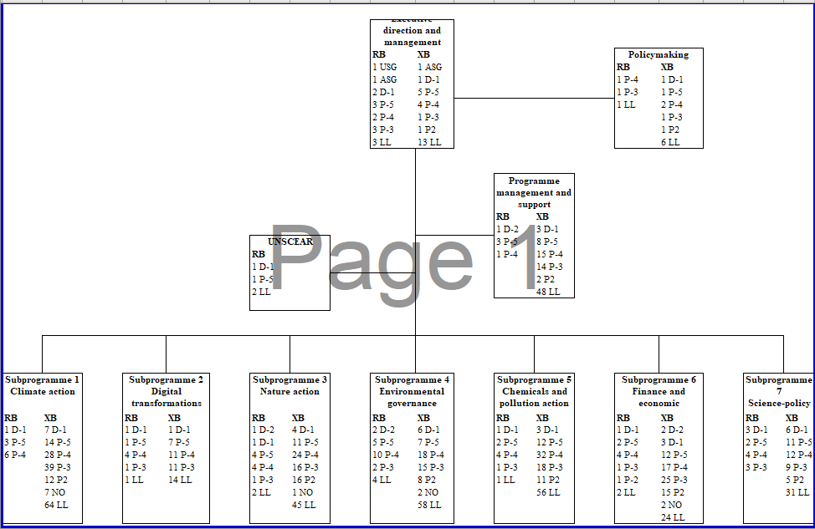
Abbreviations: ASG – Assistant Secretary-General; D – Director; LL – local level; NO – National Professional Officer; RB – regular budget; UNSCEAR – United Nations Scientific Committee on the Effects of Atomic Radiation; USG – Under-Secretary-General; XB – extrabudgetary.

* In accordance with the decisions taken at the meeting of the Bureau of the United Nations Environment Assembly held on 8 October 2020 and at the joint meeting of the Bureaux of the United Nations Environment Assembly and the Committee of Permanent Representatives held on 1 December 2020, the fifth session of the Assembly is expected to adjourn on 23 February 2021 and resume as an in-person meeting in February 2022.
** UNEP/EA.5/Rev.1.
Including by adopting integrated approaches that target nexus issues such as sustainable food systems, urban development, oceans and blue economy, waste, water and wastewater, sustainable energy and green jobs, poverty eradication, circular economy and resource efficiency, climate, environment and security, as well as the broader poverty-environment nexus.
The needs of all vulnerable groups, including people living with disability, youth, children, indigenous people and people living in poverty, are considered in the assessment of responsiveness to human rights.
The financial report and the audited financial statement for the year ending on 31 December 2019 and the report of the Board of Auditors are available at https://undocs.org/en/A/75/5/Add.7.

