GLOBAL UNIVERSITIES PARTNERSHIP ON
ENVIRONMENT & SUSTAINABILITY
Newsletter No. 2 Special Edition
News:
New Email Address, The new email address for the Environmental Education and Training Unit has changed to: Environmental.Education@unep.org

Upcoming Events
World Environment Day: Connecting People to Nature, 5 June 2017. World Environment Day (WED) is the United Nations’ principal vehicle for encouraging worldwide awareness and action for the protection of our environment. Each World Environment Day is organized around a theme that focuses attention on a particularly pressing environmental concern. The theme for 2017 is connecting people to nature. In recent years, millions of people have taken part in thousands of registered activities worldwide. Please sign up (https://unep.bsd.net/page/event/create) so we can keep you updated on various activities. On 5 June, go outside and show us that you’re #WithNature. Breathe in the beauty and remember that by keeping our planet healthy, we keep ourselves healthy too. Share photos and videos of the place that matter most to you with #WorldEnvironmentDay. We especially encourage you to carry out education-related activities and are pleased to provide a Universities Toolkit and School Lesson Plan to help with your celebrations. Please remember to register your event so we can feature it in our global celebrations. To access the lesson plans and university toolkit please visit this link http://www.worldenvironmentday.global/sites/default/files/toolkit_organizations/WED4_Lessons%20EN_FINAL.pdf
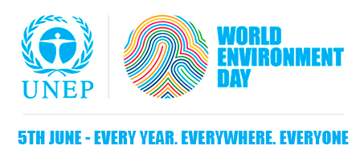

Young Champions of the Earth, 18 June 2017
Managed by UN Environment in partnership with Covestro, Young Champions of the Earth is a new initiative that aims to identify, celebrate and support individuals between the ages of 18 and 30 who have outstanding potential to create positive environmental impact. Each year, six young people – one from each of UN Environment’ s global regions – will be named Young Champions of the Earth. These winners will each receive US$15,000 in seed funding as well as intensive training and tailored mentoring to help bring their big environmental ideas to life. The winners will be selected by a global jury that includes UN Environment Executive Director Erik Solheim and Covestro CEO Patrick Thomas. Winners will be invited to attend the Champions of the Earth Gala Dinner, to be held in Nairobi in December 2017. If you have a big idea to protect or restore the environment; if you have a vision for a more sustainable future; if you have a strong track record of instigating change; if you are unafraid of failure; and if you believe in a bright future for our planet, then you just might have what it takes to become a Young Champion of the Earth. To apply visit the Young Champions website (http://www.unep.org/youngchampions/). The application period will close at midnight GMT on 18 June 2017.
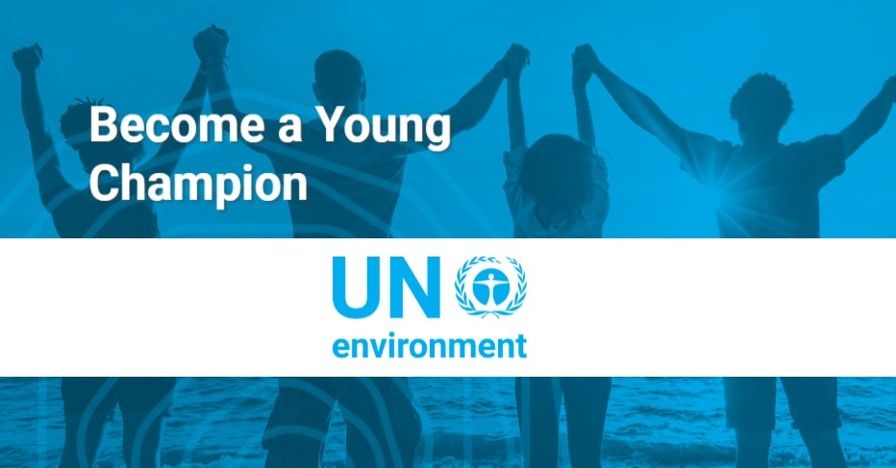
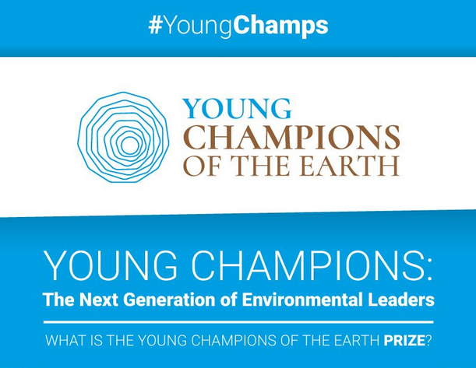

Massive Open Online Course (MOOC) Announcements:
Second MOOC on Marine Litter, 22 May- 17 July 2017.
Marine litter is a global problem that affects every ocean of the world. Litter is an environmental, human health and socio-economic problem that is a symptom of a highly disposable society. With worldwide growth in the amount of solid litter thrown away every day and slow rates of degradation, the amount of litter present in the marine environment is increasing. This MOOC seeks to inspire students to take action and leadership in the arena of marine litter through stimulating interaction with all stakeholder groups. The MOOC has been built on the highly successful first marine litter MOOC that was organized in 2015 and consisted of two-week leadership track and eight-week expert track. The Marine Litter MOOC 2.0 will start on May 22, 2017 and registration is now open at: https://www.marinelittermooc.org/learn/marine-litter-mooc-may-2017
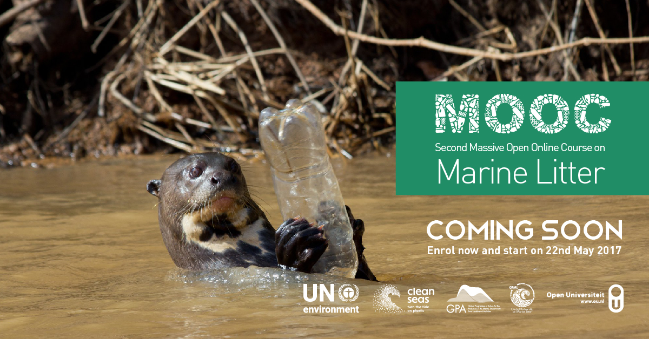

The UNDP Sustainable Consumption and Production MOOC: Greening Consumption and Production, 31 May- 12 July 2017. In the past 20 years, humanity added 1.6 billion people to the planet, while losing 20% of the world’s wilderness, and exploiting 90% of the world’s fisheries. The Aichi Biodiversity Targets and UN Sustainable Development Goals help shape a global policy agenda that strives to conserve the world’s ecosystems while meeting development priorities. How do we develop national policies and approaches that keep the global impacts of natural resources use within safe ecological limits? This six-week facilitated course, from Wed. 31 May to Wed. 12 July 2017, will provide you with the answers to this question. It is aimed at policymakers and practitioners working in the area of sustainable consumption and production (SCP). By taking this course, you will gain an overview of key issues related to SCP and sustainable commodity supply chains. You will become proficient in mechanisms to facilitate SCP at the international level and in your own country, and have the chance to interact with world-known specialists from UNDP, the private sector, NGOs and national ministries.
Registration is now open at: http://mailchi.mp/nbsapforum/massive-open-online-course-greening-consumption-production
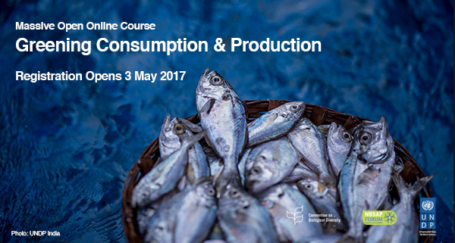

MOOC on Environmental Security and Sustaining Peace: Overcoming Risks from Extractive Industries, Resource Scarcity, and Climate Change, Early 2018. United Nations Environment, the Environmental Law Institute, the University of California-Irvine, Duke University, and Columbia University are pleased to announce a MOOC on Environmental Security and Sustaining Peace. Through examining risks from extractive industries, resource scarcity, and climate change, learners will understand how natural resources present conflict risks but also peacebuilding opportunities across the conflict lifecycle. Accessing lectures, interviews with notable experts and case studies, participants will learn how to apply innovative policies, tools and practices of this growing field. This course will take place over several weeks and will be available in early 2018.
RSVP to reserve your place today!
www.environmentalpeacebuilding.org/education/mooc

Thank you for taking your time to read the GUPES e-newsletter. If you wish to contribute to the quarterly GUPES bulletin or have news, upcoming events, or publications, you would like to share, please use this GUPES Articles Submission Form. You can email it to the GUPES Centre Environmental.Education@unep.org. Submissions must be made by the 15th of every month. In addition, we encourage you to continue using the GUPES portal to exchange ideas, share expertise and resources and deliberate emerging sustainability issues towards EE implementation at a global level.
For more information and/or to submit articles/information, please contact:
Environmental Education and Training Unit
Ecosystems Division | United Nations Environment Programme
P.O. Box 30552 – 00100, Nairobi, Kenya
Tel: +254-20-7623026 |
Email: Environmental.Education@unep.org
| Website: www.unep.org/training

