Laws and Regulations specifically on Energy Efficiency

Table of Contents

CANADA 2
Energy Efficiency Act 2
INDONISIA 2
12A-ENERGY CONSERVATION (Government Regulation of the Republic of Indonesia Number 70 Year 2009 dated November 16, 2009) 2
ISRAEL 2
ENERGY RESOURCES REGULATIONS (PERFORMING A STUDY TO FIND A POTENTIAL TO ENERGY CONSERVATION), 5753-1993 2
PAKISTAN 2
National Energy Efficiency and Conservation Act 2015 2
REPUBLIC OF ALABANIA 3
LAW No. 9072, dated 22.05.2003 ON POWER SECTOR 3
REPUBLIC OF SOUTH AFRICA 3
EIA GUIDELINES ON RENEWABLE ENERGY PROJECTS 3
SOUTH AFRICA-ENERGY EFFICIENCY LEGISLATION AND INCENTIVES 3
UNITED KINDOM 3
UK Report on Articles 4 and 14 of the EU End-use Efficiency and Energy Services Directive (ESD) 3

CANADA

Energy Efficiency Act
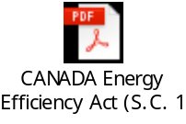

INDONESIA

12A-ENERGY CONSERVATION (Government Regulation of the Republic of Indonesia Number 70 Year 2009 dated November 16, 2009)
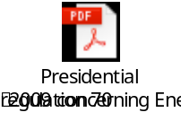

ISRAEL

ENERGY RESOURCES REGULATIONS (PERFORMING A STUDY TO FIND A POTENTIAL TO ENERGY CONSERVATION), 5753-1993
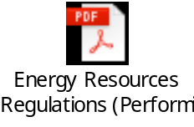

PAKISTAN

National Energy Efficiency and Conservation Act 2015


REPUBLIC OF ALABANIA

LAW No. 9072, dated 22.05.2003 ON POWER SECTOR


REPUBLIC OF SOUTH AFRICA

EIA GUIDELINES ON RENEWABLE ENERGY PROJECTS


SOUTH AFRICA-ENERGY EFFICIENCY LEGISLATION AND INCENTIVES
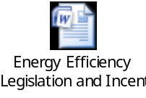

UNITED KINDOM

UK Report on Articles 4 and 14 of the EU End-use Efficiency and Energy Services Directive (ESD)



