United Nations | UNEP/ EA.3/INF/3
 | Distr.: General 2 October 2017  XX
United Nations Environment Assembly of the United Nations Environment Programme

United Nations Environment Assembly of the United Nations Environment Programme Third session
Nairobi, 4–6 December 2017 Item 2 of the provisional agenda*

Scenario note for third session of the United Nations Environment Assembly of the United Nations Environment Programme

Note of the Executive Director*
Summary
The present note, prepared with inputs from the Committee of Permanent Representatives to the United Nations Environment Programme, and the Bureau of the United Nations Environment Assembly, elected at its second session, sets out the proposed plans and general expectations for the third session of the United Nations Environment Assembly, including its high-level segment. The note is intended to assist delegations
and observers in preparing for a successful third session of the Environment Assembly.

* UNEP/EA.3/INF/3: Issued without formal editing.
K15xxxxx xxxx15

Dates and duration
  - H.E. Dr. Edgar Gutierrez, Minister of Environment and Energy of Costa Rica, President of the UN Environment Assembly, will open the third session of the UN Environment Assembly at 10:00 a.m. on Monday, 4 December 2017. The Assembly will address the theme, “Towards a Pollution-Free Planet”. The duration of the session will be three days. The session is expected to conclude at 6:00 p.m. on Wednesday, 6 December 2017.
  - The opening plenary on Monday 4 December 2017 will be preceded by informal consultations of regional groups on Sunday, 3 December 2017.
  - The Global Major Groups and Stakeholders Forum will be held from Monday 27 to Tuesday 28 November 2017. Organized by Major Groups and Stakeholders accredited to UN Environment, this multi-stakeholder Forum is open to the participation of accredited and non-accredited civil society organizations, the private sector and Member States. The Forum will allow Major Groups and Stakeholders the opportunity to coordinate their inputs into both the Open-ended meeting of the Committee of Permanent Representatives (29 November – 1 December 2017) and the Environment Assembly.

  - The Science, Policy and Business Forum will be held on Saturday 2 and Sunday 3 December 2017. This forum will engage all relevant stakeholders on the solutions required to address pollution in all its forms. The Sustainable Innovation Expo will take place from Sunday 3 to Wednesday 6 December, on the margins of the Environment Assembly. The Expo will showcase the latest developments in terms of science, innovation and technology.

  - Meeting rooms will be allocated, upon request, to all regional and political groups to hold their consultations as necessary on Sunday, 3 December, and outside the official hours of the plenary meetings of the UN Environment Assembly (10:00
a.m. to 1:00 p.m. and 3:00 p.m. to 6:00 p.m., Monday to Wednesday).

  - Journalists and media houses will have a specific space in which to conduct interviews and other reporting activities. Journalists will be granted access to the galleries during the open sessions, the high-level segment, side events and the Multi-stakeholder dialogue to ensure visibility of the UN Environment Assembly and parallel events.

  - The proceedings of the plenary meetings of the third session of the UN Environment Assembly, including the high-level segment, will be webcast to the public. The Earth Negotiations Bulletin will cover all three days of UN Environment Assembly sessions as well as selected meetings and side events, and publish informal reports.

  - Detailed information on the third session, including the documents and calendar of meetings will be made available at the official UN Environment Assembly website: http://www.unep.org/environmentassembly/ and the official event mobile app.

  - Daily Journals will also be issued online to provide participants with updated information on the organization of the session. Documents in electronic format will be available through a Mobile App that will run on both the IOS and Android platforms.

  - The Notification by the Executive Director provides detailed information on the on-line pre-registration for all participants and the process for submission of credentials of representatives from Member States.

  - All plenary meetings of the Assembly will be conducted with interpretation services in the six official UN languages. The background documentation for the Assembly as well as in-session and post-session documents, including draft resolutions, will be made available electronically on the online resolutions platform of the Assembly.

Preparation for the Session

- Pursuant to the mandate given by Governing Council decision 27/2, the Committee of Permanent Representatives is engaged in the preparatory work for the third session of the Environment Assembly. Preparations included the Fourth Annual sub-committee meeting of the Committee of Permanent Representatives held from 6 to 9 March 2017 and the third Open-ended meeting of the Committee to be held from 29 November to 1 December 2017.

- The Committee Bureau, represented by its Chair, conducted consultations with the UN Environment Assembly Bureau, with the latter providing further guidance on Assembly preparations. Joint meetings of the Bureaux of the UN Environment Assembly and the Committee of Permanent Representatives were held in October 2016 as well as in March, May, June and September 2017.
- At the first plenary meeting of the UN Environment Assembly on Monday, 4 December 2017, H.E. Mr. John Moretti, High Commissioner and Permanent Representative of Botswana and Chair of the Committee of Permanent Representatives, will report to the Assembly on the work of the Committee, including the outcomes of the 3rd Open Ended Meeting of the Committee of Permanent Representatives.

Adoption of the agenda and organization of work of the United Nations Environment Assembly
- At the first plenary meeting, the Assembly will hear opening statements by H.E. Dr. Edgar Gutierrez, President of the Assembly, Mr. Erik Solheim, Executive Director of the UN Environment Programme, and a high-level representative from the host country.

- These statements will be followed by the adoption of the Assembly’s provisional agenda (UNEP/EA.3/1). The provisional agenda, structure and organization of the Assembly were endorsed by members of the bureaux of the Assembly and the Committee of Permanent Representatives at their joint meeting of 22 May 2017.

- Following the adoption of the agenda, the President of the Assembly will invite Member States to consider the Assembly’s organization of work.

- Pursuant to rule 60 of the Rules of procedure, and on the basis of the report from the Chair of the Committee of Permanent Representatives, the Assembly may establish on Monday, 4 December 2017, sessional committees, including a Committee of the Whole, to discuss substantive reports of the Executive Director and draft resolutions and decisions prepared in advance of the Assembly, and to consider other matters of importance. The President may also establish other groups, such as a group of friends of the Chair as required.

- On the basis of a report by the Chair of the Committee of Permanent Representative, including the work of the 3rd Open-ended meeting of the Committee of Permanent Representatives, the Assembly may take early action on draft resolutions and decisions at its first plenary meeting.

Credentials Committee

- In accordance with rule 17 of the Rules of procedure, the credentials of representatives should be submitted to the Executive Director prior to the first meeting of the session. Member States are invited to send a copy of the credentials, signed by either Head of State/Government or Minister of Foreign Affairs, preferably by Wednesday, 15 November 2017, two weeks ahead of the first plenary meeting of the Assembly and to submit the original upon arrival. Member States representatives submitting original credentials concerning their participation should hand them in at the registration desk upon their arrival at the United Nations Office at Nairobi.
- The Bureau of the UN Environment Assembly will serve as the Credentials Committee and will present its report under agenda item 3 to the plenary of the third session of the Environment Assembly.

Committee of the Whole

- The Committee of the Whole is expected to conduct its work under provisional agenda items 5 (budget and programme performance, including implementation of the resolutions adopted at the previous sessions of the Environment Assembly), 6 (administrative and budgetary issues), 7 (international environmental policy and governance), and 8 (update on the Global Environmental Outlook), beginning after the first meeting of the plenary on Monday, 4 December, through to the afternoon of the same day. The Committee of the Whole is expected to report to the Assembly at its closing plenary session on Wednesday, 6 December 2017. Interpretation into the six official UN languages will be provided for the scheduled plenary meetings of the Committee.

- Pursuant to rule 62 of the Rules of procedure, the Assembly will elect the Chair and Rapporteur of the Committee of the Whole, upon recommendation by the Bureau of the Assembly and taking into account positions and distribution amongst

regional and political groups in a transparent and inclusive manner, as decided by the members of the bureaux of the Assembly and the Committee of Permanent Representatives at its joint meeting on 28 October 2016.

- To facilitate the work of the Committee, the Chair may propose that Member States take note of the updates of the Executive Director presented under agenda items 5, 6 and 8 of the provisional agenda. All relevant reports pertaining to these agenda items will be available on the online resolutions platform.

- To optimally use the limited time available for the Committee of the Whole, the Committee may wish to establish a limited number of drafting groups, if necessary, to finalize outstanding draft resolutions and decisions.

- Pursuant to rule 70 of the Rules of Procedure, Major Groups and Stakeholders will be allocated seats to observe the proceedings of the Committee and may be invited to make interventions as appropriate, subject to permission by the Chair.

- At its plenary meeting on Monday 4 December 2017, the Committee of the Whole is expected to receive the conclusions from any issues allocated to the working group or any other working party, and to approve draft resolutions or decisions for submission to the final plenary meeting of the Assembly to be held in the afternoon of the 6 December.

- The Committee of the Whole is expected to adopt its own report for submission to the plenary.

- From 3:00 pm to 6:00 pm on 4 December 2017, the Assembly is expected to consider its main theme (“Towards a Pollution-Free Planet”) through a list of speakers for national statements. Section VIII of the present note sets out the organizational modalities of the National Statements.

High-level segment

- Pursuant to decision 27/2, paragraph 5, the Environment Assembly will hold a high-level segment on Tuesday and Wednesday, 5 and 6 December 2017. It will include sessions for national statements as well as Leadership Dialogues. In accordance with decision 27/2 (paragraph 5 e), the High Level Segment will include a multi-stakeholder dialogue that will bring in diverse perspectives building on the theme of the Assembly, “Towards a Pollution-Free Planet”.

Opening Ceremony Plenary

- The opening ceremony plenary of the high-level segment will begin on Tuesday 5 December 2017 at 10:00 am. It will consist of statements from the President of the Environment Assembly, the Executive Director and a high level representative of the Host country. The opening plenary will be immediately followed by the Leadership Dialogues and with the continuation of national statements from high- level dignitaries..

- In his statement to the high-level segment of the Assembly, the Executive Director will highlight major policy matters and introduce his report on the theme of the Assembly, "Towards a Pollution Free Planet.”

National Statements

- The National Statements will take place on Monday 4 and Tuesday 5 December 2017 and will be open to representatives of Member States and, in accordance with rules 68, 69 and 70 of the Rules of procedure of the Assembly, to representatives of States not members of the Assembly, Specialized Agencies, United Nations bodies, other intergovernmental organizations and observers of international non- governmental organizations through the Major Groups and Stakeholders. Although the High Level Segment formally begins on 5 December, Heads of Delegation who arrive early will have the opportunity if they so request, to deliver their national statement on 4 December 2017 in light of the limited time at this Assembly.

- Heads of delegations will have the opportunity to continue making national statements, immediately after the opening plenary of the High-Level Segment. These statements will take place in parallel to the Leadership Dialogues.

- The list of speakers for the national statements will be prepared by the Secretariat in accordance with rule 35 of the Rules of procedure, taking into account the practices of the General Assembly. Attending Heads of State and/or Government as well as Heads of Royal Houses shall be accorded precedence.

- The Secretariat will send an invitation to all delegations inviting them to inscribe on the list of speakers as of Wednesday 4 October 2017. Inscriptions on the list will remain open until the close of business of Wednesday 15 November, 2017. Delegations wishing to inscribe on the list of speakers will be invited to indicate a preferred day to deliver a statement as well as the level of the representative who will deliver the statement on their behalf.

- The provisional list of speakers will be made available to all Member States on Friday 17 November 2017, two weeks in advance of the opening of the session.

- In accordance with rule 38, and to allow maximum participation of delegations, the President of the Assembly will recommend that the Assembly limits the time for statements to three minutes per delegation and exceptionally to six minutes to Heads of State and/or Government as well as Heads of Royal Houses and representatives speaking on behalf of regional and political groups. Statements can be made in any of the six official languages of the United Nations.

- Statements will be delivered from a lectern. They will be webcast, recorded and published on the official website of the Assembly.

- Pre-recorded statements and full written statements submitted by delegations will be made available on the electronic portal and referenced in the proceedings.

Leadership Dialogues

- Following the official opening plenary of the High-Level Segment, four consecutive Leadership Dialogues will be held on Tuesday, December 5 in Conference Room 1, under the following themes: (i) Science, evidence and citizens’ awareness for change; (ii) Regulatory frameworks, institutions and the rule of law to address pollution; (iii) Practical solutions towards a pollution-free planet and; (iv) Financing and innovation to combat pollution.

- Each dialogue will last about 90 minutes and will be organized as a high-level, interactive and moderated session. The meetings will be open to representatives of Member States and, in accordance with rules 68, 69 and 70 of the Rules of procedure of the Assembly, to representatives of States not members of the Assembly, Specialized Agencies, United Nations bodies, other intergovernmental organizations and observers of international non-governmental organizations through the Major Groups and Stakeholders. The dialogues will be broadcasted.

- The Secretariat will invite professional moderators with prior experience in the field to conduct the sessions. Moderators will conduct the session from the floor. The Dialogues will open with a short audio-visual product which will introduce the theme of the dialogue to the audience.

- For each dialogue, the Secretariat, in consultation with the Bureau of the Assembly, will identify a limited number of "guests" from the private sector, academia and civil society. These "guests" will not deliver panel presentations but may be called upon from the audience by the moderator to comment in the course of the dialogue.

- Due to the limited time available there will be no list of speakers for the dialogues; ministers and high-level participants will be informed ahead of time that they can signal their intention to intervene. The moderator will discourage statements in order to ensure the flow of an interactive dialogue.

- The outcomes of the dialogues will be presented, in the form of key messages and initiatives, during the wrap-up plenary session to be held on the morning of Wednesday 6 December 2017. In the general organization and in the compilations of the outcomes of the dialogues, the Secretariat will be guided by the theme of the Assembly, the main features of the ministerial outcome document and the voluntary commitments from member States and other stakeholders.

- A background note on the Leadership Dialogues, including guiding questions and names of moderators and guests will be distributed by the 30th October 2017.

Multi-Stakeholder Dialogue
- On Tuesday 5 December 2017 from 6:30 pm to 8:00 pm, a Multi-Stakeholder Dialogue will be organized under the theme “People and Pollution”. The dialogue will complement the process of collecting voluntary commitments by providing an opportunity for people to present how pollution affects them and what initiatives they have taken to beat it. The dialogue will also build upon the four Leadership Dialogues held earlier in the day between governments and the public sector, and will incorporate the voice of Major Groups and Stakeholders.

- The Multi-Stakeholder Dialogue will be held as an interactive informal meeting. The dialogue will include a brief panel discussion in which participants drawn from non-governmental and governmental backgrounds will share how pollution affects their communities and how they have successfully fought it. In telling their stories, participants will help to foster a constructive dialogue and bring the pollution theme back to the reality of people on the ground and celebrate lifestyle champions.

- A background note on the Multi-stakeholder Dialogue, including guiding questions and names of the moderators and panellists will be distributed by 30 October 2017.

Plenary Session

- A plenary session will be held from 10:00 am to 1:00 pm on 6 December 2017. It is expected to consider a summary of commitments from Governments, the private sector, stakeholders and a summary of the Leadership Dialogues. The Ministerial outcome document of the high-level segment, integrating key messages from Ministers of Environment, will be presented by the President of the Assembly for consideration.

Closing plenary

- The closing plenary of the third session of the Environment Assembly will convene from 3:00 pm to 6:00 pm on Wednesday, 6 December 2017. During the closing, the Assembly will consider the report of the Committee of the Whole and will consider for adoption outstanding draft resolutions and decisions prepared in the preceding two days.

Election of the Bureau of the UN Environment Assembly

- Pursuant to Governing Council decision 27/2, paragraph 6, the Bureau of the governing body of UN Environment Program will be "composed of 10 members to reflect the universality of the governing body, in accordance with equitable geographical distribution, and will perform the functions as set out in the Rules of procedure of the governing body." In line with UN Environment Assembly Decision 1/1, "each of the five regions shall be represented by two members in the 10-member Bureau of UN Environment Assembly."

- Pursuant to rule 18 of the Rules of procedure, the third session of the Environment Assembly will elect the following officers during its final plenary meeting to be held on Wednesday 6 December 2017: a President nominated by the Eastern European Group, eight Vice-Presidents and a Rapporteur nominated by the Asia- Pacific Group (in accordance with the principle of regional rotation).

- Given the critical role played by the UN Environment Assembly Bureau in the conduct of business, it is important for the regional groups to nominate officers as early as possible, so that the nominees have sufficient time to prepare for the session with support from the Secretariat. To that end, the Secretariat will

distribute to all Member States the relevant notification for nomination of members of the Bureau.

Dates and Agenda of the Fourth Session of the UN Environment Assembly

- At the closing plenary, the Assembly will consider the provisional agenda and dates for its next session.

Hospitality Events

- On Monday 4 December 2017, the host country will host a reception in honour of delegations to the third session of the UN Environment Assembly.

- To celebrate outstanding figures from the public and private sectors and civil society, whose actions have had a transformative positive impact on the environment; the Champions of the Earth Gala Dinner will take place on 5 December 2017 officially starting at 8:00 pm at the UN premises. All Heads of delegation will be invited to the Gala Dinner.

Other events associated with the UN Environment Assembly

- A number of associated events, including pre-session events, side events, media events will be organized by the UN Environment Programme, Member States and other organizations. A full list of these events will be available at http://www.unep.org/unenvironmentassembly/.

Engagement with general audiences and the digital community

- In the run-up to the UN Environment Assembly, the Secretariat has launched a global campaign to inspire pollution-beating commitments from citizens, governments, business and civil society. The pledges can be submitted at www.beatpollution.org. The most relevant and innovative pledges will be displayed on the wall of commitments during the UN Environment Assembly and communicated to media.

- The Secretariat will launch a number of publications during the UN Environment Assembly and related events. One of those is the quarterly magazine Our Planet, which will focus on the theme of pollution.

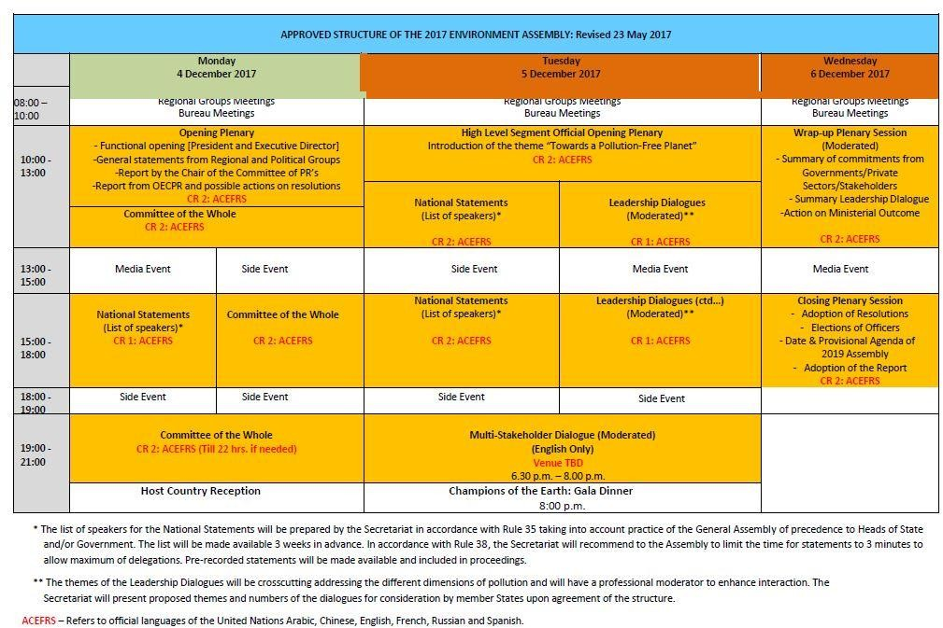
Annex 1 Organizational diagram of the Environment Assembly

